BRACT’s
Vishwakarma Institute of Technology, Pune
Practical Implementation Sheet
Department: CSE-AI Semester: 5 Academic Year: 2026-27
Division: E Batch: 01 Practical No: 01 Roll no: 01 PRN No: 12410844
Name of Student: Vaibhav Vaijnath Chate
Subject Name: Deep Learning

Problem Statement : Implement forward propagation and backpropagation using TensorFlow/Keras. Analyze the effect of different learning rates and the number of epochs on model performance
Algorithm :

Dataset Used
Fashion MNIST Dataset
- Contains 70,000 grayscale images of clothing items.
- Each image has a size of 28 × 28 pixels.
- Includes 10 different clothing categories.
- Dataset is divided into:
  - Training Set: 60,000 images
  - Testing Set: 10,000 images

Algorithms and Techniques Used

1. Artificial Neural Network (ANN)
- A Multi-Layer Perceptron (MLP) architecture is used for image classification.

2. TensorFlow/Keras
- Used to build, train, and evaluate the neural network model.

Network Architecture

Flatten Layer
- Converts each 28 × 28 image into a 1D vector of 784 features.

Dense (Fully Connected) Layers
- Hidden layers extract meaningful features from the input.
- Output layer predicts the final clothing category.

ReLU (Rectified Linear Unit) Activation Function
- Applied in hidden layers to introduce non-linearity.
- Helps the model learn complex patterns.

Softmax Activation Function
- Applied in the output layer.
- Produces probability values for all 10 classes.
- The class with the highest probability is selected as the prediction.

Training Process

Forward Propagation
- Input images pass through the neural network.
- Each layer processes the data.
- The output layer generates prediction probabilities.

Backpropagation
- Calculates prediction error using the loss function.
- Updates network weights and biases to minimize error.
- Uses gradient descent through the Adam optimizer.

Data Preprocessing

Data Normalization
- Pixel values are scaled from 0–255 to 0–1.
- Improves training stability.
- Speeds up model convergence.
- Enhances overall model performance.

Model Compilation

Optimizer
- Adam Optimizer
- Tested with different learning rates:
  - 0.1
  - 0.01
  - 0.001
  - 0.0001

Loss Function
- Sparse Categorical Crossentropy
- Suitable for multi-class classification with integer labels.

Evaluation Metric
- Accuracy
- Measures the percentage of correctly classified images.

Experimentation and Analysis

1. Epoch Analysis
- Trained the model for different numbers of epochs (e.g., 20 and 50).
- Observed changes in:
  - Training Accuracy
  - Validation Accuracy
  - Training Loss
  - Validation Loss
- Used to identify convergence and overfitting.

2. Learning Rate Analysis
- Compared model performance using different learning rates:
  - 0.1
  - 0.01
  - 0.001
  - 0.0001
- Analyzed their effect on:
  - Convergence speed
  - Model accuracy
  - Training stability

Visualization
Matplotlib was used to visualize the following:
- Sample Fashion MNIST images
- Training and validation loss curves
- Training and validation accuracy curves
- Comparison of average weight values before and after training
- Impact of different learning rates on loss and accuracy
- Model performance across different epochs

Code :
# Step 1: Import Required Libraries
import tensorflow as tf
from tensorflow.keras.datasets import fashion_mnist
from tensorflow.keras.models import Sequential
from tensorflow.keras.layers import Dense, Flatten
from tensorflow.keras.optimizers import Adam
import matplotlib.pyplot as plt
import numpy as np
from sklearn.metrics import confusion_matrix, ConfusionMatrixDisplay

# Step 2: Load the Fashion MNIST Dataset
(X_train, y_train), (X_test, y_test) = fashion_mnist.load_data()

# Step 3: Display Dataset Information
print("Training Images :", X_train.shape)
print("Training Labels :", y_train.shape)
print("Testing Images :", X_test.shape)
print("Testing Labels :", y_test.shape)

# Step 4: Define Class Names
class_names = [
"T-shirt/Top",
"Trouser",
"Pullover",
"Dress",
"Coat",
"Sandal",
"Shirt",
"Sneaker",
"Bag",
"Ankle Boot"
]

# Step 5: Display Sample Images
plt.figure(figsize=(12,5))
for i in range(10):
plt.subplot(2,5,i+1)
plt.imshow(X_train[i], cmap='gray')
plt.title(class_names[y_train[i]])
plt.axis('off')
plt.tight_layout()
plt.show()

# Step 6: Data Preprocessing
print("Minimum Pixel Value :", X_train.min())
print("Maximum Pixel Value :", X_train.max())

X_train = X_train / 255.0
X_test = X_test / 255.0

print("Minimum Pixel Value :", X_train.min())
print("Maximum Pixel Value :", X_train.max())

# Step 7: Create ANN Model
model = Sequential([
Flatten(input_shape=(28,28)),
Dense(128, activation='relu'),
Dense(64, activation='relu'),
Dense(10, activation='softmax')
])

# Step 8: Compile Model
model.compile(
optimizer=Adam(learning_rate=0.001),
loss='sparse_categorical_crossentropy',
metrics=['accuracy']
)

# Step 9: Perform Forward Propagation
sample_image = X_test[0]
prediction = model.predict(sample_image.reshape(1,28,28), verbose=0)

print("Class Probabilities:")
for i, prob in enumerate(prediction[0]):
print(f"{class_names[i]} : {prob:.4f}")

# Step 10: Store Initial Weights
initial_weights = model.layers[1].get_weights()[0].copy()

# Step 11: Train the Model (20 Epochs)
history = model.fit(
X_train,
y_train,
epochs=20,
batch_size=32,
validation_split=0.2,
verbose=1
)

# Step 12: Perform Backpropagation (Automatic During Training)
updated_weights = model.layers[1].get_weights()[0]

# Step 13: Weight Analysis
weight_difference = updated_weights - initial_weights
average_change = np.mean(np.abs(weight_difference))

print("Average Weight Change:", average_change)

# Step 14: Plot Loss Graph
plt.figure(figsize=(8,5))
plt.plot(history.history['loss'], label='Training Loss')
plt.plot(history.history['val_loss'], label='Validation Loss')
plt.title("Loss vs Epoch")
plt.xlabel("Epoch")
plt.ylabel("Loss")
plt.legend()
plt.grid(True)
plt.show()

# Step 15: Plot Accuracy Graph
plt.figure(figsize=(8,5))
plt.plot(history.history['accuracy'], label='Training Accuracy')
plt.plot(history.history['val_accuracy'], label='Validation Accuracy')
plt.title("Accuracy vs Epoch")
plt.xlabel("Epoch")
plt.ylabel("Accuracy")
plt.legend()
plt.grid(True)
plt.show()

# Step 16: Compare Average Weights
initial_avg = np.mean(np.abs(initial_weights))
updated_avg = np.mean(np.abs(updated_weights))

plt.figure(figsize=(6,5))
plt.bar(["Before Training", "After Training"], [initial_avg, updated_avg])
plt.title("Average Weight Values")
plt.ylabel("Average Absolute Weight")
plt.show()

# Step 17: Overfitting Analysis (50 Epochs)
model_overfit = Sequential([
Flatten(input_shape=(28,28)),
Dense(128, activation='relu'),
Dense(64, activation='relu'),
Dense(10, activation='softmax')
])

model_overfit.compile(
optimizer=Adam(learning_rate=0.001),
loss='sparse_categorical_crossentropy',
metrics=['accuracy']
)

history_overfit = model_overfit.fit(
X_train,
y_train,
epochs=50,
batch_size=32,
validation_split=0.2,
verbose=1
)

loss, accuracy = model_overfit.evaluate(X_test, y_test, verbose=0)

print("Test Accuracy :", accuracy)
print("Test Loss :", loss)

# Step 18: Learning Rate Analysis
learning_rates = [0.1, 0.01, 0.001, 0.0001]
lr_histories = {}

for lr in learning_rates:
temp_model = Sequential([
Flatten(input_shape=(28,28)),
Dense(128, activation='relu'),
Dense(64, activation='relu'),
Dense(10, activation='softmax')
])

temp_model.compile(
optimizer=Adam(learning_rate=lr),
loss='sparse_categorical_crossentropy',
metrics=['accuracy']
)

history_lr = temp_model.fit(
X_train,
y_train,
epochs=20,
batch_size=32,
validation_split=0.2,
verbose=0
)

lr_histories[lr] = history_lr

# Step 19: Plot Learning Rate Loss Curves
plt.figure(figsize=(12,6))

for lr, history in lr_histories.items():
plt.plot(history.history['loss'], label=f'LR={lr}')

plt.title("Loss Curves for Different Learning Rates")
plt.xlabel("Epoch")
plt.ylabel("Loss")
plt.legend()
plt.grid(True)
plt.show()

# Step 20: Plot Learning Rate Accuracy Curves
plt.figure(figsize=(12,6))

for lr, history in lr_histories.items():
plt.plot(history.history['accuracy'], label=f'LR={lr}')

plt.title("Accuracy Curves for Different Learning Rates")
plt.xlabel("Epoch")
plt.ylabel("Accuracy")
plt.legend()
plt.grid(True)
plt.show()

Output :
Dataset Images
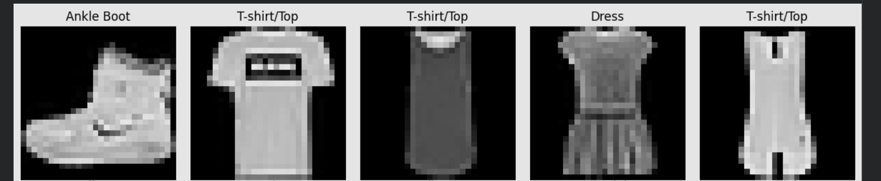
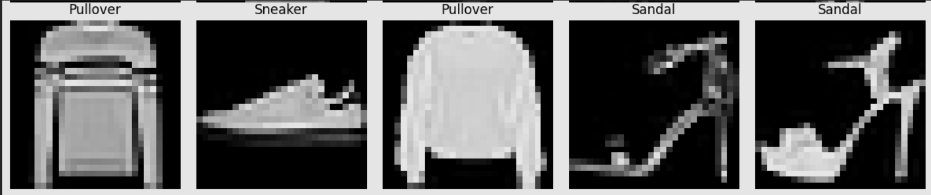
Different layers
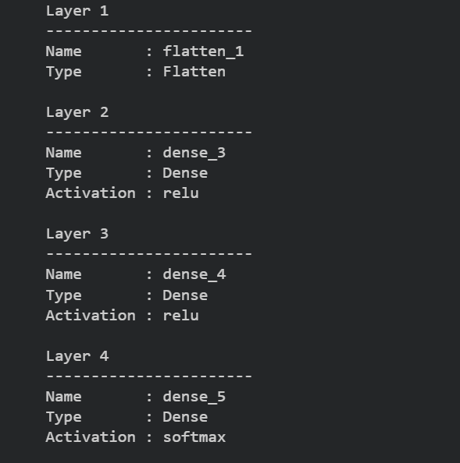
Forward Propagation result
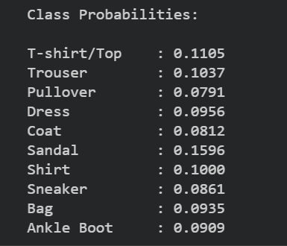
Weights are updated after back propagation
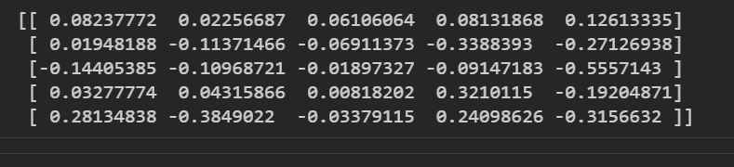
Loss Vs Epoch After backpropagation
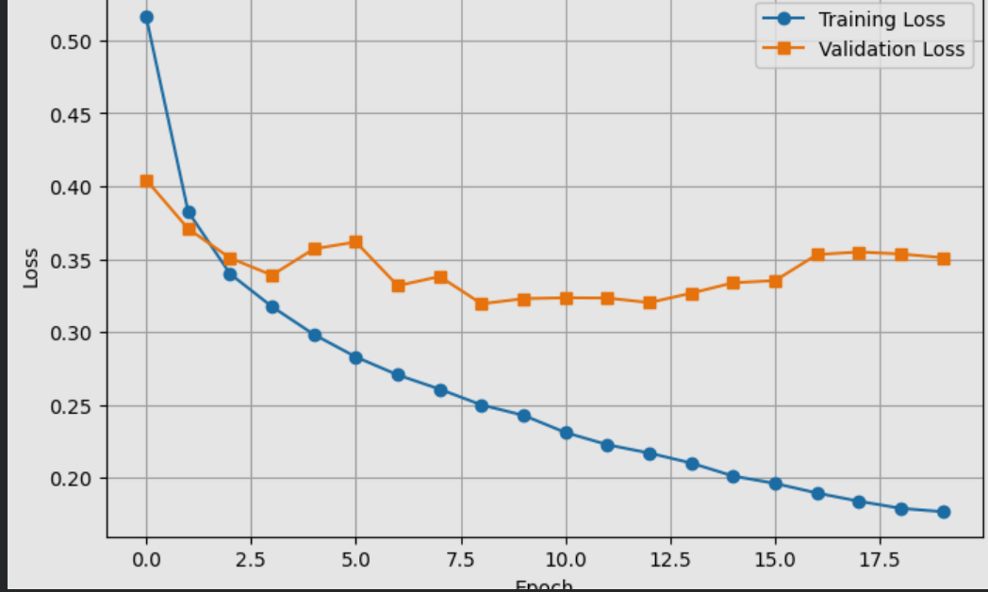
Accuracy Vs Epoch
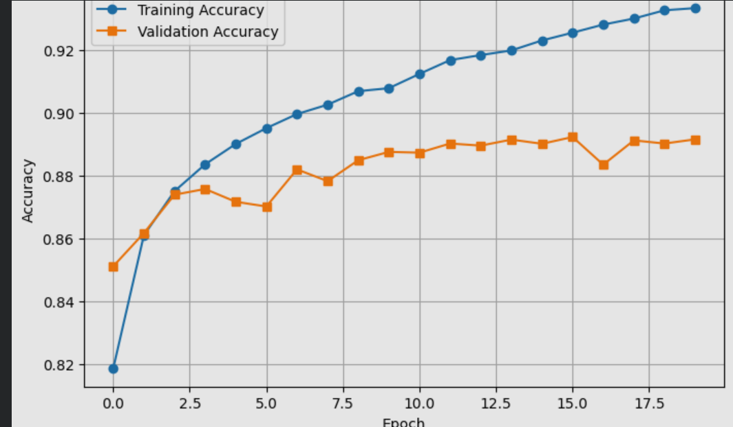
Graph for epoch vs train accuracy and validation accuracy
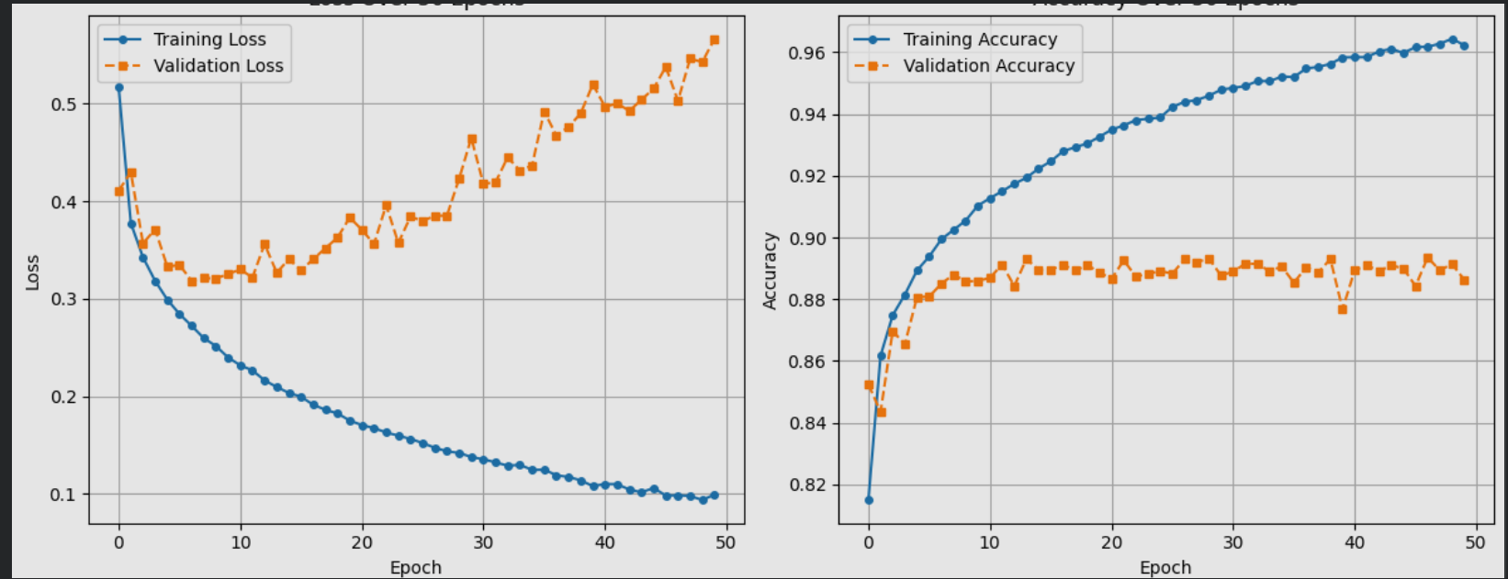

Loss Vs Epoch for different Learning rates
