BRACT’s
Vishwakarma Institute of Technology, Pune
Practical Implementation Sheet
Department: CSE-AI Semester: 5 Academic Year: 2026-27
Division: E Batch: 1 Practical No: 5
Roll no: 1 PRN No: 12410844 Name of Student: Vaibhav Vaijnath Chate
Subject Name : Deep Learning

Problem Statement :
Implement and compare RNN, LSTM, and GRU models for sequence classification, and analyze their performance using appropriate evaluation metrics.

Algorithm :
Data Preprocessing & Tokenization
- Dataset: IMDB Movie Reviews (25,000 training, 25,000 testing samples).
- Vocabulary Size (max_features): Top 10,000 most frequent words.
- Sequence Alignment (maxlen): Fixed length of 200 tokens using post/pre padding (pad_sequences).
2. Word Embedding Layer
- Input Dimension: 10,000 words.
- Output Embedding Dimension: 128.
- Function: Maps sparse integer token indices into continuous dense vector representations.
3. Recurrent Units (Compared Models)
- SimpleRNN: Standard recurrent neural network with 64 units. Suffers from vanishing gradient issues over long sequences.
- LSTM: Long Short-Term Memory network with 64 units utilizing input, output, and forget gates to capture long-term dependencies.
- GRU: Gated Recurrent Unit with 64 units using reset and update gates as a computationally efficient alternative to LSTM.
4. Output Layer & Training Configuration
- Dense Layer: Single unit with a Sigmoid activation function ($\sigma(z) = \frac{1}{1 + e^{-z}}$) producing probability outputs between 0 and 1.
- Optimizer: Adam (optimizer="adam").
- Loss Function: Binary Cross-Entropy (loss="binary_crossentropy").
- Evaluation Metrics: Accuracy, Precision, Recall, F1-Score, and Confusion Matrix.

Code :
# ==========================================
# 1. INSTALL LIBRARIES & IMPORTS
# ==========================================
!pip -q install scikit-learn

import tensorflow as tf
import pandas as pd
import numpy as np
from tensorflow.keras.datasets import imdb
from tensorflow.keras.preprocessing.sequence import pad_sequences
from tensorflow.keras.models import Sequential
from tensorflow.keras.layers import Input, Embedding, SimpleRNN, LSTM, GRU, Dense
from sklearn.metrics import (
accuracy_score,
precision_score,
recall_score,
f1_score,
confusion_matrix,
classification_report
)

# ==========================================
# 2. LOAD & PREPROCESS IMDB DATASET
# ==========================================
max_features = 10000 # Vocabulary size
maxlen = 200 # Maximum review sequence length

(x_train, y_train), (x_test, y_test) = imdb.load_data(num_words=max_features)

# Pad sequences to ensure uniform input length
x_train = pad_sequences(x_train, maxlen=maxlen)
x_test = pad_sequences(x_test, maxlen=maxlen)

print("Training data shape:", x_train.shape)
print("Testing data shape:", x_test.shape)

# ==========================================
# 3. BUILD MODEL FUNCTION
# ==========================================
def build_model(model_type):
model = Sequential([
Input(shape=(maxlen,)),
Embedding(input_dim=max_features, output_dim=128)
])

if model_type == "RNN":
model.add(SimpleRNN(64))
elif model_type == "LSTM":
model.add(LSTM(64))
elif model_type == "GRU":
model.add(GRU(64))

model.add(Dense(1, activation="sigmoid"))

model.compile(
optimizer="adam",
loss="binary_crossentropy",
metrics=["accuracy"]
)
return model

# ==========================================
# 4. TRAIN AND EVALUATE MODELS
# ==========================================
results = []

for model_type in ["RNN", "LSTM", "GRU"]:
print("\n" + "=" * 50)
print(f"Training Model: {model_type}")
print("=" * 50)

model = build_model(model_type)

# Model Training
model.fit(
x_train,
y_train,
epochs=3,
batch_size=128,
validation_split=0.2,
verbose=1
)

# Model Predictions
probabilities = model.predict(x_test, verbose=0)
predictions = (probabilities > 0.5).astype(int).ravel()

# Compute Metrics
accuracy = accuracy_score(y_test, predictions)
precision = precision_score(y_test, predictions)
recall = recall_score(y_test, predictions)
f1 = f1_score(y_test, predictions)
cm = confusion_matrix(y_test, predictions)

print("\nConfusion Matrix:")
print(cm)

print("\nClassification Report:")
print(classification_report(y_test, predictions, target_names=["Negative", "Positive"]))

results.append([model_type, accuracy, precision, recall, f1])

# ==========================================
# 5. MODEL COMPARISON SUMMARY
# ==========================================
results_df = pd.DataFrame(
results,
columns=["Model", "Accuracy", "Precision", "Recall", "F1-Score"]
)

print("\nModel Comparison:")
print(results_df)

Output :
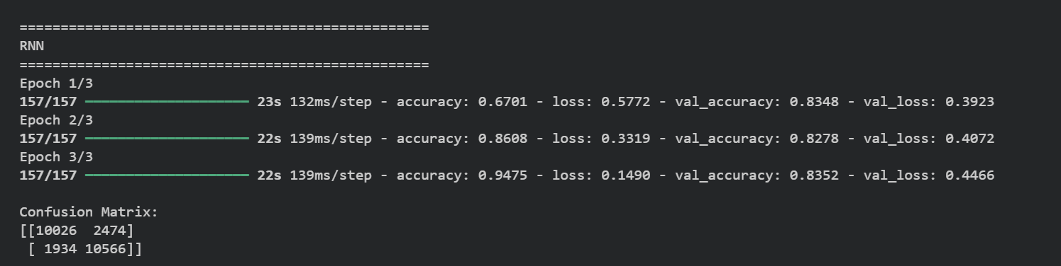
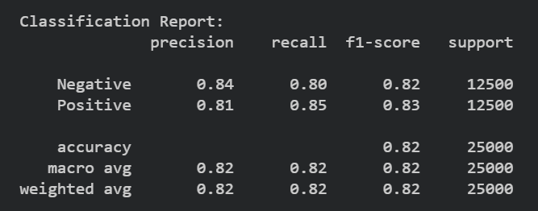
LSTM
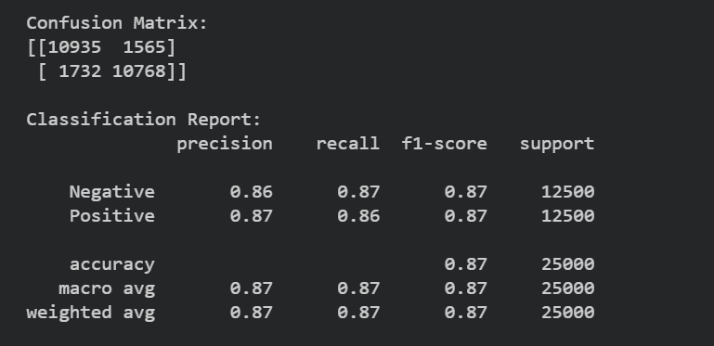
GRU
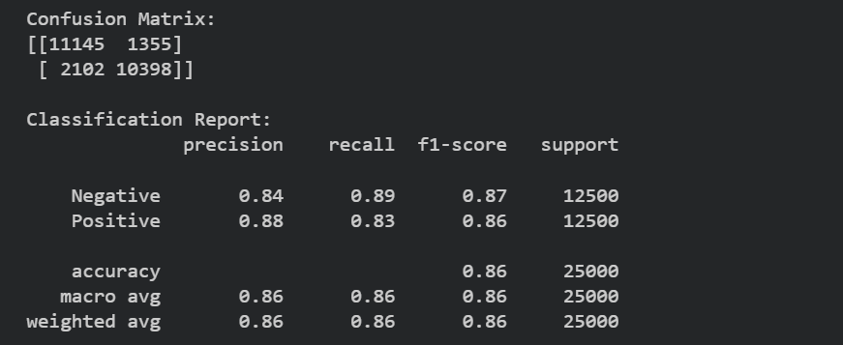
COMPARISION
