**PROJECT REPORT**

**ON**

**ONLINE METREMONIAL WEBSITE**

Submitted to

**SURYODAYA COLLEGE OF ENGINEERING & TECHNOLOGY**

**NAGPUR**

**In partial fulfillment of**

**MASTER OF COMPUTER APPLICATION**

(PART-I SEMESTER-II) Examination

*Submitted by*

**Mr. Vaibhav K. Borkar**

**Mr. Yash A. Channe**

**Under the guidance of**

**Prof. Rahul Lilhare**

**Assistant Professor**

**Department of MCA**



**DEPARTMENT OF MASTER OF COMPUTER APPLICATION**

**SURYODAYA COLLEGE OF ENGINEERING & TECHNOLOGY**

**NAGPUR**

**2024--2025**

**SURYODAYA COLLEGE OF ENGINEERING & TECHNOLOGY, NAGPUR**

**DEPARTMENT OF MASTER OF COMPUTER APPLICATION**

**SESSION 2024--2025**

**CERTIFICATE**

This is to certify that **Mr. Vaibhav K. Borkar** **and Mr. Yash A. Channe** has successfully completed the project work entitled “**Online Metremonial Website**” under my guidance towards the fulfillment of the degree of **MASTER OF COMPUTER APPLICATION** (PART-I SEMESTER-II) submitted to Suryodaya College of Engineering & Technology, Nagpur during academic year 2024-2025.

To the best of my knowledge the matter presented here in this project has not been presented earlier for similar degree.

**Prof. Rahul Lilhare Dr. Madhura Naralkar**

**Guide Head of Department**

**Dr. V. G. Arajpure**

**Principal, SCET, Nagpur**

**DECLARATION**

To,

The Principal

Suryodaya College of Engineering & Technology,

Nagpur

Respected Sir,

I the undersigned, hereby declare that the project work entitled **“Online Metremonial Website”** submitted to **Suryodaya College of Engineering and Technology, Nagpur**. This is my own independent work. This is my original work and has not been submitted anywhere for any degree. The system presented herein has not been duplicated from any other source.

Understand that any such copying is liable to be punished in any way the university authority may deems fit.

Thanking you,

Place: Nagpur Yours Sincerely,

Date: **Mr. Vaibhav K. Borkar**

**&**

**Mr. Yash A. Channe**

**ACKNOWLEDGEMENT**

I wish to express my sincere thanks to many persons who helped me to develop the project. I extend my thanks to respected **Principal, Dr. V. G. Arajpure,**  Suryodaya College, Nagpur for providing the infrastructure and facilities without which it would have been impossible to complete this hard task.

My foremost thanks are to **Dr. Madhura Naralkar,** Head of Department of MCA who has guided me in completing this project report. I take the opportunity to express my deep sense of gratitude and whole hearted thanks for his inspiration and guidance throughout the course of this project.

I am thankful to my Guide **Prof. Rahul Lilhare** for their constant inspiration and guidance throughout the course of this project work.

I express my gratitude to all members of teaching and non-teaching staff of the Department of Computer Science for their co-operation during the verification of the project.

**Place: Nagpur**

**Date**: Mr. Vaibhav K. Borkar

Mr. Yash A. Channe

**(M.C.A Part I Semester-II)**

|  |  |  |
| --- | --- | --- |
| **Sr. No.** | **Name of Topic** | **Page No.** |
| **1.** | **INTRODUCTION**   * 1. Background   2. Objectives   3. Proposed System      1. Purpose      2. Scope | **1-3** |
| **2.** | **SURVEY OF TECHNOLOGY** | **4** |
| **3.** | **REQUIREMENTS AND ANALYSIS**  3.1 Problem Definition  3.2 Planning and Scheduling  3.3 Software and Hardware Requirements  3.4 Feasibility Study  3.4.1 Economic  3.4.2 Technical  3.4.3 Operational | **5-7** |
| **4.** | **SYSTEM DESIGN**  4.1 Program Flowchart  4.2 Basic Modules  4.3 Data Design  4.3.1 Database Design  4.3.2 Data Dictionary and Data Views  4.3.3 E-R diagram and DFDs | **8-17** |
| **5.** | **IMPLEMENTATION AND TESTING**  5.1 Coding Details and screenshots  5.2 Testing Approach  5.2.1 Unit Testing  5.2.2 Integrated Testing  5.2.3 System Testing  5.3 Implementation and Maintenance | **18-41** |
| **6.** | **CONCLUSIONS**  6.1 Limitations of the System  6.2 Conclusion  6.3 Future Scope of the Project | **42-44** |
| **7.** | **BIBLIOGRAPHY** | **45** |

**1. INTRODUCTION**

In the modern digital era, technology has transformed the way people connect, communicate, and make important life decisions. One such important aspect of human life is marriage. Traditionally, matrimonial matchmaking relied heavily on family networks, intermediaries, and offline advertisements. However, with the advancement of web technologies, online matrimonial portals have emerged as a more convenient and efficient alternative.

This project, titled **"Online Matrimonial Website,"** is developed as a web-based platform that enables individuals to find potential life partners based on various personal and preference-based criteria. The website provides features such as user registration, profile creation, partner preferences, advanced search, and profile viewing, all within a secure and user-friendly environment.

The primary goal of this project is to simplify and digitize the matchmaking process by offering a platform that is easy to use, accessible from anywhere, and rich with personalized features. The system allows users to create and manage their own profiles, search for suitable matches, view detailed partner profiles, and filter results based on specific preferences such as age, religion, location, profession, and more.

The project is built using HTML, CSS, JavaScript, PHP, and MySQL. These technologies ensure a responsive front-end design, dynamic user interactions, server-side data processing, and efficient data storage and retrieval. By developing this website, the aim is to demonstrate the application of full-stack web development techniques while addressing a real-world social need in a structured and systematic way.

**1.1 BACKGROUND**

The concept of matrimonial matchmaking has existed for centuries, traditionally relying on personal networks, family introductions, and social events. With the advent of the internet, this practice has evolved into the digital realm, giving rise to online matrimonial websites. These platforms have revolutionized the way people find life partners by offering a wide range of features that enable individuals to connect based on common interests, shared values, and personal preferences.

In today's fast-paced world, finding the right life partner has become increasingly complex. The process requires time, effort, and sometimes the assistance of family or third-party matchmakers. However, online matrimonial websites have simplified this by providing users with the ability to create detailed profiles, define partner preferences, and explore potential matches in a more streamlined manner.

The rapid growth of internet penetration and smartphone usage, combined with a surge in online transactions, has made matrimonial websites an essential tool for people seeking life partners. The websites offer a more transparent, efficient, and accessible way to connect individuals who may not have met otherwise, overcoming geographical, social, and cultural barriers. Moreover, online matrimonial services enable users to browse profiles and communicate in a comfortable, secure, and private environment, which has become increasingly important in today’s digital age.

**1.2 OBJECTIVES**

1. To implement secure user registration, login, and logout functionalities.

2. To enable users to create, update, and manage their profiles.

3. To provide search and matchmaking features based on user preferences.

4. To allow users to view profiles and interact with matches.

5. To provide informational pages such as About, Privacy Policy, and Terms of Use.

6. To ensure the website is responsive and mobile-friendly.

7. To optimize website performance for fast loading and smooth navigation

**1.3 PROPOSED SYSTEM**

The proposed system is a web-based matrimonial portal that aims to digitize and simplify the traditional matchmaking process. It offers features such as registration, partner preference settings, profile browsing, and advanced search, making it convenient for users to find potential matches.

**1.3.1 PURPOSE**

The purpose of the proposed system is to bridge the gap between traditional matchmaking and modern web technology. It provides a centralized online platform where users can create detailed profiles and search for potential partners from the comfort of their homes. This system is designed to:

* Make the matchmaking process faster and more accessible.
* Reduce the need for intermediaries.
* Ensure data privacy and security for all users.

**1.3.2 SCOPE**

The scope of this project includes:

* Development of a responsive web application accessible from desktops, laptops, and mobile devices.
* Implementation of user management features: registration, login, profile update, and password management.
* Features for setting and managing partner preferences.
* Advanced search functionality based on multiple criteria.
* An admin panel for monitoring and managing user activities.
* A secure database to store user data, partner preferences, and photos

**2. SURVEY OF TECHNOLOGY**

In developing the **Online Matrimonial Website**, several technologies were explored and selected to meet the requirements of a dynamic and user-friendly platform. Below is a survey of the main technologies used:

**1. PHP**

PHP (Hypertext Preprocessor) is a server-side scripting language designed specifically for web development. It is widely used because it is open-source, easy to learn, and well-integrated with databases like MySQL. PHP helps in handling form data, user authentication, and database interactions efficiently.

**2. MySQL**

MySQL is an open-source relational database management system (RDBMS) that is used to store and manage user profiles, partner preferences, and other essential data for the website. It is popular for its speed, reliability, and ease of use, making it a perfect choice for web applications.

**3. HTML & CSS**

HTML (HyperText Markup Language) is the backbone of web pages, used to structure content, while CSS (Cascading Style Sheets) is used for styling and designing the appearance of web pages. Together, they ensure that the website is well-structured, attractive, and responsive.

**4. JavaScript**

JavaScript is a client-side scripting language that adds interactivity to web pages. It is used for features like form validation, dynamic content updates, and improving the overall user experience. JavaScript works smoothly with HTML and CSS to create a responsive user interface.

**5. XAMPP/WAMP**

For development and testing purposes, XAMPP/WAMP server packages were used. These tools provide an all-in-one solution with PHP, MySQL, and Apache bundled together, allowing local testing of the website before deployment.

**6. Bootstrap**

Bootstrap, a CSS framework, was explored for creating a responsive and mobile-friendly design. It provides ready-made components like forms, buttons, and navigation bars that help in speeding up front-end development.

**3. REQUIREMENTS AND ANALYSIS**

**3.1 PROBLEM DEFINITION**

The main problem addressed by the **Online Matrimonial Website** is the challenge individuals face when trying to find compatible life partners in the modern digital age. Traditional matchmaking methods can be time-consuming and geographically limited. This project aims to offer a fast, accessible, and secure platform for individuals to connect with potential partners based on mutual preferences, interests, and values. The website will enable users to register, create profiles, search for matches, and interact with others in a secure, private manner.

**3.2 PLANNING AND SCHEDULING**

The project was planned and executed in the following stages:

1. **Requirement Analysis:** Gathered detailed requirements and listed out features for the matrimonial site.
2. **System Design:** Designed the database, ER diagrams, and wireframes for web pages.
3. **Development:**
   * Frontend development using HTML, CSS, and JavaScript.
   * Backend scripting with PHP.
   * Database creation and management using MySQL.
4. **Testing:** Performed unit testing, integration testing, and system testing.
5. **Deployment:** Set up the system on a local server for demonstration.
6. **Documentation:** Prepared project reports.

**3.3 SOFTWARE AND HARDWARE REQUIREMENTS**

In order to develop and implement the Online Matrimonial Website, certain software and hardware requirements are necessary to ensure smooth development, deployment, and operation. Below are the detailed requirements:

**1. Software Requirements**

* **Frontend Technologies:**
* HTML5 (for structuring web pages)
* CSS3 (for designing and styling)
* JavaScript (for interactivity and client-side scripting)
* **Backend Technologies:**
* PHP (for server-side scripting)
* MySQL (for database management)
* **Development Tools:**
* XAMPP/WAMP (for local server setup)
* Visual Studio Code(for coding)
* phpMyAdmin (for database administration)
* **Other Software:**
* Web Browser: Google Chrome / Mozilla Firefox
* Operating System: Windows 10

**2. Hardware Requirements**

* **Processor:** Intel Core i3 or higher (recommended for faster processing)
* **RAM:** Minimum 4 GB (8 GB recommended)
* **Hard Disk Space:** Minimum 250 GB
* **Internet Connectivity:** Required for hosting or accessing the website if deployed online
* **Display:** 1024x768 resolution or higher (for best viewing experience)

**3.4 FEASIBILITY STUDY**

**3.4.1 ECONOMIC**

The economic feasibility analyzes the cost-effectiveness of developing the matrimonial website. The main costs involve domain purchase, web hosting, development (frontend, backend, and database), and ongoing maintenance. As an academic project, these costs are minimal because open-source tools and free hosting (for testing) are used. In a real-world scenario, premium features, marketing, and scalability might require further investment. Overall, the system is economically viable within the scope of a student project.

**3.4.2 TECHNICAL**

The technical feasibility assesses whether the available technologies and tools can support the website. The project uses HTML, CSS, JavaScript for the frontend, and PHP with MySQL for the backend and database. These are widely used, well-supported technologies with abundant resources and documentation, making development straightforward. Hosting services that support PHP & MySQL are easily available, ensuring smooth deployment. Therefore, the project is technically feasible.

**3.4.3 OPERATIONAL**

Operational feasibility examines whether the system can function smoothly after development. The website is designed to be user-friendly, allowing users to easily register, manage profiles, search for matches, and interact with other users. The admin panel provides full control over managing users and content. Basic security measures (like password encryption and validation) ensure safe operation. Thus, the system is operationally feasible and can fulfill its intended purpose effectively.

**4. SYSTEM DESIGN**

**4.1 PROGRAM FLOWCHART**

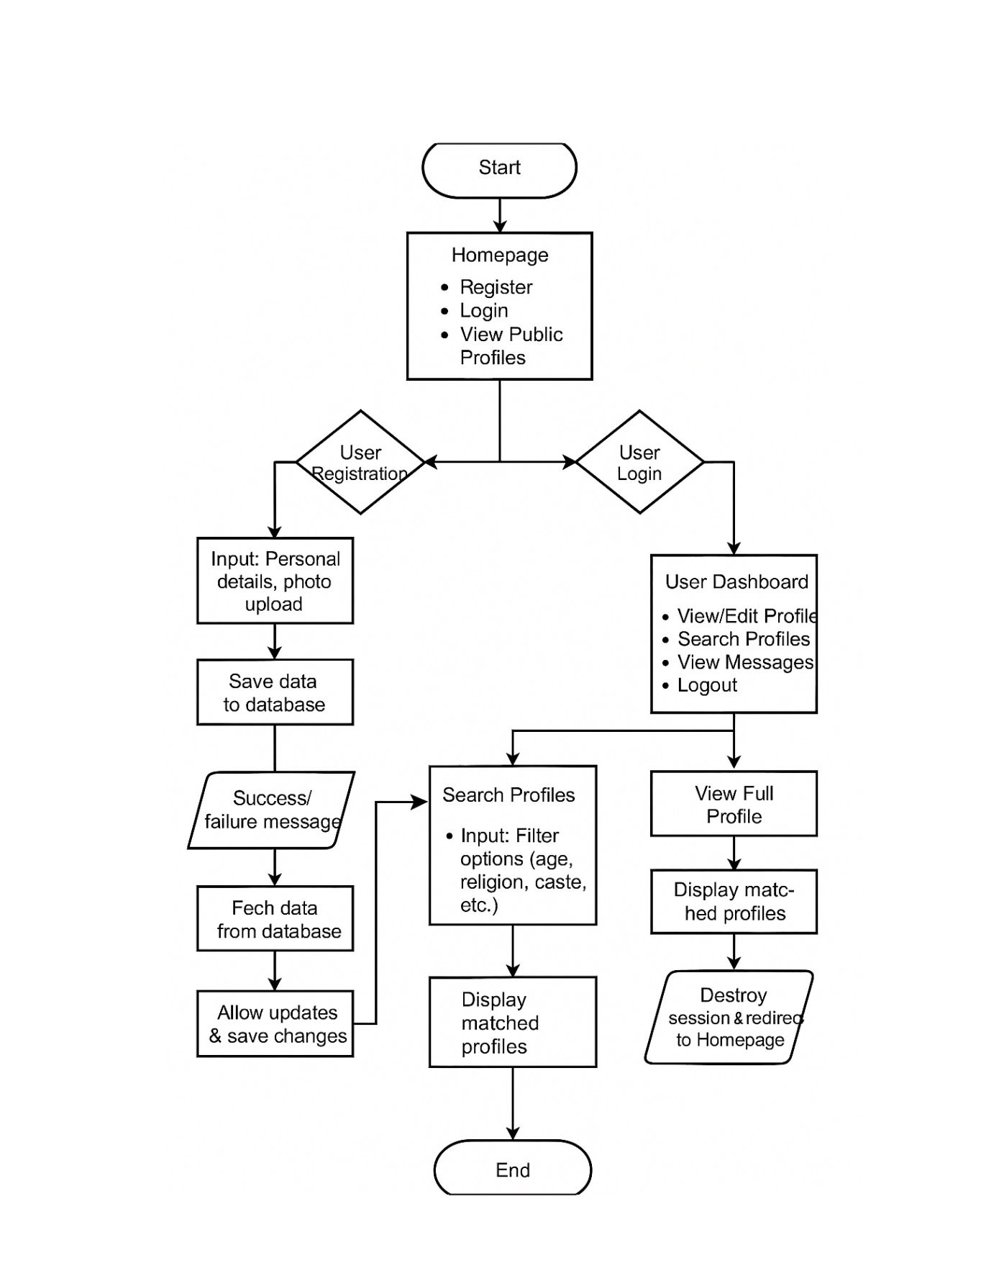

**4.2 BASIC MODULE**

**1**. **User Registration & Login Module**

* Allows users to create accounts with personal details.
* Login with email/username and password.
* Password recovery and account verification.

**2. Profile Management Module**

* Users can create, edit, and manage their profiles.
* Upload details like photos, age, education, caste, occupation, etc.
* Set preferences for partner search.

**3. Search & Filter Module**

* Enables users to search for matches based on filters like age, religion, caste, location, etc.
* Advanced search options for registered users

**4. View Public Profiles Module**

* Displays a list of public profiles for browsing.
* Limited profile details shown to unregistered visitors

**5. Photo Upload & Gallery Module**

* Users can upload profile photos (if required).
* Admin can review and approve images if moderation is needed.

**6. Matchmaking & Suggestion Module**

* Shows suggested matches based on profile preferences.

**7. Security & Privacy Module**

* Ensures data privacy (profile visibility settings).
* Secure password handling and data protection.

**8. Admin Panel Module**

* Admin manages user accounts, profiles, and site content.
* View site statistics and handle reports.

**4.3 DATA DESIGN**

This section details the database design and data structure used for the **Online Matrimonial Website.** The goal is to ensure efficient storage, retrieval, and management of user data, profiles, and matchmaking processes.

**4.3.1 DATABASE DESIGN**

The database design for the **Online Matrimonial Website** is implemented using a **relational database model**. The system consists of five core tables that store user information, preferences, photos, and admin data.

**1. users Table**

This table stores **core account information** for all users who register on the platform.

* **Primary Key:** id
* **Important Columns:**
  + username: The user's login name.
  + password: Encrypted password.
  + email: Email address.

**2. customer Table**

The customer table contains **detailed profile information** for each user, covering their personal, lifestyle, and physical details.

* **Primary Key:** id
* **Foreign Key:** cust_id references users(id)
* **Notable Columns:**
  + Personal details: firstname, lastname, age, gender
  + Lifestyle details: diet, drink, smoke, mother tongue
  + Physical details: height, weight, body_type, physical_status
  + Location details: district, state, country

**3. partnerprefs Table**

This table captures the **partner preferences** of users, defining the characteristics they seek in a partner.

* **Primary Key:** id
* **Foreign Key:** custId references users(id)
* **Important Columns:**
  + agemin, agemax: Preferred age range.
  + religion, caste, diet: Partner’s lifestyle attributes.
  + education, occupation, country: Socio-economic preferences.

**4. photos Table**

This table is used to store **profile photos** uploaded by users.

* **Primary Key:** id
* **Foreign Key:** cust_id references users(id)
* **Columns:**
  + pic1 : Paths or filenames for uploaded photos.

**5. admin Table**

Stores admin credentials for backend access (username, password, email).

Independent table without foreign key relations.

**4.3.2 DATA DICTINARY AND DATA VIEWS**

**Users Table:**

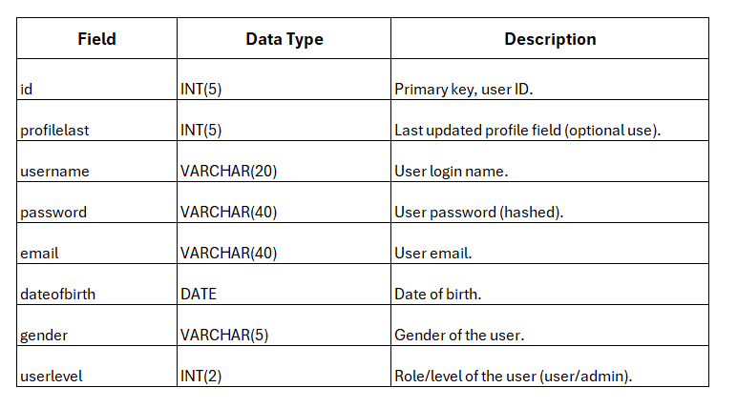

**Admin Table:**

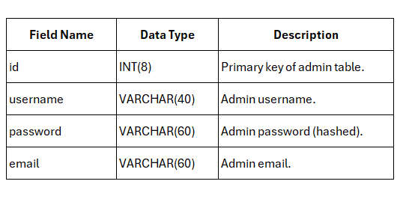

**Customer Table:**

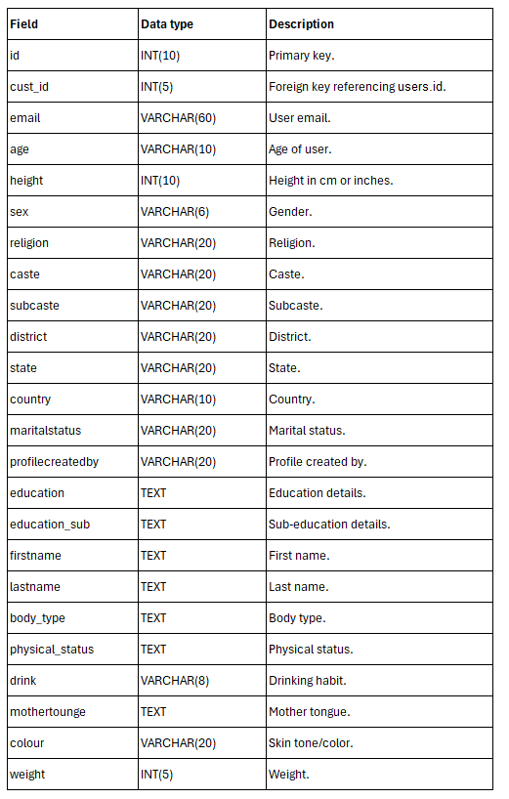

**Partner Preference Table:**

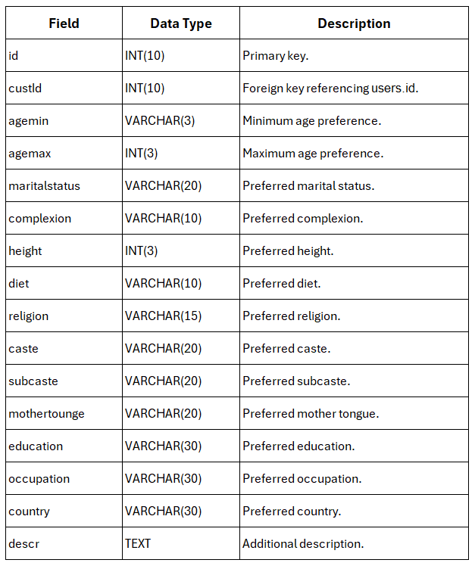

**Photos Table:**

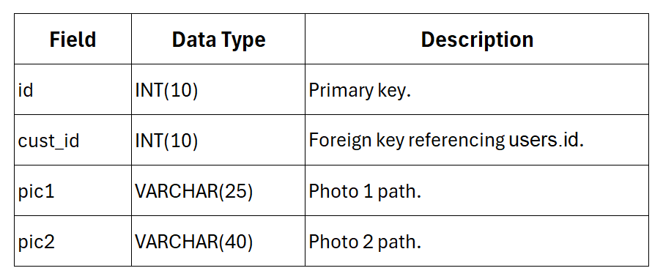

**DATA VIEWS:**

* **Admin View:** Displays all user accounts, profile updates, and moderation tools.
* **User Profile View:** Combines data from users and customer for full profile display.
* **Partner Preferences View:** Shows partner requirements stored in partner preferences.
* **Photo Gallery View:** Displays uploaded images from photos.
* **Matchmaking View:** Joins customer profiles with matching partner preference to display potential matches.

**4.3.3 E-R DIAGRAM AND DFDS**

**1. E-R Diagram**

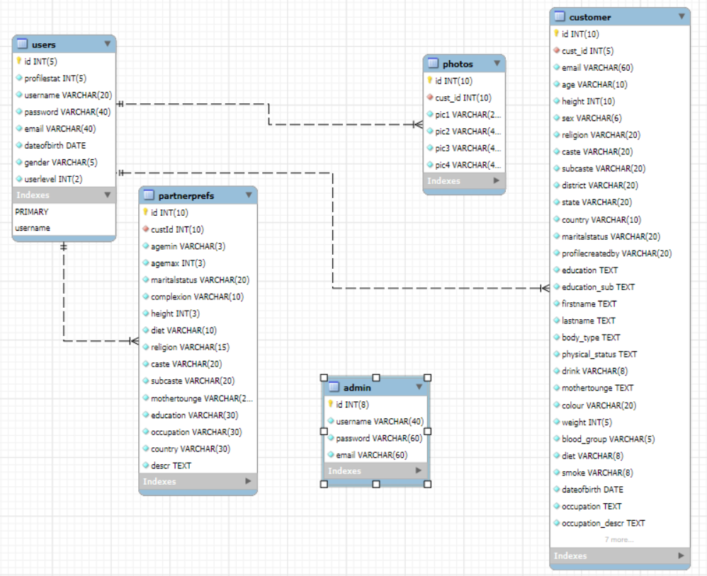

**2. DFDs**

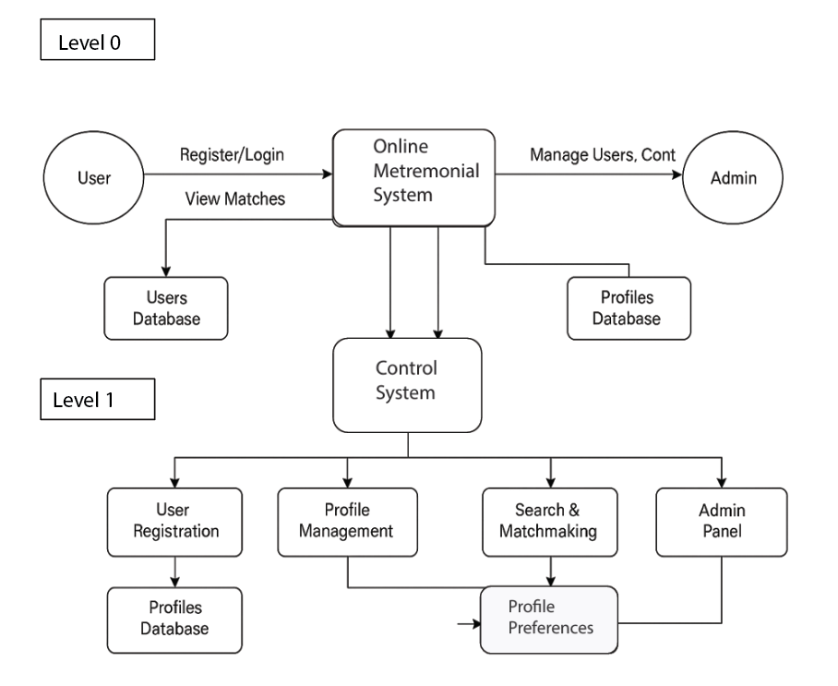

**5. IMPLEMENTATION AND TESTING**

**5.1 CODING DETAILS AND SCREENSHOTS**

<!DOCTYPE HTML>

<html>

<head>

<title>Find Your Perfect Partner - Makemylove

 | Register :: Make My Love

</title>

<meta name="viewport" content="width=device-width, initial-scale=1">

<meta http-equiv="Content-Type" content="text/html; charset=utf-8" />

<script type="application/x-javascript"> addEventListener("load", function() { setTimeout(hideURLbar, 0); }, false); function hideURLbar(){ window.scrollTo(0,1); } </script>

<link href="css/bootstrap-3.1.1.min.css" rel='stylesheet' type='text/css' />

<!-- jQuery (necessary for Bootstrap's JavaScript plugins) -->

<script src="js/jquery.min.js"></script>

<script src="js/bootstrap.min.js"></script>

<!-- Custom Theme files -->

<link href="css/style.css" rel='stylesheet' type='text/css' />

<link href='//fonts.googleapis.com/css?family=Oswald:300,400,700' rel='stylesheet' type='text/css'>

<link href='//fonts.googleapis.com/css?family=Ubuntu:300,400,500,700' rel='stylesheet' type='text/css'>

<!--font-Awesome-->

<link href="css/font-awesome.css" rel="stylesheet">

<!--font-Awesome-->

<script>

$(document).ready(function(){

    $(".dropdown").hover(

        function() {

            $('.dropdown-menu', this).stop( true, true ).slideDown("fast");

            $(this).toggleClass('open');

        },

        function() {

            $('.dropdown-menu', this).stop( true, true ).slideUp("fast");

            $(this).toggleClass('open');

        }

    );

});

</script>

</head>

<body>

<!-- ============================  Navigation Start =========================== -->

<?php include_once("includes/navigation.php");?>

<!-- ============================  Navigation End ============================ -->

<div class="grid_3">

  <div class="container">

   <div class="breadcrumb1">

     <ul>

        <a href="index.php"><i class="fa fa-home home_1"></i></a>

        <span class="divider">&nbsp;|&nbsp;</span>

        <li class="current-page">Create Your Profile</li>

     </ul>

   </div>

   <div class="services">

      <div class="col-sm-12 login_left">

         <form action="" method="POST">

            <div class="form-group col-sm-6">

              <label for="edit-name">First Name <span class="form-required" title="This field is required.">*</span></label>

              <input type="text" id="edit-name" name="fname" value="" size="60" maxlength="60" class="form-text required">

            </div>

            <div class="form-group col-sm-4">

              <label for="edit-pass">Last Name <span class="form-required" title="This field is required.">*</span></label>

              <input type="text" id="edit-last" name="lname" size="60" maxlength="128" class="form-text required">

            </div>

             <div class="form-group col-sm-2">

              <label for="edit-name">Sex <span class="form-required" title="This field is required.">*</span></label>

                <div class="select-block1">

                    <select name="sex">

                        <option value="Male">Male</option>

                        <option value="Female">Female</option>

                    </select>

                </div>

            </div>

            <div class="form-group col-sm-6">

              <label for="edit-name">Email <span class="form-required" title="This field is required.">*</span></label>

              <input type="text" id="edit-name" name="email" value="" size="60" maxlength="60" class="form-text required">

            </div>

           <!-- eighth Row starts-->

           <div class="col-lg-12">

            <div class="form-group col-sm-3">

                    <label for="edit-name">Fathers Occupation <span class="form-required" title="This field is required."></span></label>

                    <input type="text" id="edit-name" name="fatheroccupation" value="" size="60" maxlength="500" class="form-text">

           </div>

           <div class="form-group col-sm-3">

              <label for="edit-name">Mothers Occupation <span class="form-required" title="This field is required."></span></label>

              <input type="text" id="edit-name" name="motheroccupation" value="" size="60" maxlength="500" class="form-text">

            </div>

          <div class="form-group col-sm-3">

              <label for="edit-name">No . Of sisters<span class="form-required" title="This field is required.">*</span></label>

                <div class="select-block1">

                    <select name="sis">

                        <option value="1">1</option>

                        <option value="2">2</option>

                        <option value="3">3</option>

                        <option value="4">4</option>

                        <option value="5">5</option>

                    </select>

                </div>

            </div>

            <div class="form-group col-sm-3">

              <label for="edit-name">No . Of brothers<span class="form-required" title="This field is required.">*</span></label>

                <div class="select-block1">

                    <select name="bros">

                        <option value="1">1</option>

                        <option value="2">2</option>

                        <option value="3">3</option>

                        <option value="4">4</option>

                        <option value="5">5</option>

                    </select>

                </div>

            </div>

            <div class="form-group">

                <label for="about me">About Me<span class="form-required" title="This field is required.">*</span></label>

                <textarea rows="5" name="aboutme" placeholder="Write about you" class="form-text"></textarea>

            </div>

            <div class="form-actions">

                <input type="submit" id="edit-submit" name="op" value="Submit" class="btn_1 submit">

              </div>

            </div>

             <!-- eighth Row ends-->

         <hr/

         </form>

      </div>

      <div class="clearfix"> </div>

   </div>

  </div>

</div>

**HOME:**

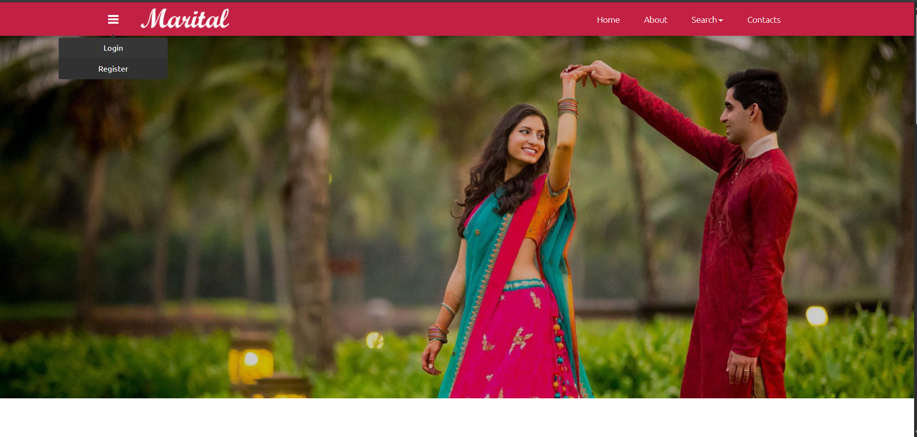

<?php include_once("includes/basic_includes.php");?>

<?php include_once("functions.php"); ?>

<?php register(); ?>

<!DOCTYPE HTML>

<html>

<body>

<!-- ============================  Navigation Start =========================== -->

<?php include_once("includes/navigation.php");?>

<!-- ============================  Navigation End ============================ -->

<div class="grid_3">

  <div class="container">

   <div class="breadcrumb1">

     <ul>

        <a href="index.php"><i class="fa fa-home home_1"></i></a>

        <span class="divider">&nbsp;|&nbsp;</span>

        <li class="current-page">Register</li>

     </ul>

   </div>

   <div class="services">

      <div class="col-sm-6 login_left">

         <form action="" method="POST">

            <div class="form-group">

              <label for="edit-name">Username <span class="form-required" title="This field is required.">*</span></label>

              <input type="text" id="edit-name" name="name" value="" size="60" maxlength="60" class="form-text required">

            </div>

            <div class="form-group">

              <label for="edit-pass">Password <span class="form-required" title="This field is required.">*</span></label>

              <input type="password" id="edit-pass" name="pass" size="60" maxlength="128" class="form-text required">

            </div>

            <div class="form-group">

              <label for="edit-name">Email <span class="form-required" title="This field is required.">*</span></label>

              <input type="text" id="edit-name" name="email" value="" size="60" maxlength="60" class="form-text required">

            </div>

          </form>

      </div>

      <div class="col-sm-6">

         <ul class="sharing">

            <li><a href="#" class="facebook" title="Facebook"><i class="fa fa-boxed fa-fw fa-facebook"></i> Share on Facebook</a></li>

            <li><a href="#" class="twitter" title="Twitter"><i class="fa fa-boxed fa-fw fa-twitter"></i> Tweet</a></li>

            <li><a href="#" class="google" title="Google"><i class="fa fa-boxed fa-fw fa-google-plus"></i> Share on Google+</a></li>

            <li><a href="#" class="linkedin" title="Linkedin"><i class="fa fa-boxed fa-fw fa-linkedin"></i> Share on LinkedIn</a></li>

            <li><a href="#" class="mail" title="Email"><i class="fa fa-boxed fa-fw fa-envelope-o"></i> E-mail</a></li>

         </ul>

      </div>

      <div class="clearfix"> </div>

   </div>

  </div>

</div>

<?php include_once("footer.php");?>

</body>

</html>

**REGISTERATION:**

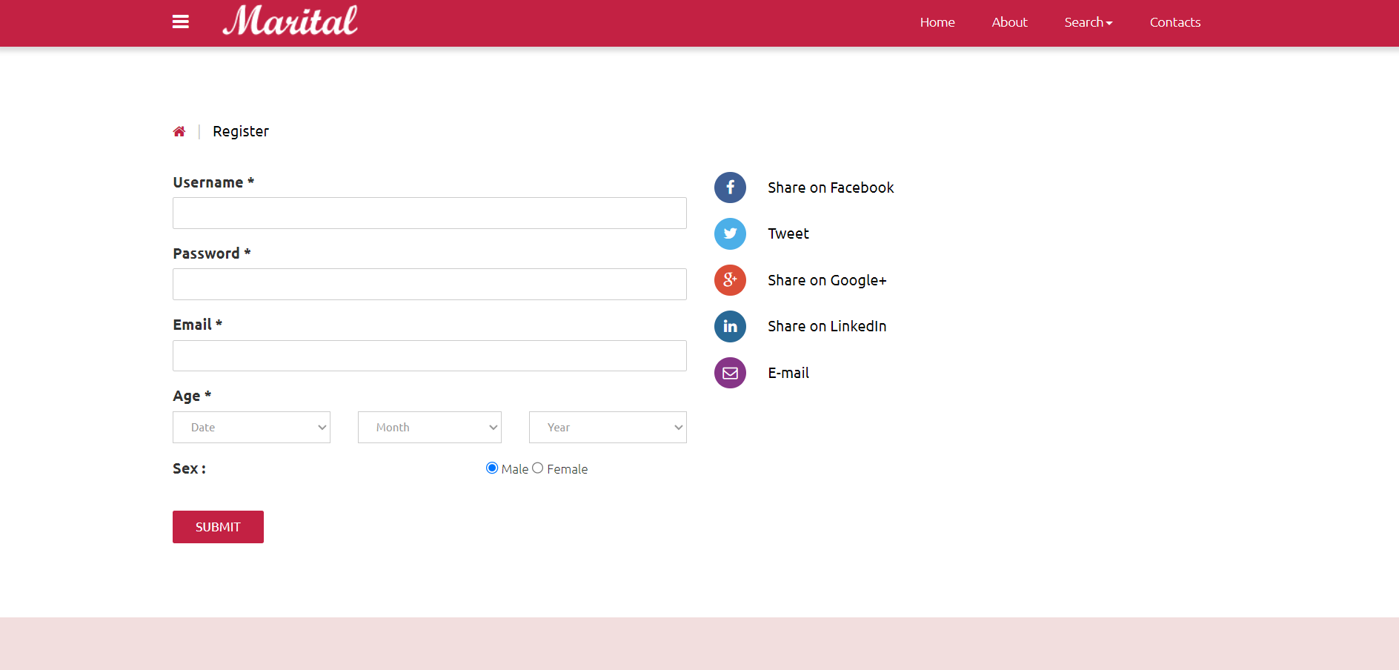

<?php include_once("functions.php");?>

<!DOCTYPE HTML>

<html>

<head>

<script>

$(document).ready(function(){

    $(".dropdown").hover(

        function() {

            $('.dropdown-menu', this).stop( true, true ).slideDown("fast");

            $(this).toggleClass('open');

        },

        function() {

            $('.dropdown-menu', this).stop( true, true ).slideUp("fast");

            $(this).toggleClass('open');

        }

    );

});

</script>

</head>

<body>

<!-- ============================  Navigation Start =========================== -->

<?php include_once("includes/navigation.php");?>

<!-- ============================  Navigation End ============================ -->

<div class="grid_3">

  <div class="container">

   <div class="breadcrumb1">

     <ul>

        <a href="index.php"><i class="fa fa-home home_1"></i></a>

        <span class="divider">&nbsp;|&nbsp;</span>

        <li class="current-page">Login</li>

     </ul>

   </div>

   <div class="services">

      <div class="col-sm-6 login_left">

       <form action="auth/auth.php?user=1" method="post">

        <div class="form-item form-type-textfield form-item-name">

          <label for="edit-name">Username <span class="form-required" title="This field is required.">*</span></label>

          <input type="text" id="edit-name" name="username" value="" size="60" maxlength="60" class="form-text required">

        </div>

        <div class="form-item form-type-password form-item-pass">

          <label for="edit-pass">Password <span class="form-required" title="This field is required.">*</span></label>

          <input type="password" id="edit-pass" name="password" size="60" maxlength="128" class="form-text required">

        </div>

        <div class="form-actions">

            <input type="submit" id="edit-submit" name="op" value="Log in" class="btn_1 submit">

        </div>

       </form>

      </div>

      <div class="col-sm-6">

        <ul class="sharing">

            <li><a href="#" class="facebook" title="Facebook"><i class="fa fa-boxed fa-fw fa-facebook"></i> Share on Facebook</a></li>

            <li><a href="#" class="twitter" title="Twitter"><i class="fa fa-boxed fa-fw fa-twitter"></i> Tweet</a></li>

            <li><a href="#" class="google" title="Google"><i class="fa fa-boxed fa-fw fa-google-plus"></i> Share on Google+</a></li>

            <li><a href="#" class="linkedin" title="Linkedin"><i class="fa fa-boxed fa-fw fa-linkedin"></i> Share on LinkedIn</a></li>

            <li><a href="#" class="mail" title="Email"><i class="fa fa-boxed fa-fw fa-envelope-o"></i> E-mail</a></li>

        </ul>

      </div>

      <div class="clearfix"> </div>

   </div>

  </div>

</div>

<?php include_once("footer.php");?>

</body>

</html>

**LOGIN :**

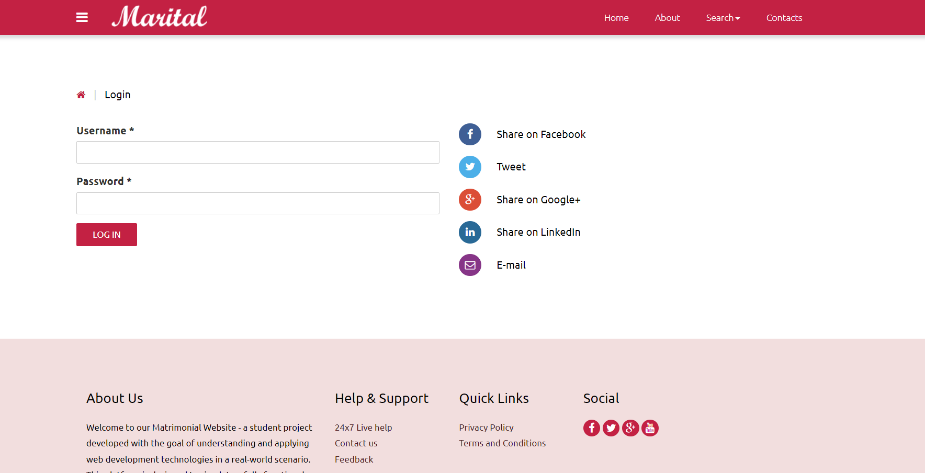

<?php include_once("includes/basic_includes.php");?>

<?php include_once("functions.php"); ?>

<?php

$id=$_GET['id'];

if(isloggedin()){

 //do nothing stay here

} else{

   header("location:login.php");

}

?>

<!DOCTYPE HTML>

<html>

<head>

<script>

$(document).ready(function(){

    $(".dropdown").hover(

        function() {

            $('.dropdown-menu', this).stop( true, true ).slideDown("fast");

            $(this).toggleClass('open');

        },

        function() {

            $('.dropdown-menu', this).stop( true, true ).slideUp("fast");

            $(this).toggleClass('open');

        }

    );

});

</script>

</head>

<body>

<!-- ============================  Navigation Start =========================== -->

 <?php include_once("includes/navigation.php");?>

<!-- ============================  Navigation End ============================ -->

<div class="grid_3">

  <div class="container">

   <div class="breadcrumb1">

     <ul>

        <a href="index.php"><i class="fa fa-home home_1"></i></a>

        <span class="divider">&nbsp;|&nbsp;</span>

        <li class="current-page">User Home</li>

     </ul>

   </div>

   <div class="navigation" style="background-color: #ccc;"><!-- Innernavigation starts -->

        <div class="collapse navbar-collapse" id="bs-megadropdown-tabs">

            <ul class="nav navbar-nav nav_1">

                <li><a href="view_profile.php?id=<?php echo $id;?>">View Profile</a></li>

              <li><a href="partner_preference.php?id=<?php echo $id;?>">Partner Preference</a></li>

            <li class="dropdown">

                  <a href="#" class="dropdown-toggle" data-toggle="dropdown">Profile<span class="caret"></span></a>

                  <ul class="dropdown-menu" role="menu">

                   <li><a href="photouploader.php?id=<?php echo $id;?>">Upload Photos</a></li>

                   <li><a href="view_profile.php?id=<?php echo $id;?>">View Profile</a></li>

                   <li><a href="create_profile.php?id=<?php echo $id;?>">Edit Profile</a></li>

                  </ul>

                </li>

          <li class="dropdown">

                  <a href="#" class="dropdown-toggle" data-toggle="dropdown">Search<span class="caret"></span></a>

                  <ul class="dropdown-menu" role="menu">

                    <li><a href="search.php">Regular Search</a></li>

                  </ul>

                </li>

            </ul>

    </div>

   </div><!-- End of inner navigation -->

   <div>

  </div>

</div>

<?php include_once("footer.php")?>

</script>

</body>

</html>

**USER HOME:**

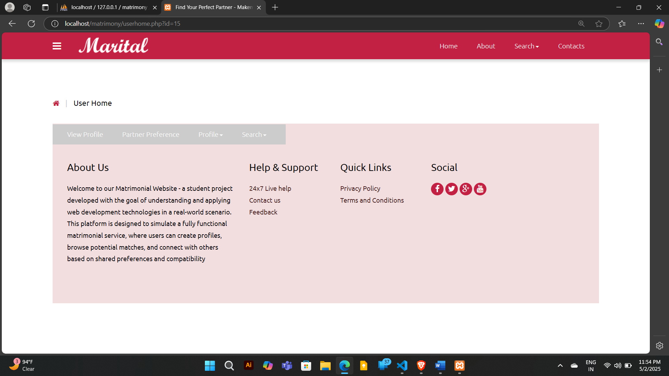

<?php include_once("includes/basic_includes.php");?>

<?php include_once("functions.php"); ?>

<?php

if(isloggedin()){

 //do nothing stay here

} else{

   header("location:login.php");

}

?>

<?php

$result=search();

?>

<!DOCTYPE HTML>

<html>

<head>

<script>

$(document).ready(function(){

    $(".dropdown").hover(

        function() {

            $('.dropdown-menu', this).stop( true, true ).slideDown("fast");

            $(this).toggleClass('open');

        },

        function() {

            $('.dropdown-menu', this).stop( true, true ).slideUp("fast");

            $(this).toggleClass('open');

        }

    );

});

</script>

</head>

<body>

 <?php include_once("includes/navigation.php");?>

<div class="grid_3">

  <div class="container">

   <div class="breadcrumb1">

     <ul>

        <a href="index.php"><i class="fa fa-home home_1"></i></a>

        <span class="divider">&nbsp;|&nbsp;</span>

        <li class="current-page">Regular Search</li>

     </ul>

   </div>

   <!--<script type="text/javascript">

    $(function () {

     $('#btnRadio').click(function () {

          var checkedradio = $('[name="gr"]:radio:checked').val();

          $("#sel").php("Selected Value: " + checkedradio);

      });

    });

   </script>-->

<div class="col-md-9 search_left">

  <form action="" method="post">

   <div class="form_but1">

  <label class="col-sm-5 control-lable1" for="sex">Gender : </label>

  <div class="col-sm-7 form_radios">

    <input type="radio" class="radio_1" name="sex" value="male" <?php echo "checked";?>/> Groom &nbsp;&nbsp;

    <input type="radio" class="radio_1" name="sex" value="female"/> Bride

    <!--<hr />

    <p id="sel"></p><br />

    <input id="btnRadio" type="button" value="Get Selected Value" />-->

  </div>

  <div class="clearfix"> </div>

  </div>

  <div class="form_but1">

  <label class="col-sm-5 control-lable1" for="Marital Status">Marital Status : </label>

  <div class="col-sm-7 form_radios">

    <input type="checkbox" class="radio_1" name="maritalstatus" value="Single" <?php echo "checked" ?>/> Single &nbsp;&nbsp;

    <input type="checkbox" class="radio_1" name="maritalstatus" value="divorced" /> Divorced &nbsp;&nbsp;

    <input type="checkbox" class="radio_1" name="maritalstatus" value="widowed" /> Widowed &nbsp;&nbsp;

    <input type="checkbox" class="radio_1" name="maritalstatus" value="seperated"/> Separated &nbsp;&nbsp;

    <input type="checkbox" class="radio_1" name="maritalstatus" value="any" /> Any

  </div>

  <div class="clearfix"> </div>

  </div>

  <div class="form_but1">

    <label class="col-sm-5 control-lable1" for="country">Country : </label>

    <div class="col-sm-7 form_radios">

      <div class="select-block1">

        <select name="country">

            <option value="">Country</option>

            <option value="Japan">Japan</option>

            <option value="China">China</option>

            <option value="India">India</option>

          </select>

      </div>

    </div>

    <div class="clearfix"> </div>

  </div>

  <div class="form_but1">

    <label class="col-sm-5 control-lable1" for="State">State : </label>

    <div class="col-sm-7 form_radios">

      <div class="select-block1">

        <select name="state">

            <option value="">State</option>

            <option value="Kerala">Kerala</option>

            <option value="Tamilnadu">Tamilnadu</option>

            <option value="Karnataka">Karnataka</option>

            <option value="Madhyapradesh">Madhyapradesh</option>

        </select>

      </div>

    </div>

    <div class="clearfix"> </div>

  </div>

  <div class="form_but1">

    <label class="col-sm-5 control-lable1" for="Religion">Religion : </label>

    <div class="col-sm-7 form_radios">

      <div class="select-block1">

        <select name="religion">

            <option value="">Religion</option>

            <option value="Hindu">Hindu</option>

            <option value="Sikh">Sikh</option>

            <option value="Muslim">Muslim</option>

            <option value="Buddhism">Buddhism</option>

            <option value="Christian">Christian</option>

        </select>

      </div>

    </div>

    <div class="clearfix"> </div>

  </div>

  <div class="form_but1">

    <label class="col-sm-5 control-lable1" for="Mother Tongue">Mother Tongue : </label>

    <div class="col-sm-7 form_radios">

      <div class="select-block1">

        <select name="mothertounge">

            <option value="Malayalam">Malayalam</option>

            <option value="English">English</option>

            <option value="French">French</option>

            <option value="Telugu">Telugu</option>

            <option value="Bengali">Bengali</option>

            <option value="Bihari">Bihari</option>

            <option value="Hindi">Hindi</option>

            <option value="Tamil">Tamil</option>

            <option value="Urdu">Urdu</option>

            <option value="Manipuri">Manipuri</option>

        </select>

      </div>

    </div>

    <div class="clearfix"> </div>

  </div>

  <div class="form_but1">

  <label class="col-sm-5 control-lable1" for="Age">Age : </label>

  <div class="col-sm-7 form_radios">

    <div class="col-sm-5 input-group1">

        <input class="form-control has-dark-background" name="agemin" id="slider-name" placeholder="18" type="text" required=""/>

      </div>

      <div class="col-sm-5 input-group1">

        <input class="form-control has-dark-background" name="agemax" id="slider-name" placeholder="40" type="text" required=""/>

      </div>

      <div class="clearfix"> </div>

  </div>

  <div class="clearfix"> </div>

  <input type="submit" name="search" value="Search"/>

  </div>

 </form>

 <div class="paid_people">

   <h1>Profiles</h1>

<?php

//only start display profiles if and only if search is triggered

if(isset($_POST['search'])){

//code to print matching profiles

// couloumn count

$c_count = '1';

while ($row = mysqli_fetch_assoc($result))

  {

    $profid=$row['cust_id'];

    //getting photo for display

    $sql="SELECT * FROM photos WHERE cust_id=$profid";

    $result2=mysqlexec($sql);

    $photo=mysqli_fetch_assoc($result2);

    $pic=$photo['pic1'];

  // printing left side profile

  echo "<div class=\"row_1\">"; //starting row

  if ($c_count == '1')

    {

    echo "<div class=\"col-sm-6 paid_people-left\">"; //left statrted

    echo "<ul class=\"profile_item\">";

    echo "<a href=\"view_profile.php?id=$profid\">";

    echo "<li class=\"profile_item-img\"><img src=\"profile/". $profid."/".$pic ."\"" . "class=\"img-responsive\" alt=\"\"/></li>";

    echo "<li class=\"profile_item-desc\">";

    echo "<h4>" . $row['firstname'] . " " . $row['lastname'] . "</h4>";

    echo "<p>" . $row['age']. "Yrs," . $row['religion'] . "</p>";

    echo "<h5>" . "View Full Profile" . "</h5>";

    echo "</li>";

    echo "</a>";

    echo "</ul>";

    echo "</div>"; //left end

    $c_count++;

    }

  else

    {

    echo "<div class=\"col-sm-6\">"; //right statrted

    echo "<ul class=\"profile_item\">";

    echo "<a href=\"view_profile.php?id=$profid\">";

    echo "<li class=\"profile_item-img\"><img src=\"profile/". $profid."/".$pic ."\"" . "class=\"img-responsive\"" ;

    echo "alt=\"\"/></li>";

    echo "<li class=\"profile_item-desc\">";

    echo "<h4>" . $row['firstname'] . " " . $row['lastname'] . "</h4>";

    echo "<p>" . $row['age']. "Yrs," . $row['religion'] . "</p>";

    echo "<h5>" . "View Full Profile" . "</h5>";

    echo "</li>";

    echo "</a>";

    echo "</ul>";

    echo "</div class=\"test\">"; //right end

    // end of right side

    $c_count = '1';

    }

    echo "</div>"; //row end

  } //loop end

}//end of if

?>

  </div>

</div>

<!-- Match Right Starts -->

<div class="col-md-3 match_right">

  <?php include_once("matchright.php");?>

</div>

<!-- Match Right ends -->

     <div class="clearfix"> </div>

  </div>

</div>

</body>

</html>

**SEARCH:**

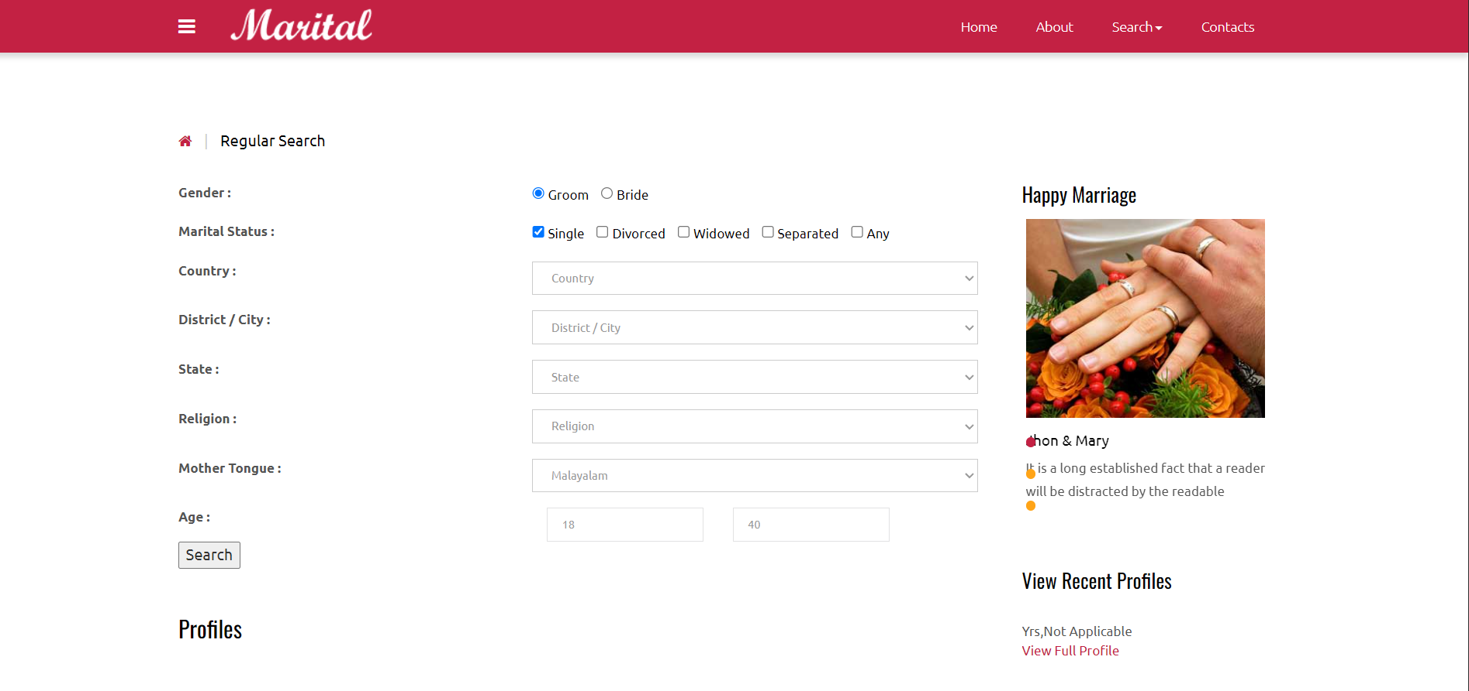

**5.2 TESTING APPROACH**

To ensure the reliability and proper functioning of the **Online Matrimonial Website**, different levels of testing were carried out. The testing process focused on verifying individual components, the integration between modules, and the overall system performance.

**5.2.1 UNIT TESTING**

Unit testing was performed to test each module or component individually. This included testing functions such as:

* **User Registration:** Checked if the form accepts valid data and handles invalid inputs properly.
* **Login and Authentication:** Tested the login functionality for both valid and invalid credentials.
* **Profile Creation and Editing:** Verified if users can successfully create and update their profiles.
* **Search Feature:** Ensured that the search returns accurate results based on user input filters.

PHP functions and SQL queries were manually tested to ensure each performed its task correctly

**5.2.2 INTEGRATED TESTING**

After unit testing, integrated testing was done to check how different modules interact with each other. Some of the key integrations tested were:

* **User Registration with Database:** Verified that new user data is correctly stored in the database after registration.
* **Partner Preferences and Search:** Checked that the partner preferences entered by the user are linked properly and used in search results.

We also tested data flow between tables (users, customer, partner preferences, photos) to ensure relationships were functioning as expected.

**5.2.3 SYSTEM TESTING**

In the final stage, system testing was carried out to evaluate the performance of the entire website as a complete product. This included:

* **Functionality Testing:** Verified that all features, such as registration, login, profile viewing, and search, worked as intended from the user’s perspective.
* **Usability Testing:** Checked the ease of navigation and whether the website was user-friendly.
* **Performance Testing:** Observed the website’s response time with multiple user operations running.
* **Security Testing (Basic):** Checked that unauthorized access is prevented (e.g., restricted admin access).

**5.3 IMPLEMENTATION AND MAINTENANCE**

**1. Implementation**

In my project, **Online Matrimonial Website**, I implemented the system step by step to make sure it worked properly. I used HTML, CSS, and JavaScript for designing the web pages and PHP for the backend to manage user actions like registration, login, and profile updates. For storing data, I created a MySQL database where all the user profiles, photos, and preferences are saved.

I started by designing the database and created different tables like users, customer, partnerprefs, photos, and admin. Then, I developed the user registration and login system. After that, I worked on profile creation and the search feature so users can search for matches based on their preferences.

I tested everything on XAMPP (a local server) to make sure it worked fine. Once all the modules were ready and connected properly, I tested the full website to check its flow and usability.

**2. Maintenance**

Maintenance is important to ensure the smooth and secure operation of the website over time. For this project, the following maintenance steps are considered:

* **Bug Fixing:** Regularly checking for any errors or bugs and resolving them quickly.
* **Database Updates:** Ensuring the database is backed up regularly and optimized for performance.
* **Security Updates:** Applying necessary security patches to prevent unauthorized access or data breaches.
* **Feature Enhancements:** Based on feedback, adding new features or improving existing ones to make the website more user-friendly.
* **Compatibility Checks:** Testing the website regularly on different browsers and devices to maintain full compatibility.

**6. CONCLUSIONS**

**6.1 LIMITATIONS OF THE SYSTEM**

While developing this matrimonial website project, I have identified some limitations that can be considered for future improvement:

**1. Basic Security :**

Currently, passwords are stored in the database, but the system does not implement advanced security measures like password hashing and encryption, which are important for real-world applications.

**2. No Automatic Matchmaking** :

The project allows users to set partner preferences, but it does not include any automated matching system to suggest suitable partners based on preferences.

**3. Admin Features** :

The admin panel is basic and provides only login access. It does not include advanced features like user management, report generation, or detailed monitoring of activities.

**4. No Chat or Messaging** :

The website does not provide any feature for users to chat or communicate directly within the platform, which is an important feature in matrimonial sites.

**5. Profile Verification** :

There is no process for verifying the authenticity of user profiles, which means fake or incomplete profiles might exist.

**6. Limited Location Search** :

The system captures district, state, and country, but it does not support advanced location-based search or filtering options (like searching within a specific radius).

**7. Scalability** :

This project is designed for small-scale use. If a large number of users join, performance issues may arise as there is no optimization for a high-traffic environment.

**8. No Logs or History** :

The system does not maintain logs of user activities, like login history or profile edits, which are important for tracking and security purposes.

**9. No Payment Integration** :

The system does not support any kind of paid membership or online payment integration, which is usually present in professional matrimonial websites.

**6.2 CONCLUSION**

This project, **Online Matrimonial Website,** was developed to provide a simple platform where users can create profiles, search for potential matches, and manage their preferences easily. The system includes basic modules like user registration, profile creation, photo uploads, partner preferences, and admin control. It also provides essential database management using MySQL with well-defined relationships between different tables such as users, customers, photos, and partner preferences.

Although the system is functional and meets the core requirements of a matrimonial platform, it has some limitations such as basic security, limited search filters, and the absence of advanced features like real-time chat and profile verification. However, as a college project, it successfully demonstrates the fundamental concepts of web development, database design, and user interaction.

In the future, the system can be enhanced by adding features like strong security measures, payment integration, mobile app support, and advanced matchmaking algorithms to make it a more complete and professional matrimonial platform.

Overall, this project helped me gain practical experience in developing a web application, working with databases, and understanding how different modules of a system interact with each other.

**6.3 FUTURE SCOPE OF THE PROJECT**

**1. Advanced Security :**

Implementing strong security features like password hashing, two-factor authentication (2FA), and secure data encryption to protect user information.

**2. Profile Verification :**

Adding a verification process to ensure that all user profiles are genuine, such as document uploads or manual approval by admins.

**3. Real-Time Chat and Messaging :**

Integrating a secure chat or messaging system to allow users to communicate directly within the platform.

**4. Email and SMS Notification :**

Sending automated notifications for activities like registration confirmation, profile matches, and password recovery to keep users informed.

**5. Premium Membership** **Plans :**

Introducing paid membership features with added benefits like higher visibility, advanced search filters, and personalized matchmaking.

**6. Mobile Application** :

Developing a mobile app version of the website to provide users with easy access to the platform on their smartphones.

**7. User Privacy Control :**

Allowing users to customize their privacy settings, such as hiding certain profile details or controlling who can view their photos.

**8. Report and Analytics** :

Enhancing the admin panel to include reports, analytics, and user activity monitoring for better management of the platform.

**9. Scalability and Performance** :

Optimizing the system for better performance and the ability to handle a large number of users smoothly.

**7. BIBLIOGRAPHY**

I. **Welling, Luke, and Laura Thomson.** *PHP and MySQL Web Development.* Addison-Wesley, 2017.

II. **Duckett, Jon.** *HTML and CSS: Design and Build Websites.* Wiley, 2011.

III. **Murach, Joel.** *Murach's PHP and MySQL.* Mike Murach & Associates, 2014.

IV. **Nixon, Robin.** *Learning PHP, MySQL & JavaScript: With jQuery, CSS & HTML5.* O'Reilly Media, 2018.

V. **MySQL Documentation.** *MySQL 8.0 Reference Manual.* Available at: <https://dev.mysql.com/doc/>

VI. **PHP Documentation.** *PHP Manual.* Available at: <https://www.php.net/manual/en/>

VII. **W3Schools.** *Online Web Tutorials.* Available at: <https://www.w3schools.com/>

VIII. **Mozilla Developer Network (MDN).** *Web Docs.* Available at: <https://developer.mozilla.org/>

IX. **GeeksforGeeks.** *PHP and MySQL Articles and Tutorials.* Available at: <https://www.geeksforgeeks.org/>