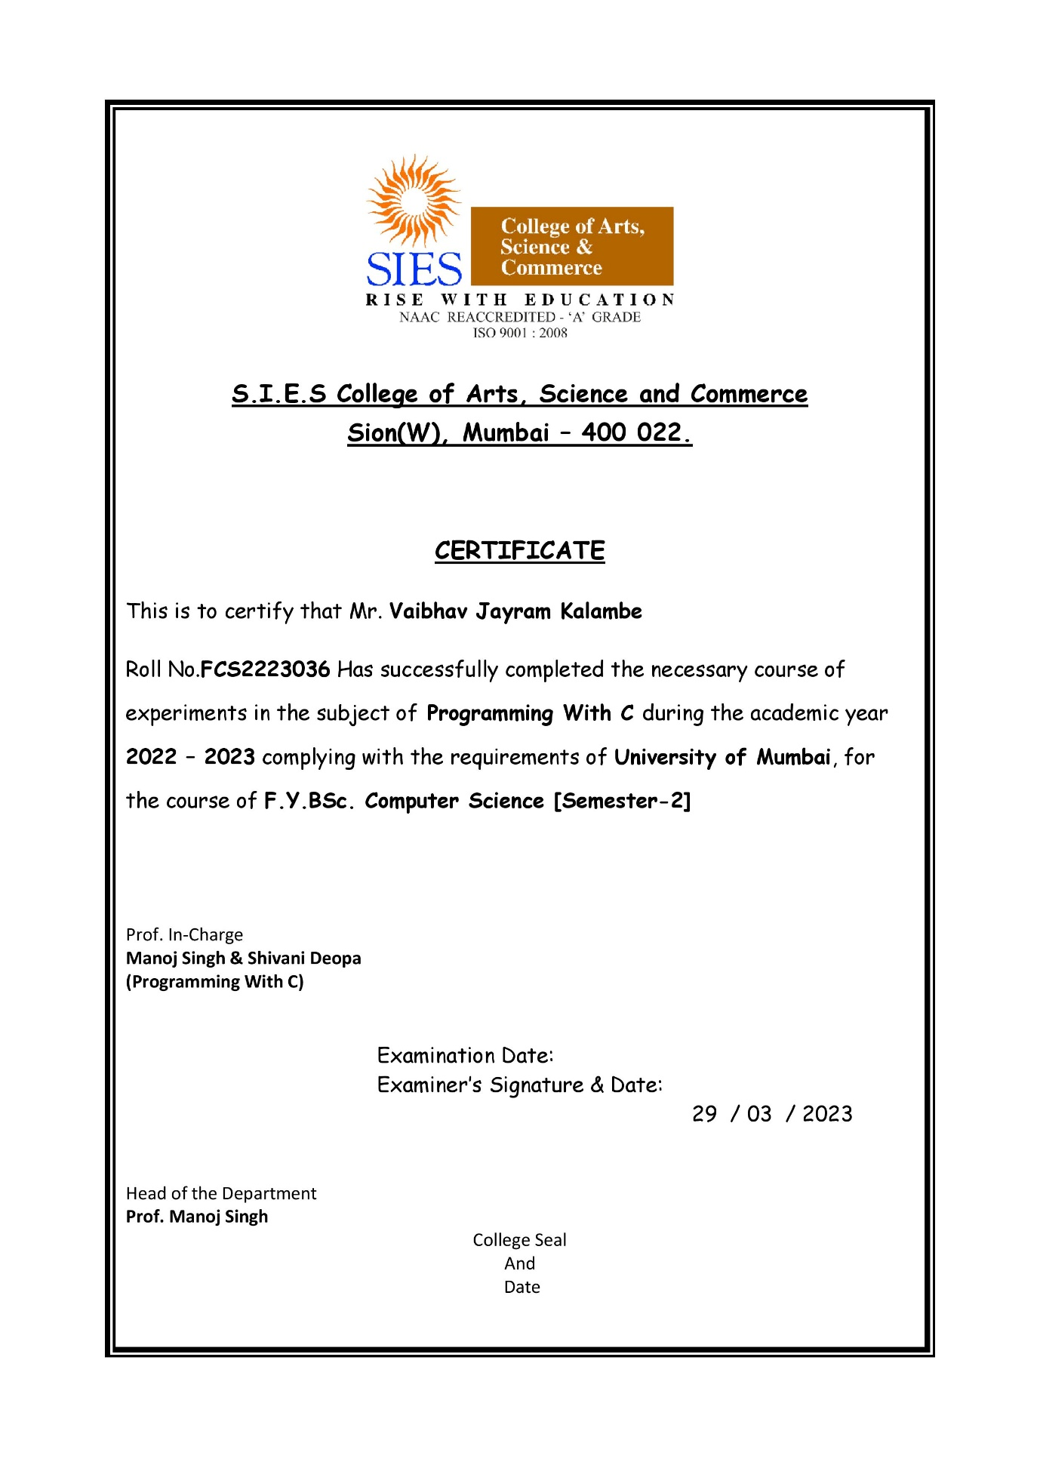

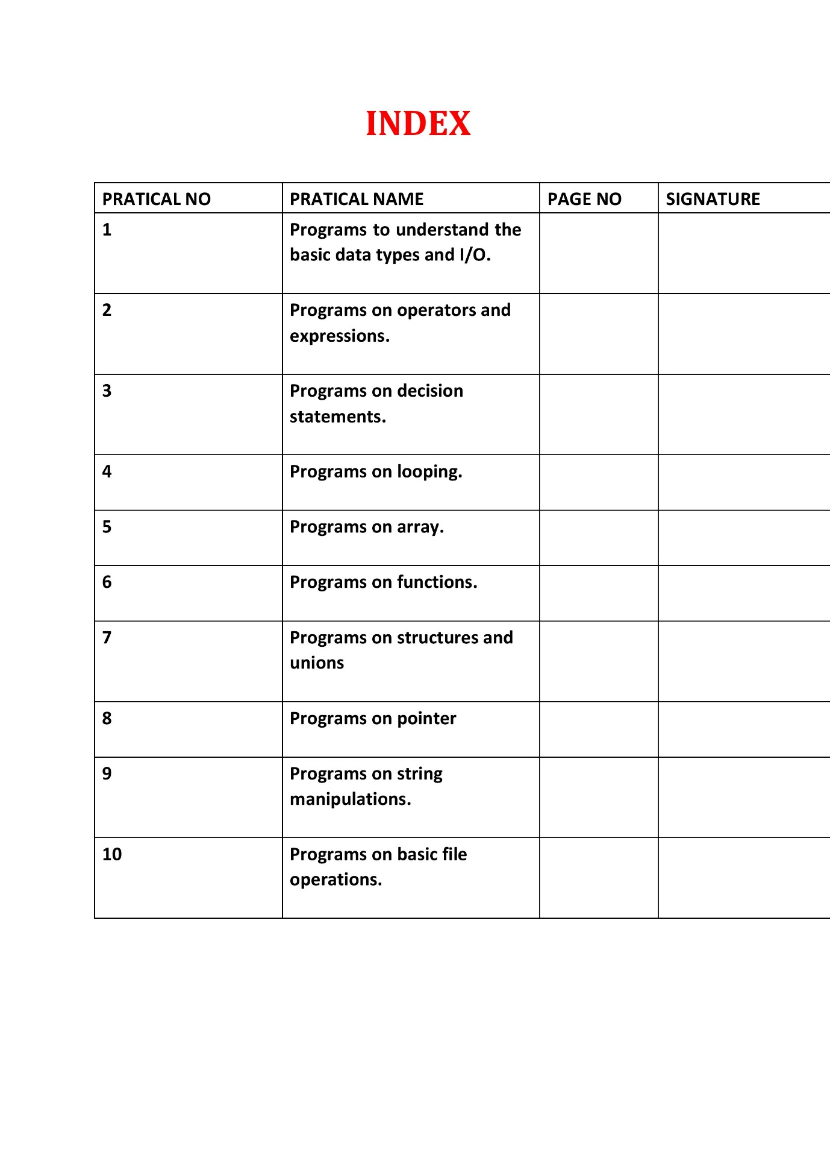

**Practical No.1**

Aim: Programs to understand the basic data types and I/O.

#include <stdio.h>

int main()

{

 char chr;

 printf("Enter a character");

 scanf("%c",&chr);

 printf("You entered %c ",chr);

 int testinteger;

 printf("Enter an integer");

 scanf("%d",&testinteger);

 printf("Number=%d\n",testinteger);

 float num1;

 printf("Enter a Number");

 scanf("%f",&num1);

 printf("num1=%f\n",num1);

 double num2;

 printf("Enter an another Number");

 scanf("%lf",&num2);

 printf("num2=%lf\n",num2);

 return 0;

}

Output:

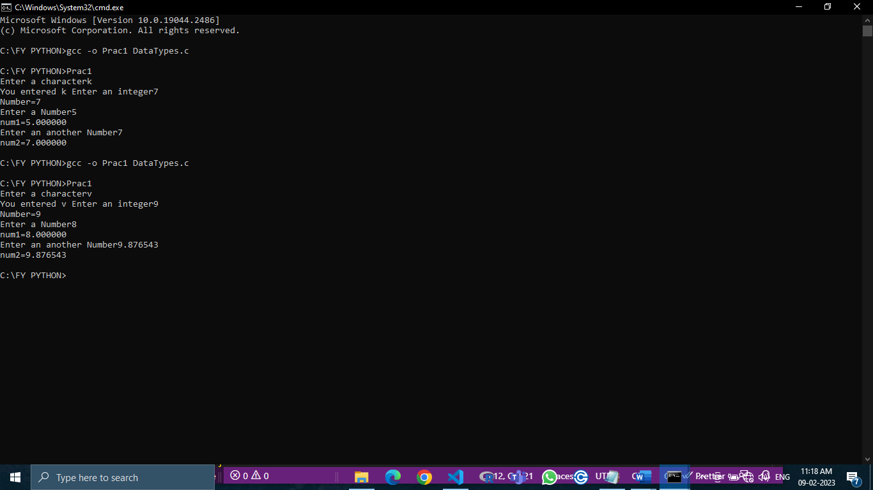

**Practical No.2**

Aim: Programs on operators and expression.

#include <stdio.h>

int main()

{

 int a,b,c;

 float d;

 printf("Enter first number");

 scanf("%d",&a);

 printf("Enter Second number");

 scanf("%d",&b);

 printf("Choose the operation\n 1.addition\n 2.substraction\n 3.multiplication\n 4.division\n");

 scanf("%d",&c);

 if(c==1)

 {

  d=a+b;

  printf("addition=%f\n",d);

 }

 if(c==2)

 {

  d=a-b;

  printf("substraction=%f\n",d);

 }

 else if(c==3)

 {

  d=a*b;

  printf("multiplication=%f\n",d);

 }

 else if(c==4)

 {

  d=a/b;

  printf("division=%f\n",d);

 }

 else

 {

  printf("Invalid Option");

 }

return 0;

}

Output:

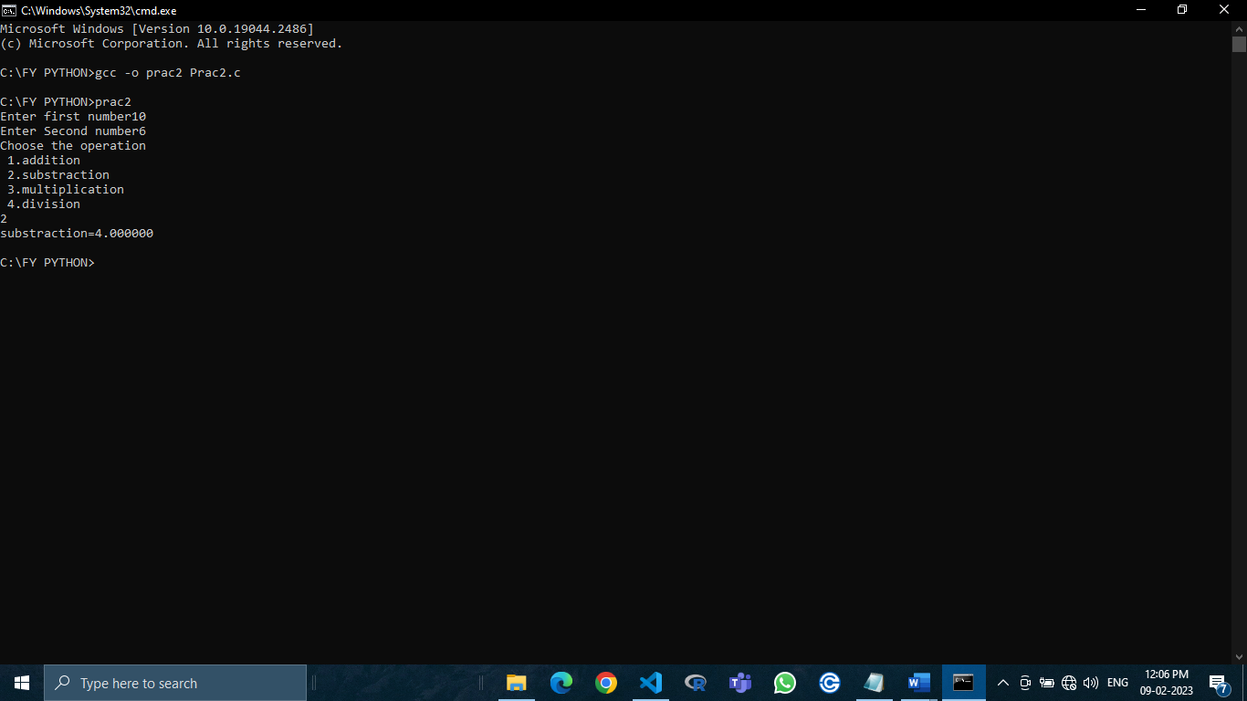

**Practical No.3**

**Aim:** Programs on decision statement

(a) Write a program to find largest number demonstrating nested if-else condition.

#include <stdio.h>

int main()

{

 int a,b,c,max;

 printf("Enter three integers");

 scanf("%d%d%d",&a,&b,&c);

if (a>b && a>c)

 {

  max=a;

  printf("The maximum number is %d",max);

 }

if (b>a && b>c)

 {

  max=b;

  printf("The maximum number is %d",max);

 }

if (c>b && c>a)

 {

  max=c;

  printf("The maximum number is %d",max);

 }

 return 0;

}

Output:

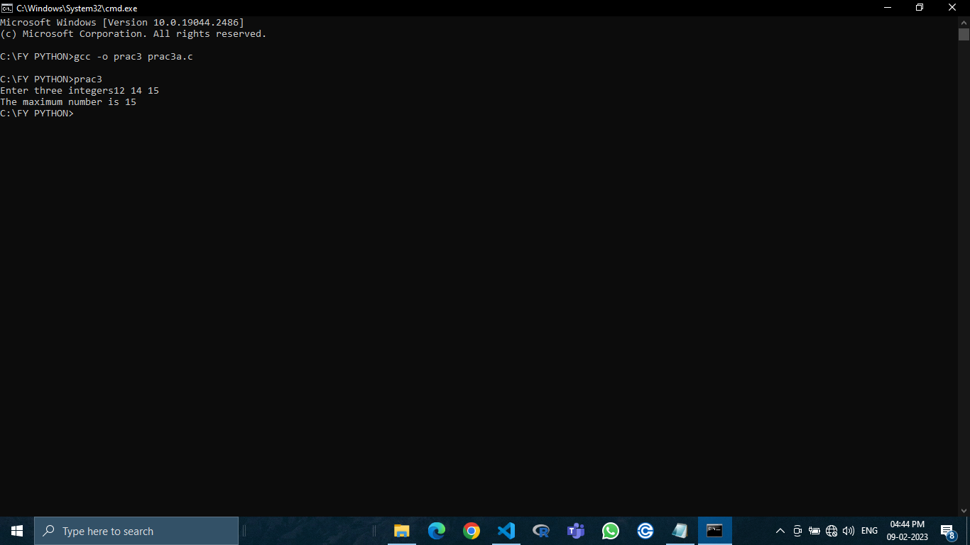

(b) Write a menu-driven program using switch case to calculate the following:

1.Area of circle

2.Area of square

3.Area of sphere

Also use functions input() and output() to input and display respective values.

#include<stdio.h>

int main( )

{

 int choice;

 float num,result;

 printf("Press 1 to calculate area of circle\n");

 printf("Press 2 to calculate area of square\n");

 printf("Press 3 to calculate area of sphere\n");

 printf("enter your choice :");

 scanf("%d",&choice);

 switch(choice)

 {

    case 1:

    {

        printf("Enter radius:\n");

        scanf("%f",&num);

        result=3.142*num*num;

        printf("Area of a circle=%f",result);

        break;

    }

    case 2:

    {

        printf("Enter side of square:\n");

        scanf("%f",&num);

        result=num*num;

        printf("Area of a square=%f",result);

        break;

    }

    case 3:

    {

        printf("Enter radius:\n");

        scanf("%f",&num);

        result=4*(3.142*num*num);

        printf("Area of a sphere=%f",result);

        break;

    }

    default:

    printf("Wrong input\n");

 }

 return 0;

}

Output:

Area of a circle

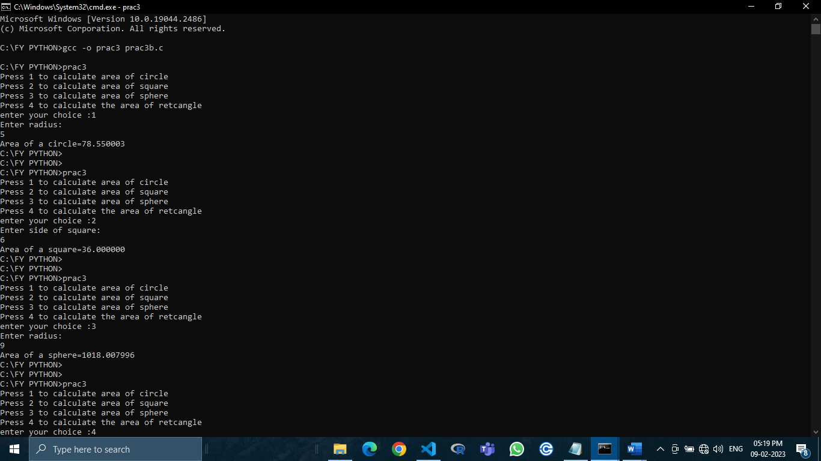

Area of a square



Area of a sphere



**Practical No.4**

Aim: Programs on looping

(a) Write a program on palindrome demonstrating while loop.

#include <stdio.h>

int main()

{

 int n,r=0,rev=0,orgnum=0;

 printf("Enter a number:");

 scanf("%d",&n);

 orgnum=n;

 while(n!=0)

 {

  r=n%10;

  rev=rev*10+r;

  n=n/10;

 }

 if(orgnum==rev)

  printf("%d is a palindrome number",orgnum);

 else

  printf("%d is a not palindrome number",orgnum);

 return 0;

}

Output:

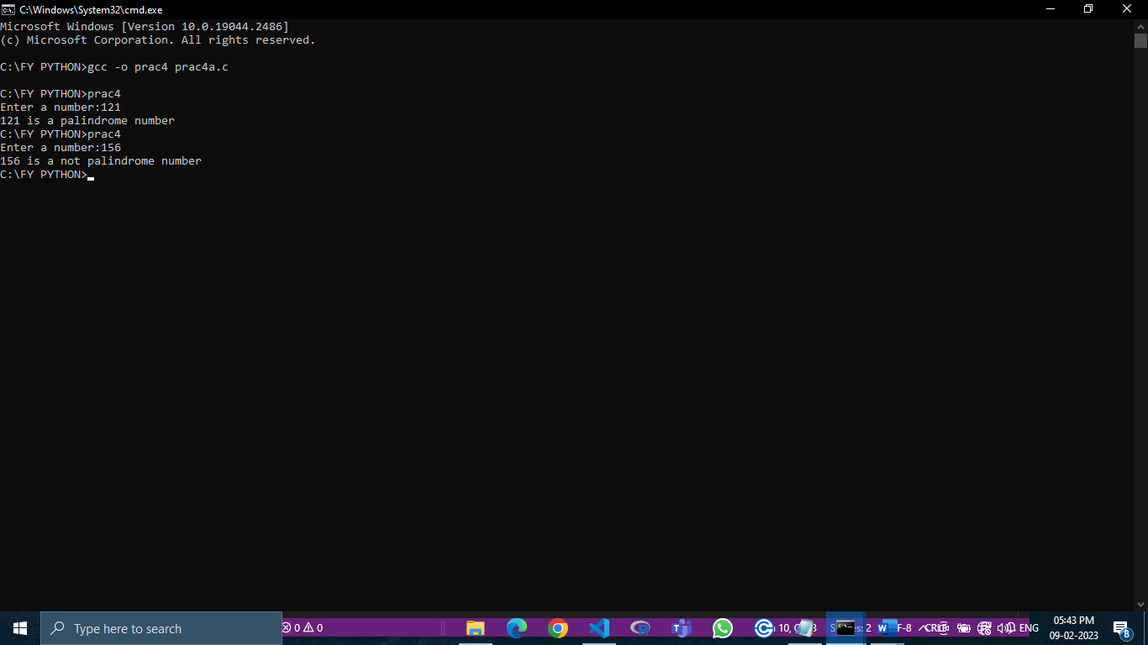

(b) Write a program on armstrong demonstrating while loop.

#include <stdio.h>

int main()

{

 int n,a,r,s=0;

 printf("Enter the number:");

 scanf("%d",&n);

 a=n;

 while(n!=0)

 {

  r=n%10;

  s=s+(r*r*r);

  n=n/10;

 }

 if(s==a)

   printf("%d is an armstrong number",a);

 else

   printf("%d is not an armstrong number",a);

 return 0;

}

Output:

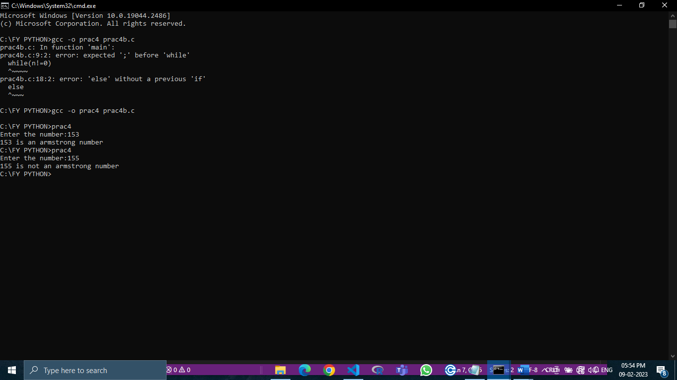

**Practical no 5**

**AIM:**- **Programs on arrays.**

Write a program on Addition of 2 Matrix and Write a program on Multiplication of 2 Matrix.

1. Addition of matrix

Input:-

// FCS2223036 //

#include<stdio.h>

int main()

{

int a[10][10],b[10][10],c[10][10],i,j,k;

int sum=0;

printf("Enter the firsrt Matrix: \n");

for(int i=0;i<3;i++)

{

 for(int j=0;j<3;j++)

 {

   scanf("%d",&a[i][j]);

 }

}

printf("Enter the second Matrix-Value: \n");

for(int i=0;i<3;i++)

{

 for(int j=0;j<3;j++)

 {

   scanf("%d",&b[i][j]);

 }

}

printf("First Matrix is :\n");

for(i=0;i<3;i++)

{

 for(j=0;j<3;j++)

 {

   printf(" %d ",a[i][j]);

 }

 printf("\n");

}

printf("Second Matrix is :\n");

for(i=0;i<3;i++)

{

 for(j=0;j<3;j++)

 {

   printf(" %d ",b[i][j]);

 }

 printf("\n");

}

printf("\nAddition of Two Matrices\n");

for(i=0;i<3;i++)

{

 for(j=0;j<3;j++)

 {

   c[i][j]=a[i][j]+b[i][j];

 }

}

printf("\nAddition of Matrix is\n");

for(i=0;i<3;i++)

{

 for(j=0;j<3;j++)

 {

   printf(" %d ",c[i][j]);

 }

 printf("\n");

}

return 0;

}

Output:-

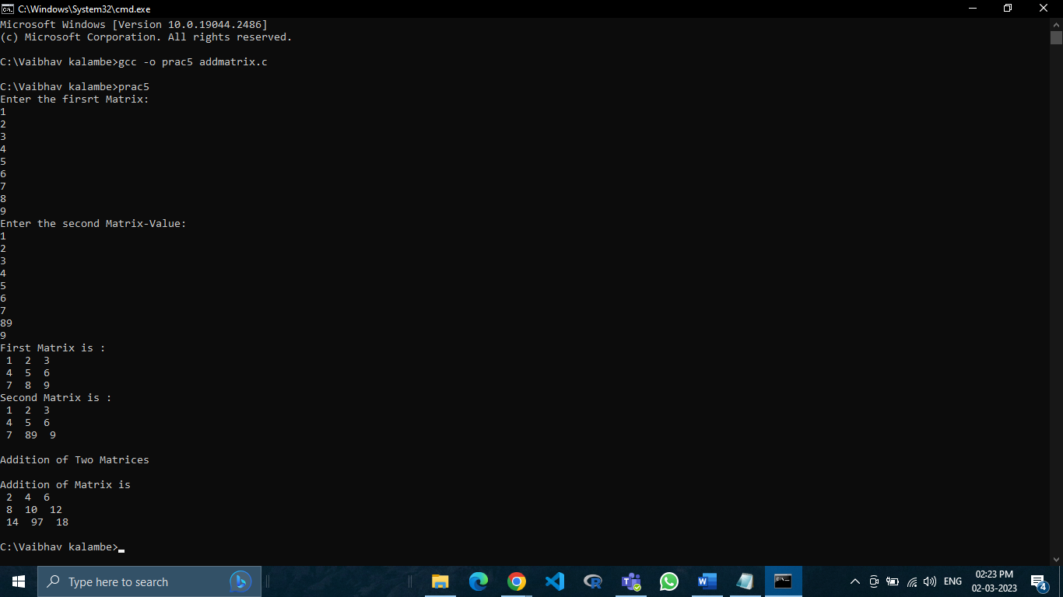

2. Multiplication of matrix

//FCS2223036//

#include<stdio.h>

int main(){

int a[10][10],b[10][10],c[10][10],i,j,k;

int sum=0;

printf("Enter the firsrt Matrix: \n");

for(int i=0;i<3;i++){

for(int j=0;j<3;j++){

  scanf("%d",&a[i][j]);

}

}

printf("Enter the second Matrix-Value: \n");

for(int i=0;i<3;i++){

for(int j=0;j<3;j++){

  scanf("%d",&b[i][j]);

}

}

printf("First Matrix is :\n");

for(i=0;i<3;i++){

for(j=0;j<3;j++){

printf(" %d ",a[i][j]);

}

printf("\n");

}

printf("Second Matrix is :\n");

for(i=0;i<3;i++){

for(j=0;j<3;j++){

printf(" %d ",b[i][j]);

}

printf("\n");

}

printf("Multiplication \n");

for(i=0;i<3;i++){

for(j=0;j<3;j++){

 sum=0;

 for(k=0;k<3;k++){

  sum=sum+a[i][k]*b[k][j];

 }

 c[i][j]=sum;

}

}

for(i=0;i<3;i++){

 for(j=0;j<3;j++){

  printf(" %d ",c[i][j]);

}

printf("\n");

}

return 0;

}

Output:-

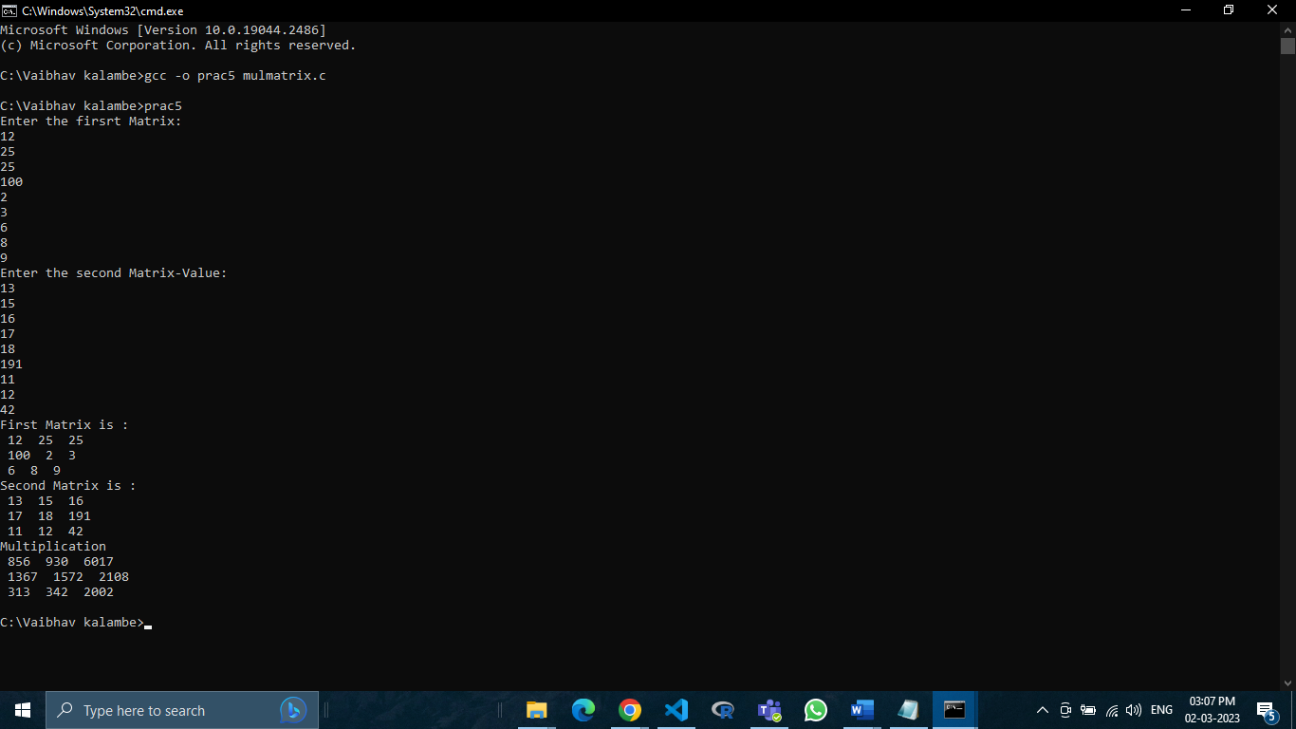

**PRACTICAL NO.6**

**Aim:-Programs on functions.**

Write a Switch Case having menu for

1]Find out maximum and minimum of some values using function.

2]Check perfect numbers using the function.

3]Find the factorial of a number using the function.

4]Fibonacci Series using Recursion function.

Input:-

//FCS2223036//

#include<stdio.h>

int choice;

int printFibonacci(int n)

{

 static int n1 = 0,n2 = 1,n3;

 if (n>0)

 {

   n3 = n1 + n2 ;

   n1 = n2 ;

   n2 = n3 ;

   printf("%d",n3);

   printFibonacci(n-1);

 }

}

int printFactorial(int n)

{

 int i,fact=1;

 if (n<0)

 printf("Error!Factorial of a negative number doesn not exist.");

 else

 {

   for(i=1;i<=n;i++)

   {

     fact=fact*i;

   }

    printf("Factorial of %d = %d",n,fact);

 }

}

int printperfect(int n)

{

 int i=1,sum=0;

 while(i<n)

 {

   if(n%i==0)

   sum=sum+i;

   i++;

 }

 if(sum==n)

 printf("%d is a perfect number",i);

 else

 printf("%d is not a perfect number",i);

}

int maxmin(int a[],int n)

{

 int min,max,i;

 min=max=a[0];

 for(i=1;i<n;i++)

 {

   if(min>a[i])

   min=a[i];

   if (max<a[i])

   max=a[i];

 }

 printf("maximum of array is :%d",max);

 printf("minimum of array:%d",min);

}

//Start of Switch Case

int main()

{

 printf("Press 1 to find out maximum and minimum of some value.\n");

 printf("Press 2 to check perfect number.\n");

 printf("Press 3 to find the factorial of any number.\n");

 printf("Press 4 to fibonacci series a number,\n");

 scanf("%d",&choice);

 switch(choice)

 {

  case 1:

  {

   int a[1000],i,n,sum;

   printf("Enter size of array:");

   scanf("%d",&n);

   printf("Enter elements in array :");

   for(i=0;i<n;i++)

   {

     scanf("%d",&a[i]);

   }

   maxmin(a,n);

    break;

  }

  case 2:

  {

   int n;

   printf("Enter a number: ");

   scanf("%d",&n);

   printperfect(n);

   break;

  }

  case 3:

  {

   int n;

   printf("Enter an integer:");

   scanf("%d",&n);

   printFactorial(n);

   break;

  }

  case 4:

  {

   int n ;

   printf("Enter the number of elements:");

   scanf("%d",&n);

   printf("Fibonacci Series:");

   printf("%d %d",0,1);

   printFibonacci(n-2);

   break;

  }

  default:

  printf("wrong Input\n");

 }

 return 0;

}

Output:-

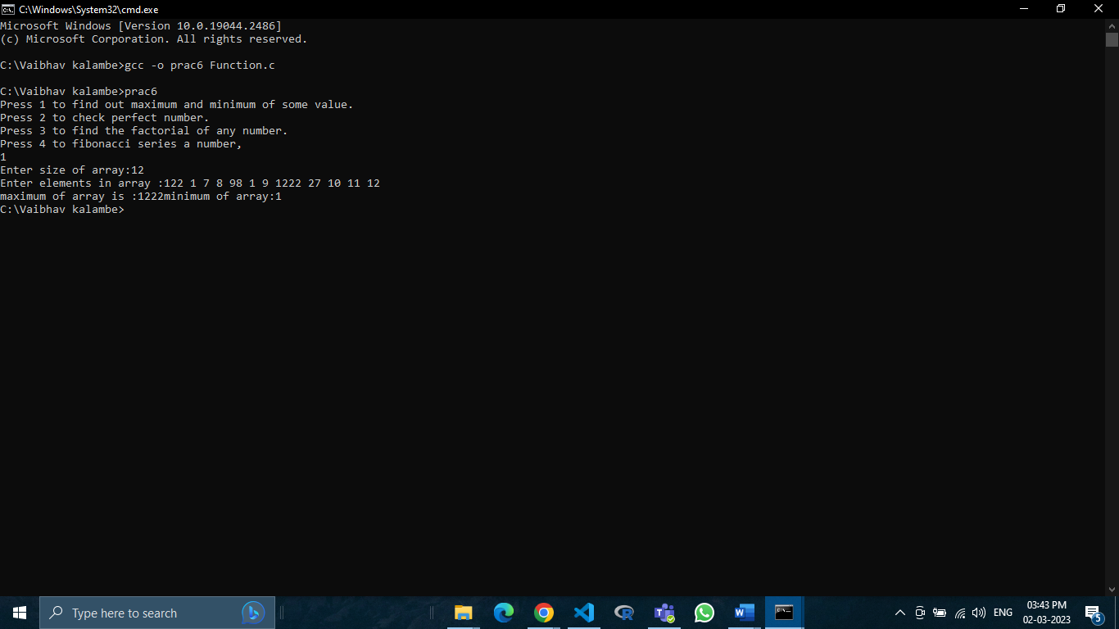

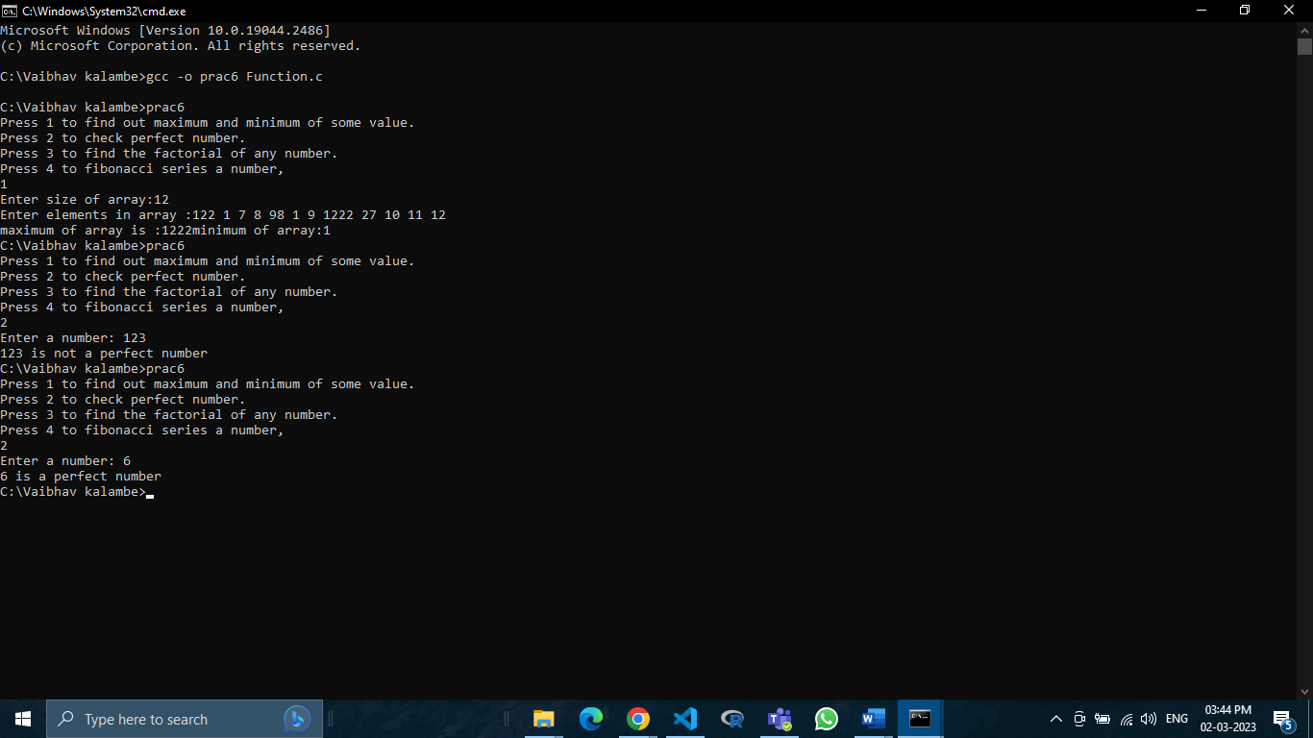

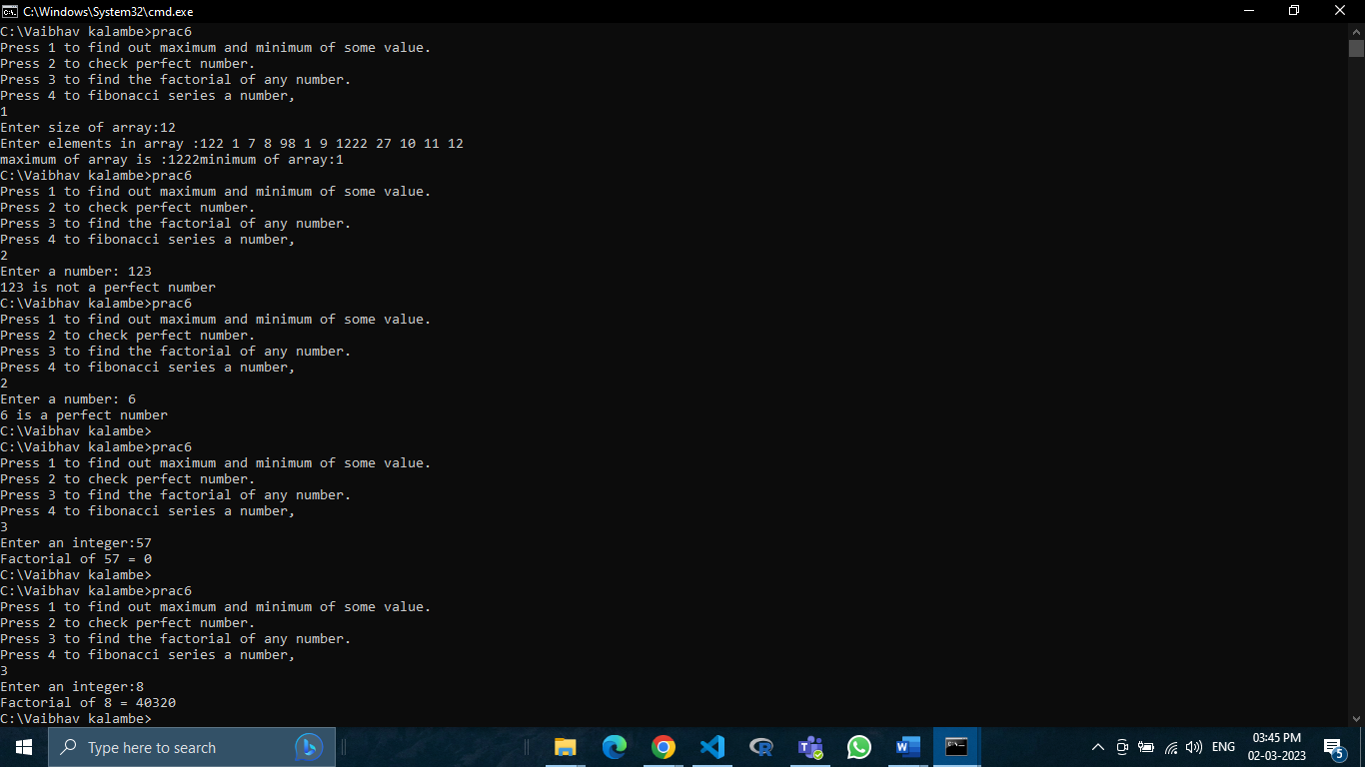

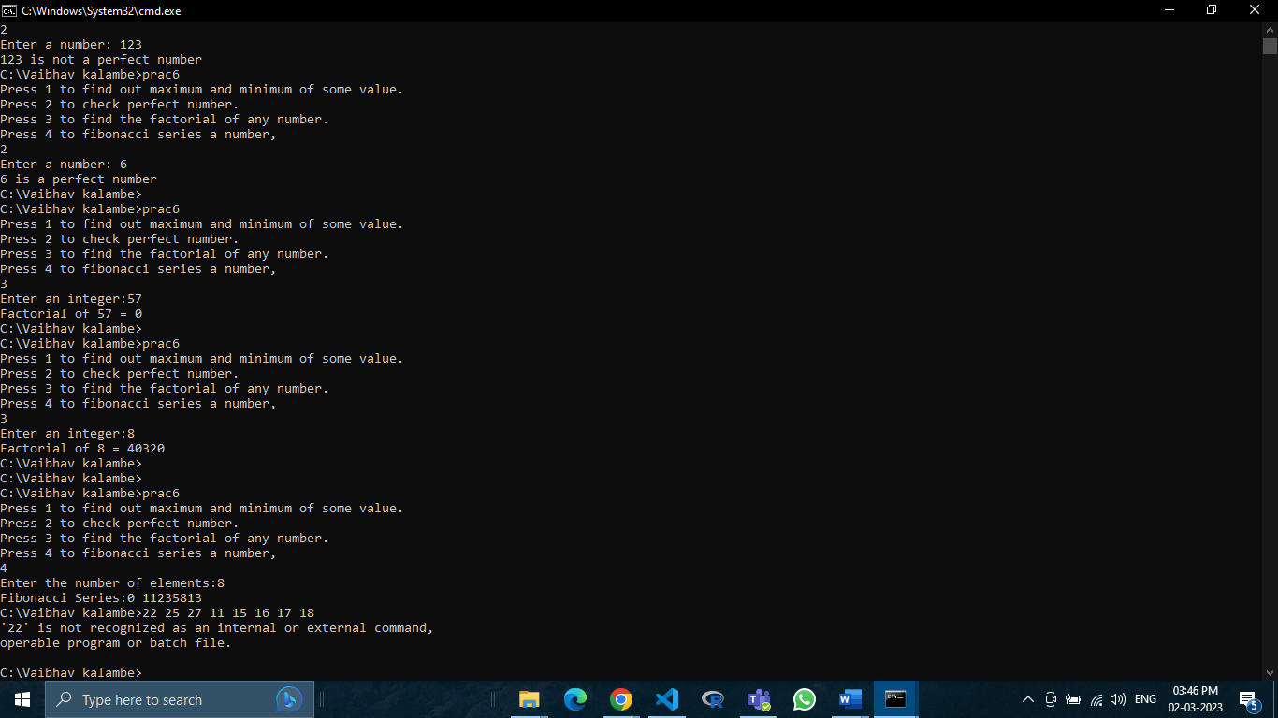

Practical No.7

Aim: Programs on structures and unions

Input:

// Practical No.7 FCS2223036

#include <stdio.h>

#include <string.h>

struct student

{

int rollno;

char name[50];

}s1;      //Declaring s1 variable for structure students

union student1

{

int rollno;

char name[50];

}u1;      //Declaring u1 variable for union students

int main()

{

s1.rollno=1;

strcpy(s1.name,"Vaibhav");

printf("Rollno:%d\n", s1.rollno);

printf("Name:%s\n", s1.name);

u1.rollno=1;

strcpy(u1.name,"Kalambe");

printf("Rollno:%d\n", u1.rollno);

printf("Name:%s\n", u1.name);

return 0;

}

Output:

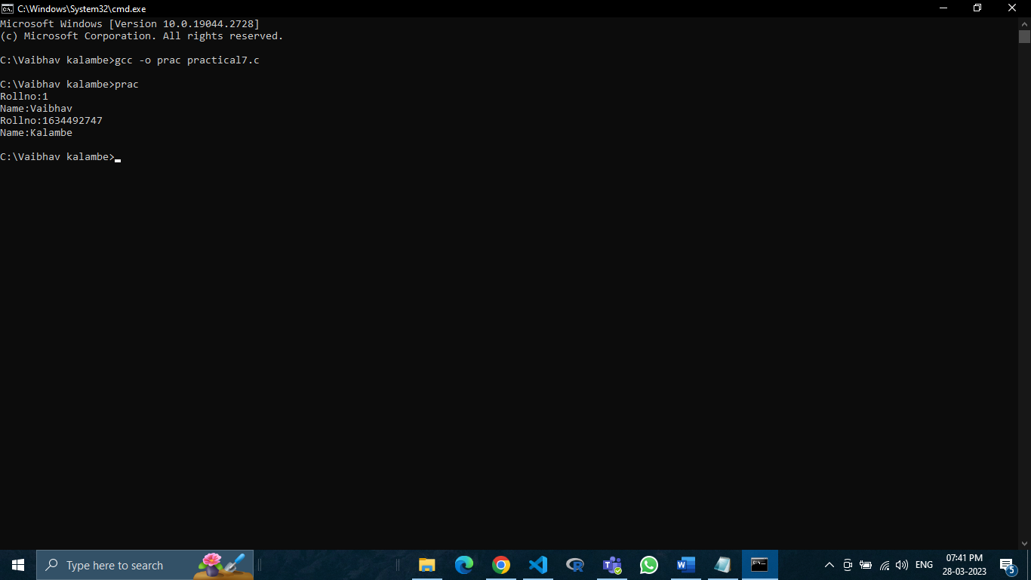

Practical No.8

Aim: Programs on pointers

Input:

//Practical 8 FCS2223036

#include <stdio.h>

int main()

{

    int num1,num2;

int *a,*b;

a=& num1;

b=& num2;

printf("Enter value of num1: ");

scanf("%d",&num1);

printf("Enter value of num2: ");

scanf("%d",&num2);

// print values before swapping

printf("Before swapping: num1=%d,num2=%d\n",*a,*b);

printf("Address before swapping of num1 %u\nand num2%u\n",a,b);

int t;

t=num1;

num1=num2;

num2=t;

a=& num1;

b=& num2;

// print values after swapping

printf("After swapping: num1=%d,num2=%d",*a,*b);

printf("After swapping: num1=%u\nand num2=%d",a,b);

return 0;

}

Output:

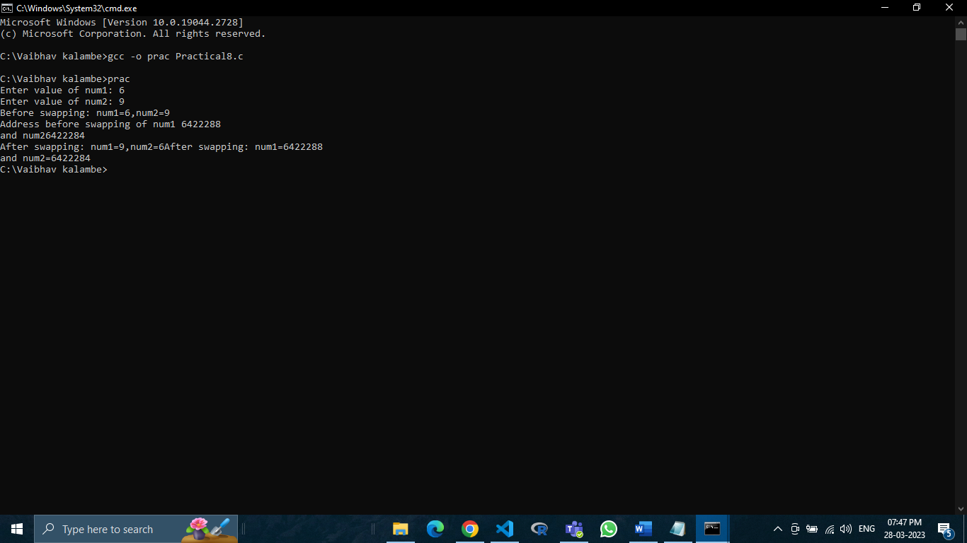

Practical No.9

Aim: Programs on string manipulation

Input:

//Practical 9   FCS2223036

#include <stdio.h>

#include <string.h>

int main()

{

char str1[50], str2[50], str3[50]=" ";

int len , mid, tmp,i;

printf("Enter string1:");

gets(str1);

printf("Enter string2:");

gets(str2);

//comparision

if (strcmp(str2,str2)==0){

printf("Both are same:\n");

}

else{

printf("Both are diffferent.\n");

}

//concatination

strcat(str3, str1);

strcat(str3," ");

strcat(str3, str2);

printf("concatenated stringn:\n",str3);

//reverse

len=strlen(str3);

mid=len/2;

for (i =0;i<mid;i++){

tmp=str3[len -1 -i];

str3[len -1 -i]=str3[i];

str3[i]=tmp;

}

//output

printf("Reverse string:%s\n",str3);

return 0;

}

Output:

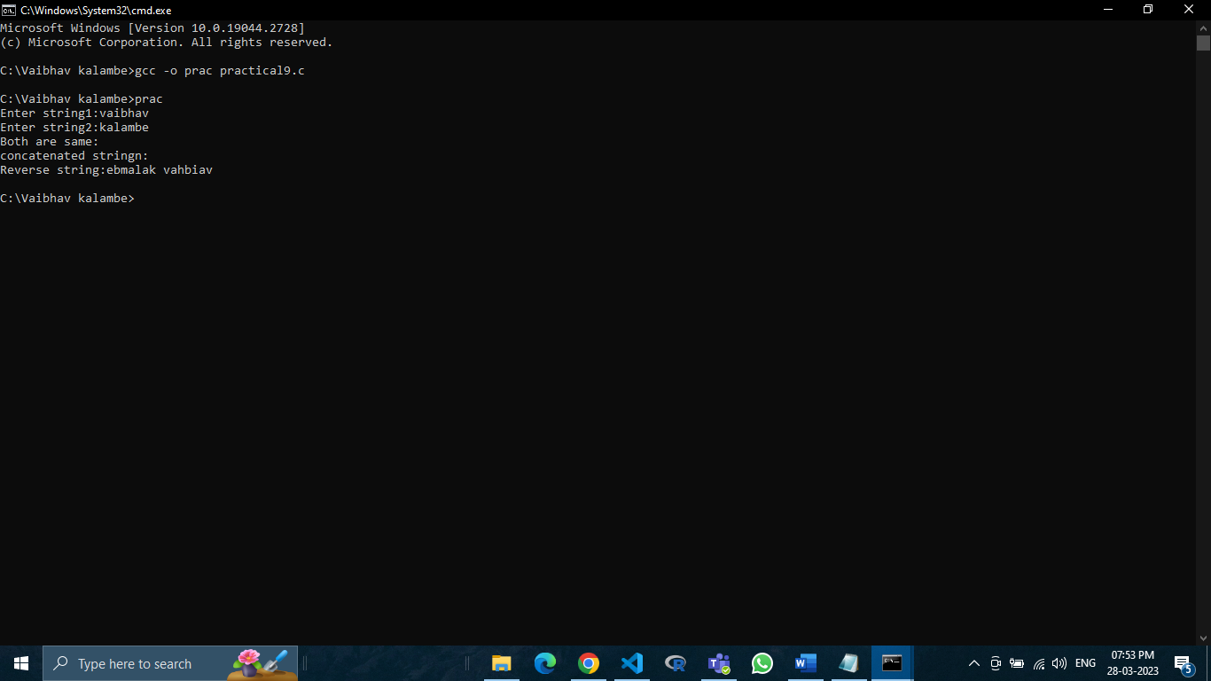

Practical No.10

Aim: Programs on file pointers.

Input:

//Practial 10  FCS2223036

#include <stdio.h>

#include <string.h>

int main()

{

FILE *filepointer;

char dataToBeWritten[200] = "This file is generated by vaibhav";

filepointer = fopen("FileOperstion.c","w");

if (filepointer==NULL)

{

printf("FileOperation.c file failed to open");

}

else

{

printf("The file is now opened\n");

if (strlen(dataToBeWritten)>0)

{

fputs(dataToBeWritten,filepointer);

fputs("\n",filepointer);

}

fclose(filepointer);

printf("Data succefully writtem in the FileOperstion.c\n");

printf("The file is now closed");

}

return 0;

}

Output:

