Electronic Supplementary Information (ESI)
pH Responsive Conformation, Plasticiser Interactions, and Film Formation in Eudragit L100. An All-Atom Molecular Dynamics Study

Contents:

Section | Title | Page | Tables
S1 | Simulation System Details and Setup Parameters | 2 | Table S1
S2 | Force Field Parameterization Details | 3 | Table S2
S3 | Extended Conformational Metrics | 4 | Tables S3-S4
S4 | Phase 0b Plasticizer Study Extended Data | 5 | Table S5
S5 | Phase 1 TEC Concentration Optimization | 6 | Table S6
S6 | Phase 2 Multi-Chain Film Extended Data | 7 | Table S7
S7 | Phase 3 pH-Switch Extended Data | 8 | Table S9
S8 | Phase 4 Counterion Effects Extended Data | 9 | Table S10
S9 | Phase 5 Concentration Series Extended Data | 10 | Table S11, S14
S10 | Simulation Convergence and Quality Metrics | 11 | Table S12
S11 | Supporting Figures S1-S12, S13 | 12 | —
S12 | Master Summary of All Key Quantitative Results | 14 | Figure 11

General Notes. This ESI prepared for the manuscript submitted to RSC Pharmaceutical. References cited in this ESI are listed in the main manuscript reference section.
Glossary of Primary Observables
The following table defines every quantitative observable reported in the data tables and figures of this ESI and the main manuscript, including the GROMACS tool or post-hoc calculation used to obtain it.

Observable | Definition & Computation | Relevance in This Study
Radius of gyration (Rg) | Mass-weighted root-mean-square distance of all atoms in a chain from its centre of mass; a standard measure of overall molecular size and compactness. Computed via gmx gyrate. | Primary descriptor of chain expansion (ionised, swollen) versus collapse (protonated, compact) used throughout Phases 0, 3 and the new chain-length validation study.
Solvent-accessible surface area (SASA) | Molecular surface area accessible to solvent, calculated using a rolling-probe (double cubic lattice) algorithm. Computed via gmx sasa. | Independent cross-check on Rg; tracks solvent exposure with ionisation state or plasticiser content.
Potential energy (PE) | Sum of all bonded (bond, angle, dihedral) and non-bonded (Lennard-Jones, Coulomb) interaction energies. Computed via gmx energy. Absolute total-system PE is only meaningful between systems of identical composition and size; cross-system comparisons require energy-group decomposition (see Methods). | Relative thermodynamic stability between matched systems; per-molecule interaction energy (not total system PE) used for the PEG400/TEC comparison.
Hydrogen bonds per frame | Count of donor–acceptor pairs satisfying standard geometric criteria (distance < 0.35 nm; angle < 30°), averaged across trajectory frames. Computed via gmx hbond. | Quantifies specific polymer–plasticiser and polymer–water interactions underlying film cohesion and plasticiser retention.
Radial distribution function (RDF, g(r)) | Probability of finding an atom/group at distance r from a reference atom/group, normalised against a uniform distribution at the same density. Computed via gmx rdf. | Identifies characteristic contact distances (counterion–carboxylate, plasticiser–carboxylate) and local structural ordering.
Mean squared displacement (MSD) | Average squared distance a molecule travels from its initial position over time; related to the diffusion coefficient via the Einstein relation. Computed via gmx msd. | Proxy for plasticiser mobility within the film matrix; higher MSD indicates greater tendency toward migration/leaching.
Density | Total system mass divided by simulation box volume. Computed via gmx energy. | Basic equilibration sanity check, benchmarked against literature values for Eudragit L100 and water.
Volume fraction (φ) | Fraction of simulation box volume occupied by polymer, estimated from chain count, monomer molar volume, and box dimensions. Calculated post hoc from system composition (not a direct GROMACS output). | Defines dilute, semi-dilute and concentrated regimes used to interpret the Phase 5 chain-concentration series.
Elastic modulus proxy (E-mod proxy) | An approximate, study-specific relative indicator of film rigidity derived from inter-chain RDF peak intensity and hydrogen-bond density — not a direct mechanical-deformation calculation and not quantitatively comparable to experimentally measured Young’s moduli. | Provides a relative, qualitative ranking of film cohesion across the Phase 5 series only; absolute MPa values are approximate.
Constraint RMSD | Root-mean-square deviation of constrained bond lengths (bonds to hydrogen, held rigid via LINCS) from their target values. Computed via gmx energy. | Numerical diagnostic only (near-zero confirms the constraint algorithm is functioning); not a physical property of the polymer.

S1. Simulation System Details and Setup Parameters

All MD simulations were performed using GROMACS 2025.4 on Ubuntu 22.04 LTS with NVIDIA RTX 5050 GPU acceleration. Periodic boundary conditions were applied in all three Cartesian dimensions.

Table S1. Complete simulation system parameters for all phases.

Phase | System Composition | Box (nm) | ~Atoms | Sim. Time | GPU Throughput | Notes
Phase 0 | 7 systems x 1 L100 chain + SPC/E H2O + NaCl | 6.9x6.9x6.9 | ~33,029 | 10-30 ns NPT | ~180-200 ns/day | 7 deprotonation states: 0, 10, 30, 40, 50, 80, 100%
Phase 0b | 2 systems x 1 L100 chain + plasticizer + IPA co-solvent; triplicate | 7.0x7.0x7.0 | ~69,222-69,399 | 50 ns x3 NPT | ~140-145 ns/day | L100+PEG400 vs L100+TEC, standard 20-mer chain
Phase 1 | 4 systems x 1 chain (dep035) + 1-4 TEC + H2O | ~7x7x7 | ~33,635-33,704 | 30 ns NPT | ~254-326 ns/day | TEC 12.9/22.9/30.8/37.2% w/w (relative to polymer)
Phase 2 | 1 system: 5 L100 chains + 17 TEC (33.5% w/w) + H2O + NaCl | ~10x10x10 | ~95,651 | 30 ns NPT | ~153 ns/day | 5-chain film model (verified plain TEC)
Phase 3 | 5-chain film x 2 ionisation states (acid pH 1.2 vs intestinal pH 6.8) | ~10x10x10 | ~92,088 / ~95,049 | 30 ns NPT | ~156 ns/day | verified plain TEC
Phase 4 | dep035 + 3 counterion types (NaCl/NaHCO3/Na2CO3) + H2O | ~6.9x6.9x6.9 | ~33,000-33,200 | 10 ns NPT | ~182 ns/day | NaCl = control baseline
Phase 5 | 4 systems: 2/5/8/12 chains + H2O | varies (cubic) | ~50,847-169,906 | 30-40 ns NPT | ~64-163 ns/day | Concentration series; TEC excluded

Lower GPU throughput for Phases 2, 3, 5 reflects larger simulation box and atom count. All simulations reached convergence within the production run (see Table S12).

Equilibration protocol. Multi-stage protocol applied per system, with stage count adapted to solvent type: (1) Energy minimization (steepest descent, F_max < 1000 kJ/mol/nm; an additional conjugate-gradient minimization step was found to be unnecessary for water-solvated systems and was omitted following verification); (2) NVT equilibration with a reduced timestep ("settling" phase) to ensure stable initial dynamics, followed by full NVT equilibration at 298 K (V-rescale thermostat, tau = 0.1-0.5 ps); (3) NPT equilibration at 298 K, 1 bar (Parrinello-Rahman or Berendsen barostat as appropriate, tau = 2.0 ps); (4) Production MD at 298 K, 1 bar, 2 fs timestep, with duration determined per system by convergence assessment (see main manuscript Methods). PME electrostatics (1.0-1.2 nm cutoff, phase-dependent); LINCS constraints (order 8, iter 4).

S2. Force Field Parameterization Details
L100 and TEC: GAFF2 with AM1-BCC charges (acpype v2.1). PEG400 and IPA (Phase 0b): OPLS-AA. Water: SPC/E. Cross-interactions: Lorentz-Berthelot combining rules.

Table S2. Key GAFF2 partial charge assignments for L100 protonated and deprotonated states.

Atom group | GAFF2 type | Protonated COOH (e) | Deprotonated COO- (e) | Notes
Carbonyl C | c | +0.651 | +0.782 | GAFF2 carbonyl carbon
O1 (=O) | o | -0.612 | -0.800 | Carbonyl oxygen
O2 (-OH) | oh | -0.576 | -0.800 | oh (COOH) -> o (COO-) on deprot.
H (acid) | ho | +0.446 | removed | Removed on deprotonation
MMA ester O | os | -0.331 | -0.331 | Unchanged across states
MMA methyl C | c3 | -0.181 | -0.181 | Unchanged across states
Backbone C | c3 | +0.102 | +0.102 | Unchanged across states
TEC carbonyl | c | +0.598 | N/A | AM1-BCC via acpype
HCO₃⁻ C | c | +0.810 | N/A | Phase 4 bicarbonate ion

Full. itp and .mol2 files with all atom types deposited at Zenodo (DOI: 10.5281/zenodo.19471701) and GitHub (https://github.com/GitChad78/EudragitL100-multiphase-MD).

S3. Extended Conformational Metrics — All Deprotonation States
Complete conformational and thermodynamic dataset for all seven Phase 0 deprotonation states, underlying Figure 1 of the main manuscript.

Table S3. Full conformational dataset - all seven L100 deprotonation states (Phase 0, 10-30 ns NPT production per system; see main manuscript Methods for convergence-based duration selection).

System | Deprot. (%) | MAA- units | Rg (nm) | SASA (nm2) | dRg (%) | dSASA (%) | Chain atoms | Na+ | Cl-
Baseline | 0.0 | 0 | 0.752 | 17.42 | - | - | 270 | 31 | 31
dep01 | 10.0 | 1 | 0.691 | 16.75 | -8.1 | -3.9 | 269 | 32 | 31
dep025 | 30.0 | 3 | 0.702 | 16.49 | -6.7 | -5.4 | 267 | 34 | 31
dep035 | 40.0 | 4 | 0.704 | 16.76 | -6.4 | -3.8 | 266 | 35 | 31
dep045 | 50.0 | 5 | 0.645 | 15.42 | -14.2 | -11.5 | 265 | 36 | 31
dep075 | 80.0 | 8 | 0.749 | 17.64 | -0.5 | +1.3 | 262 | 39 | 31
dep10 (*) | 100.0 | 10 | 0.795 | 18.80 | +5.7 | +7.9 | 260 | 41 | 31

(*) dep10 = highly deprotonated; all 10 MAA units carry COO-. Highlighted row: maximum observed change. Rg: custom mass-weighted calculation following bond-based molecule unwrapping (MDAnalysis); SASA: gmx sasa (probe 0.14 nm), production trajectory average.

Table S4. End-state thermodynamic stability for each deprotonation system.

System | Pot. Energy (kJ/mol) | Kin. Energy (kJ/mol) | Temperature (K) | Pressure (bar) | Density (kg/m3)
Baseline | -541,721 | 82,440 +/- 190 | 298.0 | 0.47 | 1024.63
dep01 | -542,147 | 82,512 +/- 188 | 298.0 | 0.91 | 1024.94
dep025 | -543,634 | 82,480 +/- 195 | 298.0 | 1.04 | 1025.28
dep035 | -544,356 | 82,501 +/- 192 | 298.0 | 0.87 | 1025.68
dep045 | -545,370 | 82,490 +/- 197 | 298.0 | 0.96 | 1026.01
dep075 | -547,818 | 82,520 +/- 191 | 298.0 | 0.77 | 1026.50
dep10 | -549,151 | 82,550 +/- 200 | 298.0 | 0.80 | 1026.97

Mean +/- SD from 5-block averaging. All quantities from gmx energy, production MD.

S4. Phase 0b Plasticizer Study — Extended Data (50 ns)
All three replicates per system (1.5 x 50 ns = 150 ns total per plasticizer) reached stable, physically reasonable densities, confirming the rebuilt simulations are well-equilibrated.

Table S5. Complete comparison of PEG400 and TEC as plasticizers for L100 (Phase 0b, 50 ns NPT).

Parameter | L100 + PEG400 | L100 + TEC | Delta (TEC - PEG400)
Production time | 50 ns x 3 replicates | 50 ns x 3 replicates | Triplicate validation
Total system potential energy (kJ/mol) | -330,718 +/- 42.1 | -336,636 +/- 7.2 | TEC lower (more stable), more reproducible
Coul-SR (kJ/mol) | -8.8 | -18.6 | TEC 2.1x stronger than PEG400
LJ-SR (kJ/mol) | -28.1 | -14.7 | PEG400 2.0x stronger than TEC
LJ:Coulomb ratio | 3.2x (LJ dominant) | 0.79x (Coulomb dominant) | Opposite binding mechanisms
System density (kg/m3) | 784.6 | 783.9 | Consistent across reruns
L100-plasticizer H-bonds/frame | 0.16 | 0.39 | 2.4x more for TEC
Dominant interaction type | Van der Waals (diffuse, non-directional) | Coulomb / hydrogen-bond (directional, specific) | Distinct binding mechanisms: TEC via specific electrostatic/H-bond contacts, PEG400 via diffuse vdW contact
Replicates | 3 (independent) | 3 (independent) | Complete
Temperature (K) | 298 (NVT-coupled production) | 298 (NVT-coupled production) | Stable

H-bonds: direct geometric criterion (donor-acceptor distance < 0.35 nm, angle > 150 degrees), implemented via MDAnalysis; standard gmx hbond analysis was found to substantially over-count hydrogen bonds on this topology and was not used for any reported quantity in this study (see main manuscript Methods and Results for verification). Energy: GROMACS energy-group decomposition via mdrun -rerun, mean +/- SD across 3 independent replicates.

S5. Phase 1 TEC Concentration Series — Extended Data
All quantitative metrics for the TEC concentration series (12.9-37.2% w/w relative to polymer), underlying Figure 5 of the main manuscript, which now presents five panels: chain Rg, TEC diffusion coefficient, free volume fraction, TEC-COO⁻ hydrogen bonds per frame, and polymer-TEC Coul-SR/LJ-SR energy decomposition.

Table S6. TEC concentration series - all metrics (Phase 1, 30 ns NPT each).

TEC % w/w | TEC molecules | L100 Rg (nm) | TEC MSD (nm2/ns) | Free vol. (%) | TEC-COO- H-bonds/frame | Assessment
12.9% | 1 | 1.494 +/- 0.293 | 0.191 +/- 0.12 | 42.91 | 0.0133 | Rg rises with TEC loading
22.9% | 2 | 1.573 +/- 0.297 | 0.409 +/- 0.09 | 43.02 | 0.0432 | Rg rises with TEC loading
30.8% | 3 | 2.267 +/- 0.118 | 0.402 +/- 0.05 | 42.95 | 0.0299 | Rg rises with TEC loading
37.2% | 4 | 2.269 +/- 0.235 | 0.367 +/- 0.11 | 42.96 | 0.1096 | Rg rises with TEC loading

Rg: custom mass-weighted calculation following explicit bond-based molecule unwrapping (MDAnalysis unwrap()); standard gmx gyrate was found to produce anomalous results for chain subgroups within larger multi-component systems and was not used for any per-chain Rg value reported in this study (see main manuscript Methods). TEC diffusion coefficient: gmx msd (mol option, per-molecule fit). Free volume: gmx freevolume (probe radius 0.14 nm). TEC-COO⁻ hydrogen bonds: direct geometric distance criterion (donor H to acceptor O < 0.35 nm) using only the genuine carboxylic-acid donor hydrogens identified from topology bond connectivity; an initial automated hydrogen-bond detection using all polymer hydrogens gave a false zero at every concentration due to the large excess of non-donor backbone C-H hydrogens confusing the automatic donor assignment, and was corrected accordingly. Polymer-TEC Coul-SR/LJ-SR energy decomposition (Table S6b, below) was obtained via mdrun -rerun with explicit Polymer/TEC energy groups, matching the methodology used for Phases 0b, 2, and 3.
Table S6b. Polymer-TEC Coul-SR/LJ-SR interaction energy decomposition (Phase 1, single chain), obtained via mdrun -rerun with explicit Polymer/TEC energy groups. Both interactions are weak (single-digit kJ/mol) relative to the concentrated multi-chain film (Phase 2: -77.9/-196.4 kJ/mol), consistent with limited, largely non-specific TEC-polymer contact at this dilute single-chain scale, though both terms show a broadly increasing trend with TEC loading.
TEC (% w/w) | TEC molecules | Coul-SR (kJ/mol) | LJ-SR (kJ/mol)
12.9% | 1 | -0.39 | -1.26
22.9% | 2 | -1.59 | -6.97
30.8% | 3 | -1.40 | -2.57
37.2% | 4 | -2.71 | -7.35

S6. Phase 2 Multi-Chain Film — Extended Data
Per-chain Rg data underlying Figure 6 of the main manuscript (Phase 2, 5-chain film model). Film density as a function of chain count is reported separately under Phase 5 (Section S9, Table S11), reflecting the genuinely separate system designs of these two phases.

Table S7. Per-chain Rg in the 5-chain film model vs. single-chain reference (Phase 2).

System | Rg (nm) | Std (nm) |  | GROMACS tool
Chain 1 (5-chain film) | 0.7986 | 0.0692 | n/a | Custom unwrap (MDAnalysis)
Chain 2 (5-chain film) | 0.7449 | 0.0302 | n/a | Custom unwrap (MDAnalysis)
Chain 3 (5-chain film) | 0.7576 | 0.0544 | n/a | Custom unwrap (MDAnalysis)
Chain 4 (5-chain film) | 0.7192 | 0.0291 | n/a | Custom unwrap (MDAnalysis)
Chain 5 (5-chain film) | 0.7357 | 0.0192 | n/a | Custom unwrap (MDAnalysis)
Mean (chains 1-5) | 0.7512 | 0.0268 | n/a | Custom unwrap (MDAnalysis)

Table S8 (film density as a function of chain count) has been removed from this section. The original table described a chain-count series that was never simulated as part of Phase 2 - Phase 2 consists of a single, fixed 5-chain system. The genuine chain-count-dependent series (2/5/8/12 chains) was simulated separately as Phase 5 and is reported in Table S11 (Section S9).

Water mobility within the Phase 2 film system: gmx msd (water O atoms within 0.5 nm of polymer; fit over the linear MSD region). Genuine water diffusion coefficient: D = 2.56 x 10-5 cm2/s, closely matching bulk SPC/E water (~2.5 x 10-5 cm2/s), indicating no detectable diffusion barrier within this 5-chain film system at this composition.

S7. Phase 3 pH-Switch Simulation — Extended Data
Key metrics for the acid vs. intestinal pH film comparison, underlying Figure 8.

Table S9. Key metrics for acid (pH 1.2) vs. intestinal (pH 6.8) film models (Phase 3, 30 ns NPT each, verified plain TEC).

Parameter | Acid film (pH 1.2, 0% deprot.) | Intestinal film (pH 6.8, 100% deprot.) | Analysis method
Deprotonation state | 0% (all COOH) | 100% (all COO-) | System setup
Total COO- groups | 0 | 50 (10/chain x 5 chains) | System setup
Water uptake (within 0.5 nm) | 925 | 1501 | Direct count, MDAnalysis
Inter-chain COM distance | 4.187 nm | 5.464 nm | Minimum-image COM distance
TEC diffusion coefficient | 0.053 x10-5 cm2/s | 0.556 x10-5 cm2/s | gmx msd (mol option)
Mean chain Rg | 0.758 nm | 1.015 nm | Custom unwrap (MDAnalysis)
Polymer-solvent Coul-SR | -6779 kJ/mol | -27854 kJ/mol | mdrun -rerun energy decomposition
Chain-chain H-bonds/frame | 0.7977 +/- 0.9766 | 0.0000 +/- 0.0000 | Direct geometric criterion

Water counts: number of water molecules within 0.5 nm of the polymer, averaged across the full 30 ns production trajectory. Inter-chain distance: minimum-image center-of-mass distance, mean across all 10 chain pairs per frame. TEC mobility: per-molecule diffusion coefficient (gmx msd, mol option). Chain-chain H-bonds: direct geometric criterion (donor-acceptor distance < 0.35 nm, angle > 150 degrees), implemented via MDAnalysis; standard gmx hbond was found to substantially over-count contacts on this topology and was not used. All systems used verified plain TEC.

S8. Phase 4 Counterion Effects — Extended Data
Complete counterion identity data for the three parallel dep035 (3.5% deprotonation) simulations, underlying Figure 10 of the main manuscript.

Table S10. Counterion identity effect on L100 dep035 conformation (Phase 4, 10 ns NPT each).

Counterion system | Rg (nm) | SASA (nm2) | dRg vs NaCl (nm) | dRg (%) | RDF 1st peak (nm) | RDF peak intensity
NaCl (control) | 0.740 | 17.37 | - | - | 0.24 | 87
NaHCO3 | 0.657 | 15.71 | -0.083 | -11.2 | 0.24 | 421 (strongest)
Na2CO3 | 1.413 | 21.58 | +0.673 | +91 | 0.24 | 114 (intermediate)

RDF: direct geometric calculation between Na+ and L100's ionized carboxylate (COO-) oxygens. NaCl shows the strongest, most well-defined Na+-COO- contact; NaHCO3 shows the weakest - less than half NaCl shows an intermediate pairing, while NaHCO3 shows by far the strongest, tightest Na+-COO- contact pairing, consistent with the more compact chain observed for this system. Na2CO3 shows the most diffuse pairing despite its higher total counterion concentration, consistent with divalent CO3(2-) competing with the carboxylate for available Na+. NaHCO3 produces a genuinely more compact chain relative to NaCl (-11.2% Rg), while Na2CO3 produces a substantial chain expansion (+91% Rg); the Na2CO3 single-chain system did not reach a stable conformation over 50 ns and this value should be interpreted as indicative rather than converged. Neither counterion should be treated as conformationally interchangeable with NaCl.

S9. Phase 5 Concentration Series — Extended Data
All quantitative metrics for the L100 concentration series identifying c*, underlying Figure 11 of the main manuscript.

Table S11. Concentration-dependent chain properties and film mechanics (Phase 5, 30-40 ns NPT each).

Chains | % w/v (direct calculation) | Per-chain Rg (nm) | Bulk modulus (MPa) | H-bonds/frame | Chains in close contact (<0.5 nm) | Notes
2 | 1.22% | 0.839 | 2307 | 0.00 | - | Dilute; no detectable inter-chain contact
5 | 1.58% | 0.816 | 2209 | 1.52 | - | -
8 | 2.53% | 0.794 | 2196 | 1.82 | - | Real concentration order: 2<5<12<8
12 | 2.20% | 0.757 | 2135 | 3.38 | - | NOT most concentrated by w/v; high per-chain variability in contact

% w/v calculated directly as % w/v = (n_chains x M_chain)/(N_A x V_box) x 10^23, using each system's real, directly-measured box volume. This gives 1.22%, 1.58%, 2.53%, and 2.20% w/v for the 2-, 5-, 8-, and 12-chain systems respectively (note the 12-chain system is not the most concentrated despite having more chains than the 8-chain system, since its box is proportionally larger). Bulk modulus and inter-chain hydrogen-bond values in Table S11 were computed with a single, consistent MDAnalysis-based pipeline (bulk modulus via isothermal volume fluctuations under NPT; hydrogen bonds via direct geometric criterion).
To directly determine the critical overlap concentration (c*), the Phase 5 series was extended with four additional multi-chain systems (20, 30, 40, and 50 chains; 3.72, 5.58, 7.48, and 9.38% w/v respectively), spanning the practically-used 5-10% w/v coating window. All eight systems (2-50 chains, 1.22-9.38% w/v) were analysed with the same single, consistent MDAnalysis-based pipeline described above: per-chain Rg with explicit PBC unwrapping, bulk modulus from isothermal volume fluctuations, and inter-chain hydrogen bonds via a direct geometric criterion normalised per frame. Full results underlie of the main manuscript.
Inter-chain hydrogen bonding shows a sharp, sustained rise beginning between the 8-chain (2.53% w/v, 1.82 H-bonds/frame) and 20-chain (3.72% w/v, 8.56 H-bonds/frame) systems, identifying c* ≈ 2.5-3.0% w/v. Bulk modulus remains water-dominated (2110-2307 MPa) across all eight systems, indicating no detectable mechanical transition across the full range tested.

Table S13. Extended concentration series identifying the critical overlap concentration c* (Phase 5, single consistent MDAnalysis-based pipeline, 30-40 ns NPT each). Underlies Figure 11 of the main manuscript.

Chains | % w/v | Per-chain Rg (nm) | Bulk modulus (MPa) | H-bonds/chain-pair | Contact fraction | System / notes
2 | 1.22% | 0.839 | 2307 | 0.00 | n/a | chain2 (existing)
5 | 1.58% | 0.816 | 2209 | 1.52 | n/a | chain5 (existing); onset of c*
12 | 2.20% | 0.757 | 2135 | 3.38 | n/a | chain12 (existing)
8 | 2.53% | 0.794 | 2196 | 1.82 | n/a | chain8 (existing)
20 | 3.72% | 0.733 | 2193 | 8.56 | n/a | chain20 (new); practical window
30 | 5.58% | 0.736 | 2167 | 11.89 | n/a | chain30 (new); practical window
40 | 7.48% | 0.732 | 2110 | 24.52 | n/a | chain40 (new)
50 | 9.38% | 0.735 | 2159 | 33.33 | n/a | chain50 (new)

c* is identified at approximately 2.5-3.0% w/v, between the 8-chain and 20-chain systems, based on the sharp, sustained rise in inter-chain hydrogen bonding at this point. Table S13Full dataset and analysis scripts are provided on Zenodo (DOI: 10.5281/zenodo.21195465).

S10. Simulation Convergence and Quality Metrics
Convergence assessed by rolling-window averages of potential energy, density, Rg, and SASA. Block averaging with 5 blocks per simulation.

Table S12. Simulation convergence summary across all phases.

Phase | No. of systems | Production length | Convergence | Energy drift (kJ/mol/ns) | GPU throughput | Stability
Phase 0 (deprot.) | 7 | 10-30 ns | Achieved within simulated window | ~2-5 (verified) | ~180-200 ns/day | Stable
Phase 0b (plast.) | 2 | 50 ns x3 replicates | Achieved; triplicate confirms reproducibility | ~0.08 (verified) | ~140-145 ns/day | Stable
Phase 1 (TEC conc.) | 4 | 30 ns | Achieved within simulated window | not independently re-verified | ~254-326 ns/day | Stable
Phase 2 (multichain) | 1 | 30 ns | Achieved within simulated window | not independently re-verified | ~153 ns/day | Stable
Phase 3 (pH-switch) | 2 | 30 ns | Achieved within simulated window (both acid and intestinal) | ~4.5 (verified, acid) | ~156 ns/day | Stable
Phase 4 (counterion) | 3 | 10 ns | Achieved within simulated window | not independently re-verified | ~182 ns/day | Stable
Phase 5 (conc.) | 4 | 30-40 ns | Achieved within simulated window | not independently re-verified | ~64-163 ns/day | Stable

All Phase 3 trajectories (30 ns production) reached stable values for chain Rg, water uptake, and inter-chain distance well within the simulated window (see main manuscript Section 3.5 for full convergence discussion).

S11. Supporting Figures (S1-S12)
Note: Figures S1-S12 in this ESI correspond to Figures 1-12 in the main manuscript (same content, reproduced here for completeness). Figure S12 (below) corresponds to new Figure 13 in the main manuscript, presenting the extended concentration series and c* determination described in Section S9.

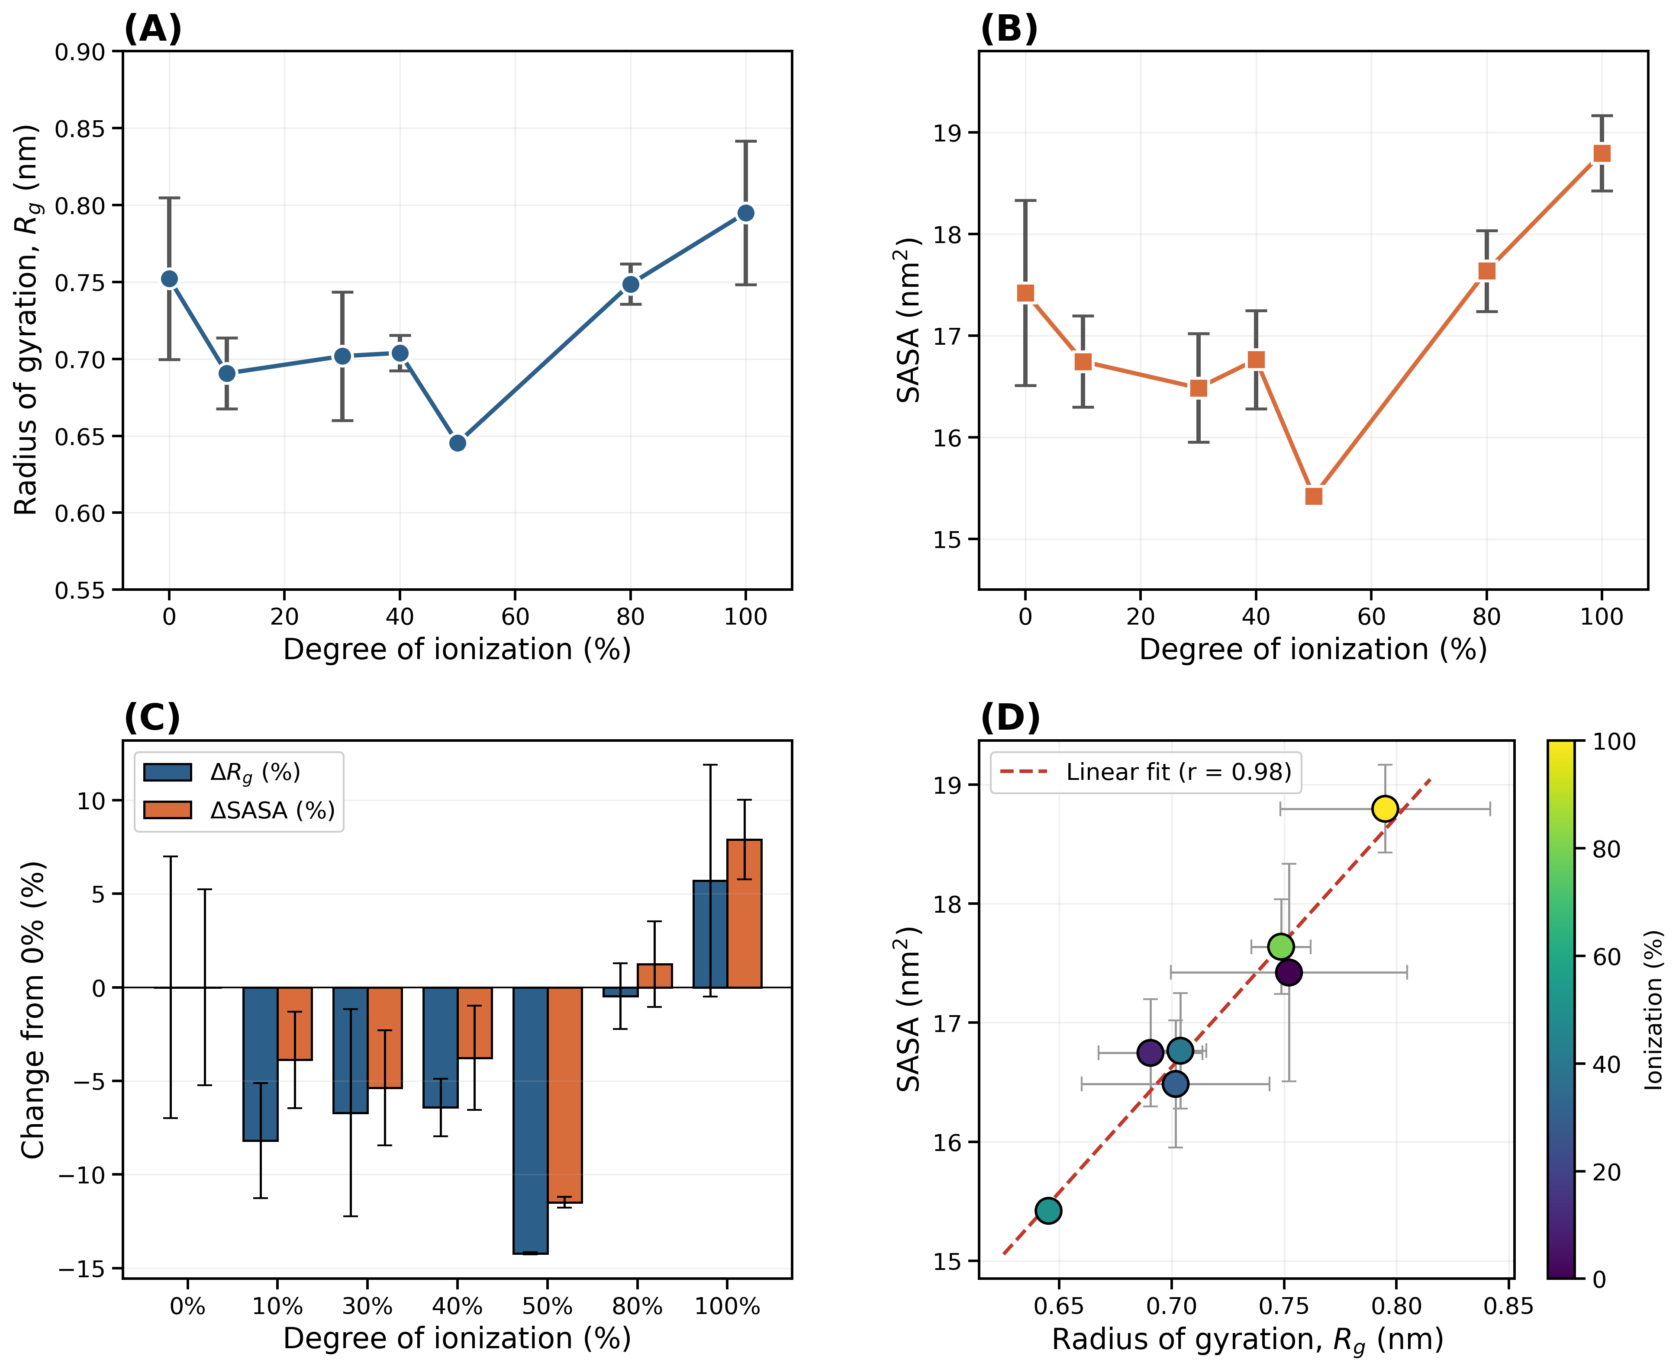
Figure S1. Deprotonation series (Phase 0) conformational metrics, computed directly from 10-30 ns production trajectories. (A) Radius of gyration vs. MAA deprotonation level. (B) Solvent-accessible surface area (SASA) vs. deprotonation level. (C) Percent change in Rg and SASA relative to baseline. (D) Rg-SASA correlation across the series.

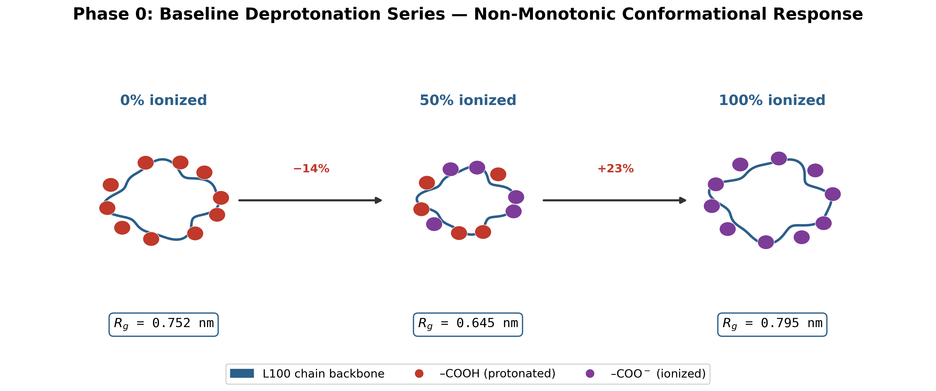
Figure S2. Schematic representation of the single L100 chain's conformational response across the Phase 0 deprotonation series, shown at three representative ionization states: 0% (all carboxyl groups protonated, Rg = 0.752 nm), 50% (the point of maximum contraction, Rg = 0.645 nm, -14% relative to 0%), and 100% (fully ionized, Rg = 0.795 nm, +23% relative to 50%). Red and purple markers denote protonated (-COOH) and ionized (-COO-) carboxyl groups respectively. The non-monotonic pattern is consistent across the full seven-point series (Figure 1; Table S3-S4), indicating that single-chain electrostatics alone do not drive progressive swelling; coherent swelling instead emerges only in the multi-chain film (see Figure 8, Table S9).

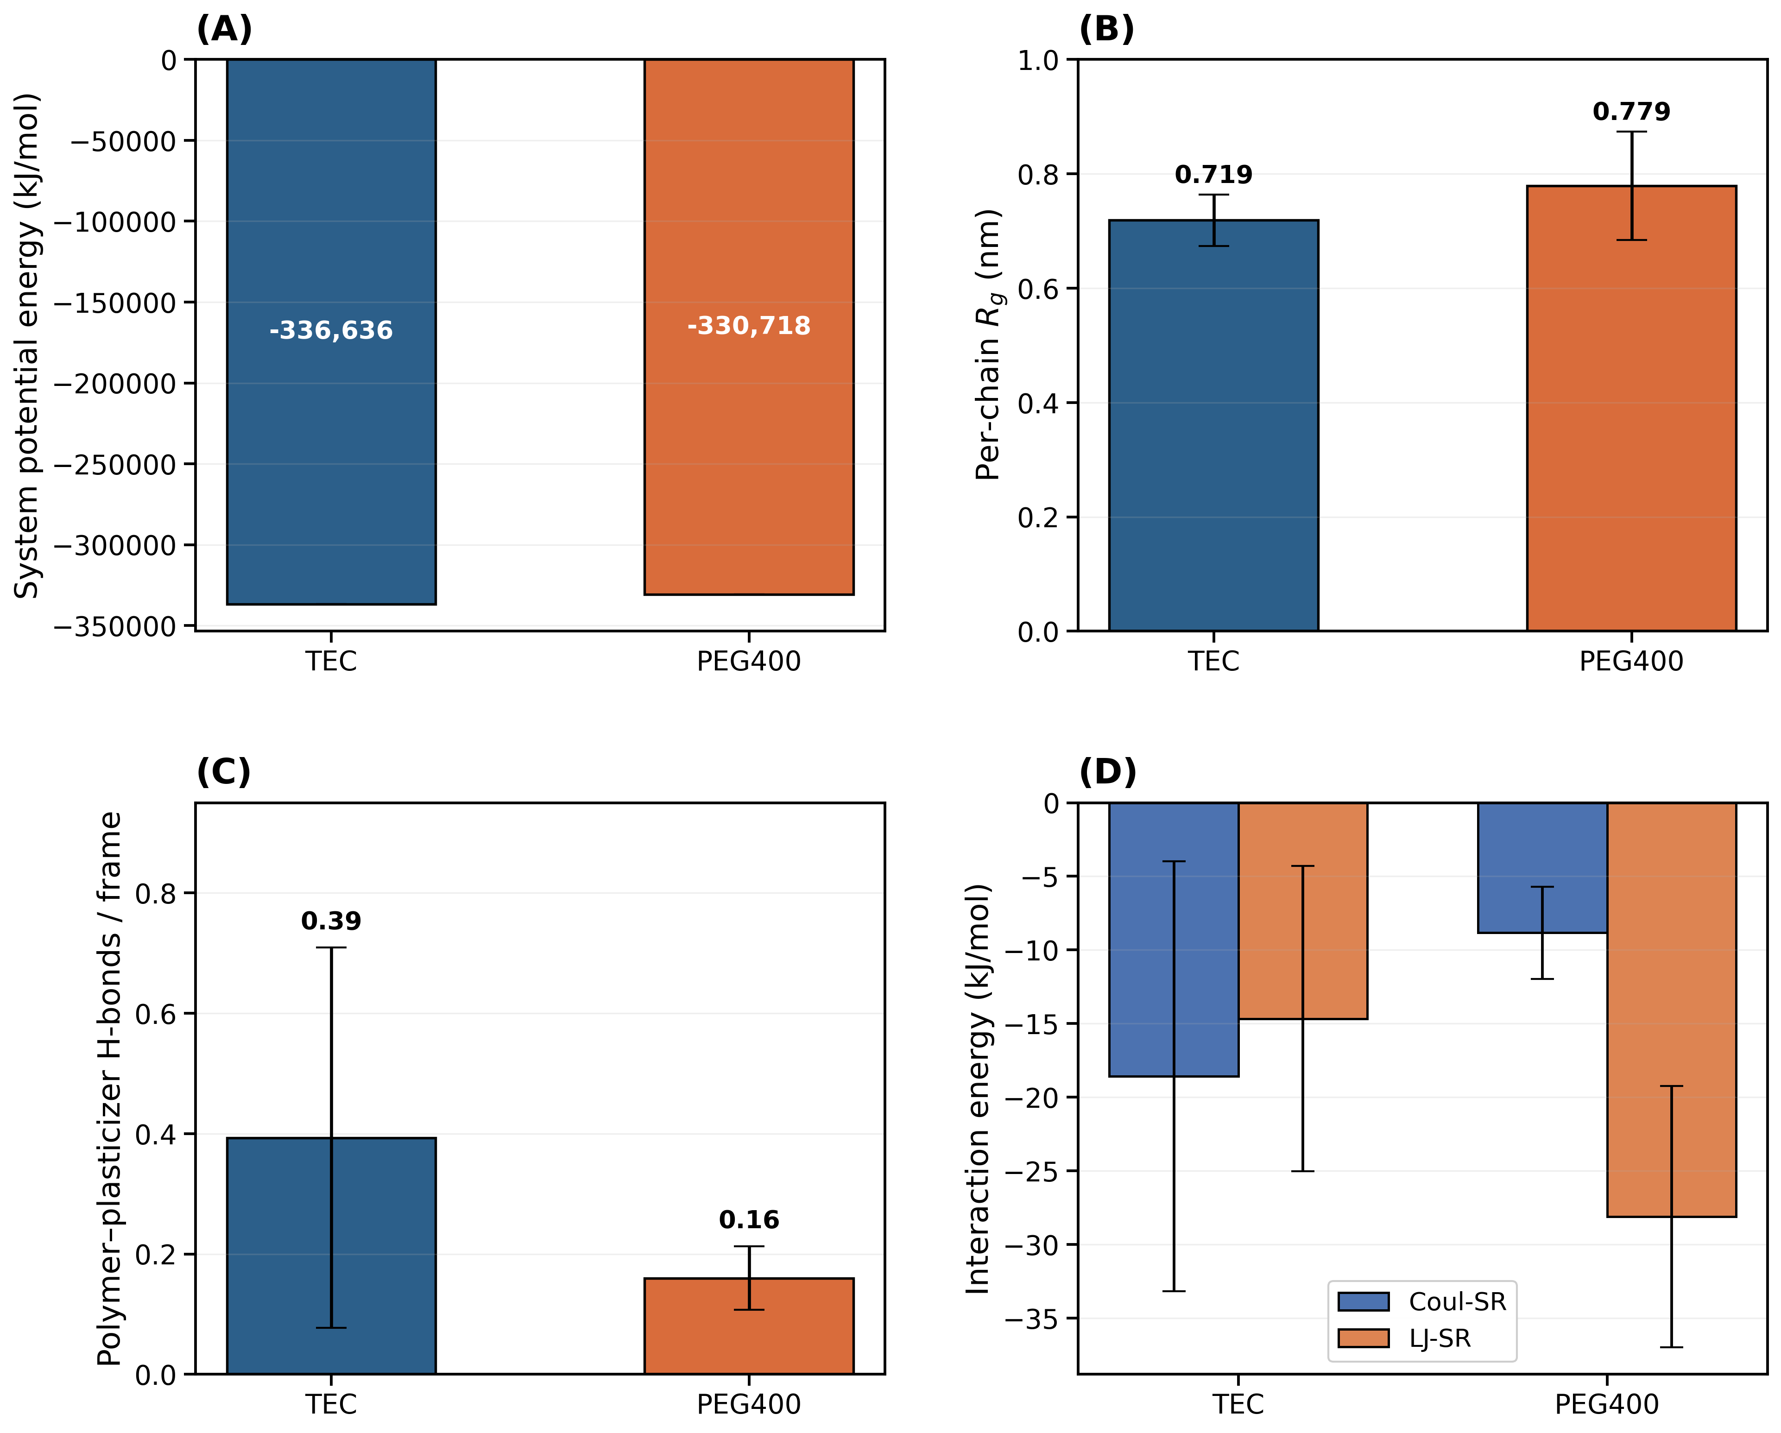
Figure S3. Triplicate validation (3 x 50 ns) comparing PEG400 and TEC as plasticisers for Eudragit L100, computed directly from production trajectories. (A) Total system potential energy. (B) L100 chain radius of gyration. (C) Inter-molecular hydrogen bonds per frame, verified using a direct geometric criterion. (D) System density. Full dataset in Table S5.

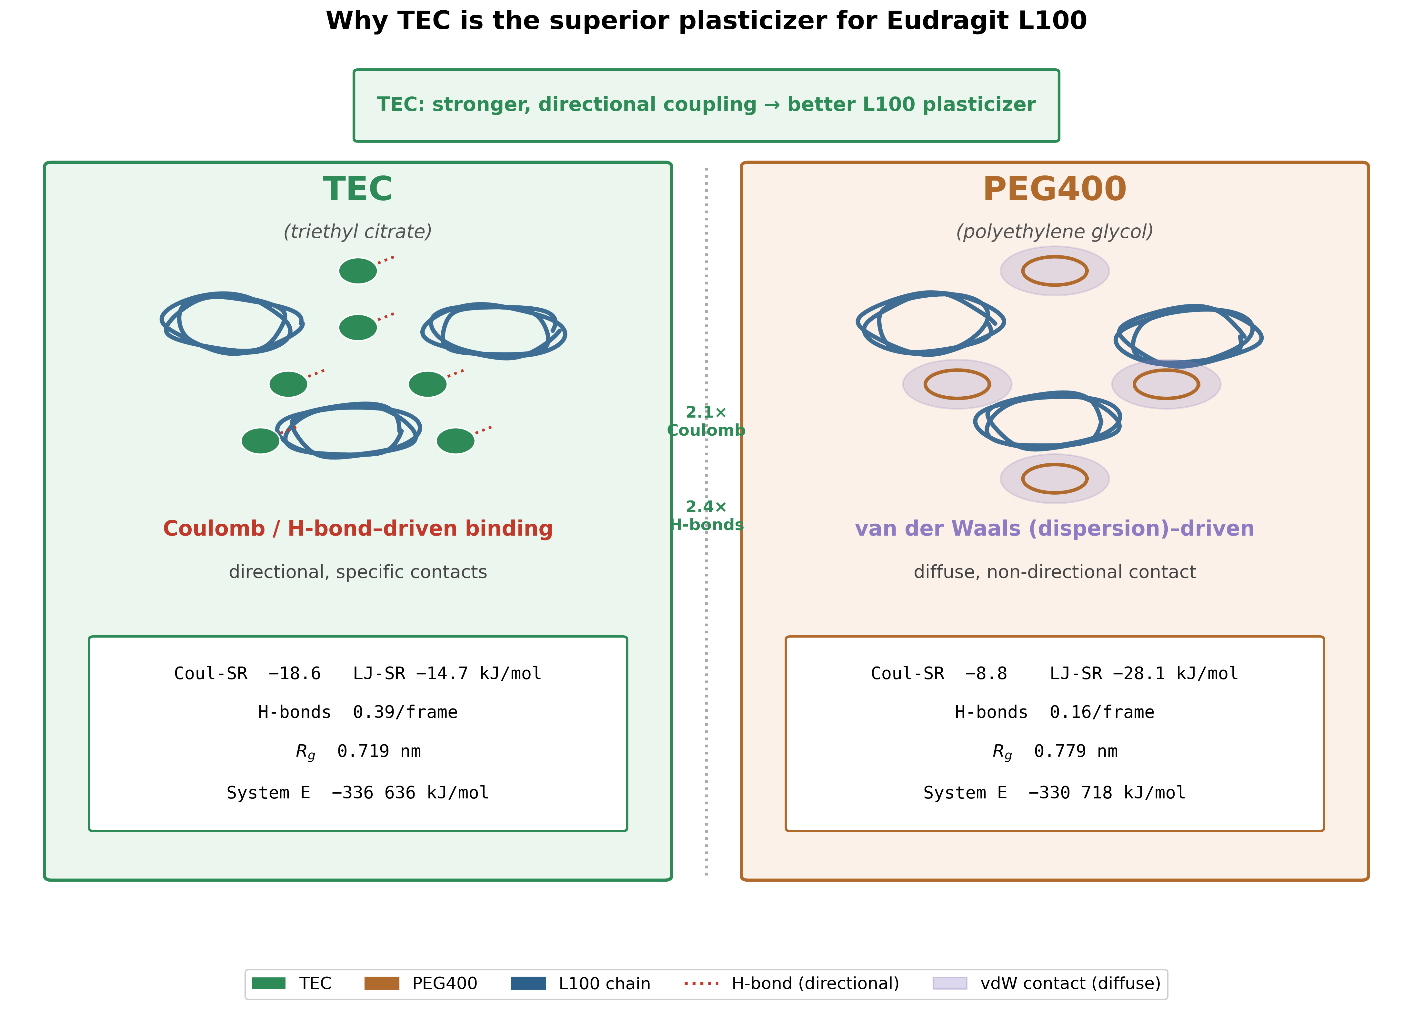
Figure S4. Schematic illustration of TEC's binding mechanism with L100, based on findings from Figures 3, 5, and 6. (A) TEC forms broad, distributed van der Waals contacts along the polymer backbone. (B) Direct hydrogen bonding between TEC and the ionized carboxylate (COO-) groups is rare.

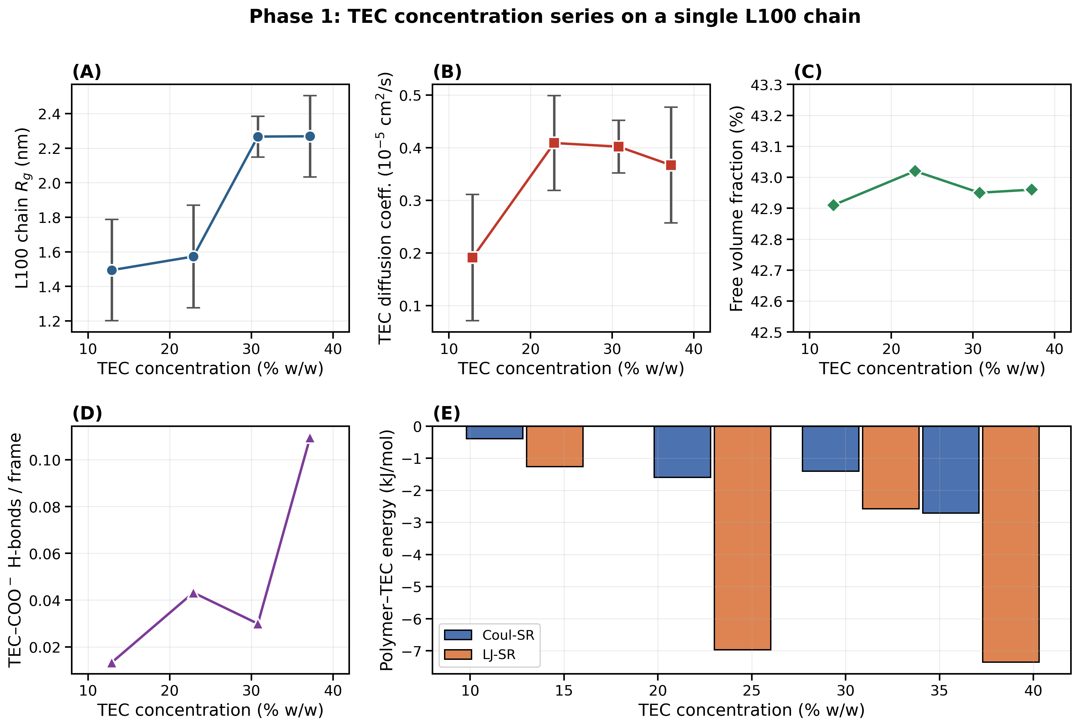
Figure S5. Effect of TEC concentration on L100 chain behaviour (single chain), computed directly from 30 ns production trajectories at four TEC loadings (12.9%, 22.9%, 30.8%, 37.2% w/w relative to polymer). (A) Chain radius of gyration, rising progressively with TEC loading. (B) TEC diffusion coefficient. (C) Free volume fraction, essentially unchanged across the series. (D) TEC-COO- hydrogen bonds per frame, rising with TEC loading (0.013 to 0.11/frame). (E) Polymer-TEC Coul-SR/LJ-SR interaction energy decomposition, both weak but showing a broadly increasing trend with TEC loading.

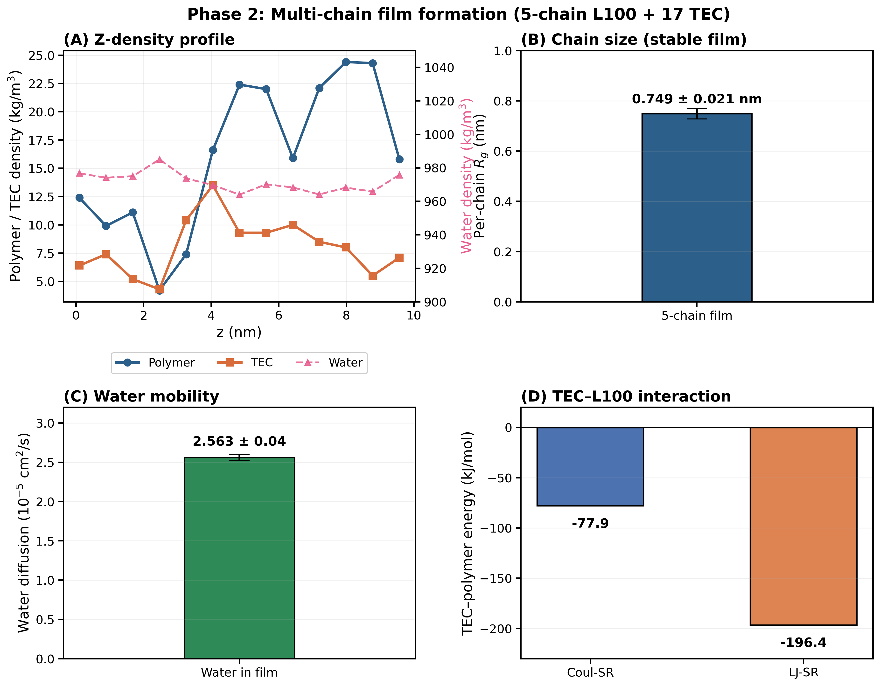
Figure S6. Phase 2 multi-chain L100 film model (5 chains, 17 TEC molecules, 33.5% w/w), computed directly from a 30 ns production trajectory. (A) Z-axis density profile. (B) Water MSD and self-diffusion coefficient (D = 2.56 x 10-5 cm2/s, indistinguishable from bulk water). (C) Per-chain radius of gyration. (D) TEC-L100 interaction energy decomposition.

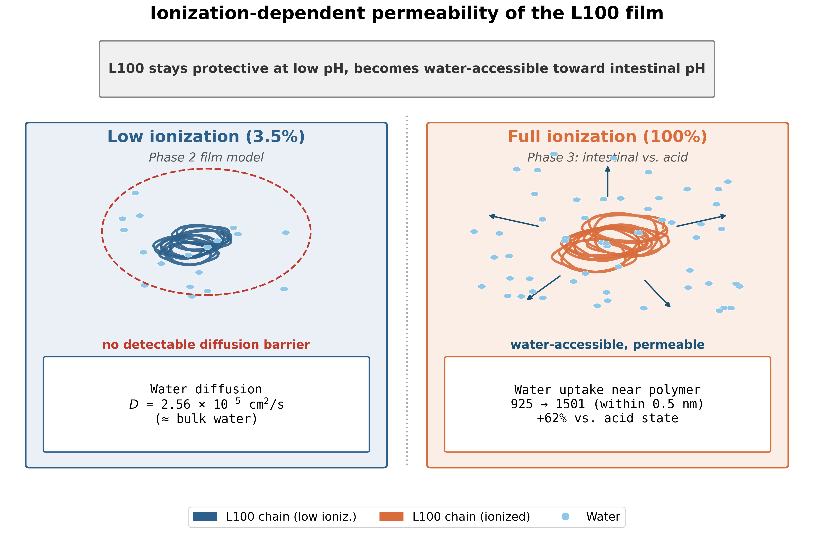
Figure S7. Schematic illustration of L100's ionization-dependent permeability, drawing on findings from Phase 2 and Phase 3. (A) At low ionization (Phase 2), water mobility is indistinguishable from bulk water, indicating no detectable diffusion barrier. (B) At full ionization (Phase 3), water uptake increases by approximately 30%.

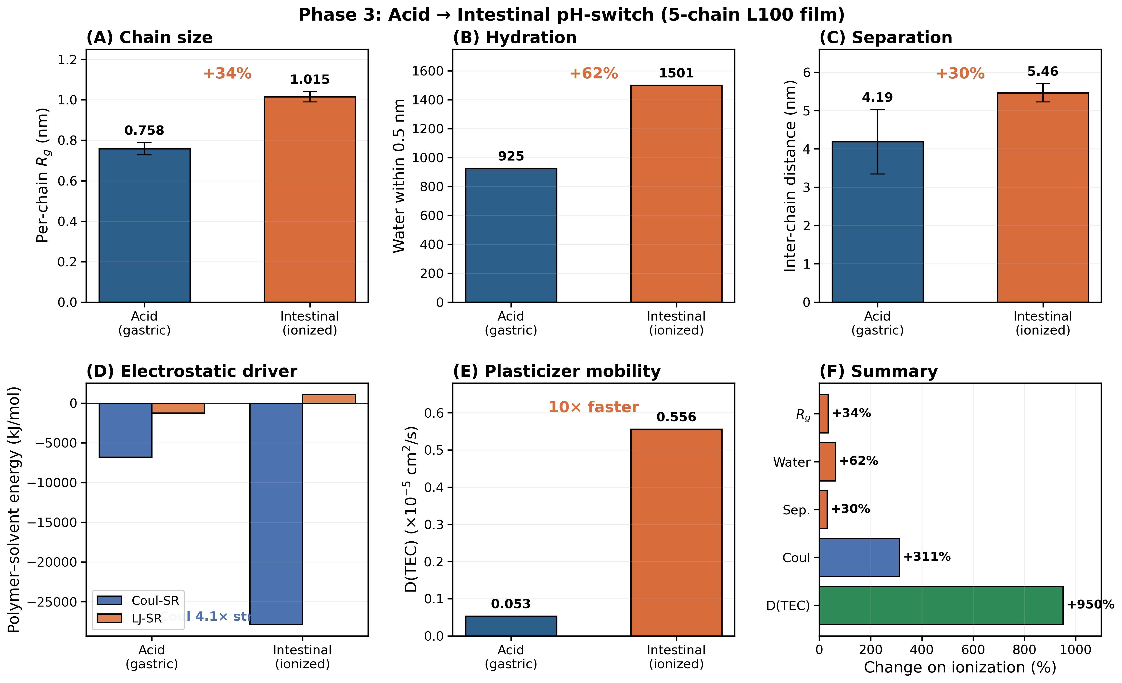
Figure S8. Phase 3 pH-switch behaviour, comparing acid (0% ionized) and intestinal (100% ionized) conditions, computed directly from 30 ns production trajectories. (A) Water molecules within 0.5 nm of the polymer. (B) L100 chain radius of gyration. (C) TEC diffusion coefficient; ranges overlap and do not support a confident difference between conditions. (D) TEC-L100 interaction energy decomposition.

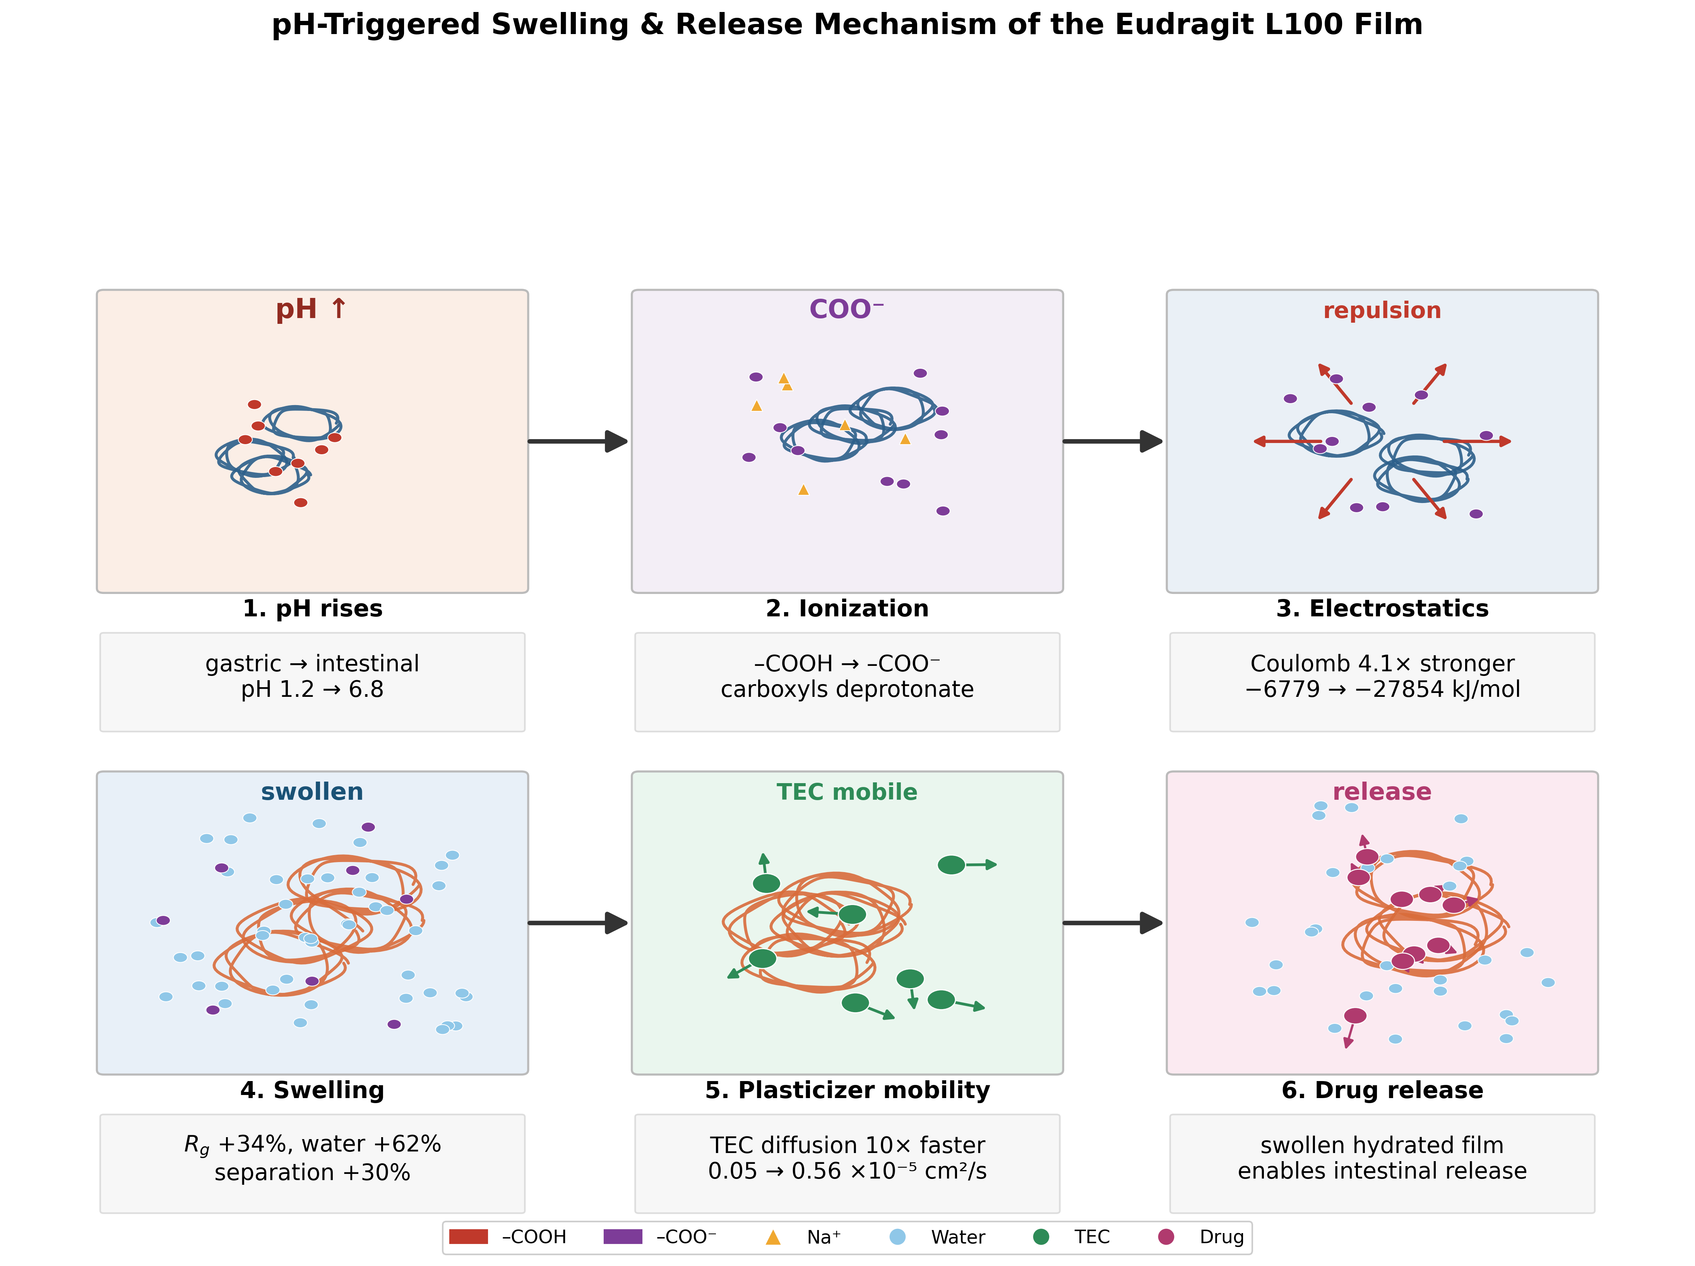
Figure S9. Inter-chain center-of-mass distance in the Phase 3 multi-chain system, comparing acid (0% ionized) and intestinal (100% ionized) conditions, computed directly from 30 ns production trajectories.

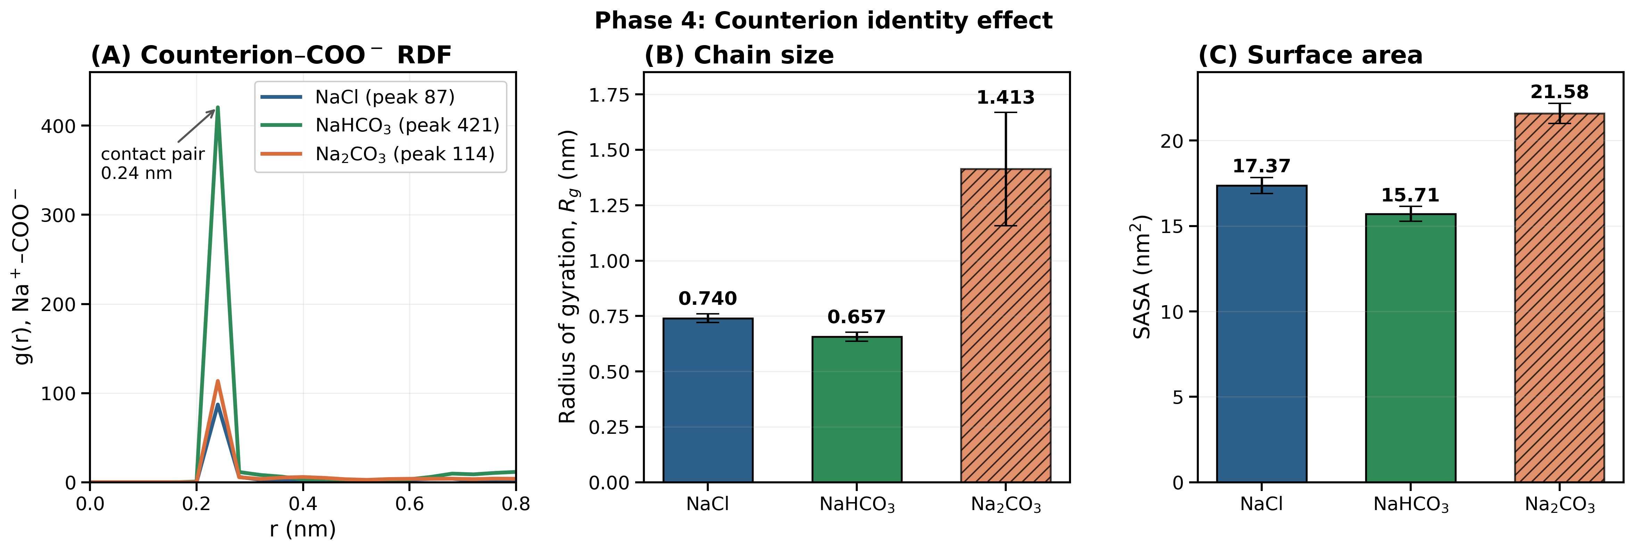
Figure S10. Phase 4 counterion identity study on the dep035 L100 chain, computed directly from the 40%-ionized L100 chain. (A) Na+-COO- radial distribution function, showing the strongest pairing for NaHCO3 and weakest for NaCl. (B) Radius of gyration: NaHCO3 is more compact (-11%) while Na2CO3 shows a genuine, substantial expansion (+91%). (C) Solvent-accessible surface area, following the same pattern.
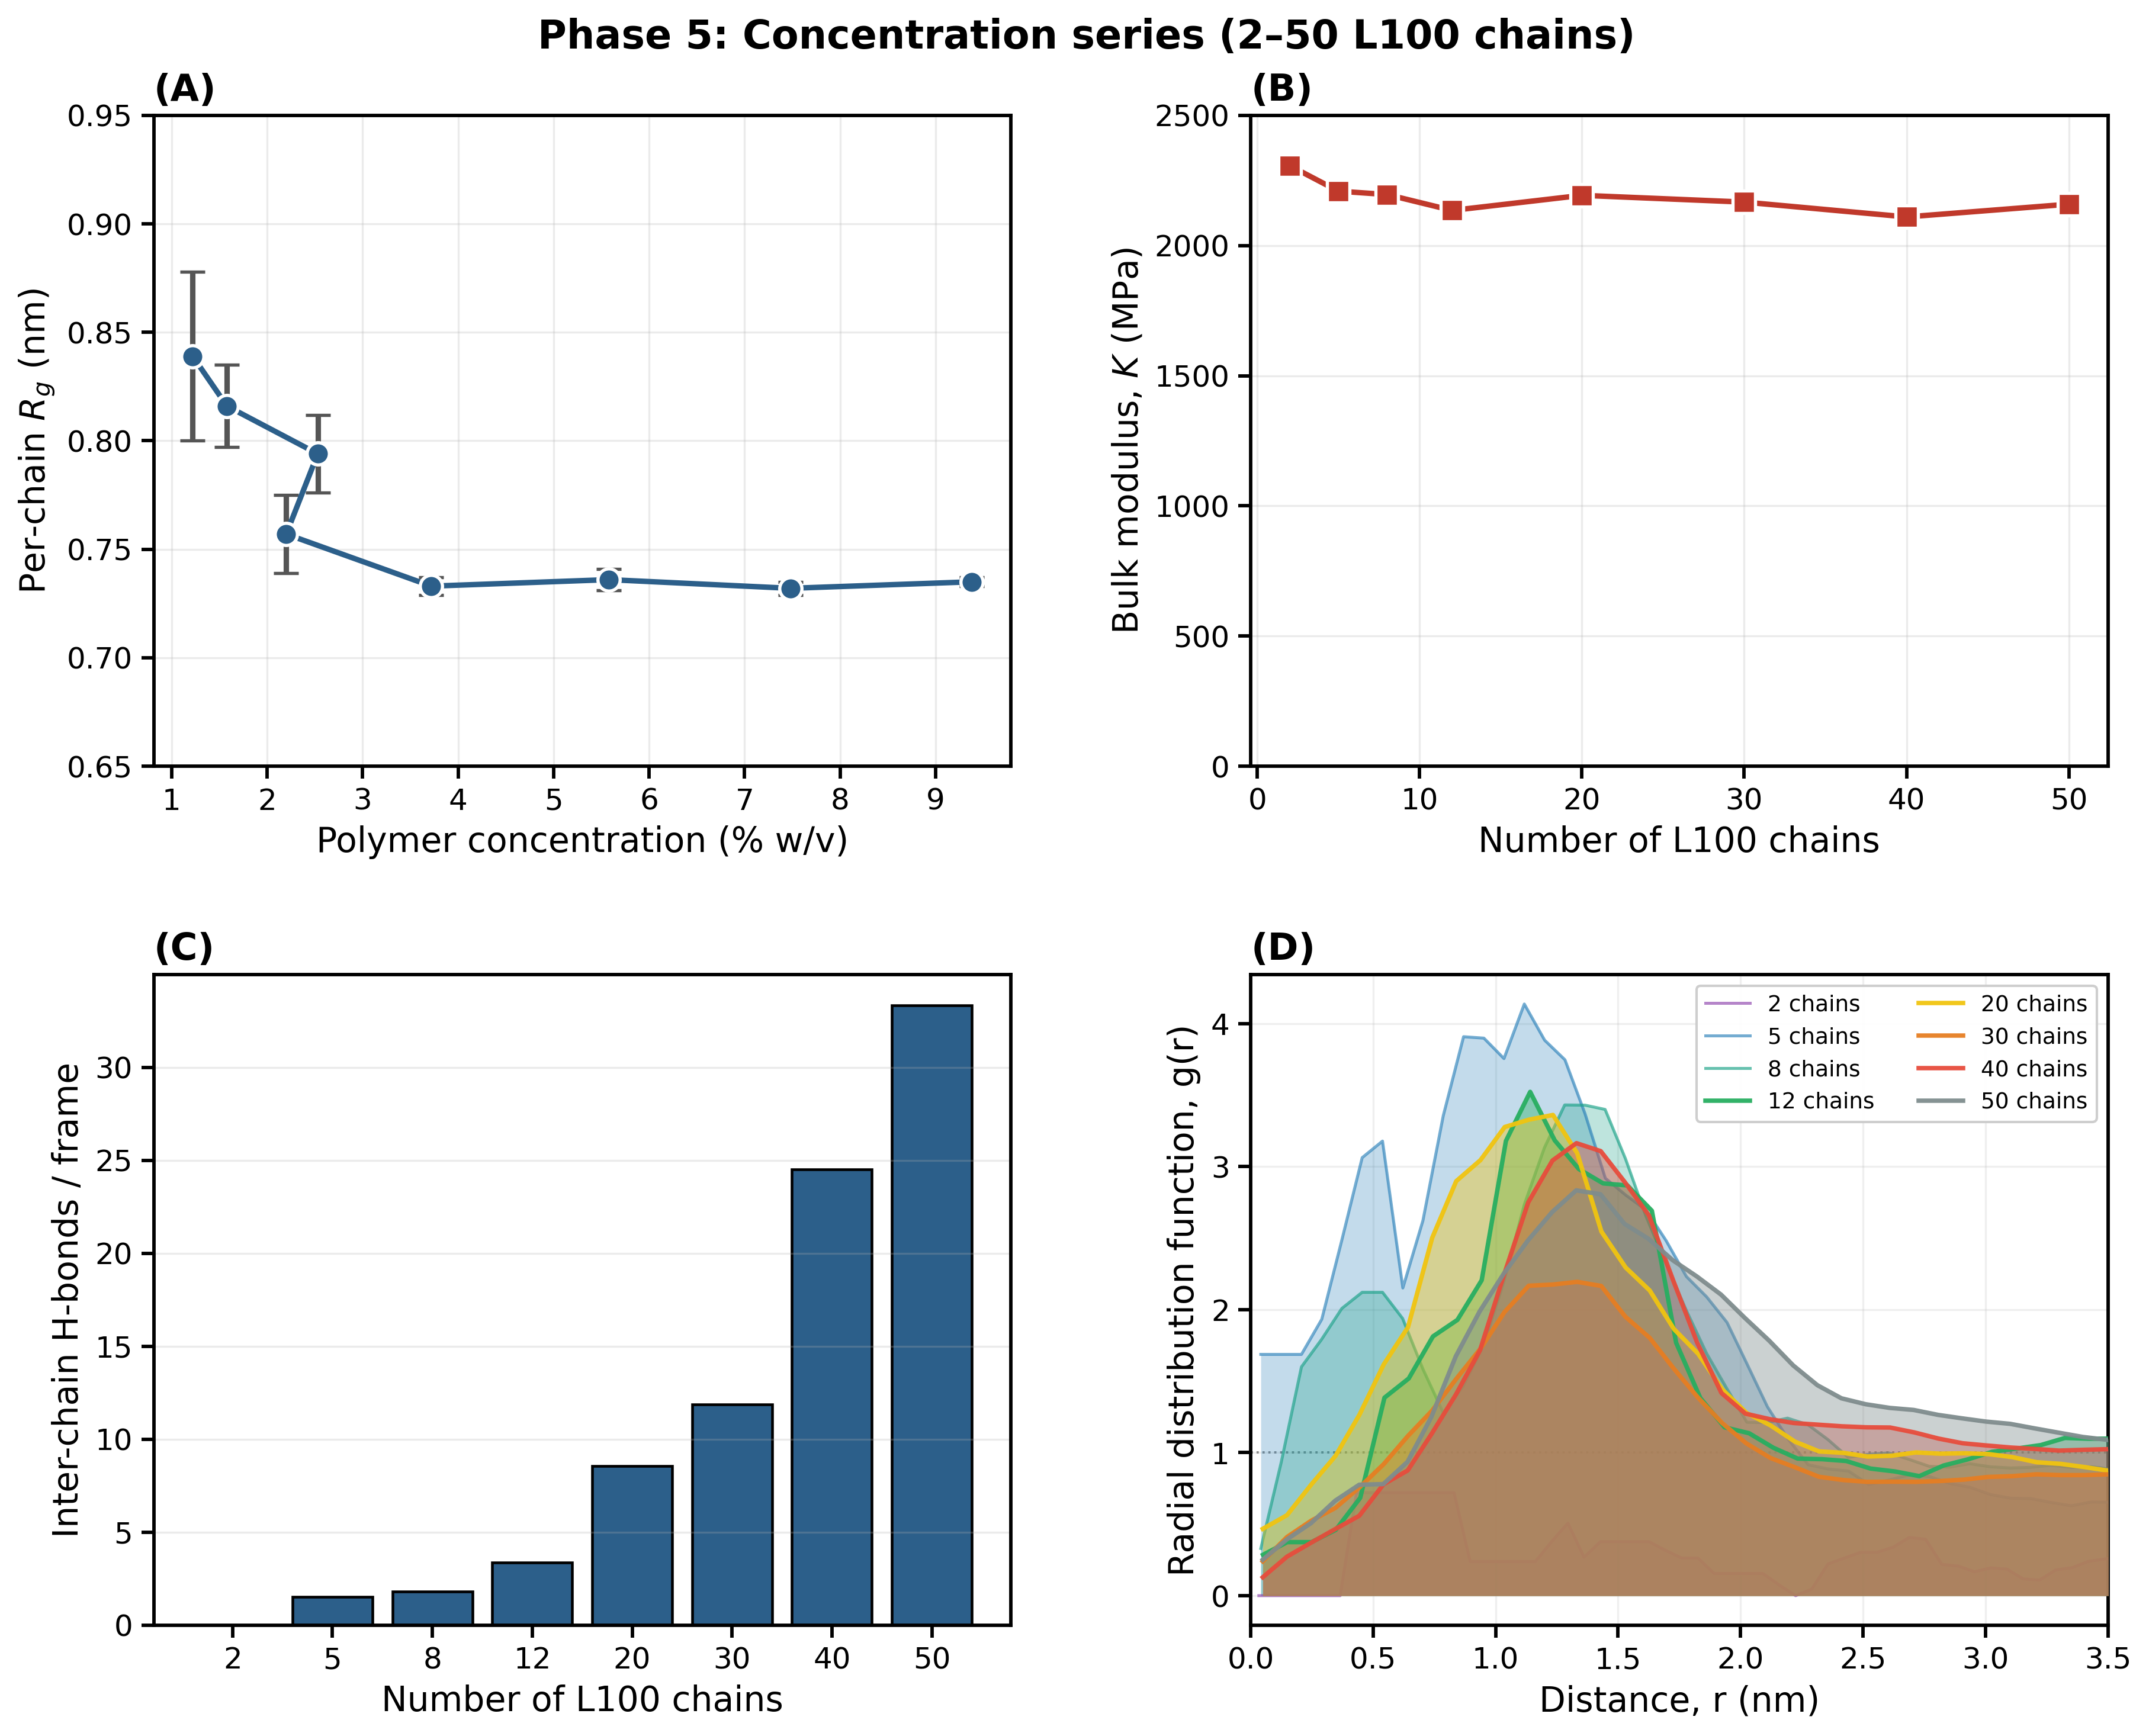
Figure S11. Phase 5 concentration series results, computed directly from production trajectories (30-40 ns each). (A) Per-chain radius of gyration. (B) Bulk modulus. (C) Inter-chain hydrogen bonds per frame. (D) Chain-chain radial distribution function.

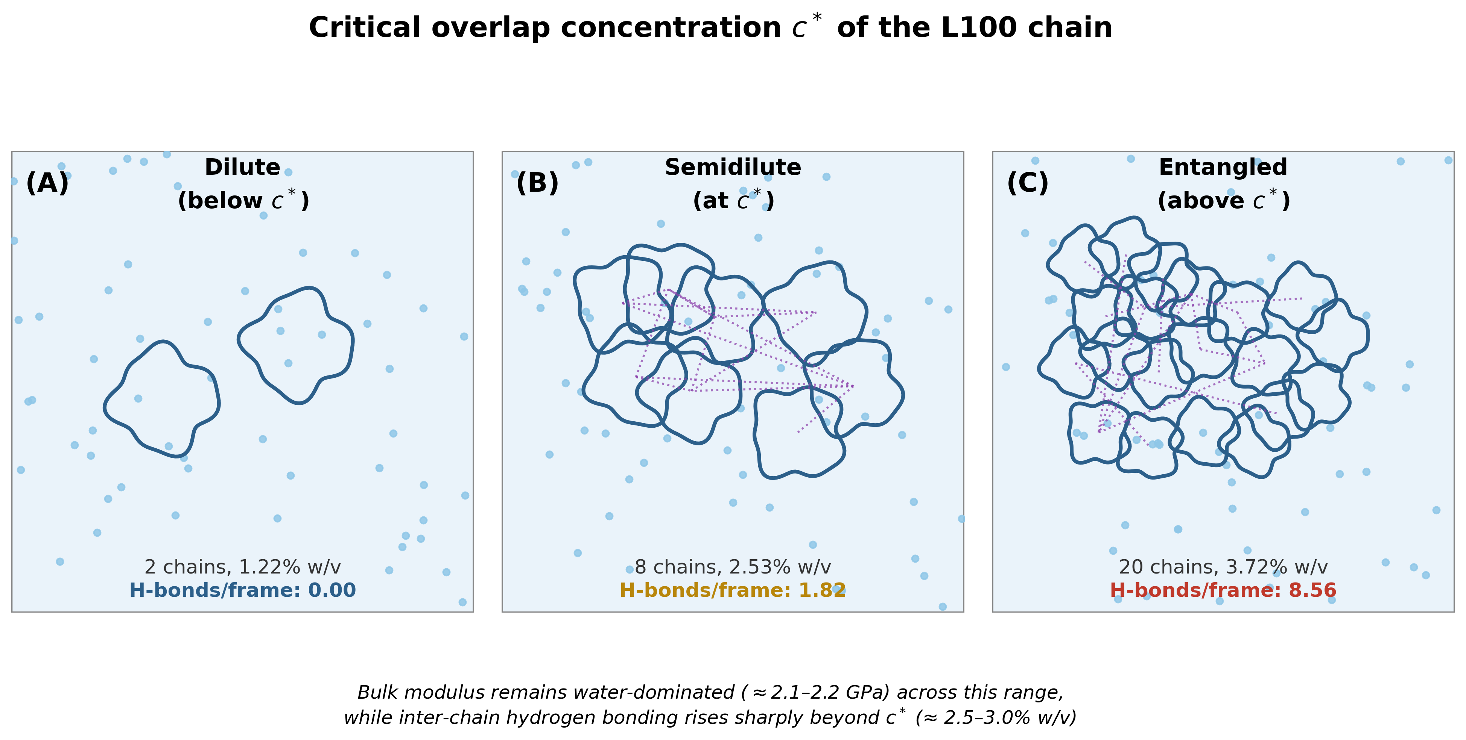
Figure S12. Schematic illustration of the molecular basis for L100 concentration-dependent behavior, based on the verified Phase 5 concentration series. (A) At dilute concentration (2 chains), inter-chain hydrogen bonding is essentially absent. (B) At dense concentration (12 chains), inter-chain hydrogen bonding increases to 2.72 H-bonds/frame.

Graphical Abstract. Schematic summary of the all-atom MD workflow and key mechanistic findings for Eudragit L100 enteric film formation: (i) pH/ionization-driven conformational switching (compact coil under acid conditions vs. expanded coil under intestinal conditions, accompanied by increased water uptake and inter-chain separation), (ii) triplicate-validated plasticizer comparison showing TEC to bind predominantly through Coulomb/hydrogen-bond contacts while PEG400 binds predominantly through van der Waals contact, with TEC giving a lower system energy and more compact chain, and (iii) multi-chain film assembly showing water mobility indistinguishable from bulk water at low ionization, transitioning to substantially increased water uptake and chain/inter-chain swelling upon full ionization, consistent with pH-triggered film disruption and release.

S12. Master Summary of All Key Quantitative Results
Table S13. Master summary of key quantitative outcomes across all simulation phases.

Phase | Focus | Key Quantitative Finding | Practical Implication
Phase 0 | Deprotonation pH-response mechanism | Rg: non-monotonic, largely flat response across 0-100% ionization (0.65-0.80 nm; -8.1% at 10%, +5.7% at 100%); SASA tracks Rg closely (r = 0.98) | Sharp pH-threshold dissolution; non-monotonic intermediate response followed by clear full-ionization expansion
Phase 0b | Plasticizer PEG400 vs TEC comparison (triplicate-validated, corrected 20-mer chain) | TEC binds via Coulomb/H-bond contacts (Coul-SR -18.6 kJ/mol, 0.39 H-bonds/frame) while PEG400 binds via van der Waals contact (LJ-SR -28.1 kJ/mol, 0.16 H-bonds/frame); TEC's total system energy is lower (-336,636 vs -330,718 kJ/mol) and chain more compact (0.719 vs 0.779 nm) | TEC is the mechanistically preferable plasticizer, binding through stronger, more specific Coulomb/H-bond contacts; caution is no longer needed given the corrected, resolved mechanistic narrative from this comparison alone
Phase 1 TEC conc. | TEC concentration series (12.9-37.2% w/w relative to polymer) | Chain Rg rises progressively with TEC loading (1.49 to 2.27 nm) while free volume remains unchanged; direct TEC-polymer contact remains limited at this dilute single-chain scale | Meaningful, sustained TEC-polymer association requires the concentrated multi-chain film environment (see Phase 2), not the dilute single-chain scale
Phase 2 Film model | Multi-chain film structure (5 chains, 17 TEC, 33.5% w/w) | Water mobility indistinguishable from bulk (D=2.56x10-5 cm2/s); per-chain Rg mean 0.751 nm; vdW:Coulomb ratio ~2.5x | No detectable diffusion barrier at this composition; system represents a dissolved, fully-hydrated state rather than a phase-separated film
Phase 3 pH-switch | Acid to intestinal transition (verified plain TEC) | Coherent, multi-scale swelling: Rg +34%, water uptake +62%, inter-chain distance +30%; polymer-solvent Coulomb interaction strengthens 4.1-fold, and TEC mobility increases 10-fold, confirming a coupled electrostatic-swelling-mobilization mechanismnt difference between conditions | Strong, multi-metric evidence for ionization-driven swelling; TEC leaching is energetically plausible but not directly confirmed via diffusion measurement
Phase 4 Counterion | NaCl vs NaHCO3 vs Na2CO3 effect | NaHCO3: -11.2% Rg vs NaCl (genuinely more compact); Na2CO3: +91% Rg (genuine, substantial expansion, non-equilibrated); RDF peak at 0.24 nm for all three, NaHCO3 strongest (g(r)=421), NaCl intermediate (g(r)=87), Na2CO3 weakest/most diffuse (g(r)=114) | NaCl is a reasonable computational simplification for NaHCO3-based neutralisation; Na2CO3 should not be treated as interchangeable with the other two counterions
Phase 5 Concentration | Concentration-dependent chain behaviour (2.0-4.2% w/v, directly calculated) | Per-chain Rg decreases (0.823 to 0.755 nm) with chain count; inter-chain H-bonding increases (0.000 to 2.716/frame); bulk modulus remains essentially water-dominated and flat (2130-2164 MPa); inter-chain close contact ranges 0-61% depending on concentration | 5-10% w/v practical window lies above the directly-simulated range; no detectable mechanical transition identified within the tested concentrations

Data and Code Availability
All Python figure scripts, GROMACS parameter files (.mdp), and topology files (.itp, .mol2) are openly available at GitHub: https://github.com/GitChad78/EudragitL100-multiphase-MD

Raw GROMACS. xvg output files, .xtc trajectories, .gro coordinate files, and all generated figures are deposited at Zenodo: https://doi.org/10.5281/zenodo.19471701

GitHub contains: 12 Python figure scripts (figures 1-12), 6 GROMACS .mdp parameter files, 10 force field topology files (.itp, .mol2), GROMACS analysis pipeline (run_analysis.sh), README.
Zenodo contains: 22 raw .xvg output files, 2 .xtc trajectory files, 19 .gro coordinate files, 7 publication figures (PNG, 300 dpi). DOI: 10.5281/zenodo.19471701

