MADHAV INSTITUTE OF TECHNOLOGY & SCIENCE, GWALIOR
(Deemed to be University)

CORNERSTONE PROJECT
PROJECT SYNOPSIS

“AI Chatbot for Academic and College Information Services”

Submitted by
S. No. | Student Name | Enrollment No.
1 | Shahid Khan | BTIT24O1124
2 | Vaibhav Bansal | BTIT25O3D06

Under the Guidance of
Dr./Mr./Ms. ______________________________
Designation: ______________________________
School of _____________________________

School of _____________________________
Madhav Institute of Technology & Science, Gwalior
Academic Session: 2026–27

1. Introduction
Every semester, students of our department keep asking the same kind of questions: when do the mid-sem exams start, where is the 5th semester syllabus, who is teaching which subject, what is this week's time table. Most of this information is already published on the IT department's section of the MITS website. The problem is that it is spread across many pages, PDF files and even Google Drive links, so finding one small detail means opening several links and scrolling through long PDFs. Many students give up and ask a faculty member or a senior instead, which takes their time as well.
In the last few years, large language models (LLMs) like ChatGPT and Gemini have become very good at understanding questions typed in normal language, including Hinglish. But if we directly ask them something about our college, they either do not know it or make up an answer that sounds correct but is wrong. This is called hallucination, and for things like exam dates or rules it can actually mislead a student.
Our project combines the two ideas. We are building a chatbot that first searches the official department content and then uses an LLM only to write the answer from what it found. This method is called Retrieval-Augmented Generation (RAG). Every answer also shows the page or PDF it came from, so the student can open it and check for themselves.
The system is written in Python. A web crawler (requests + BeautifulSoup) collects the IT department pages and the PDFs linked from them, pypdf extracts text from PDFs, the sentence-transformers model all-MiniLM-L6-v2 converts text into embeddings, and FAISS stores them for fast similarity search. A Flask server provides the chat page for students and an admin page for staff. For writing the final answer, the system can use Gemini, OpenAI or Claude through their APIs, or a free local model through Ollama.
Our motivation is simple: we are students of this department and we face this problem ourselves, so we wanted to build something we would actually use.

2. Problem Statement
Students do not have a quick and reliable way to get answers to routine academic questions about their department. The information exists, but it is scattered and hard to search. The current ways of getting it have clear limitations:
- Department website: information is available but spread over many pages and PDFs, and there is no search that looks inside the PDFs.
- Asking faculty or the office: only possible during college hours, and staff answer the same questions again and again.
- WhatsApp groups: messages get buried, and sometimes old or wrong information gets forwarded.
- General chatbots (ChatGPT etc.): they have no knowledge of our college's documents, may give a confident but wrong answer, and do not show any source.
- Rule-based FAQ bots: every question and answer has to be written by hand, they fail when a question is phrased differently, and someone has to keep updating them.
So there is a need for a system that answers only from official college content, understands questions written in plain English, Hindi or Hinglish, always shows where the answer came from, and is easy to keep up to date when the college updates its information.

3. Objectives
- To design and develop an AI-based chatbot system that answers academic and department-related questions for students of the IT department, MITS Gwalior.
- To implement document search using Retrieval-Augmented Generation (RAG) with sentence embeddings and a FAISS vector index.
- To improve the accuracy and trustworthiness of answers by answering only from official college content and showing the source of every answer.
- To provide a simple web chat interface for students and an admin panel for staff to upload documents and view usage.
- To evaluate the proposed system using retrieval accuracy, answer correctness, source correctness and response time parameters.

4. Scope of the Project
- Target users: students of the IT department (main users) and faculty/office staff (admin users who manage documents).
- Functional scope: collecting the IT department section of the MITS website along with linked PDFs; answering questions in English, Hindi or Hinglish; showing the source for every answer; letting admins upload or remove extra documents (PDF, Word, text); showing basic usage statistics.
- Technical scope: Python based, runs on a normal laptop without a GPU. The embedding model and vector search run locally; only the final answer writing uses an LLM, which can be a cloud API or a local model.
- Application area: a help desk for the college. Since the crawler's domain and path are set in one config file, the same system can be pointed at any other department.
- Limitations: answers can only be as good and as current as the content on the website and uploaded files. No connection to ERP, attendance or results. Text only, no voice. Scanned PDFs (images of text) cannot be read yet because there is no OCR.
- Future extensions: covering all departments, OCR for scanned notices, a multilingual embedding model for better Hindi search, automatic weekly re-crawling, a WhatsApp/Telegram version, and student login with personal chat history.

5. Existing System / Literature Survey
Most colleges today depend on their website, notice boards and ERP portals to share information. Some have added FAQ chatbots built with tools like Dialogflow or AIML, where answers are written by hand for each expected question. General-purpose AI chatbots are now common, but they are not connected to a particular college's documents. The papers and tools below shaped our approach.
S. No. | Author/Source | Year | Existing Method/System | Key Finding | Limitation
1 | Ranoliya, Raghuwanshi & Singh [4] | 2017 | University FAQ chatbot using AIML and Latent Semantic Analysis | Pattern matching with LSA can answer common questions about a university | Answers must be written by hand; new questions need manual updates
2 | Lewis et al. [1] | 2020 | Retrieval-Augmented Generation (RAG) | Fetching relevant passages before generating gives more factual answers than the model alone | If the retriever misses the right passage, the answer is wrong
3 | Reimers & Gurevych [2] | 2019 | Sentence-BERT sentence embeddings | Sentences with similar meaning get close vectors, which allows fast semantic search | Base models are mostly English; mixed-language text is weaker
4 | Johnson, Douze & Jégou [3] | 2021 | FAISS similarity search library | Can search millions of vectors quickly on ordinary hardware | Stores only vectors; text and metadata must be kept separately
5 | Ji et al. [5] | 2023 | Survey of hallucination in language generation | LLMs often produce fluent but false text; grounding in sources is a main fix | Grounding reduces but does not fully remove hallucination

6. Proposed System
The proposed system is a RAG-based chatbot made of two parts: an offline pipeline that collects and prepares the department's content, and an online part that answers student questions through a web page. It has the following modules:
- Web Crawler: starts from the IT department page and follows only links inside the department section and its sidebar menu. It never leaves web.mitsgwalior.in, visits every URL only once (so link loops cannot cause an endless crawl), respects robots.txt and saves every page and linked file (PDF, images, public Google Drive files) along with a manifest.
- Document Processing: removes menus, scripts and footers from HTML, extracts text from PDFs and Word files, and splits everything into chunks of about 1000 characters with 150 characters of overlap.
- Embedding & Indexing: converts each chunk into a 384-dimension vector using all-MiniLM-L6-v2 and stores all vectors in a FAISS index.
- Retrieval & Answer Generation: converts the student's question into a vector, finds the 5 most similar chunks by cosine similarity, and sends them with the question to the LLM. The prompt tells the model to answer only from this context, cite sources, say so if the answer is not there, and reply in the student's own language.
- Chat Interface: a WhatsApp-style chat page that shows the answer with source tags linking to the original page or PDF, and a typing indicator while the answer is being prepared.
- Admin Panel: shows everything indexed, lets staff upload or remove documents (protected by an admin password) and rebuilds the index automatically. Also shows total questions, average response time, most referenced sources and recent questions.
- Chat Log: every question, answer, cited sources and response time is saved in SQLite for review and evaluation.
Inputs: department web pages, linked PDFs, documents uploaded by staff, and the student's question. Outputs: a short answer with its source links, and usage statistics for staff.
Expected improvement: students get an answer in a few seconds at any time instead of searching through many pages, answers can be verified through the source link, and faculty get fewer repeated questions.

Proposed Architecture / Block Diagram
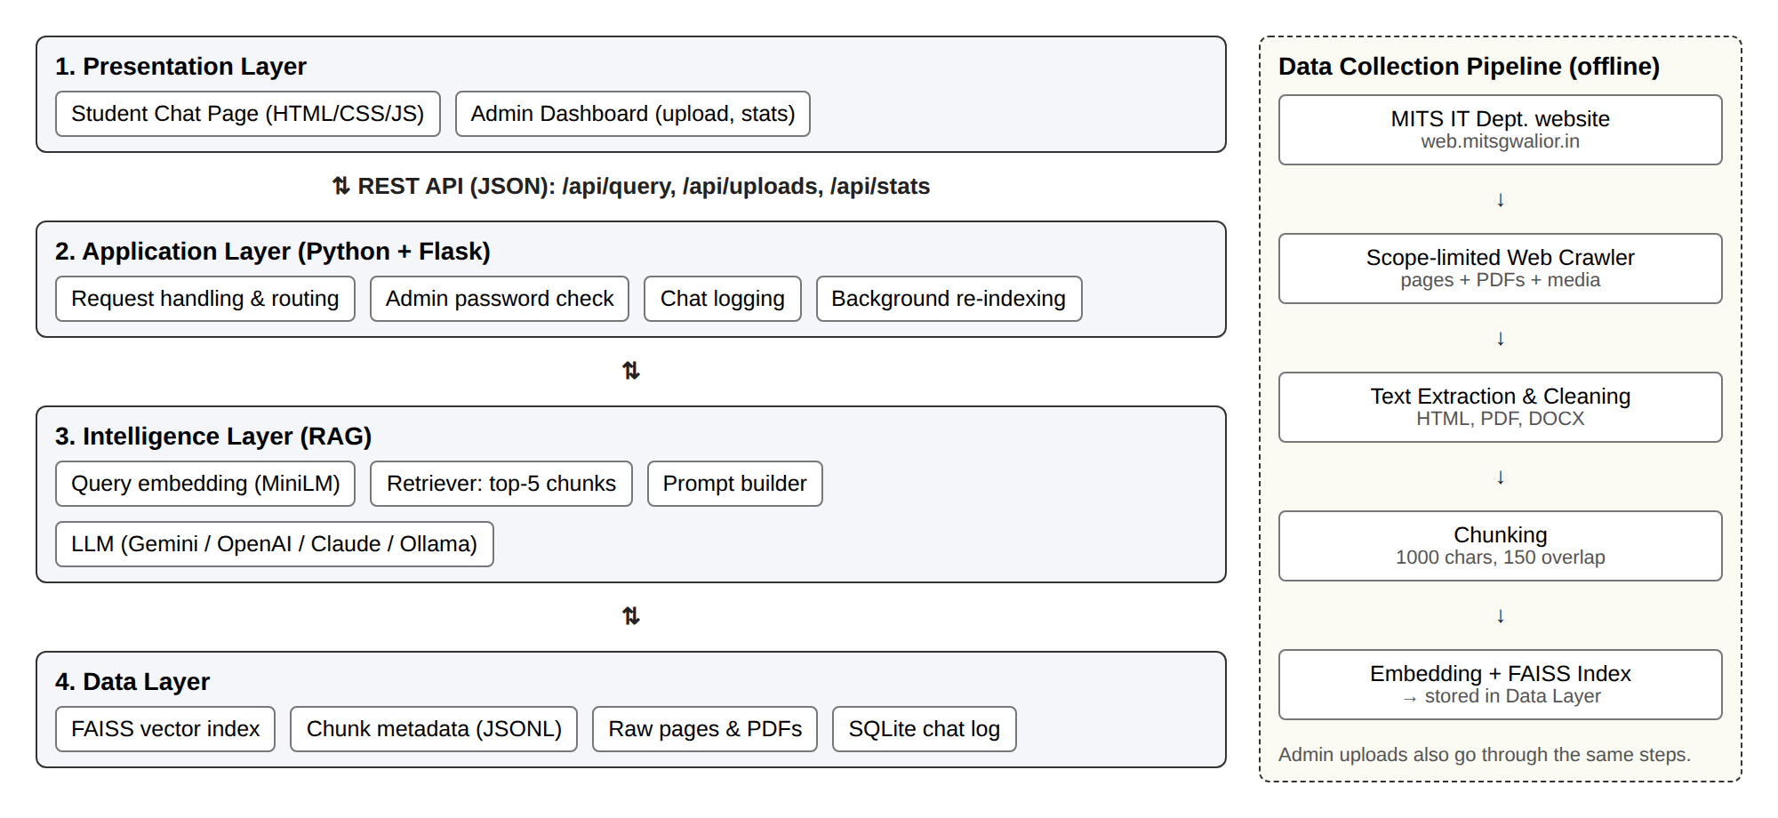
Figure 1: Proposed system architecture

7. Methodology
- Requirement Analysis: listed what students ask most often and wrote down functional and non-functional requirements (Milestone 1).
- Data Collection / Dataset Preparation: built a crawler that collects the IT department pages and every PDF, image and Drive file linked from them, with a manifest recording where each item came from.
- Preprocessing: cleaned HTML (removed menus, scripts, footers), extracted PDF and Word text, and split it into overlapping chunks.
- System Design: designed a four-layer architecture (presentation, application, intelligence, data), the query flow and the modules (Milestone 2).
- Algorithm / Model Development: used a pre-trained sentence embedding model with FAISS cosine similarity search for retrieval, and prompt design so the LLM answers only from the retrieved text.
- Implementation: Python modules for crawler, ingestion, indexing and RAG pipeline; Flask REST API; HTML/JavaScript chat and admin pages.
- Testing: automated unit tests with pytest plus manual testing of the chat and admin flows.
- Performance Evaluation: measure answer correctness, retrieval accuracy and response time on a prepared set of test questions.

8. Hardware and Software Requirements

Hardware Requirements
Component | Specification
Processor | Intel Core i3 / i5 or equivalent (no GPU needed)
RAM | 8 GB recommended (4 GB minimum)
Storage | About 5 GB free (Python packages, embedding model, scraped PDFs, index)
Microcontroller / Hardware | Not applicable
Sensors / Other Components | Not applicable

Software Requirements
Software / Technology | Version / Details
Operating System | Windows 10/11 or Ubuntu 22.04
Programming Language | Python 3.10+, HTML, CSS, JavaScript
Framework | Flask 3 (backend and web pages)
Database | FAISS (vector index), SQLite (chat log)
IDE / Tools | VS Code, Git & GitHub, uv (package manager)
Libraries | requests, BeautifulSoup4, lxml, pypdf, sentence-transformers, faiss-cpu, numpy, pytest
AI Models | all-MiniLM-L6-v2 (embeddings); LLM: Gemini / OpenAI / Claude API or local model via Ollama

9. Expected Outcomes
- Working web-based chatbot for the IT department that answers with sources
- Searchable index of the department's web pages and PDFs
- Admin panel to upload/remove documents and view usage statistics
- Evaluation results on a set of real student questions
- Project report, presentation and source code on GitHub

10. Testing and Evaluation
- Unit testing: 16 automated tests (pytest) check that the crawler never leaves the department's scope, never visits a page twice even when pages link in a loop, extracts and chunks text correctly, indexes uploaded files, and that the web API handles questions, uploads and wrong passwords properly. The model and network are replaced by fakes in these tests, so they run offline in under a second.
- Functional testing: asking questions through the chat page and checking answers and source links; uploading and removing documents from the admin page.
- Evaluation set: we are preparing a set of about 50 questions (English and Hinglish) whose answers we know from the department website, plus some questions that are outside the website's content.
Evaluation parameters:
- Retrieval accuracy (Hit@5): the percentage of questions where the correct chunk is among the top 5 retrieved.
- Answer correctness: each answer marked correct, partly correct or wrong by us.
- Source correctness: whether the cited page/PDF actually contains the answer.
- Refusal behaviour: for out-of-scope questions, the bot should say it does not know instead of guessing.
- Response time: logged automatically for every question; target is under 5 seconds.

11. Project Timeline
Activity | Week 1–2 | Week 3–4 | Week 5–6 | Week 7–8 | Week 9–10
Problem Identification | ✓
Literature Survey | ✓ | ✓
Requirement Analysis |  | ✓
System Design |  | ✓ | ✓
Implementation |  |  | ✓ | ✓
Testing |  |  |  | ✓
Documentation / PPT |  |  |  |  | ✓
Current status: requirement analysis, system design and most of the implementation (crawler, processing, RAG pipeline, chat page and admin panel) are complete. Evaluation on the test question set and final documentation are in progress.

12. Team Member Contribution
Student | Enrollment No. | Assigned Responsibility
Shahid Khan | BTIT24O1124 | Requirement analysis, literature survey, chat and admin UI design, testing, documentation
Vaibhav Bansal | BTIT25O3D06 | Web crawler, document processing, RAG pipeline (embeddings, FAISS, LLM), backend API

13. References
[1] P. Lewis et al., "Retrieval-augmented generation for knowledge-intensive NLP tasks," in Advances in Neural Information Processing Systems (NeurIPS), vol. 33, 2020, pp. 9459–9474.
[2] N. Reimers and I. Gurevych, "Sentence-BERT: Sentence embeddings using Siamese BERT-networks," in Proc. EMNLP-IJCNLP, 2019, pp. 3982–3992.
[3] J. Johnson, M. Douze, and H. Jégou, "Billion-scale similarity search with GPUs," IEEE Transactions on Big Data, vol. 7, no. 3, pp. 535–547, 2021.
[4] B. R. Ranoliya, N. Raghuwanshi, and S. Singh, "Chatbot for university related FAQs," in Proc. Int. Conf. on Advances in Computing, Communications and Informatics (ICACCI), 2017, pp. 1525–1530.
[5] Z. Ji et al., "Survey of hallucination in natural language generation," ACM Computing Surveys, vol. 55, no. 12, pp. 1–38, 2023.
[6] W. Wang et al., "MiniLM: Deep self-attention distillation for task-agnostic compression of pre-trained transformers," in Advances in Neural Information Processing Systems (NeurIPS), vol. 33, 2020, pp. 5776–5788.
[7] Department of Information Technology, Madhav Institute of Technology & Science, Gwalior. [Online]. Available: https://web.mitsgwalior.in/academics/departments/information-technology

Mentor Approval
The synopsis has been reviewed and approved for Cornerstone Project Minor Evaluation.
Student Signatures: ______________________________
Project Mentor: __________________________________
Date: __________________

