Cauvery Basin Water Allocation
LSTM rainfall and reservoir forecasting with seven strategies for sharing water in Karnataka
Vaibhav Bhatia · Independent project · October 2026
Abstract. Rainfall over the Cauvery basin swings sharply from day to day, while reservoir storage changes slowly. I built one traceable pipeline that handles both and then asks the decision question: when there is not enough water, who should be cut, and by how much? A single PyTorch LSTM, shared across twelve Western Ghats and Mysuru towns through a site embedding, forecasts daily rainfall from Open-Meteo ERA5 and ECMWF IFS data. Town forecasts are averaged into four catchments (Harangi, Hemavathi, KRS and Kabini). Four Keras LSTMs then predict the next-day change in gross storage from thirty days of storage, inflow, outflow, rainfall and season, and the change is added to today's storage. Results are mixed and reported honestly: Hemavathi and KRS beat persistence on MAE and RMSE, Harangi is marginally worse and Kabini is much worse, despite every model having R² above 0.96. The latest combined forecast, 56.10 TMC, is used as an availability proxy and compared with a configurable 30-day demand of 28.49 TMC for Bengaluru, other towns, a minimum river flow and agriculture. Because the forecast case has no shortage, I stress-test seven allocation strategies (essential priority, proportional, minimum guarantee, weighted cuts, equal cuts, a KKT-derived optimised rule and drought hedging) at 75% and 50% supply. Every rule redistributes the same shortfall, except hedging, which deliberately accepts a larger deficit to keep a reserve.
Keywords: Cauvery basin, LSTM, rainfall forecasting, reservoir storage, water demand, water allocation, bankruptcy rules, hedging.

1. Introduction
Rain does not fall evenly over the Karnataka part of the Cauvery basin. The Western Ghats receive very heavy monsoon rain while the eastern side stays much drier, and the effect reaches each reservoir with a delay. Rainfall, inflow, releases and previous storage form one connected sequence, which is why I treated Harangi, Hemavathi, Krishnaraja Sagara (KRS) and Kabini as parts of one system instead of four separate spreadsheets. LSTMs are a natural fit for this kind of memory, although published work shows they can struggle with extremes and with changes in climate behaviour [1]–[8].
I kept forecasting and decision-making strictly separate. The forecasting part predicts rain and next-day storage; it does not say how the water should be used. The allocation part takes one availability number and asks what seven different sharing rules would do with it. This is a modelling exercise, not an interpretation of Cauvery law or advice for reservoir operators. The scope is Bengaluru, other domestic use in the basin, a minimum environmental flow and agriculture.
The main contribution is a complete, auditable path from raw data to an allocation table: strictly chronological splits, scalers fitted only on training data, simple baselines for every model, and every demand assumption stated in one place rather than hidden in code.

2. Related Work
LSTM memory has been used for regional rainfall prediction [1] and for rainfall–runoff modelling that competes with conceptual hydrological models [2]. Sequence-to-sequence designs [3] and multi-timescale networks [4] address how far back a network should remember. Large benchmarks show deep learning is not always better than conceptual models [5], that average skill can hide poor performance on floods [6], and that uncertainty estimates matter [7]; hydrological understanding should complement machine learning rather than be replaced by it [8].
For reservoirs, decomposition-ensemble LSTMs [9] and CNN-LSTM hybrids [10] have been used for inflow forecasting, and multireservoir optimisation has a long history [11]. On the allocation side, bankruptcy rules such as proportional, constrained equal awards and constrained equal losses are a standard way to share a shortage between claimants [12], and hedging rules hold water back in anticipation of future shortage [13]. Across all this work, four principles recur, and I followed them: keep time order, fit transformations on training data only, never feed future observations as inputs, and always compare against a simple alternative. For slowly varying storage, that alternative is persistence.

3. Objectives
- Prepare and validate daily rainfall and reservoir datasets.
- Forecast daily rainfall for twelve towns and four catchment means.
- Predict next-day storage change for Harangi, Hemavathi, KRS and Kabini, and compare each model with persistence.
- Estimate configurable 30-day demand for Bengaluru, other towns, the environment and agriculture.
- Design, implement and compare seven allocation strategies on the forecast case and two synthetic shortages.
- Report weak results and uncertainty openly, and publish the results as an interactive website.

4. Data
All analysis uses fixed snapshots so results can be reproduced even if the source archives change. Rainfall comes from Open-Meteo: ERA5 reanalysis for 1991–2025 and ECMWF IFS for 2017–2026 at twelve coordinates [14]. The blind rainfall experiment trains on IFS 2017–2022 with ERA5 calendar normals up to 2022 and holds out 2023–2025. Reservoir data are daily NWIC records for the four reservoirs from 1990 to 2026 [15].
Table 1. Datasets used in the pipeline
Dataset | Source | Variables / period | Records | Use
IFS rainfall | Open-Meteo / ECMWF IFS | rain_sum, 2017–2026 | 39,444 site-days (to 2025) | LSTM train / blind test
ERA5 rainfall | Open-Meteo / ECMWF ERA5 | rain_sum, 1991–2025 | 153,408 site-days | Calendar normals, trends
Climate models | Open-Meteo Climate API | 7 models, 1995–2029 | 4 reference sites | Seasonal change factors
Reservoirs | NWIC | storage, inflow, outflow, evaporation, 1990–2026 | 53,706 rows | Four storage models
Agriculture | Cauvery Tribunal [16] | 18.85 lakh acres | 250.62 TMC / year | Demand benchmark
Several reservoir fields needed care. Current gross storage changes daily, whereas design gross capacity is the fixed upper bound I use to clip impossible predictions. Inflow, outflow and evaporation are in cusecs. Cumulative evaporation was excluded because its resets make it ambiguous. The source does not give a dependable dead-storage figure for every reservoir, so the forecast total is treated as a gross-storage availability proxy, not confirmed releasable water.
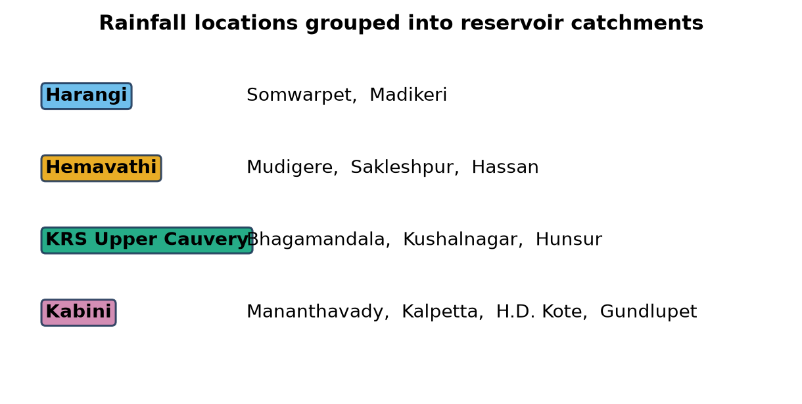
Figure 1. Town-to-catchment mapping used for averaging.

5. Method

5.1 Rainfall model
All twelve towns are placed on the same Asia/Kolkata daily calendar, and the pipeline stops if dates repeat or rainfall becomes negative. Each day is described by eight numbers: transformed previous-day rain, a wet/dry flag, annual and semi-annual sine–cosine terms, and the ERA5 normal rainfall and wet-day probability for that time of year. A four-number embedding identifies the town.
Instead of twelve separate networks I use one PyTorch model whose LSTM weights are shared by all towns, with the embedding letting it specialise. The 12-value input feeds a 24-unit LSTM with two heads: the probability of rain and a positive expected amount. Training uses 90-day chunks, 12 epochs of AdamW (learning rate 0.003, weight decay 0.02), binary cross-entropy plus a Poisson-style loss, gradient clipping and a fixed seed.
Time order is never broken. In the blind recursive test the network is warmed on prior history and then, for three full years, receives its own simulated rain as input instead of the observations. A one-day-ahead mode that is allowed to see yesterday's real rain is scored separately and is not a three-year test.

5.2 Catchment aggregation
R̄c,t = (1 / nc) Σi∈c Ri,t
Each day, the town values belonging to a catchment are averaged. Missing values stay missing rather than becoming zero, and the town columns are kept so every catchment value can be traced back.

5.3 Reservoir delta-LSTM
Reservoir records are merged with observed catchment rainfall by date. Only samples with thirty consecutive, finite input days are kept. Inputs are gross storage, recent storage change, inflow, outflow, catchment rainfall and day of year; evaporation is added only where at least 95% complete, which holds for Harangi, Hemavathi and KRS but not Kabini (79.1%).
Each reservoir has its own Keras network: LSTM(64) → dropout 20% → LSTM(32) → dropout 20% → Dense(16, ReLU) → Dense(1), trained with Adam on MSE for up to 30 epochs (batch 512) with early stopping after ten epochs and learning-rate halving after five. Sequences are not shuffled.
ΔSt+1 = St+1 − St Ŝt+1 = St + ΔŜt+1
My first models predicted absolute storage. They looked accurate on a chart but did not consistently beat persistence, so I switched to predicting the daily change. Inputs end on day t and the target is day t+1; rainfall from day t+1 is never used. Samples are split chronologically 70/15/15, scalers are fitted on training data only, and the predicted change is added to today's storage. A raw copy is kept, and a second copy is clipped to [0, design capacity] for reporting.

5.4 Baseline and evaluation
Ŝpersist,t+1 = St
Persistence is deliberately hard to beat for a slowly changing reservoir. MAE, RMSE and R² are computed in TMC after inverse scaling. MAE and RMSE measure the size of daily errors; R² can look excellent even when a model loses to persistence, which turned out to matter.

5.5 Demand
Demand (TMC) = population × LPCD × days ÷ (1 − loss) ÷ 28,316,846,592
The medium Bengaluru scenario uses 14.5 million people, 150 litres per person per day, 30 days and 20% distribution losses, giving 2.880 TMC. Other domestic demand is 0.300 TMC and the environmental requirement 0.250 TMC (both scenario assumptions). Agriculture uses 10% of the Tribunal's 250.62 TMC annual figure for an October month, 25.062 TMC. Low and high Bengaluru scenarios are also provided.

5.6 Seven allocation strategies
Each strategy receives the supply S and the four demands dᵢ in priority order (Bengaluru, other towns, environment, agriculture) and returns allocations xᵢ. The weighted rules use weights 4 : 3 : 2 : 1.
Table 2. Allocation strategies
Strategy | Rule | Character
1. Essential priority | Fill each sector fully, in priority order | Protects cities; farms absorb the whole shortage
2. Proportional | xᵢ = dᵢ · min(1, S/D) | Same percentage for everyone
3. Minimum guarantee | Floors 85/80/75%, then agriculture, then top-ups | Explicit policy floors
4. Weighted cuts | satisfactionᵢ = 1 − μ/wᵢ | Everyone shares the cut, scaled by importance
5. Equal cuts | xᵢ = max(0, dᵢ − λ) | Bankruptcy "equal losses"; wipes out small users
6. Optimised | min Σ wᵢ(sᵢ/dᵢ)², KKT: sᵢ = min(dᵢ, μdᵢ²/wᵢ) | Tiny cuts for all, largest user absorbs most
7. Drought hedging | If S < D keep 10% reserve, share rest by rule 3 | Larger deficit now, reserve for later
The level parameters μ and λ are found by bisection so that total allocation equals supply. After every run the code checks the water balance: no allocation is negative, no sector receives more than its demand, and the total released plus any reserve never exceeds supply. The same rules are ported to JavaScript for the website simulator, and the two implementations agree to within rounding.

6. Implementation
The project uses Python 3.13 with TensorFlow 2.21, pandas 3.0, NumPy 2.5, scikit-learn 1.9, Matplotlib 3.11 and joblib; the rainfall model uses CPU PyTorch 2.4.1 with fixed input snapshots. All randomness is seeded, and split dates and feature order are saved with each model. The results are presented on a React + Vite website with Recharts, deployed on Vercel.
Table 3. Main files
File | Purpose
rainfall/lstm_open_meteo.py | Train and blind-test the shared 12-town rainfall LSTM
rainfall/build_lstm_outlook.py | Refit through Oct 2026 and simulate a 256-member outlook
rainfall/analyze_climate_ensemble.py | Seasonal climate-change factors from 7 models
reservoir_delta_lstm.py | Train four delta LSTMs; save models, scalers and metrics
allocation/demand.py | 30-day demand scenarios
allocation/strategies.py | The seven allocation rules and water-balance check
allocation/run_allocation.py | Forecast case, 75% and 50% stress tests, supply sweep
website/ | Interactive results site and live allocation simulator

7. Results

7.1 Rainfall
Table 4. Blind recursive rainfall test by town, 2023–2025 (mm/day)
Town | LSTM MAE | LSTM RMSE | LSTM R² | Base MAE | Base RMSE | Base R²
Somwarpet | 5.360 | 11.254 | 0.202 | 5.783 | 10.658 | 0.284
Madikeri | 4.924 | 11.061 | 0.204 | 5.586 | 10.555 | 0.276
Mudigere | 4.264 | 8.109 | 0.255 | 4.942 | 8.340 | 0.212
Sakleshpur | 4.325 | 8.368 | 0.231 | 4.746 | 8.420 | 0.221
Hassan | 3.256 | 5.077 | 0.015 | 3.030 | 4.793 | 0.122
Bhagamandala | 6.107 | 13.887 | 0.180 | 7.440 | 13.213 | 0.257
Kushalnagar | 3.709 | 6.691 | 0.143 | 3.726 | 6.581 | 0.170
Hunsur | 3.331 | 5.499 | 0.115 | 3.295 | 5.443 | 0.133
Mananthavady | 5.014 | 8.939 | 0.124 | 4.924 | 8.798 | 0.152
Kalpetta | 4.862 | 9.553 | 0.189 | 5.720 | 9.696 | 0.165
H.D. Kote | 3.599 | 6.031 | 0.098 | 3.515 | 5.930 | 0.128
Gundlupet | 3.454 | 5.461 | −0.002 | 3.205 | 5.263 | 0.069
The rainfall result is useful precisely because it is not a clean win. Pooled over the blind test, the LSTM MAE is 4.350 mm/day against 4.659 for the frozen historical baseline, and the Brier scores are 0.13325 and 0.13362. The LSTM lowers MAE at seven towns but RMSE at only Mudigere, Sakleshpur and Kalpetta: it gets ordinary days a little closer without reliably capturing the biggest downpours, which is plausible for intermittent rain and grid-cell data.
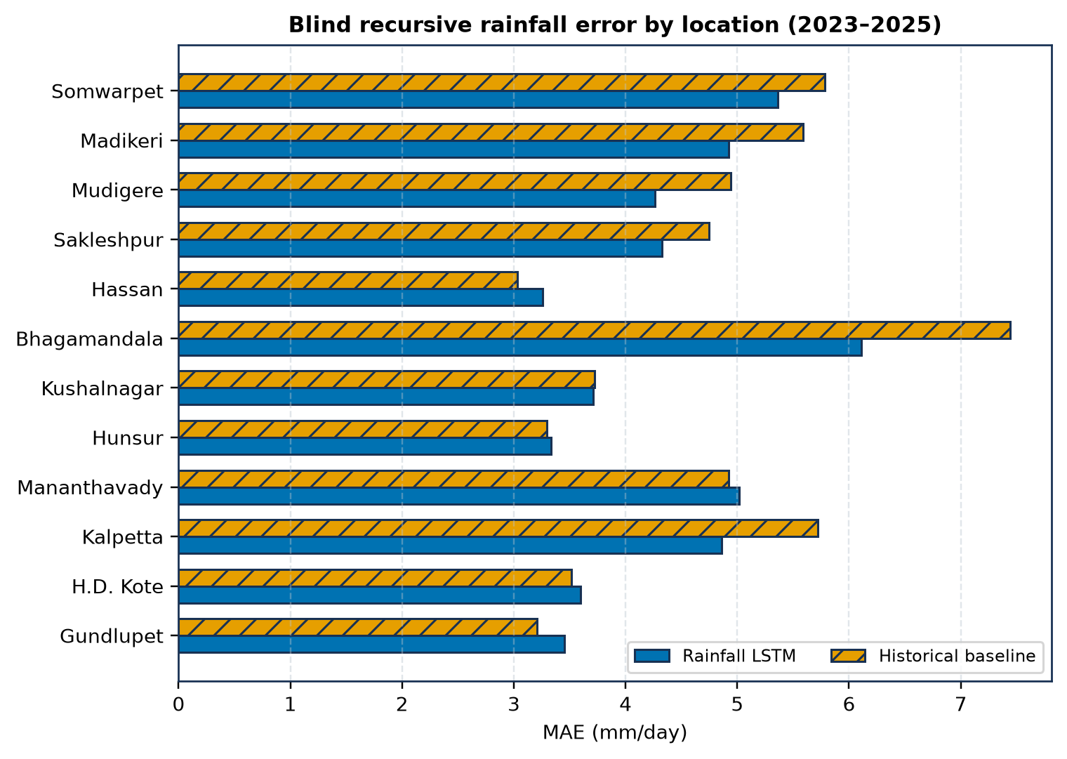
Figure 2. Blind recursive rainfall MAE for all twelve towns; lower is better.
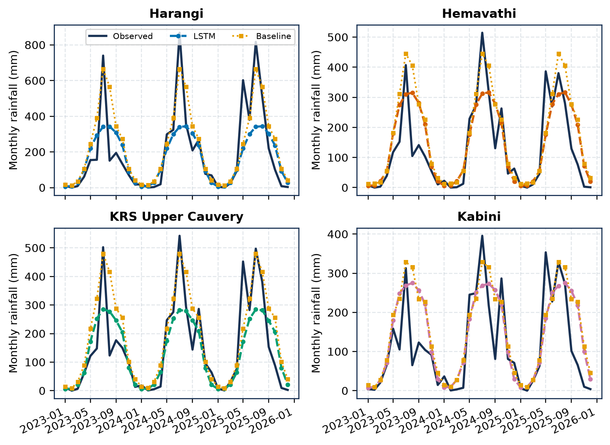
Figure 3. Monthly catchment totals aggregated from daily outputs (evaluation remains daily).

7.2 Reservoir storage
Table 5. Delta-LSTM test performance (TMC)
Reservoir | LSTM MAE | Persist. MAE | LSTM RMSE | Persist. RMSE | LSTM R² | Persist. R² | Result
Harangi | 0.0683 | 0.0607 | 0.1124 | 0.1095 | 0.9971 | 0.9972 | Slightly worse
Hemavathi | 0.1298 | 0.1418 | 0.2191 | 0.2813 | 0.9993 | 0.9989 | Beats
KRS | 0.1555 | 0.2406 | 0.2712 | 0.4668 | 0.9996 | 0.9988 | Beats
Kabini | 0.3970 | 0.1231 | 0.8401 | 0.2338 | 0.9665 | 0.9974 | Much worse
Hemavathi and KRS beat persistence on both MAE and RMSE, so the learned correction adds real value there. Harangi falls just short. Kabini's MAE of 0.397 TMC is three times persistence (0.123 TMC), even though its R² is 0.97. The lesson is that a high R² does not make a forecast useful; the comparison with a simple baseline is what matters.
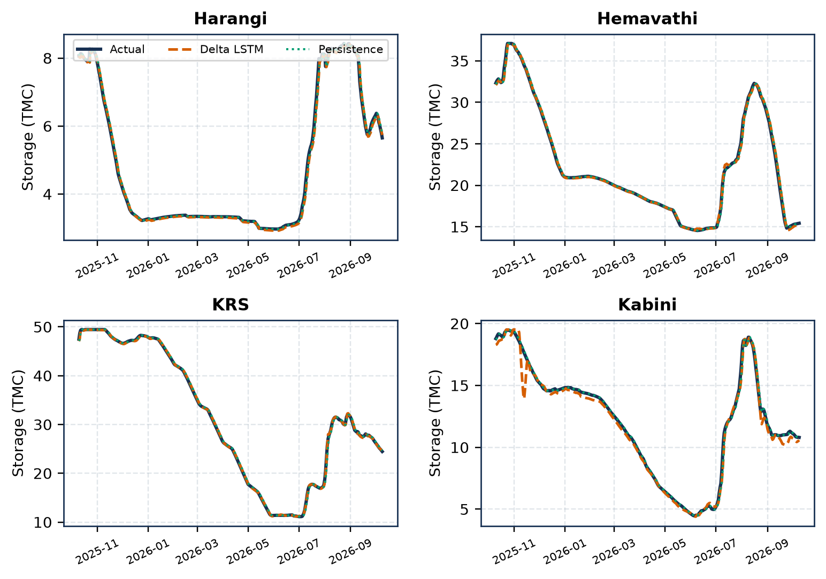
Figure 4. Actual, delta-LSTM and persistence storage over the latest 365 test days.
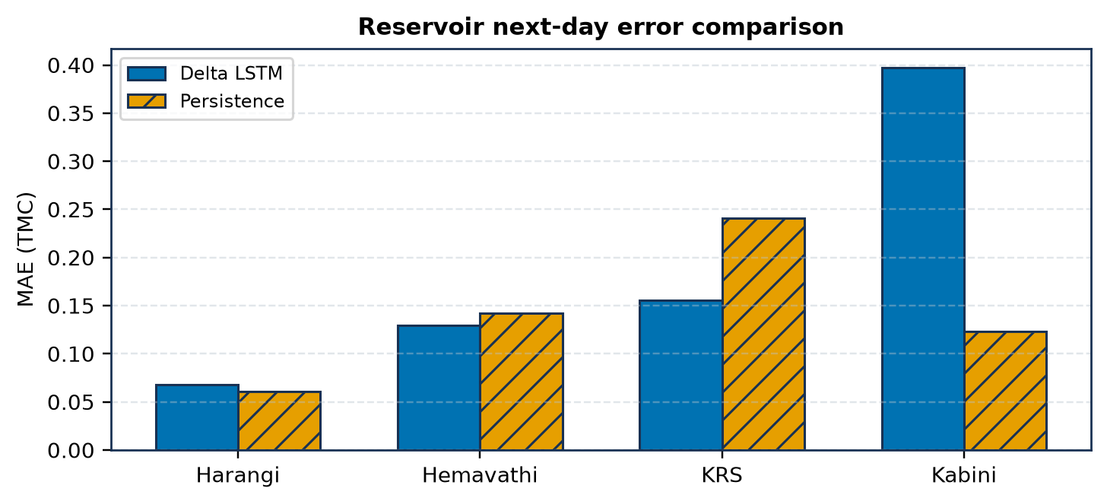
Figure 5. Where the delta-LSTM does and does not beat persistence.

7.3 Availability
The four forecast files share 1,586 target dates from 25 August 2021 to 9 October 2026. On the last date the clipped forecasts are 5.741 TMC (Harangi), 15.224 (Hemavathi), 24.545 (KRS) and 10.587 (Kabini), a total of 56.096 TMC, or 49.0% of the 114.571 TMC combined design capacity.

7.4 Demand
Table 6. Medium 30-day October demand
Sector | Demand (TMC) | Basis
Bengaluru | 2.880 | Population × LPCD × days ÷ (1 − losses)
Other domestic | 0.300 | Scenario assumption
Environment | 0.250 | Scenario assumption
Agriculture | 25.062 | 10% of Tribunal annual benchmark
Total | 28.492 | 30-day window
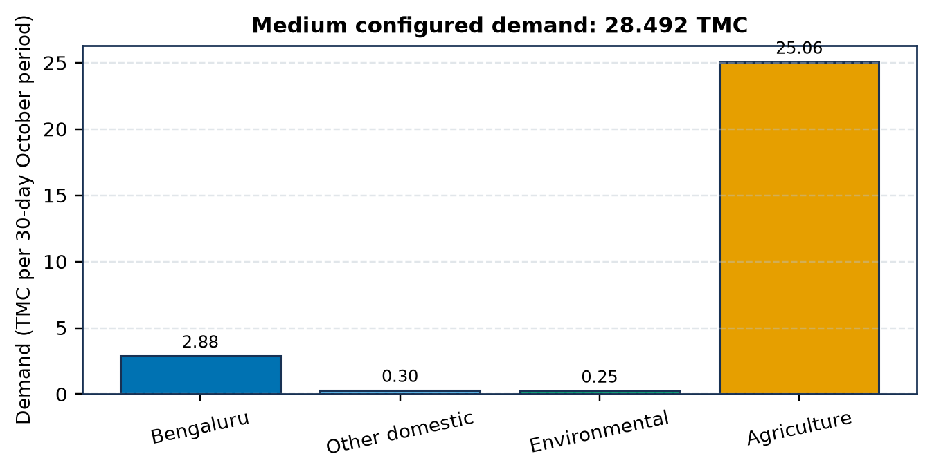
Figure 6. Composition of the medium 30-day demand. Agriculture is 88% of the total.

7.5 Allocation
With 56.10 TMC available against 28.49 TMC of demand, every strategy meets every sector in full and leaves 27.60 TMC unallocated. That only compares a proxy with an assumed demand; it is not proof that the water can be released. The stress tests are where the rules differ.
Table 7. Sector satisfaction under synthetic shortages (supply as % of demand)
Case · strategy | Bengaluru | Other towns | Environment | Agriculture | Deficit (TMC) | Reserve (TMC)
75% · Essential priority | 100.0% | 100.0% | 100.0% | 71.6% | 7.123 | 0.000
75% · Proportional | 75.0% | 75.0% | 75.0% | 75.0% | 7.123 | 0.000
75% · Minimum guarantee | 85.0% | 80.0% | 75.0% | 73.8% | 7.123 | 0.000
75% · Weighted cuts | 93.2% | 90.9% | 86.3% | 72.6% | 7.123 | 0.000
75% · Equal cuts | 0.0% | 0.0% | 0.0% | 85.3% | 7.123 | 0.000
75% · Optimised | 99.2% | 99.9% | 99.9% | 71.7% | 7.123 | 0.000
75% · Drought hedging | 85.0% | 80.0% | 75.0% | 65.3% | 9.260 | 2.137
50% · Essential priority | 100.0% | 100.0% | 100.0% | 43.2% | 14.246 | 0.000
50% · Proportional | 50.0% | 50.0% | 50.0% | 50.0% | 14.246 | 0.000
50% · Minimum guarantee | 85.0% | 80.0% | 75.0% | 45.4% | 14.246 | 0.000
50% · Weighted cuts | 86.3% | 81.7% | 72.6% | 45.2% | 14.246 | 0.000
50% · Equal cuts | 0.0% | 0.0% | 0.0% | 56.8% | 14.246 | 0.000
50% · Optimised | 98.4% | 99.8% | 99.7% | 43.4% | 14.246 | 0.000
50% · Drought hedging | 85.0% | 80.0% | 75.0% | 39.7% | 15.671 | 1.425
At 75% supply (21.369 TMC) the shortfall is 7.123 TMC. Essential priority keeps cities and the river at 100% and gives agriculture 71.6%. Proportional gives everyone 75%. Minimum guarantee holds Bengaluru at 85%, towns at 80%, the river at 75% and gives agriculture 73.8%. Weighted cuts spread the pain more evenly (93.2% / 90.9% / 86.3% / 72.6%). The optimised rule keeps the three small users above 99% and gives agriculture 71.7%: because agriculture is so large, a small percentage cut there frees the most water. Equal cuts look fair but take the same 3.69 TMC from everyone, which zeroes out Bengaluru, other towns and the river; I keep it as a cautionary example of why equal is not the same as fair when claims differ by two orders of magnitude.
The first six rules all produce the same total deficit, because a sharing rule never creates or destroys water: it only decides who carries the shortage. Drought hedging is the exception. It keeps 10% of supply as carry-over storage, raising this month's deficit (9.26 TMC at 75%, 15.67 TMC at 50%) in exchange for a reserve that would only show its value in a multi-month simulation.

8. Limitations
Table 8. Principal limitations
Area | Limitation
Rainfall data | ERA5/IFS grid cells may miss local orographic and convective extremes.
Rainfall model | One shared, town-aware LSTM, not twelve separately tuned networks.
Reservoir target | Gross storage; dead storage and confirmed live availability are unresolved.
Kabini | Substantially worse than persistence, weakening the combined total.
Demand | Urban, domestic and environmental values are scenario assumptions; the farm figure is from 2007.
Stress tests | 75% and 50% supplies are synthetic tests, not forecasts or policy.
Single month | Hedging can only be judged properly over many months.
Scope | No legal, inter-state or operational allocation conclusions.

9. Conclusion and Future Work
The project links twelve town-level rainfall forecasts, four catchment averages, four reservoir delta models and a seven-strategy allocation study into one reproducible pipeline, with results published as an interactive website. The most important finding is not that LSTMs always win. They do not: Hemavathi and KRS beat persistence, Harangi barely misses and Kabini clearly loses, and keeping that visible made the availability figure more honest. On the decision side, comparing seven rules side by side shows that the choice of rule is a choice about who carries a shortage, that intuitive "equal" rules can be the least fair, and that an optimisation view explains why the largest user ends up absorbing most of the cut.
Next steps: add temperature, humidity, soil moisture, ENSO and Indian Ocean Dipole signals; try attention, transformer and hybrid physics–ML models with probabilistic outputs; use validated live and dead storage to estimate releasable water; and extend allocation to a multi-month simulation so hedging and carry-over can be evaluated. Persistence and physical baselines should stay alongside any model.

References
[1] W. Li, P. Zhang, H. Dong, Y. Jia, and W. Cao, "RSDF-AM-LSTM: Regional scale division rainfall forecasting using attention and LSTM," ACM/IMS Trans. Data Sci., vol. 2, no. 4, pp. 1–27, 2021.
[2] F. Kratzert, D. Klotz, C. Brenner, K. Schulz, and M. Herrnegger, "Rainfall–runoff modelling using Long Short-Term Memory (LSTM) networks," Hydrol. Earth Syst. Sci., vol. 22, no. 11, pp. 6005–6022, 2018.
[3] Z. Xiang, J. Yan, and I. Demir, "A rainfall-runoff model with LSTM-based sequence-to-sequence learning," Water Resour. Res., vol. 56, no. 1, 2020.
[4] M. Gauch et al., "Rainfall–runoff prediction at multiple timescales with a single Long Short-Term Memory network," Hydrol. Earth Syst. Sci., vol. 25, no. 4, pp. 2045–2062, 2021.
[5] T. Lees et al., "Benchmarking data-driven rainfall–runoff models in Great Britain," Hydrol. Earth Syst. Sci., vol. 25, no. 10, pp. 5517–5534, 2021.
[6] J. M. Frame et al., "Deep learning rainfall–runoff predictions of extreme events," Hydrol. Earth Syst. Sci., vol. 26, no. 13, pp. 3377–3392, 2022.
[7] D. Klotz et al., "Uncertainty estimation with deep learning for rainfall–runoff modeling," Hydrol. Earth Syst. Sci., vol. 26, no. 6, pp. 1673–1693, 2022.
[8] G. S. Nearing et al., "What role does hydrological science play in the age of machine learning?" Water Resour. Res., vol. 57, no. 3, 2021.
[9] Y. Qi, Z. Zhou, L. Yang, Y. Quan, and Q. Miao, "A decomposition-ensemble learning model based on LSTM neural network for daily reservoir inflow forecasting," Water Resour. Manag., vol. 33, pp. 4123–4139, 2019.
[10] S. Khorram and N. Jehbez, "A hybrid CNN-LSTM approach for monthly reservoir inflow forecasting," Water Resour. Manag., vol. 37, pp. 4097–4121, 2023.
[11] J. W. Labadie, "Optimal operation of multireservoir systems: State-of-the-art review," J. Water Resour. Plan. Manag., vol. 130, no. 2, pp. 93–111, 2004.
[12] K. Madani and M. Zarezadeh, "Bankruptcy methods for resolving water resources conflicts," in World Environmental and Water Resources Congress, ASCE, 2012.
[13] J. R. Stedinger, "The performance of LDR models for preliminary design and reservoir operation," Water Resour. Res., vol. 20, no. 2, pp. 215–224, 1984 (hedging rules background).
[14] Open-Meteo, "Historical Weather API" and "Climate API," documentation. https://open-meteo.com/en/docs. Accessed Oct. 2026.
[15] National Water Informatics Centre, daily reservoir data for Harangi, Hemavathi, KRS and Kabini, 1990–2026.
[16] Cauvery Water Disputes Tribunal, "Water requirement of Karnataka in Cauvery Basin," Report, vol. V, 2007.

