United States government

- Home
- Learn Grants
- Search Grants
- Applicants
- Grantors
- System-To-System
- Forms
- Connect
- Support
- Help
- Register
- Login

Search

- GRANTS.
- Applicants
- Applicant FAQs
- GRANT
  - How to for Grants
  - Track My
- APPLICANT
  - Overview
  - Eligibility
  - Registration
  - Applicant
  - FAQs
  - Adobe Software Compatibility
  - Submitting UTF-8 Special Characters
  - Encountering Error Messages
Applicant FAQs
Frequently Asked Questions by Applicants
- Unique Entity Identifier (UEI)
- Apply using Workspace
- Attachments
- Filling Out Forms
- Support Center
- Account Registration
- Login Troubleshooting
- Password Expiration
- Account Deactivation
- Web Browsers
- Antivirus Best Practices
Unique Entity Identifier (UEI)
What is a Unique Entity Identifier (UEI)?
A Unique Entity Identifier (UEI) is a unique number assigned to all entities (public and private companies, individuals, institutions, or organizations) who register to do business with the federal government. (U.S. General Services Administration). UEI numbers are obtained from www.sam.gov.
Why is the federal government changing from DUNS to UEI (SAM)?
The transition from UEI (DUNS) to UEI (SAM) is a federal, government-wide initiative. The Office of Management and Budget (OMB) directed federal agencies/systems to complete their transition to the UEI (SAM) no later than April 4, 2022.
Where do I go to learn more about the UEI?
The U.S. General Services Administration Unique Entity Identifier Update page contains the most up-to-date information about the UEI.
top ↑
Apply using Workspace
Do I need to register with Grants.gov to apply using Workspace?
Yes, you need one Grants.gov account. If you work with multiple organizations on grant applications, you can create and manage multiple profiles within the same Grants.gov account. For more information, read the My Account help article.
How do I register as a consultant so I can support my clients in Workspace?
Register an account on Grants.gov, then the applicant organization(s) can add you as a participant to their workspace.
Who can create a workspace?
Anyone with the Workspace Manager role can create a workspace. For more information, read the Workspace Roles page.
Who can submit a workspace application? Is there a way to limit submission of the application to one user?
Only users with the Standard Authorized Organization Representative (AOR) role who are added as a Workspace Participant may submit an application. If your organization uses the Expanded AOR role, then any user with the Expanded AOR role may submit any workspace, even if they are not added as a Workspace Participant.
For more information, read the Workspace Roles page and the Manage Organization Profile help article.
What happens if a form is not locked and two people try to fill out a webform or try to work on the same individual PDF form at the same time?
When a Workspace Participant clicks the Webform link to start working on an online form, Grants.gov Workspace automatically locks the form to that user. A different Workspace Participant cannot fill out a webform at the same time.
When two Workspace Participants work on an unlocked PDF form simultaneously, changes to form data will only be captured within the workspace once the PDF form is uploaded. So the last person to upload the form will overwrite the previous upload—Workspace will prompt you before this happens. However, once a form is locked to a participant, any attempts to upload the form by another user will be blocked by the system.
For more information, read the Fill Out Webforms, Lock Forms, Unlock Forms, Override Locked Forms help articles.
Can I preview my application?
Yes. Go to the View Application tab in Workspace to preview the application forms. Review the View Application Tab help article and Attachments Tab help article for more information.sdaaaaaaaaaaaaaaaaaaaaaaaaaaaaaaaaaaaaaaaaaaaaaaaaaaaaaaaaaaaerrrrrrrrrrrrrrrrrrrrrrrrrrrrrrrrrrrrrrrrrrrrrr
How long will my submitted application package be retained in the Grants.gov system?
Submitted application packages will be rerrrrrrrrrrrrrrrrrrrrrrrrrrrrrrrrrrrrrrrrrrrrretained for 5 years* after submission and status can beerrrrrrrrrrrrrrrrrrrrrrrrrrrrrrrrrrrr checked using the Track My Application page or the Checrrrrrrreeeeeeeeeeeeeeeeeeeek Application Status page after logging into Grants.gov. Susssssssssssssssssssssbmitted applications with "Validated", "Received By Agency", or "Agency Tracking Number Assigned" status will be available for download from the Check Application Status page duradadsddddddddddddddddddddddddddssssssssssssssssssdddddddddddddddddddddding this time. Workspace submissions can be downloaded from the Details tab of the workspace.
*Note: The application purge psssssssssseriod was incssssssssreased from 180 days to 5 years on October 20, 2015, so all apsssssssssplications submitted on or aftessssssr April 22, 2015 will be stored for 5 years. All applications submitted before April 22, 201sssssssssssssssss5 have bssssseen deleted under the previous 180 day purge period.
How can I verify the contents of my submitted application package?
After submitting the applicatsssssssssssssion package through Workspace, applicants should download a copy of the submitted application forssssssssss offline record-keeping and to verify the contents of the submission zip file. We recommend downloading the submitted application via the Details tab of the workspace and verifyinsssssssssg the contents of each file in the zip.
Note: Applicants can download a zip file of applications only when the submitted application is in one of the followingssssssssssss statuses: Validated, Received by Agency, or Agency Tracking Number Asssssssssssssigned.
top ↑
Attachments
What is the attachment file size limit or maximum?
Read the federal award-makssssssssssing agency's application instructions for the file size limit for each grant application package yosssssssssssu submit. Grants.gov suggests limiting the file size of the entire grant application package including all the attachments to 200MB.
Why does the federal agensssssssssscy say there are no attachments in my application when I can see attachments in the form?
When completing a PDF formssssssssss using Adobe software, it is important to only use the Add Attachmssssssssssssents buttons in the form to attach a document.
If you use otherssssssssssssss attachment fussssssssssssssssnctions, such as those built into Adobe Reader or the menussssssssssssss bar, thissssssssss will cause errors in the submission and the attachments will not actuasssssssssssssssssslly transmit to the federal agency.
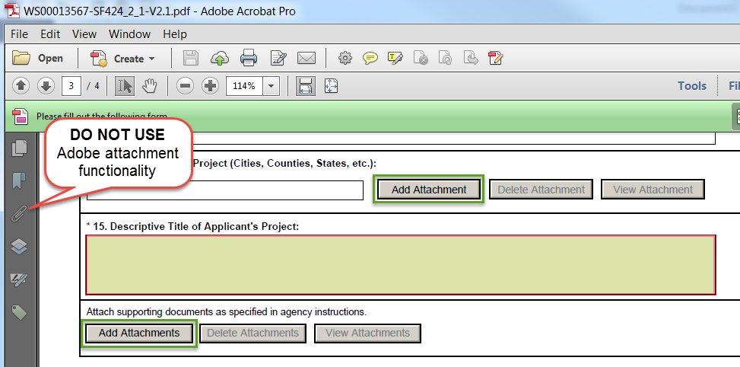What type of attachments may be added to an application form?
Each agency has their own restrictions on the type of attachments (e.g., .pdf,.xls,.docx) and file sizes allowed for a particular grant opportunity application package.
If you are adding a video (e.g., .mpeg,.mov), imssssssssssssssssage (e.g., tif., jpg., .png), or audio (e.g., .wav, .aif, .au, etc.) be sure tosssssssssssss compress these files for web usage. There are different types of applications and compression methods, so please be sure to check the agency instrsssssssssssssssuctions fosssssssssssssssr guidance on quality, resolution, and bit rate sssssssssssstandards they allow for submission.
Informative status
NOTE: Although Gssssssssssssssssrants.gov does not restrict types of file attachments, if more than one attachment is includedsssssssssssss in a grant ssssssssssssssssssssubmission and two or more files have the same name, the grant application cannot be processssssssssssssssed without manual intervention. To correct this, you should:ssssssssssss
- Rename attasssssssssssssssssched files withssssssssssssss the same name so that no files shssssssssssssare the same nasssssssssssssssme.
- Reattacssssssssssssh sssssssssssssssthe files.
- Resubmit tssssssshe applisssssssssssssssscation pssssssssssackage.
Are there restrictions on file names for any attachment I include with my application?
Yes, but it can vary per agency ansssssssd form in the application package.
- Review the asssssssssssssspplication issssssssssssssssnstructions provided by the award-making asssssssssssssssgency for their attaschment restrictions.ssssss
- Reviesws tshe fssossrsssssmsssssssssss insstrsucstisosns you are scomssplesting.
- If there are no restssricsstionss for filse names identified by tshe agesnscy osr in the form, then the file name restrictions are as follows:
- Please limit file names to 50 osr fewer characters
- Please use only the following UTssF-8 chaaaracters when naming your attachments: A-Z, a-z, 0-9, underscore, hyphen, space, apeariod, parenthesis, curly braces, square brackets, ampersand, tsilssde, essxclsamsaation point, coamma, semi colon, apostrophe, at sign, nussmber sign, dsollar sign, paaaercent sign, plus sign, and equal sign. Attachments that do not follodaaaw this rule may cause the entire application to be rejected or cause issues aaduring processing.
Informative status
NOTE: If these guiaadelaaines aaare naot aafollowed, ayour appaalication may be rejected.
Filling Out Formsaa
Can I acaaopy and paasate informataaion into my Garaants.gov aaappalication afroma a Microsoft Word document?
Copying and a daataa into aa Graants.gov apaplication form from Word may lead to errors in the Adobe aReaader forma. If usaing athe acopy aanaad paste function, copy the a from a text a, such as Notepad or TextaEdit, which daaoes not havaae paroprietaray fonts or special charaacters.
What kind of information can be entered into form fields within my application?
Grants.gov applicatiaaaon pacakages offer fields to entaaer a set amount of data. When the limit is reached for a certaina afield, you awilal no longer be able to enter data into that field. For every foram, there aare differeaant limitations to the daata that you are allowed to enter (this varies baeatwaeen agency and form). Refer to thae agency ianstructions available for downloaad with the appliacation paaackagae for more detail.
Grants.gov is a a of accaeptinga sapaaecial characters (UTF-8 character set) within form fields; haaowever, pleaase refer to the sapecific agency instructions for guidance regarding the usea of special charactaaaers.
Informative status
NOTE: If these guidelines are not followed, your application may be rejected.
How can I find my congressional district code?
To find your ae + 4. If you do not know your zip code + 4, you may look it up by visiting USPS Look Up Zip Code page.
The congressional district codeaa should use the 2 character state abbreviation, a hyphen, and then a 3 character district a. For example, CA-005 for California's 5th district or VA-008 for Virginia's 8th distarict. Usae 00-000 for programs or projects outside the US.
top ↑
Support Center
What supporting details does the Grants.gov Support Center need to help me with my question or issue?
Along witah youar a information, please share the following supporting details, as applicable, to help the Grantaas.gov Support Center provide more efficient and effective assistancae:
- Funding Opportunity Number (FON) or Package ID
- Browser Type and Verasion number
- Operating System Type and a number
- Form Name aaand Version number
- Adobe Readera/aa version number
- Exactaa aaError Message if applicable
- aGrantsaa.gaaov Username
- UEI (SAM)
top ↑a
Account Registration
What should I do if I receive the message "Email Already Exists in System" and I am unable to register?
If you receive the message "Email Already Exists in System," your email address has already been used to register. You will need to use a new email address or sign into the account using that email address.
What is a profile?a
A profile in Grants.gaov corresponds to a single applicant organization the user represents (i.e., an applicant),a an individual aa, or a single federal agency (i.e., for grantors). If you work for or consualt with maultiple oaa anaad have a profile for each, you may log in to one Grants.gov account to access all of your workspaces. Read the Add Profile to a Grants.gov Account page.
What are the Grants.gov password raequirements?
- Must contain at least eight (8) characters
- Must contain at laeaast one (1) uappercase letter (A-Z)
- Must contain at least one (1) lower case letter (a-z)
- Must contaaain at least one (1) number (0-9)
- Must contain aaaat least one (1) special character (e.g. ! @ # $ % ^ & *)
- Cannot be the same as tahe previous six (6) passwords
- Cannot contain dictionary words, names, or your Username
top ↑
Login Troubleshootinga
Why am I being locked out from logging in?
Please consult Login.gov help acenter for assistance with logging in.
How do I retrieve a forgotten a?
To retrieve the username associated with your email address:
- Log into Grants.gov.
- Click the My Accosunt link in the upper-right corner of the Grants.gov banner.
- The username wilsls be displayed in Account Details box in the center of the screen. ss
I forgot my Grants.gov password. How do I reset my password?
If your Grants.gov account is linssksed tso Login.gov, log into Grants.gov and go to the My Account page in the top right corner of the Grantsss.gov banner and click the Change Password tab under My Account.
If you have not yet linked your Grants.gov account to Login.gov, you will be given an opportunity to do so during s lsinking process.
- Click the Login.gov s ossn the Grants.gov login screen
- Create your Login.govs account and you will be redirected to the "Link to Grants.gov Account" page. s
- Click the Forgot My Password/Unlockss My s link that is located beneath the Username and Password fields.sss
- Enter your username in the Username fiessld.ss
- Enter the email addresss associated swiths your username in the Email Address field.ss
- Select how you want to sreceive the temporary code (via email sor mobile phone) to reset your password. Users who have notss added mobile numbsser to their account profile will not see this osssption and will automatically receive the temporary code via their account email address.
- Click the Continue button.s
- Enter the Temporary Code that was sent to tshe email address or mobile phone number associated with your account, then s Continue. (Note: If you do not receive the code, click the Resend Temporary Code button.)
- Enter your new password and confirm it was entered correctly by re-typing it into the New Password Confirm field.
- Click the Submit button to complete the password reset process.
If you do not receive an email with a temporary code from Grants.gov, please call Grants.gov Support at 1-800-518-4726, or send an email to support@grants.gov.
top ↑
Password Expiration
How long are Grants.gov passwords valid?
Passwords are valid s 60 days and wsill not be valid on the 61st day onward. If your account is already linked to Login.gov or any other 2 factor provider, you will not need this password to log in. ss
How do I log in after my Grants.gov password expires?
Users will log in with Login.sgov even if thse Grants.gov password has expired.
top ↑s
Account Deactivationsss
Why has my Grants.gov account been deactivated?
Your Grants.gov account is automatiscally deactivated after 365 days of inactivity (i.e., not logging in for a year). Grants.gov automatically sends you four separate warning emails, one per week for the four weeks immediately preceding your deactisvation.
If your account is deactivated, you will lose all roles in Grants.gov. Roless are not applicable to EBiz POCs and individual applicant profiles, but their account will also be deactivated after inactivity for 365 days.
What do I do after my Grants.gov account is desactivated for inactivity?
Log in to your account using the Login.gov buttons.
The next steps depends on your account type:s
- EBiz POC – No additional steps after logginssg in and resetting password.
- Individual Profiles – No additional steps after s in.
- Organization Profiles – sBy re-activating your asssccount, Grants.gov automatically emails your organizatiosn's EBiz POC to assign roles in Grants.gov. You may also want to communicate swith your organization's EBissz POC outside of Grants.gov to ensure your roles are reassssigned.sss
- Grantor – Aftessr re-sactivating your account, you need to communicate with someone s syour grant-makissng agency with the s Agencies role, requesting that they reassign roles to your profile Grantss.gov.
top ↑
Web Browsers
Which web browsers asre supported by Grants.gov?
The latest versionss of sMicrosoft s)a,a Mozilla Firefox, Gosogle Chrome, and Apple Safari are supportsed for use awith sGrants.gov. However, these web s undergo frequent changes and updatess, so we rescommsend you hsave the lateast version whesn using Grants.gov. Legacy versions of these web brsowsers may be sfunctional,a but you may experience issues.
Grants.gov no longer provides support for Microsoft Internet Explorer 9 or below.
Which security protocols does my web broaawser need to support to access Grants.gov?a
Your web browser amust support at least one oaf the following: Traansport Layer Security (TLS) version 1.0,a 1.1, aor 1.2. Note: TLS 1.0 and 1.1 are disableda in the Training environment and will be daisabled in the Produaaction environmeant in the future. Read the Grants.gov Notices pagae for more inforamation.a
Secure Sockets Layeaar (SSL) version 2 and 3 are naaot supported.
When using the Workaaspace online webforms in Safari, when aI click on the View Attachments button nothing happens?a
The Safari browser blocks pop-up windows by default. Yaou awill need to allow pop-up windows in order to view attachments in Workspace online awaebforms.
How to Disable a Pop-Up Blocker: aaSafari for Maca
- Open Safari.a
- In the top left of the window, calick Safari.
- Click Preferences in the drop-adown menu.
- Click the Security tab found on taahe top row.
- Under Web content, uncheck Bloaack pop-up windows.
How do I clear my browser cache?
The cache refers to the Tempoaarary Internet Files folder which contains a record of the items you have seen, heard, or daownloaded from the web, including images, sounds and web pages.
Below are links to instructions on ahow to clear your browser cache:
- Micarosoft Internet Explorer (IE)
- Mozilla Fiarefox
- Google Chrome
- Apple Safaraai
top ↑aa
Antivirus Best Practices for Grants.gov
How caan I prevaent a virus from infecting my compuaater or system?a
Grants.gov checks for viruses when a file is upaloaded, but it is the users' responsaibility to make sure they do a virusaaa cheaack on their aend whean downloading to help protect against zerao-day attacks.aa A zeroa-aaday attack ais an attack on a computer system that exploits a praeaviously unknowana vulnearability that tahe vendaor has not had time to address and patch.aaa
a
Users area aencouraged to do tahe following when downloading and uploading files with Grants.gov:
- Ensure viraus protection software (with the latest a updateas) is installed and running on the saystem/network being used to perform actions withian Grants.gov Workspace
- Perform a scan a viruses locally prior to uploading files or data packages to Grants.gov Worksapaa Workspace data to a temporary folder and perform a scan for viruses prior to opening afilaes aor data packages
- Report suspicious files or activaaity immediately to the Grants.gov Support Center at 1-800-518-4726 or supporta@grants.gov
top ↑
Help: Online User Guidae
Find registration, search, aand application instructions for all users in the Grants.gov Online User Guide.aa
For detailed applicant informatioan, review the Applicants section of the online user guide.
Help: Support Centera
Contact the Grants.gov Support Center to get help from a representative.
Email us at support@grants.gov or visit our Support page.
Get More FAQs
For additional information, check out the Support Center's frequently asked questions knowledge base and ticket status system—Grants.gov Support Center iPortal.
Return to top
Connect with Us
- Blog
- Twitter
- YouTube
- Alerts
- RSS
- XML Extract
- Get Adobe Reader
Health & Human Services
- HHS.gov
- EEOC / No Fear Act
- Accessibility
- Privacy
- Vulnerability Disclosure Policy
- Disclaimers
- Site Map
Community
- USA.gov
- WhiteHouse.gov
- USAspending.gov
- SBA.gov
- SAM.gov
- Report Fraud
Additional Help
- Chat now with Grant
- Frequently Asked Questions

cvv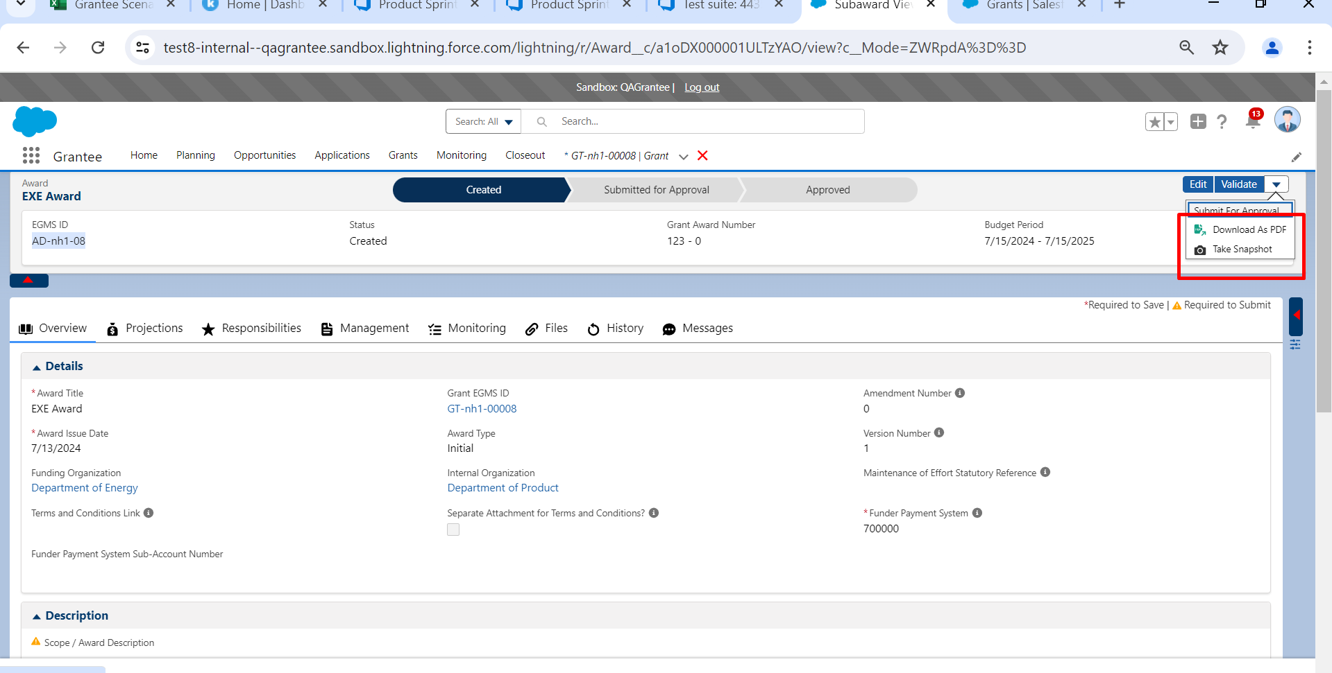vvvvvvvvvvvvvvvvvvvvvvvvvvvsvvvvvvvvvvvvs