**Practical no. 6**

Name : Vaibhav Vitthal Deore  
Roll no .: 15

**Aim** : Create a program that illuminates the green LED if the counter is less than 100, illuminates the  
yellow LED if the counter is between 101 and 200 and illuminates the red LED if the counter is  
greater than 200.  
**************************************INPUT***************************************  
int counter = 0;  
void setup()  
{  
Serial.begin(9600);  
pinMode(7,OUTPUT);  
pinMode(8,OUTPUT);  
pinMode(9,OUTPUT);  
}  
void loop() {  
if(counter == 300)  
{  
counter=0;  
}  
if(counter <= 1000)  
{  
Serial.println(counter);  
}  
counter = counter + 10;  
delay(1000);  
if(counter > 0 && counter < 100 )  
{  
digitalWrite(7,HIGH);  
digitalWrite(8,LOW);

digitalWrite(9,LOW);  
Serial.println("green light is blinking ");  
}  
if(counter > 101 && counter < 200 )  
{  
digitalWrite(7,LOW);  
digitalWrite(8,HIGH);  
digitalWrite(9,LOW);  
Serial.println("Yellow light is blinking ");  
//Serial.println(counter);  
}  
if(counter > 201 &&counter < 300 )  
{  
digitalWrite(7,LOW);  
digitalWrite(8,LOW);  
digitalWrite(9,HIGH);  
Serial.println("Red light is blinking ");  
// Serial.println(counter);  
}  
}

***************************************OUTPUT************************************  
Step1 : select the Arduino.  
Step 2: select the bread board.  
Step 3 : select 3 LED of red ,yellow and green color and connect their cathode to negative of bread  
board and to the pins 7,8 ,9 pins of Arduino

Step 4 : Start The Serial Monitor And illuminates the red LED if the counter is  
greater than 200

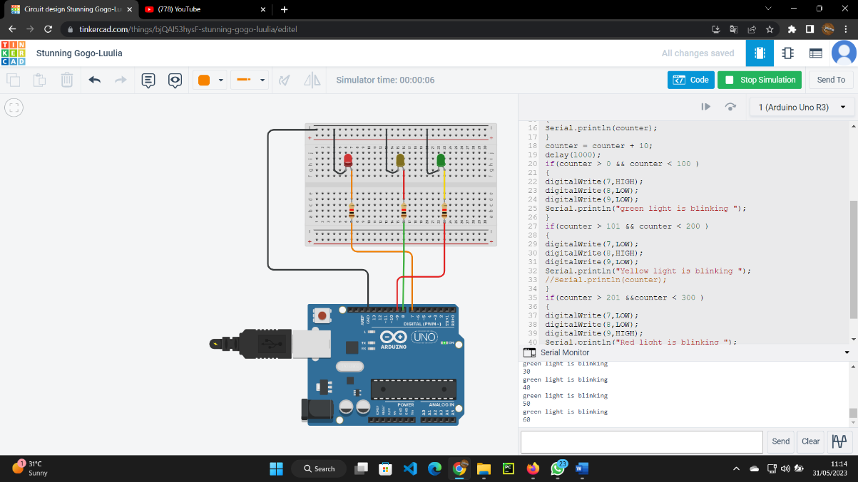

Step 5 : And then illuminates the yellow LED if the counter is between 101 and 200

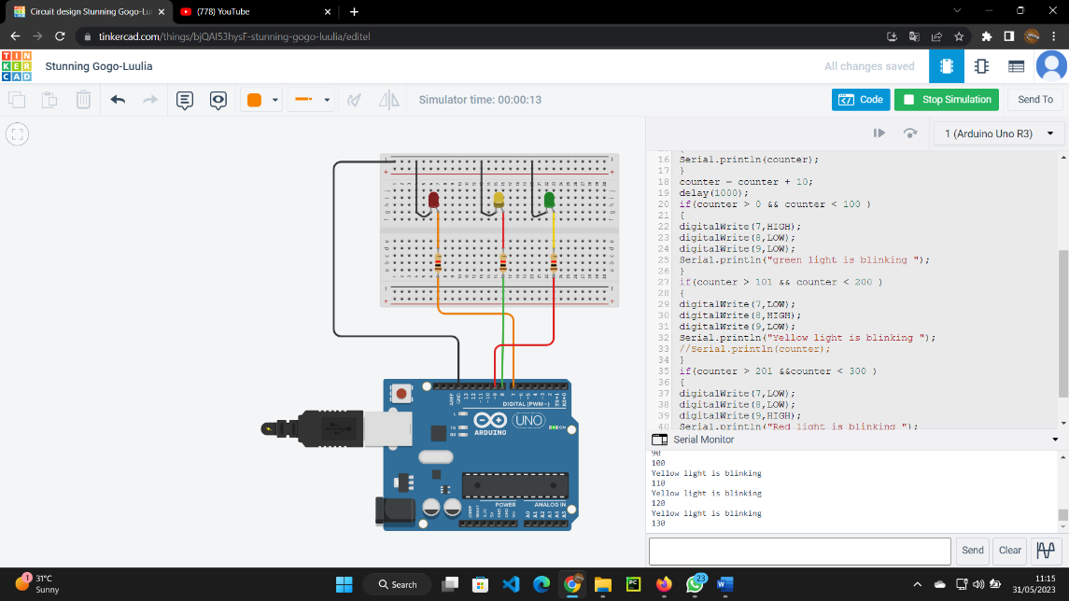

Step 6 : And last illuminates the green LED if the counter is less than 100

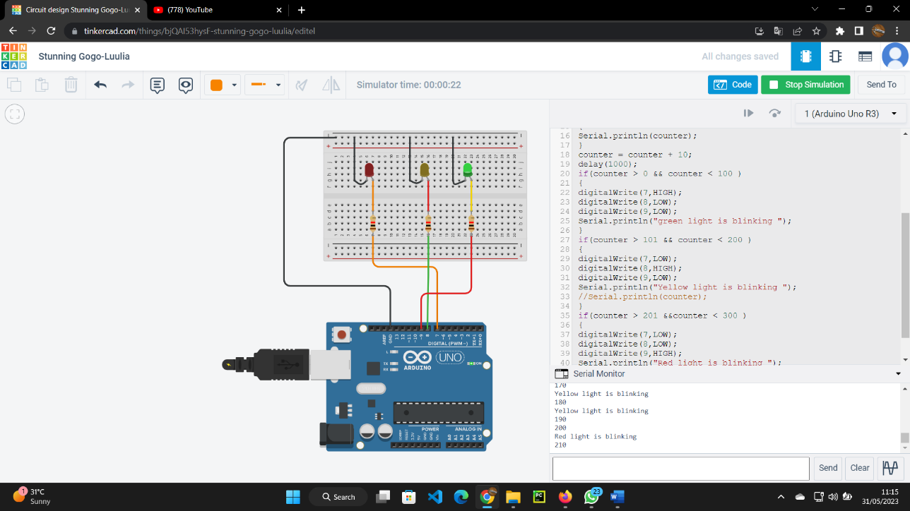  
step 7: output

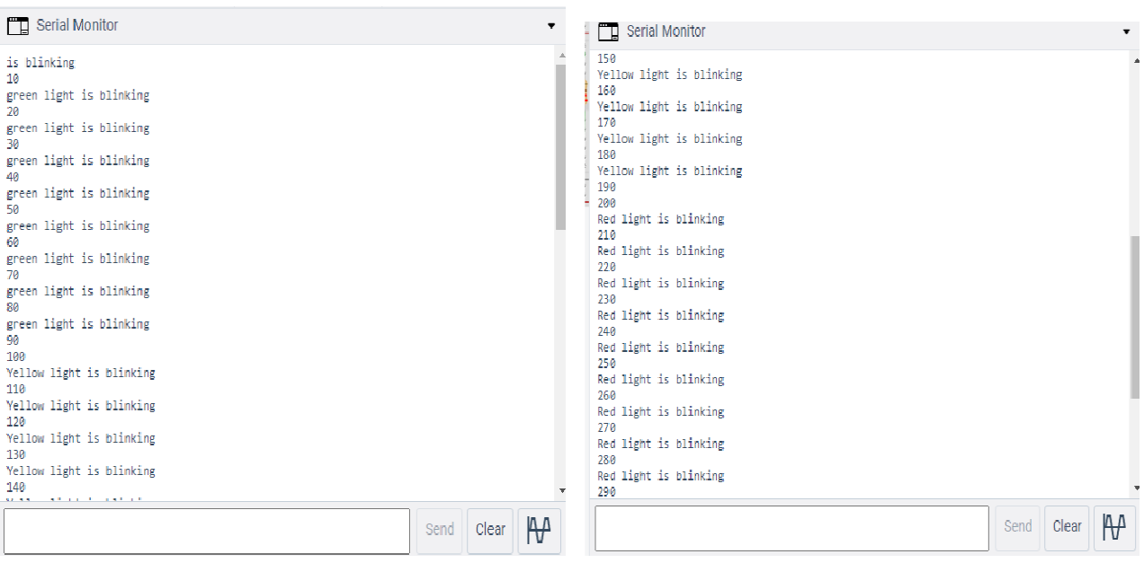

Step 8 : cricuit diagram

