**Fundamentals of Economics**

**Economics of Ideas with Data**

**Impact of Covid-19 on Unemployment in India**

* **Vaibhav Agarwal (B21CS077)**
* **Varun Purwar (B21AI043)**

horizontal line

# Abstract

It is not wrong to say that the corona virus is a ‘Black Swan Event- a term used to describe unpredictable events that have severe impacts worldwide. The economic impact of the pandemic has severe consequences on the Indian economy by dragging them into recession.

This report attempts to analyze the impact of the Covid-19 pandemic on unemployment in India, considering the secondary data collected through websites, newspapers, journals, and reports. For the past few years, the Indian economy is experiencing jobless growth. The existence of the unemployment crisis has been going on for a long time. Nevertheless, it was accomplished in developed countries during the great depression, while it was seen after the Second World War in developing countries. The rate of unemployment in India has risen rapidly over the past few years, despite the boost in the Indian economy. Due to the Covid-19 pandemic lockdown, as most private enterprises have fired their employees, the economy was further exacerbated by the unemployment crisis. The informal sector is the most affected by the lockdown, as construction works were closed, and most workers lost their jobs.

# Introduction

Unemployment has become a significant issue in many developing and developed countries. The most complicated socio-economic aspect in India is the unemployment problem. Increasing the army of unemployed has a diverse range of consequences on households, societies, and economies. At the household level, unemployment reduces the consumption level of the household because of a lack of income. At the social level, individuals who have been unemployed for a long time are compelled to commit crimes. At the economic level, unemployment reduces savings, output, and the amount of tax levied by the government, and as a result, the budget deficit grows in the economy.The most complicated macro-economic issue in India is unemployment the problem can't be removed by a golden touch instantly; the pressure on the unemployed could only be minimized by durable planning. In India Unemployment is considered a curse of development particularly the literate unemployed. In India, any person working about 8 hours a day for 273 days annually is considered as employed on a standard person-year basis. Thus, a person to be called an employed person must get meaningful work for a minimum of 2184 hours in a year. The person, who does not get work for this duration, is known as an unemployed person Ali et al. (2020).The vastness of job creation in an economy depends to a large extent on the level of its progress, thus when an economy makes progress and its production expands, employment opportunities increase. Over the past four decades, the Indian economy has been growing at unprecedented rates, but it has been characterized by jobless growth and the formalization of job opportunities in the organized sector. According to Jha & Mohapatra (2019), every 1% increase in GDP increases jobs by only 0.18%. Theoretically, if India achieves 10% growth for a significant number of years, it would mean jobs will grow at 1.8% annually- hardly enough to take care of the numbers entering the jobs market in any year (about 12 million). While jobs will not grow in proportion to GDP ,the unemployment scenario is unlikely to be gloomy . The International Labor Organization (ILO) report says that the number of unemployed in India increased from 1.7 crores in 2017 to 1.8 crores in 2018, and employment elasticity reduced to 0.15%, which means 1% GDP growth has increased just 0.15 % of jobs in the country (ILO). This indicates jobless growth in the country during the past decade.

The Covid-19 health crisis has evolved into a global economic crisis, putting at risk the job, health, and income of millions of people worldwide and will have long-lasting ramifications for economies around the world. The pandemic has incapacitated the global labor market and governments around the globe. With the number of Covid-19 cases rising, the Indian government announced a complete lockdown between March 2020 and May 2020 to practice social distancing, as many other countries did. The pandemic revealed India’s jobless growth by hitting the middle and lower-income groups quite hard.

### Result and Discussion

Employment has been a significant worry for policymakers and the government in recent years. By raising the economy’s growth rate and creating new jobs, each plan aims to eliminate unemployment. Most economists believe that a higher rate of economic growth can alleviate the backlog of unemployed workers and create new jobs, although this theory has yet to be proven. Despite being the world’s sixth-largest nominal GDP economy and the third-largest in terms of purchasing power parity, it remains by and large in the grip of a high unemployment rate. The Indian economy had recovered from a significant downturn in April and May 2020 when the labor participation rate decreased, unemployment soared, and there was much stress, many jobs were lost during that period. Roughly 126 million employment were destroyed when the epidemic struck in April 2020, which is a lot, and about 90 million of those positions were more daily wage earners (CMIE). A daily-wage earner can get work by going out to the curb, going to a construction site, or pulling a cart to sell his wares and finding work in those places. There was no way for the daily-wage workers to earn a living or keep their jobs after the nation went into lockdown on 24 March 2020, with one of the most strict preventative and containment measures against the epidemic. After the opening of lockdown, all of them pushed up their cards and started seeking for hiring opportunities again. So these are the daily-wage earners who can in a sense move in and out of the employment fairly casually. What happened though is their income-earning propensities declined, and so are the job opportunities for them. Many persons who had formal occupations before the pandemic returned to work in an informal capacity, indicating a rise in informality following the epidemic (Kesar et al., 2021). Even more worrisome, approximately 73 million salaried employees have been affected by Covid-19 (CMIE).

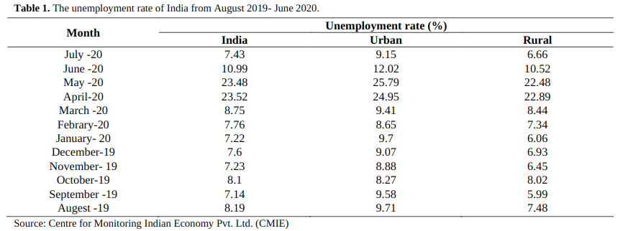

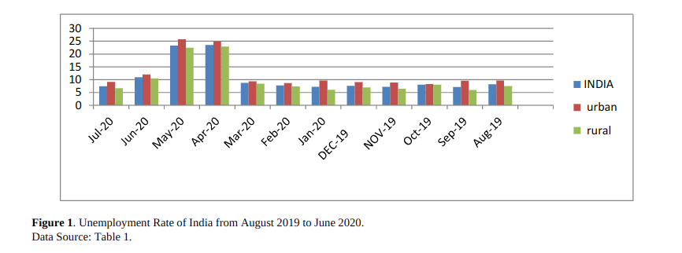

India’s unemployment rate decreased to 11% in June 2020, from a record high of 23.5% in April and May 2020, when the closed businesses reopened after weeks of Covid-19 pandemic lockdown (Table1). The Report of CMIE says the unemployment rate in India has risen to 29% since the country went into lockdown in (March 2020).

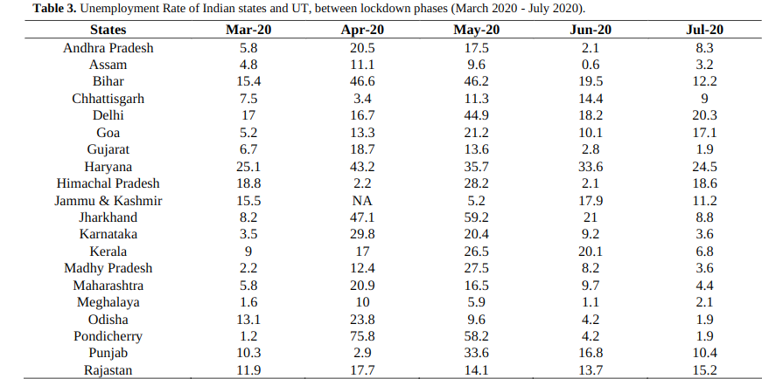

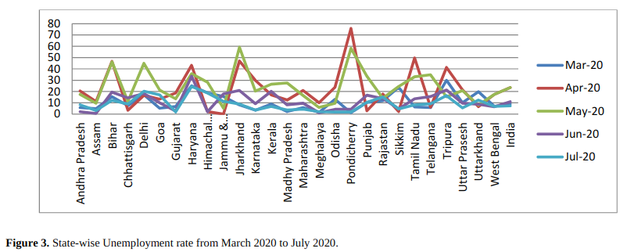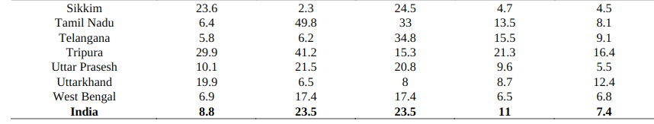

As a result of the coronavirus lockdown, India’s unemployment rate jumped to 23.5% in April (Table3). Urban India’s unemployment rate stands higher at 24.95% than in rural India at 22.89% (Table1). During the final week of April 2020 and the first two weeks of May 2020, the unemployment rate remained around 23.48-23.52 % (Table 1).

Unemployment was also shockingly high in metropolitan areas of India. A spike in urban India’s unemployment rate of 30 and 31% occurred during the first and second weeks of the shutdown respectively. However, the percentage drops dramatically to 23% and 25% over the next two weeks. Urban unemployment has fallen dramatically, yet it is still quite high (Table1, 3). The unemployment rate in March was 8.8%, the highest since the August 2016 demonetization, according to a recent CMIE Survey. The unemployment rate was 9.59% in August 2016 (Business Today 2020). When the Indian economy was growing at a jobless growth, this jobless growth level suggests that something was fundamentally wrong with policies and overall structure. The deterioration of the situation is partly long-term neglect of the employment issue in policy making and the consequences such as demonetization, Goods and Services Tax (GST) implementation, and paradigm shift of the Indian economy directly from agriculture to the service sector without much development in the industrial sector. In 2016-17 Indian economy was booming and it earned the tag of fastest-growing economy in the world by keeping impressive growth numbers for successive quarters but job creation remains a top concern. The years of jobless growth increased inequalities, and the wealthy got prosperous, and the poor got poorer. 77% of India’s gross domestic product (GDP) was owned by just 10 percent of the population (Oxfam, 2019). The affluent 1 percent of Indians received 73 per cent of the nation’s wealth in 2017, while the 670 million people who make up the country’s bottom half saw just a 1% increase in their income (Savera 2020). People’s purchasing power decreases due to high inflation in the economy. People simply didn’t have enough money to buy things because they didn’t have jobs or having low-paying jobs, this reduced demand and as a result, industry output and the services market were adversely affected and the country is currently on a downward trend.

Then the Indian economy coped with the twin shocks of Covid-19, and Prime Minister Modi declared a lockdown on 24 March. It has brought global growth to a halt for the past two months. The most significant impact of this tragedy was the unprecedented loss of unemployment in all sectors of the economy. Following the loss of nearly 8 million workers in March, most of them in the last week since the country-wide lockdown was imposed, the CMIE dated reveals that 12.8 crore employment loss in April 2020. Roughly one-third of all workers were laid off in a single month, relative to last year.

**Unemployment Data and its Analysis during Covid-19 period**

**Dataset Details:**

The dataset encompasses key indicators such as States, Date, Measuring Frequency, Estimated Unemployment Rate (%), Estimated Employed Individuals, and Estimated Labour Participation Rate (%).

The dataset provides insights into the unemployment scenario across different Indian states:

**States:** The states within India.

**Date:** The date when the unemployment rate was recorded.

**Measuring Frequency:** The frequency at which measurements were taken (Monthly).

**Estimated Unemployment Rate (%):** The percentage of individuals unemployed in each state of India.

**Estimated Employed Individuals:** The count of people currently employed.

**Estimated Labour Participation Rate (%):** The proportion of the working population (age group: 16-64 years) participating in the labor force, either employed or actively seeking employment.

**Exploratory Data Analysis**

Mean Unemployment Rate, mean Employed, mean Labour Participation Rate are given below for each region in India.

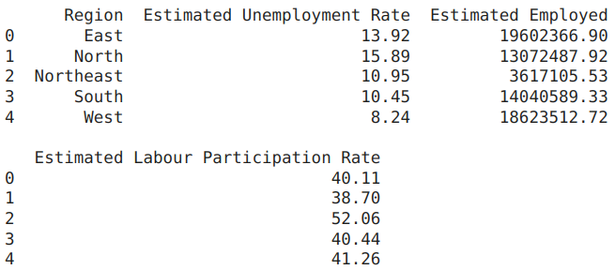

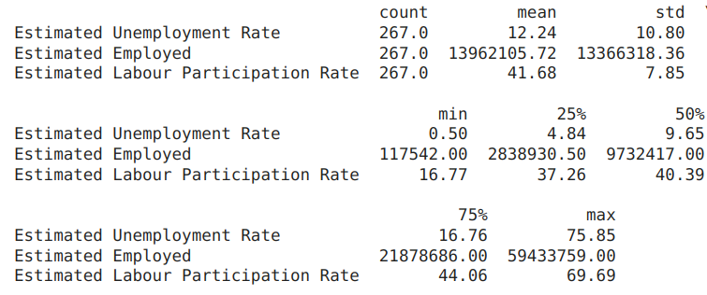

**Bar plots showing the average unemployment rate in each state**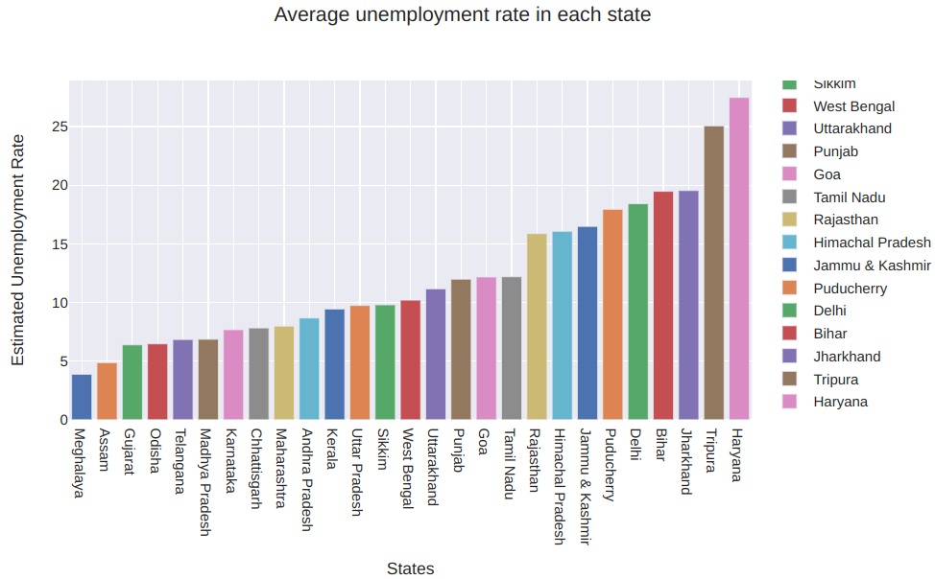

Haryana and Jharkhand have long been the most unemployed.

**Boxplot of Unemployment rate per States**

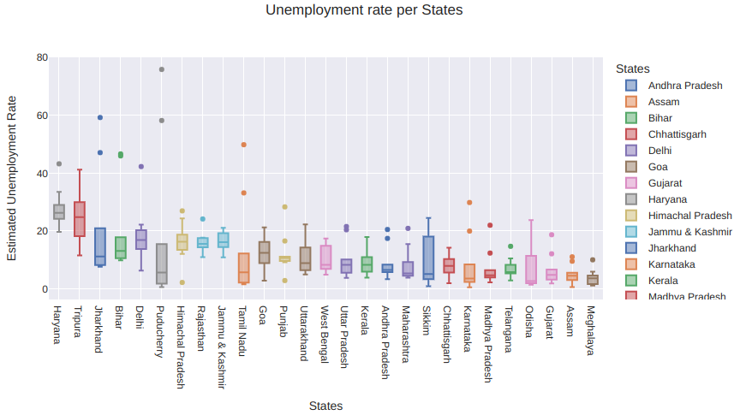

**Scatter matrix considering the employed and unemployed rates**

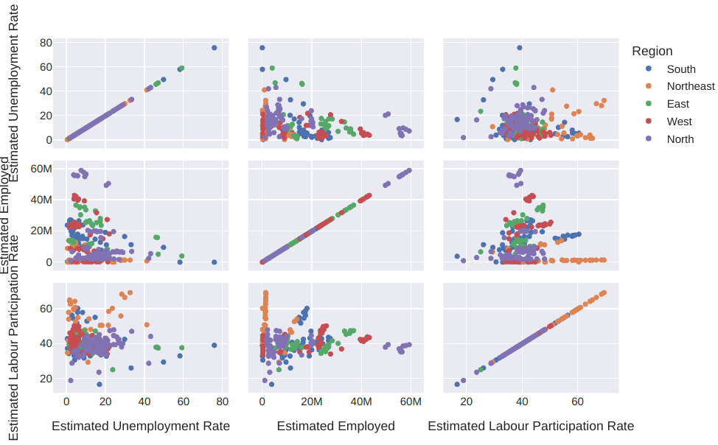

**Bar chart showing the unemployment rate across regions from Jan. 2020 to Oct. 2020**

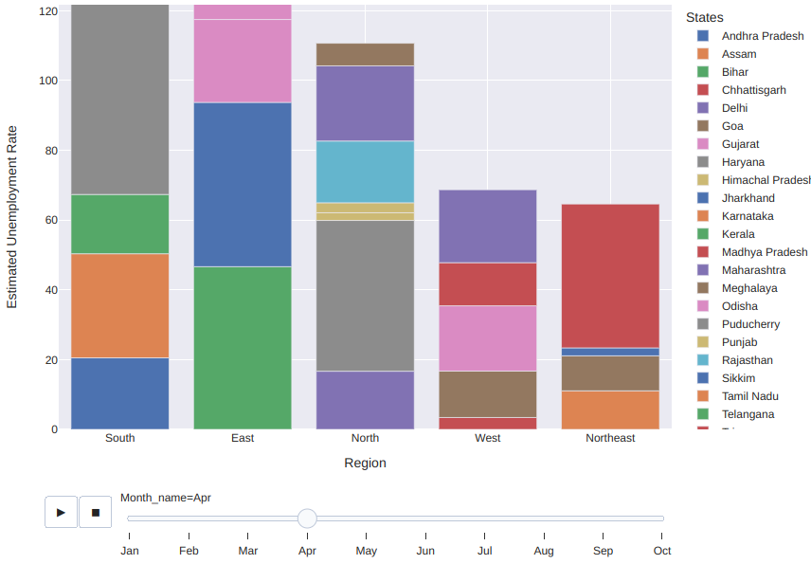

We see that during the month of April, the states Puducherry, Tamil Nadu, Jharkhand, Bihar, Tripura, Haryana of India saw the major unemployment hike.

**Sunburst chart showing the unemployment rate in each Region and State**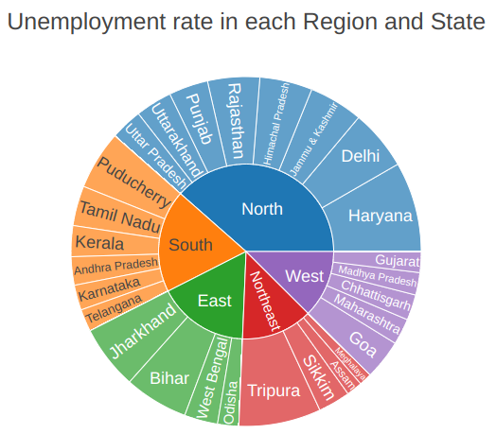

**Impact of Lockdown on States Estimated Employed**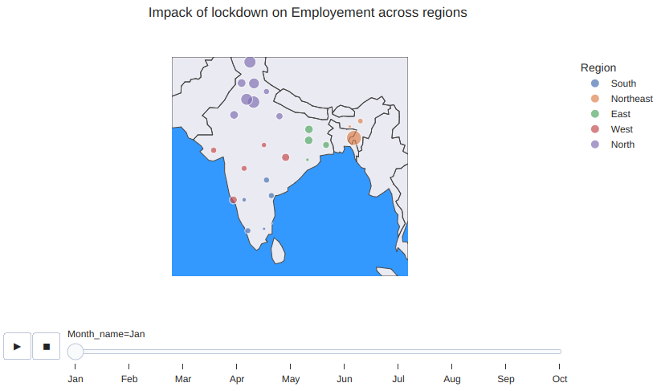

The northern regions of India seem to have more unemployed people.

**Mean unemployment rates before and after lockdown by state**

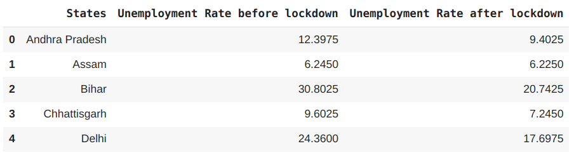

**Percentage change in Unemployment in each state after lockdown**

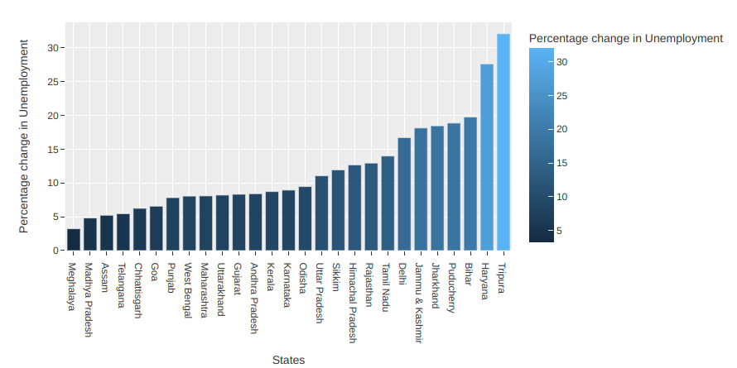

The most affected states/territories in India during the lockdown in case of unemployment were:

* Tripura
* Haryana
* Bihar
* Puducherry
* Jharkhand
* Jammu & Kashmir
* Delhi

**Consequences of Covid-19 Pandemic on India’s job market**

One of the most visible and devastating consequences of this job-loss crisis was that migrant workers began to return to their homes. The surge of reverse migration was one of the straightforward consequences of the lockdown. In this process, at least 8700 people have died, many of them were migrants (Indian Express, 2020). Many citizens expected that if the lockdown were lifted gradually, the economy would improve so that jobs would return. In fact, the employment situation is not optimistic. As seen in Figure 1, the unemployment rates in June and July were much higher than that before the pandemic.

The situation of the salaried and wage-earning groups remains bleak. According to CMIE estimates, approximately 1.8 crores of salaried or wage-earning jobs have been lost, including manufacturing workers and service sector employees. As of June, around 30-40 lakh jobs had returned to work only (CMIE).

**Suggestions**

The Covid-19 Pandemic shocks will continue to be expensive unless the government Increases investment in healthcare systems and tightens norms to govern the same. This kind of biological crisis demands a large investment in technology infrastructure. Make it mandatory for businesses to provide social security benefits to their employees. It is important to decentralize the industrial sector to reduce unemployment. If the industrial sector is centralized in one place, in the underdeveloped areas there will be fewer job opportunities. So the government should implement policies that support the decentralization of the industrial sector. Job prospects and labor productivity should be the key goals of the country’s employment policy. Creating jobs for everyone is a policy the government should promote. To boost employment, we must boost agricultural and industrial production. The best way to reduce unemployment is to foster small, local businesses in rural areas. Most people in India work for themselves, either directly or indirectly, through cattle, cottage, or small-scale industry. Self-employment should be supported. To help these people, the government should provide them with financial aid, raw materials, and training in their chosen fields. If the government wants to create more job possibilities in rural areas of India, it should enhance funding for the Mahatma Gandhi National Rural Employment Guarantee Scheme (MGNREGS). In the wake of the epidemic, the success of MGNREGAS has rekindled interest in an urban version of the program. This type of program could help urban economies cope with any exogenous shocks in the future. To address the issue of unemployment, population growth must be curtailed and family planning policies be strictly enforced and the government should adopt a holistic approach to strengthen the Self Help Groups (SHGs), particularly in rural areas.

**Conclusion**

India is on the path of progression. The economy needs to use its available resources to the full extent. For any economy, unemployment is a grave problem. The pandemic has wrought havoc on the public health system and various other sectors of the economy. Due to the Covid-19 pandemic, many people's lives and livelihoods in India and around the world were affected. All sectors of the economy and the working population have been adversely affected, those already at a disadvantage in the labor market are at greater risk due to their status as migrant workers, lower wages, lower education achievement etc. Nevertheless, governments and citizens alike must boost productivity and raise living standards to achieve long-term, sustainable economic growth. If India aspires to a 5 trillion-dollar economy, structural and institutional changes must be made to the current growth path.

**Data Sources**

**Kaggle Datasets - Unemployment in India.**

* [**https://drive.google.com/file/d/1XieTk8yBXIoTCE6LeyXFS8rBoHfElqH9/view?usp=sharing**](https://drive.google.com/file/d/1XieTk8yBXIoTCE6LeyXFS8rBoHfElqH9/view?usp=sharing)
* [**https://drive.google.com/file/d/10Kbe9M3xa6VGTXrD893oUOemATRvs1rb/view?usp=sharing**](https://drive.google.com/file/d/10Kbe9M3xa6VGTXrD893oUOemATRvs1rb/view?usp=sharing)

**Appendix**

1. [**https://www.researchgate.net/publication/348555450_A_STUDY_ON_IMPACT_OF_COVID-19_PANDEMIC_ON_UNEMPLOYMENT_IN_INDIA**](https://www.researchgate.net/publication/348555450_A_STUDY_ON_IMPACT_OF_COVID-19_PANDEMIC_ON_UNEMPLOYMENT_IN_INDIA)**.**
2. [**https://prsindia.org/theprsblog/impact-of-covid-19-on-unemployment-in-urban-areas#:~:text=The%20lockdown%20restrictions%20were%20gradually,rate%20had%20reduced%20to%2010.3%25.**](https://prsindia.org/theprsblog/impact-of-covid-19-on-unemployment-in-urban-areas#:~:text=The%20lockdown%20restrictions%20were%20gradually,rate%20had%20reduced%20to%2010.3%25.)
3. **Ali, M. A., & Kamraju, M. (2020). A study on impact of covid-19 pandemic on unemployment in India. Re-Imagining the New Normal-The Transformational Lens of COVID, 19, 50-61.** [**https://www.researchgate.net/profile/Mohd-Akhter-Ali/publication/348555450_A_STUDY_ON_IMPACT_OF_COVID-19_PANDEMIC_ON_UNEMPLOYMENT_IN_INDIA/links/6003e9e692851c13fe17fbae/A-STUDY-ON-IMPACT-OF-COVID-19-PANDEMIC-ON-UNEMPLOYMENT-IN-INDIA.pdf**](https://www.researchgate.net/profile/Mohd-Akhter-Ali/publication/348555450_A_STUDY_ON_IMPACT_OF_COVID-19_PANDEMIC_ON_UNEMPLOYMENT_IN_INDIA/links/6003e9e692851c13fe17fbae/A-STUDY-ON-IMPACT-OF-COVID-19-PANDEMIC-ON-UNEMPLOYMENT-IN-INDIA.pdf)**.**
4. [**https://www.sciencedirect.com/science/article/pii/S2590291121001200**](https://www.sciencedirect.com/science/article/pii/S2590291121001200)**.**
5. **Dev, S. M., & Sengupta, R. (2020). Covid-19: Impact on the Indian economy. Indira Gandhi Institute of Development Research, Mumbai April.** [**http://www.igidr.ac.in/pdf/publication/WP-2020-013.pdf**](http://www.igidr.ac.in/pdf/publication/WP-2020-013.pdf)**.**
6. [**https://www.businesstoday.in/latest/economy-politics/story/at-7-2-percent-india-unemployment-rate-feb-worst-29-months-labour-force-down-25-7-million-cmie-174729-2019-03-06**](https://www.businesstoday.in/latest/economy-politics/story/at-7-2-percent-india-unemployment-rate-feb-worst-29-months-labour-force-down-25-7-million-cmie-174729-2019-03-06)**.**
7. **Jha, S., & Mohapatra, A. K. (2019). Jobless Growth in India: The Way Forward. Available at SSRN:** [**https://ssrn.com/abstract=3476599**](https://ssrn.com/abstract=3476599)**.**
8. **Savera. (2020). Unemployment Ravages Indian Economy But Resistance Mounts | NewsClick. NewsClick. Retrieved 7 September 2020, from** [**https://www.newsclick.in/Unemployment-India-COVID-19-Lockdown-Modi-Govt-Neoliberal-Policies**](https://www.newsclick.in/Unemployment-India-COVID-19-Lockdown-Modi-Govt-Neoliberal-Policies)**.**
9. **Ozili, P. K., & Arun, T. (2020). Spillover of COVID-19: Impact on the Global Economy (SSRN Scholarly Paper ID 3562570). Social Science Research Network. SSRN:** [**https://ssrn.com/astract=3562570**](https://ssrn.com/astract=3562570)**.**

**Google Colab file link:** [AIL4070_Project_Python_Code.ipynb](https://colab.research.google.com/drive/1y9P6i__jKNZlRMo2uFwakN-cthpUhWy-?usp=sharing)

**Libraries and tools used**

Python libraries such as Matplotlib, Seaborn, Plotly, Pandas, etc. are used for interactive data analysis and visualization purposes.