**1.STUDY THE TRAFFIC SIGNALS AND THE IMPORTANCE OF RULES AND PROCESS**

=) **STUDYING THE TRAFFIC SIGNALS :-**

Traffic signals are an essential part of road infrastructure that is designed to ensure the safe and efficient movement of vehicles and pedestrians. They are typically located at intersections and other areas where traffic needs to be controlled, and their importance cannot be overstated. The rules and processes associated with traffic signals play a crucial role in ensuring that they function properly and serve their intended purpose.



=) **TRAFFIC LIGHTS TO BE FOLLOWED :-**

1)Green light: A green light indicates that it is safe to proceed through the intersection. However, drivers should still exercise caution and look out for pedestrians and other vehicles before proceeding.

2) Yellow light: A yellow light indicates that the signal is about to change to red. Drivers should slow down and prepare to stop, unless they are already too close to the intersection to stop safely.

3) Red light: A red light indicates that traffic must stop. Drivers should come to a complete stop at the stop line or crosswalk and wait for the signal to turn green before proceeding.

=) **IMPORTANCE OF TRAFFIC SIGNALS :-**

The importance of traffic signals lies in the fact that they provide clear and consistent guidance to drivers and pedestrians, indicating when it is safe to proceed and when to stop. They help prevent accidents, reduce traffic congestion, and enable the smooth flow of traffic. Traffic signals are also essential in areas with high pedestrian traffic, where they can be used to control pedestrian crossings and ensure their safety.

=) **RULES AND PROCESS OF TRAFFIC SIGNAL**

=) The rules and processes associated with traffic signals are designed to ensure that they function effectively and safely. For example, traffic signals typically operate on a set cycle, with each signal phase lasting a specific amount of time. This cycle is designed to provide sufficient time for vehicles and pedestrians to safely cross the intersection and for traffic to flow smoothly.

=) In addition to the cycle, traffic signals are also subject to specific rules and procedures that govern their operation. These include rules related to the sequencing of signal phases, the timing of yellow lights, and the placement of signals themselves. By following these rules and procedures, traffic engineers can ensure that signals operate as intended and provide the necessary guidance to drivers and pedestrians.

=) **ADVANTAGES OF TRAFFIC SIGNAL :-**

1) Improved safety: Traffic signals help improve safety by providing clear guidance to drivers and pedestrians, indicating when it is safe to proceed and when to stop. This reduces the risk of accidents and ensures that traffic flows smoothly and safely.

2) Reduced congestion: By controlling the flow of traffic, traffic signals help reduce congestion and ensure that traffic moves efficiently through intersections. This can help reduce travel time, fuel consumption, and emissions.

3) Pedestrian safety: Traffic signals also help ensure pedestrian safety by controlling pedestrian crossings and providing safe crossing times. This is especially important in areas with high pedestrian traffic, such as downtown areas and school zones.

4) Improved traffic flow: By coordinating the timing of lights and adjusting the signal cycle based on traffic volume and other factors, traffic signals help improve traffic flow and reduce delays. This can be especially important in areas with heavy traffic or during peak travel times.

5) Increased predictability: Traffic signals provide a predictable and consistent pattern of traffic flow, which can help drivers anticipate when they need to stop or proceed. This can reduce confusion and the risk of accidents.

**2. VISIT VARIOUS CONSULTING COMPANY WEB PORTALS AND COLLECT CASE STUDIES**

**=) What Is A Web Portal**

=) A web portal refers to a web-based platform that gathers information from various resources and displays it in a single user interface. There are many types of portals used by businesses today, such as patient portals, student portals, vendor portals, government portals, knowledge management portals and workplace portals. What makes each of these portal types similar is that they deliver personalized access to users based on assumed or assigned user roles.

=) asid custom web portal loaded onto a laptopThe term “web portal” refers to any type of access-gateway that enables users to log in to a business’s back-end cloud system using a web interface. Web portals are often used to access business services or sensitive data, such as customer information. With a custom web portal, individuals can gain access to private data repositories on the cloud, giving businesses the opportunity to enhance communications, improve collaboration and streamline operations.

**=) TYPES OF WEB PORTALS**

**1. Customer Portals**

=) Customer web portals refer to secure websites that provide a business’s customers with a single point of access to sensitive information that is relevant to them, such as invoices, policies, orders, deliveries or online payments. Customer web portals are usually available around the clock for convenience and can be accessed from any web-enabled device.

=) Supplying customers with their own portal can have countless benefits. When customers are able to reference personalized information on their own, they are often able to resolve issues or answer questions on their own, saving businesses time and money. Customer portals can provide many solutions; they can share and exchange relevant documentation, allow customers to arrange online payments, extend customer support services, issue customer invoices or aid in order placement and delivery tracking.

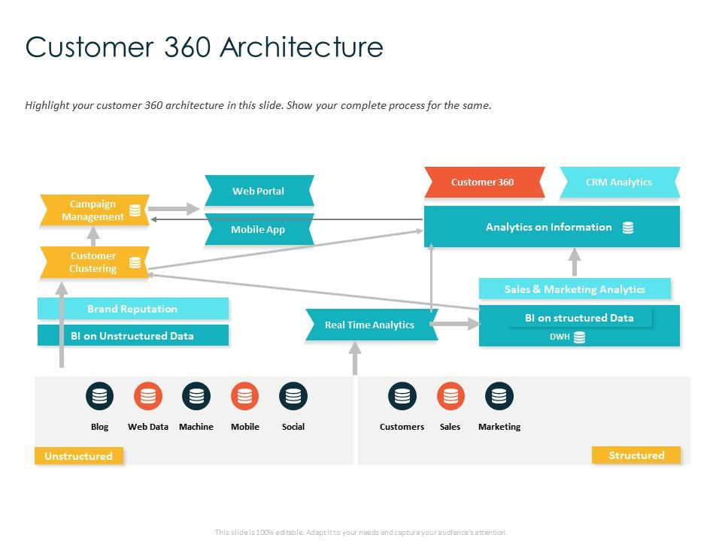

**2. Employee Portals**

=) Employee web portals, also known as intranet portals or enterprise portals, refer to a secure website in which a business can easily share information or discuss ideas within a secure environment. Employee portals are an excellent way to keep all staff members on the same page through effective knowledge-sharing capabilities.

=) An employee portal often makes relevant HR content readily available, including information on HR policies, benefits and pay. Many portals provide valuable content relating to employee well-being and career advice. Interface tools such as ‘search’ make it easy for employees to find the content they need quickly and efficiently.

=) Employee web portals are considered a self-service tool that can improve HR operations and essentially save businesses time and money. When employees have a resource for locating answers to common questions, it takes some of the burdens off HR staff. Comprehensive web portals also improve the employee experience which can have a positive effect on talent retention. When employees are satisfied in their job roles and have access to the knowledge they need, they are less likely to leave.

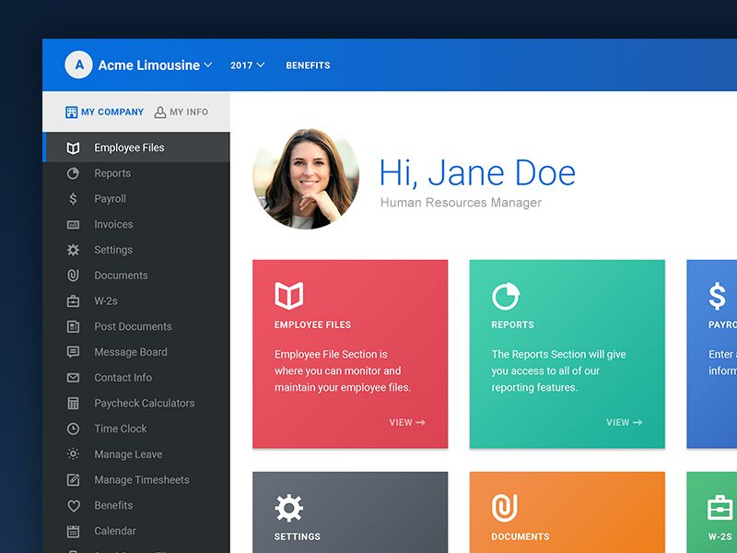

**3. Partner Portals**

=) In the world of business, it is not uncommon for businesses to work together to provide customers with a shared product or service. To work productively with one another, these businesses must constantly share up-to-date information, which can be difficult without the right technologies. Partner web portals make it simple to collaborate by providing both parties with a web-based secure site that can be securely accessed.

=) Partner portals aim to connect partners and streamline communications. Portals play a critical role in partner relationship management (PRM), a system used to link interconnected businesses. Similar to other types of web portals, partner portals are generally password protected and may take on a look and feel that reflects the business’s brand and mission.

=) Although partner portals may be used in a variety of ways to suit the needs of the businesses that use them, the company that creates the portal is usually the supplier. The companies that require the information from the supplier are known as the partners. A partner web portal is typically recommended to businesses that already have an existing relationship with a company. Businesses may include service providers, installers, resellers, vendors, distributors or similar groups that do business with a company.

**=) CASE STUDY ON ACCENTURE :-**

Accenture is a global professional services firm that offers consulting, technology, and outsourcing services. Their website features case studies in areas such as digital transformation, customer experience, and sustainability. One case study focuses on how a leading telecommunications company used analytics to improve their customer experience and reduce churn.

The Accenture Portal includes a menu system and a search capability that enable Accenture users to have a one-stop destination for finding Accenture resources and services.

The Accenture Portal has long been a starting point for company information and has a rich history. It is an asset that several internal stakeholder groups and the global IT organization take a fresh look at every few years to evaluate whether the balance of information and functionality on the portal reflects the current needs of employees. During one of these reviews, portal stakeholders decided it was time for something more than just a technology refresh to optimize the employee experience. The group decided to transform the way Accenture delivers not only information through the Accenture Portal, but all forms of internal communications geared toward employees.

**One of an employee’s first actions of the day is to visit the Accenture Portal, the gateway to all things Accenture and the main means of keeping our workforce connected, informed and enabled.**

**:-INTER FACE OF ACCENTURE**

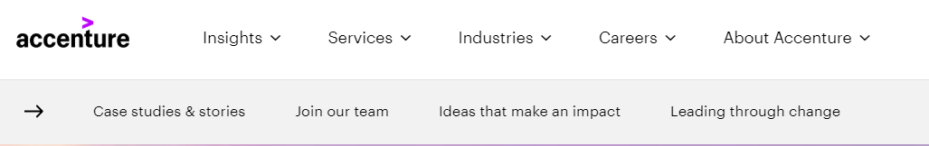

**:-SERVICES PROVIDED BY ACCENTURE**

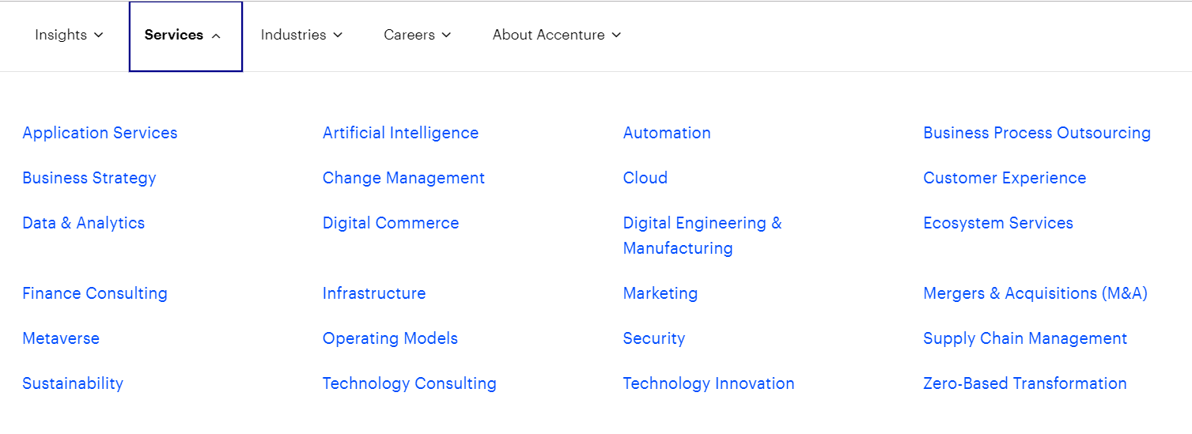

**:-ABOUT ACCENTURE**

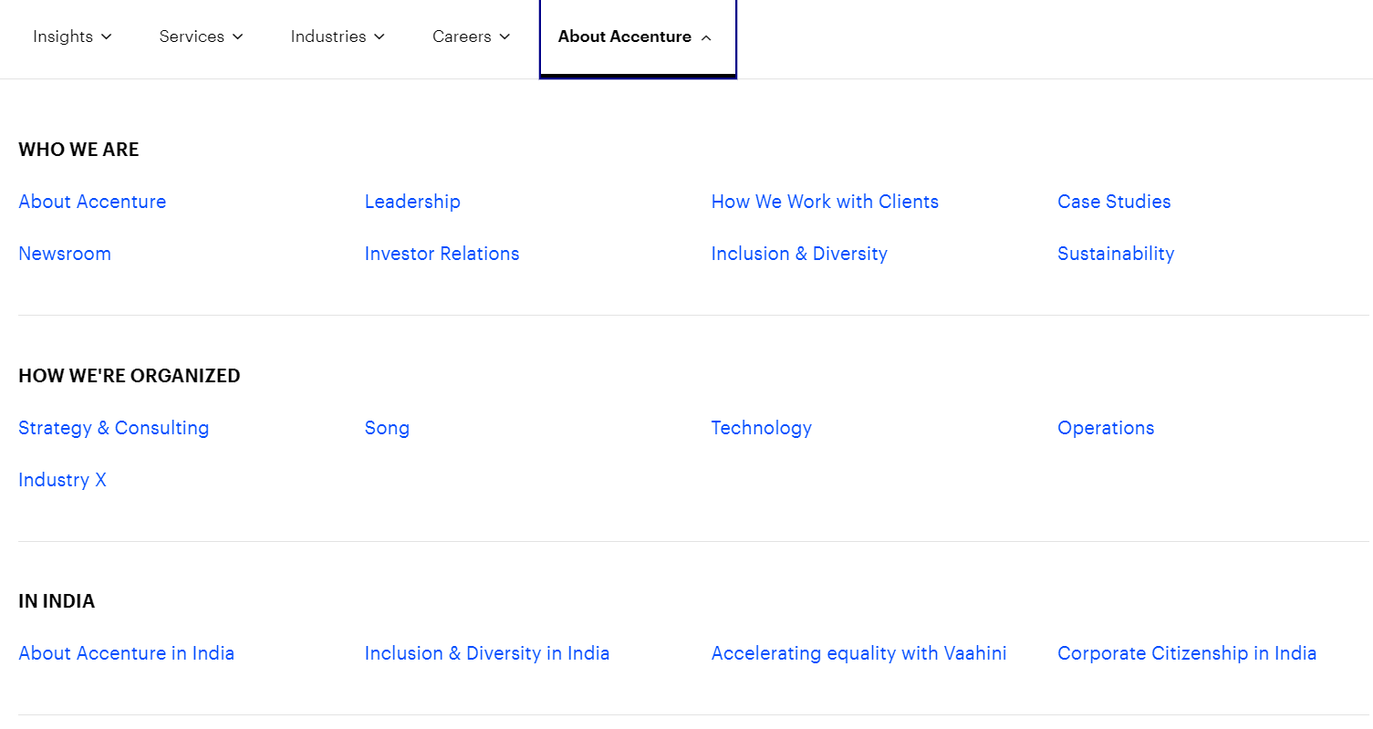

**:-SEARCH JOB AT ACCENTURE**

