1. Edit the html file in front-dashboard-v1.1 -> dist -> documentation-> profile-cover.html
2. In the Avatar section of profile-cover.html file, I have disabled the default input field and added the cropper just below the pen icon which will trigger the cropper.

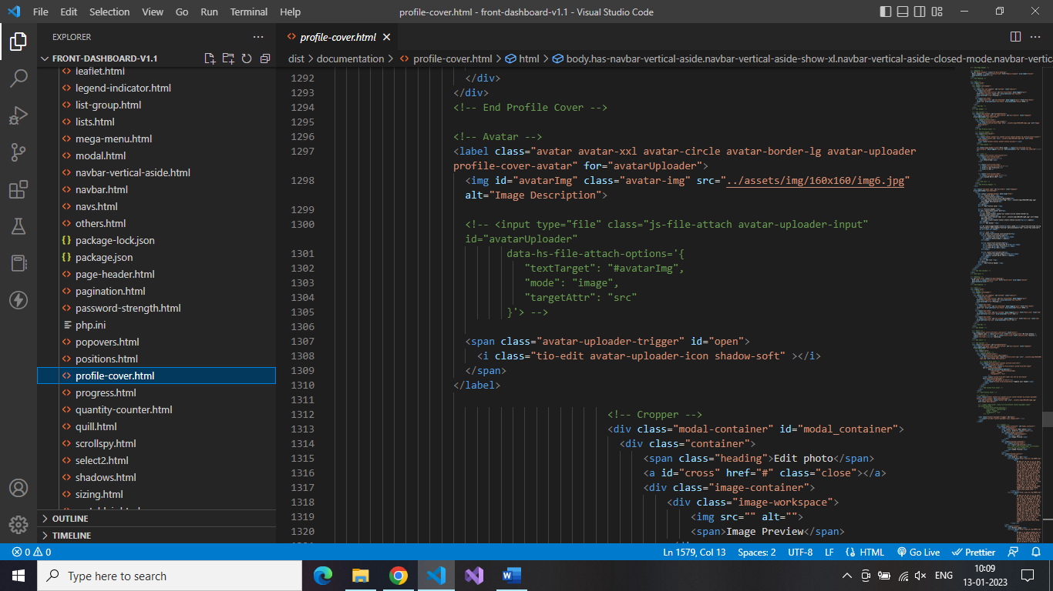

1. And saved all the supporting css and Js files in the same directory.
2. Below are the images showing how cropper is working in the theme.

1. The pen icon is triggering the cropper.

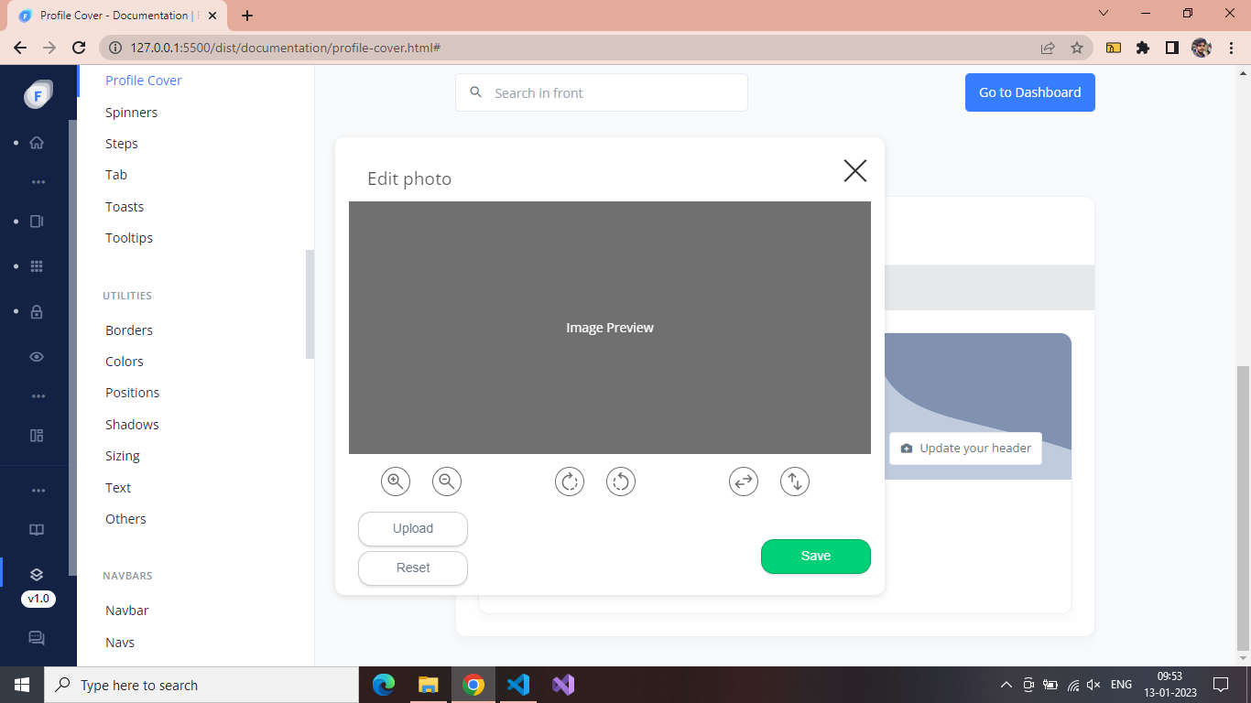

1. This repo is compatible with theme and only cropper code needs to be added along with css and js files.