

**UNIVERSITY OF PETROLEUM AND ENERGY STUDIES**

**School of Computer** **Science**

**2020-21**

**GRAPHICS AND ANIMATION TOOLS LAB**

**Faculty: Dr. DURGANSH SHARMA**

**Assistant Professor**

**Department of Cybernetics.**

**School of Computer Science, UPES**

**Submitted By:**

**Name- Vaibhav Kansal**

**Roll no-R100217086**

**Batch-B3**

**Semester- 7**

**Course-B.tech. CSE-OSOS**

**Sap Id- 500061579**

**Steps to Create our project**

Making the bowl of a Cup

1. Click on Add >> Mesh >> Cylinder for your beginning shape.
2. In the lower-left, go to the Add Cylinder alternatives.
3. Snap where it says NGON and select Triangle Fan.
4. Zoom in nearer to the chamber (utilizing the parchment wheel in the event that you have one), at that point, select the Object Mode in the lower left and change it to Edit Mode
5. Go to the Display Method (directly close to Edit Mode) and select Wireframe.
6. Right-click on the center point of the vertices at the highest point of the chamber to choose that face
7. Zoom in nearer, be certain your mouse is over your article and afterward press CTRL R. Keeping your cursor over the item, utilize your parchment haggle it up until there are 4 lines.
8. With your cursor at the top left of the cube, press B on your keyboard. Press and hold the left mouse button to make the selection that you need; the top vertices.
9. Abbreviate the top area. Snap on the blue bolt and move the chose vertices until they are more limited.
10. With the selection actually made, press S (Scale) and afterward type in size acc to your decision and afterward Enter.
11. Go to Edit Mode, switch back to Object Mode and change Wireframe to Solid.

Making the Coffee Cup Handle

1. Click your mouse to one side of your espresso mug to give Blender an essential 'purpose of inception' and afterward go to Add >> Curve >> Path.
2. With your latest choice (the Path) actually chose, change the Object Mode to Edit Mode.
3. Right click the left most node to choose it. You will utilize the bolts to move it where it should be.
4. Start calibrating the handle. You need it to associate about midpoint between the areas appeared previously. Get a decent shape, yet have it not exactly contacting the body of the cup.
5. Change from Edit Mode back to Object Mode then Deselect everything. Go to Add >> Curve >> Circle.
6. To apply the shape to your handle, right snap on the handle to choose it. Go to the Object Data button and select it.
7. In the Geometry area that you will see underneath the toolbar is a part called Bevel Object:. Snap on that and select BezierCircle. This will apply the shape to your handle.
8. Convert the handle into a Mesh object. Right snap the handle, select ALT C >> Mesh from Curve.
9. If your cup and handle are too far apart, select the cup and move it so that it is closer to the handle. Join the cup and the handle together so that they are one object.

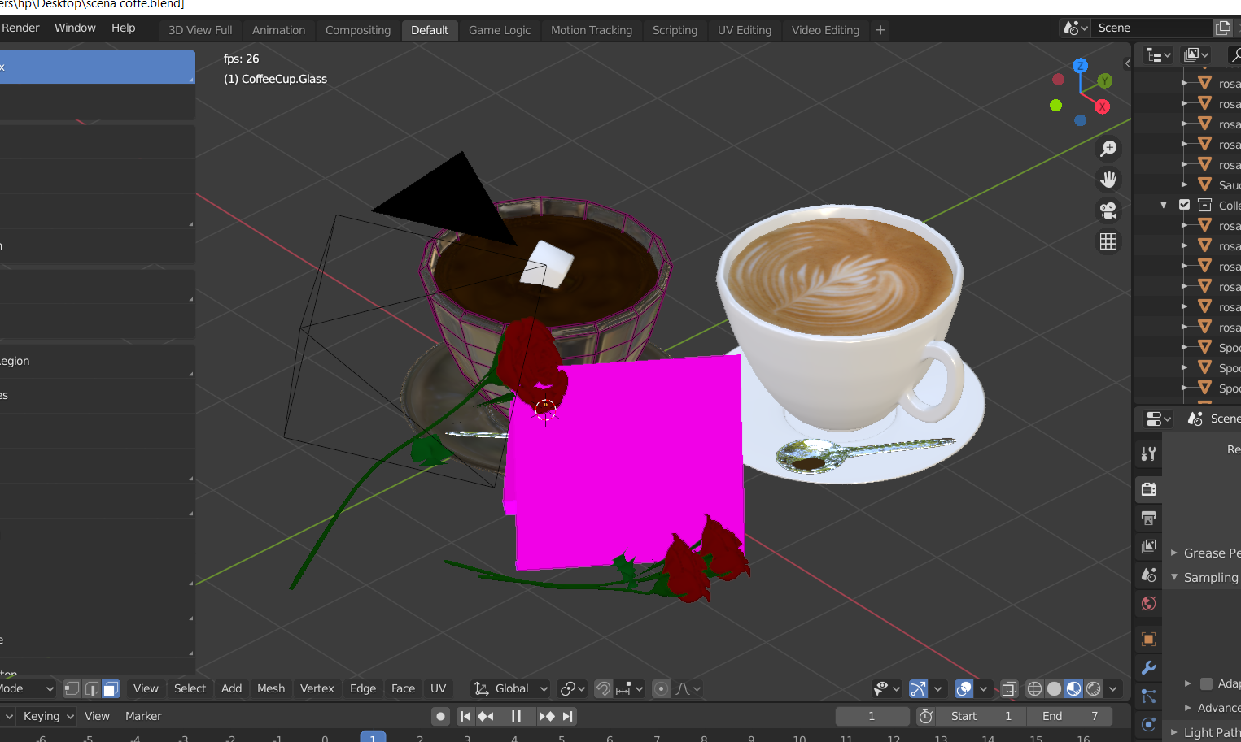

Connecting the Cup and the Handle

1. Go to where you selected Face Selection and change it to Edge Selection.
2. Hold down the SHIFT key, then press the other two edges that you see selected. Press F. This connects the edges into one face. Repeat for the other side.
3. On the bottom side of the top connection of the cup handle, do the same, but you will only be connecting two edges.
4. Do the same for the bottom part of the cup handle. Three on the outside connections, two on the inside.

After draw all the four things we can join them .