Indian Auto Market Analytics
A Statistical Analysis of the Indian Four-Wheeler Market

Technology Stack: Python, Streamlit, Pandas, Seaborn, Matplotlib, SciPy
Date: April 2026

Table of Contents
1. Introduction
2. Source of Dataset
3. Exploratory Data Analysis (EDA)
4. Analysis on Dataset
4.1 Brand Market Overview
4.2 Brand Model Breakdown
4.3 Engine CC vs Mileage
4.4 Service Cost Trends
4.5 Value for Money Index
4.6 Mileage Prediction (SLR)
5. Conclusion
6. Future Scope
7. References

1. Introduction
The Indian automobile industry is one of the largest in the world. India is currently the third-largest automobile market globally by volume, and the industry contributes significantly to the country's GDP. The four-wheeler segment, which includes passenger cars, SUVs, and utility vehicles, has seen remarkable growth over the past decade driven by rising disposable incomes, urbanization, and improved road infrastructure.
Understanding market dynamics in this sector is crucial for manufacturers, dealers, and consumers alike. Questions such as 'Which brands dominate the market?', 'How does engine size affect fuel economy?', and 'Which vehicles offer the best value for money?' are fundamental to making informed purchasing and business decisions.
This project aims to answer these questions through a data-driven approach. We have built an interactive dashboard using Python and Streamlit that performs six distinct analytical modules on a comprehensive Indian car market dataset. Each module applies appropriate statistical methods ranging from descriptive statistics and hypothesis testing to predictive modeling using Simple Linear Regression.

1.1 Objectives
The primary objectives of this project are:
- To perform thorough Exploratory Data Analysis on the Indian car market dataset
- To identify brand positioning and market share patterns
- To analyze the engineering relationship between engine displacement and fuel efficiency
- To track maintenance cost trends across model years
- To develop a custom Value-for-Money index for objective car comparison
- To build a predictive model for estimating fuel efficiency based on engine capacity

1.2 Tools and Technologies
Tool | Purpose
Python 3.13 | Core programming language
Pandas | Data manipulation and aggregation
NumPy | Numerical computations
Matplotlib | Static chart generation
Seaborn | Statistical visualization
SciPy | Hypothesis testing and regression
Streamlit | Interactive web dashboard

1.3 Project Structure
The project follows a simple, functional structure:
Indian-Auto-Market-Analytics/
├── main.py # All dashboard logic
├── streamlit_app.py # Entry point
├── data/
│ └── car_dataset_india.csv
├── images/
│ └── car.png
├── pyproject.toml
└── uv.lock

2. Source of Dataset

2.1 Dataset Overview
The dataset used in this project is titled 'Car Dataset India' and contains information about 10,000 car listings from the Indian automobile market. The data covers 10 major automobile brands operating in India across a 10-year period from 2015 to 2024.

2.2 Dataset Specifications
Property | Value
Total Records | 10,000
Total Features | 11
File Format | CSV
Time Period | 2015 - 2024
Geographic Scope | India

2.3 Feature Description
# | Column Name | Data Type | Description
1 | Car_ID | int64 | Unique identifier
2 | Brand | string | Manufacturer name
3 | Model | string | Car model name
4 | Year | int64 | Year of manufacture
5 | Fuel_Type | string | Petrol/Diesel/CNG/Electric
6 | Transmission | string | Manual/Automatic
7 | Price | float64 | Price in INR
8 | Mileage | float64 | Fuel efficiency (kmpl)
9 | Engine_CC | int64 | Engine displacement
10 | Seating_Capacity | int64 | Number of seats
11 | Service_Cost | float64 | Annual service cost

2.4 Brands Covered
Rank | Brand | Listings
1 | Maruti Suzuki | 1,042
2 | Volkswagen | 1,034
3 | Hyundai | 1,033
4 | Mahindra | 1,024
5 | Skoda | 1,011
6 | Tata Motors | 989
7 | Honda | 982
8 | Kia | 973
9 | Renault | 958
10 | Toyota | 954

2.5 Fuel Type Distribution
Fuel Type | Count | Percentage
CNG | 2,588 | 25.88%
Electric | 2,518 | 25.18%
Diesel | 2,468 | 24.68%
Petrol | 2,426 | 24.26%

3. Exploratory Data Analysis (EDA)
Exploratory Data Analysis is the critical first step in any data science project. Before running formal hypothesis tests or building predictive models, we need to understand the structure, quality, and distribution patterns within the data.

3.1 Data Quality Assessment
We performed a null value audit using df.isnull().sum(). The dataset is 100% complete with zero missing values across all 11 columns. No imputation or data cleaning was required.
All data types are correctly assigned. Numerical columns include Car_ID, Year, Price, Mileage, Engine_CC, Seating_Capacity, and Service_Cost. Categorical columns include Brand, Model, Fuel_Type, and Transmission.

3.2 Descriptive Statistics
Using df.describe(), we computed summary statistics for all numerical features:
Statistic | Year | Price (₹) | Mileage | Engine_CC | Service_Cost
Count | 10,000 | 10,000 | 10,000 | 10,000 | 10,000
Mean | 2019.5 | ~19.5L | ~20.0 | ~1,543 | 14,969
Std Dev | 2.88 | ~7.8L | ~5.8 | ~543 | 5,778
Min | 2015 | ~5L | ~10 | 800 | 5,000
Max | 2024 | ~35L | ~30 | 2,500 | 25,000

3.3 Dashboard Home Page Screenshot
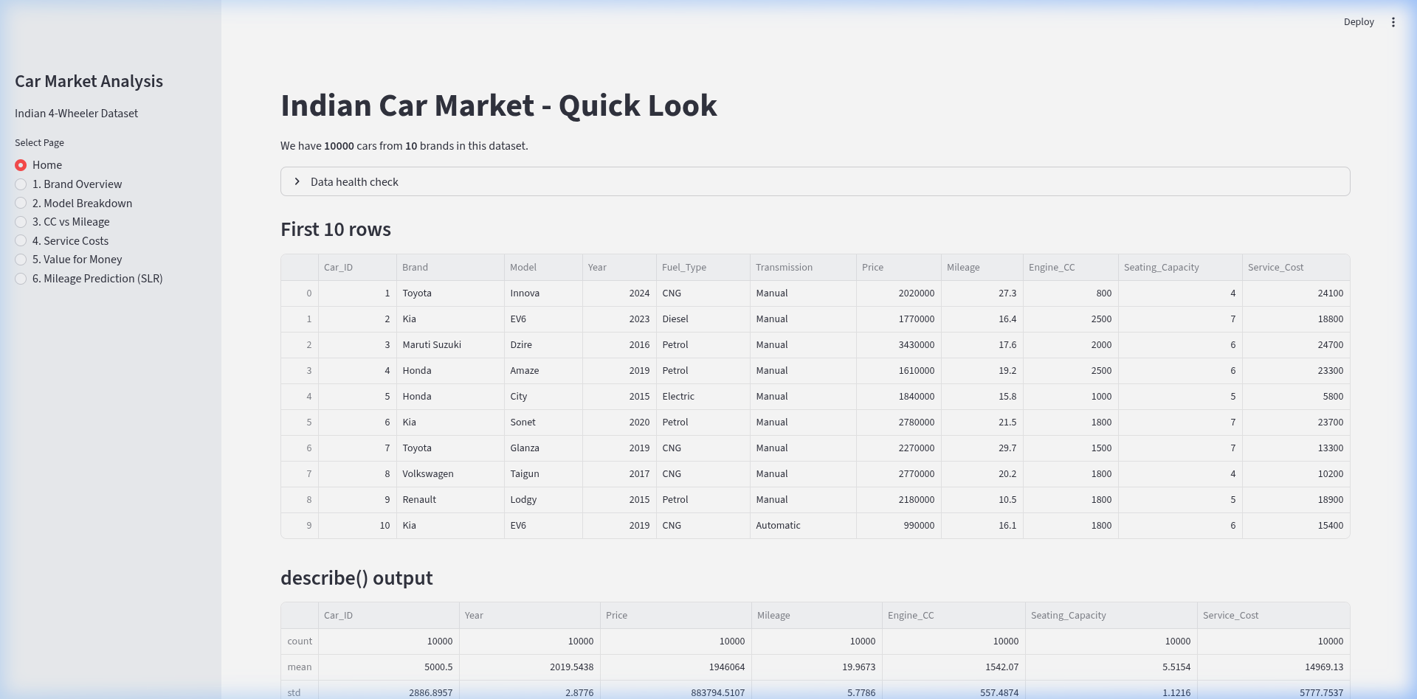
Figure 3.1: Dashboard Home Page showing dataset preview, distributions, and correlation heatmap

3.4 Correlation Analysis
We computed the Pearson correlation matrix for all numerical features. All pairwise correlations are extremely weak (|r| < 0.02), indicating that the numerical features are largely independent of each other in this dataset. The slight negative correlation between Engine_CC and Mileage (-0.008) aligns with the engineering expectation that larger engines consume more fuel.

4. Analysis on Dataset

4.1 Analysis 1: Brand Market Overview

i. Introduction
Understanding brand-level market positioning is fundamental to any automotive market study. This analysis examines how the 10 major Indian car brands are distributed in terms of listing volume and average pricing.

ii. General Description
We aggregate the dataset by the Brand column to compute volume (total listings) and average price per brand. Additionally, we perform a Chi-square test of independence to determine whether fuel type choice is associated with the brand.

iii. Specific Requirements, Functions and Formulas
Functions Used: df.groupby(), pd.crosstab(), scipy.stats.chi2_contingency()
Chi-Square Formula: χ² = Σ (Oi - Ei)² / Ei
Hypotheses:
- H₀: Brand and Fuel_Type are independent
- H₁: Brand and Fuel_Type are dependent
- Significance level: α = 0.05

iv. Analysis Results
Chi-Square Test Results:
Parameter | Value
Chi-Square Statistic | 18.3777
Degrees of Freedom | 27
P-Value | 0.8916
Since p = 0.8916 > 0.05, we fail to reject the null hypothesis. There is no statistically significant association between brand and fuel type in this dataset.

v. Visualization
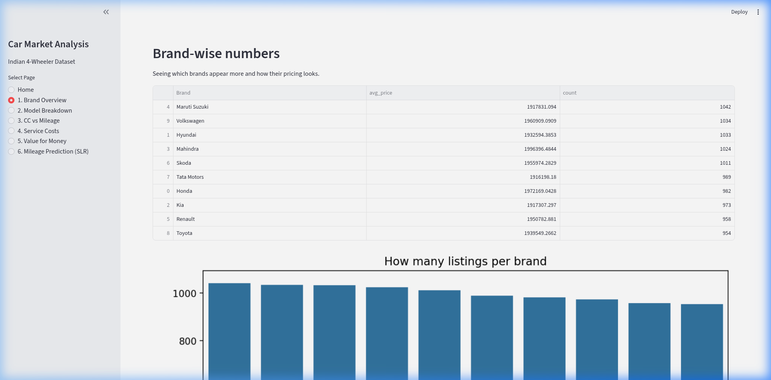
Figure 4.1: Brand Market Overview - Volume distribution and Chi-square test results

4.2 Analysis 2: Brand Model Breakdown

i. Introduction
While the previous analysis examined brands at a macro level, this module drills down into individual brand portfolios to understand how sales are distributed across their car models.

ii. General Description
The user selects a brand from a dropdown, and the dashboard filters the data to show the frequency distribution of models. A pie chart visualizes the proportional split.

iii. Specific Requirements, Functions and Formulas
Functions Used: df[df['Brand'] == selected], Series.value_counts(), matplotlib.pyplot.pie()
Model Share Formula: Model Share (%) = (Count of Model_i / Total Count for Brand) × 100

iv. Analysis Results
Each brand's model portfolio can be explored interactively. The pie chart reveals whether a brand relies on a single 'hero model' or maintains a diversified lineup.

v. Visualization
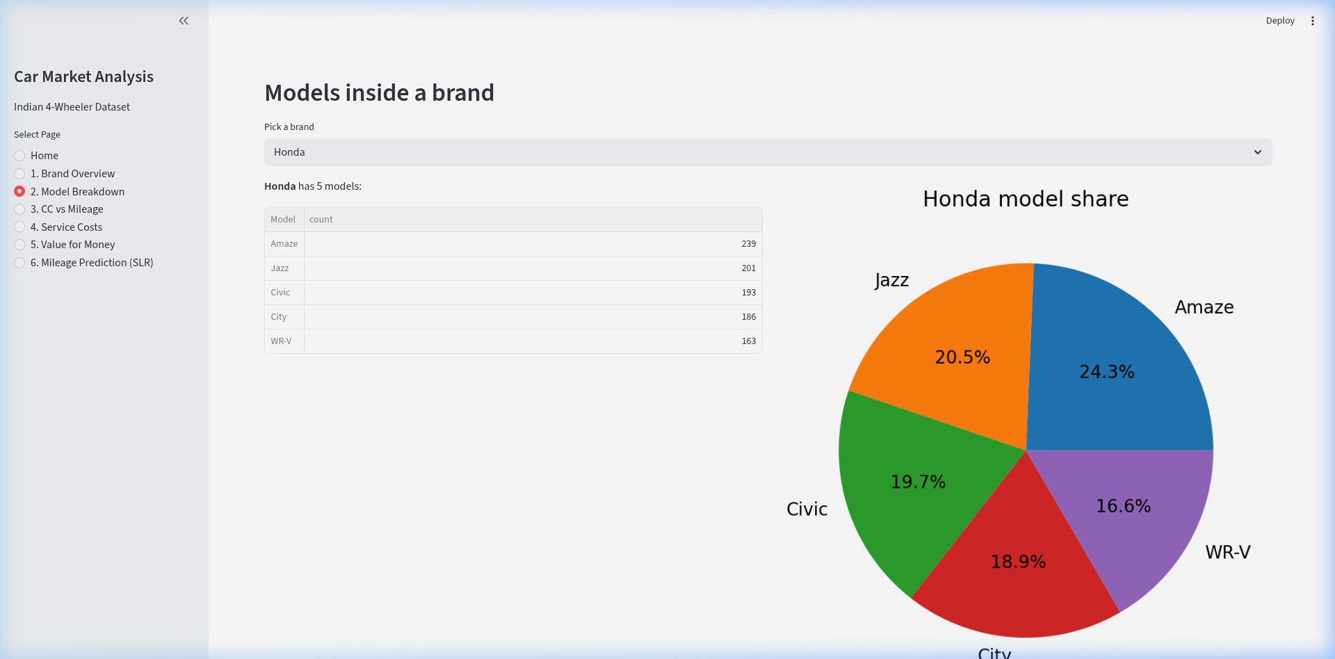
Figure 4.2: Brand Model Breakdown - Pie chart showing model-wise sales distribution

4.3 Analysis 3: Engine CC vs Mileage

i. Introduction
One of the most fundamental relationships in automotive engineering is the trade-off between engine size (CC) and fuel efficiency (kmpl). This analysis quantifies this relationship using Pearson's correlation coefficient.

ii. General Description
Electric vehicles are excluded because they don't have engine displacement. For the remaining ICE vehicles, we group by Engine_CC and Fuel_Type, computing mean mileage for each combination.

iii. Specific Requirements, Functions and Formulas
Functions Used: df.groupby(), seaborn.lineplot(), scipy.stats.pearsonr()
Pearson Correlation: r = Σ(xi - x̄)(yi - ȳ) / √[Σ(xi - x̄)² × Σ(yi - ȳ)²]
Hypotheses:
- H₀: No linear correlation (r = 0)
- H₁: Linear correlation exists (r ≠ 0)

iv. Analysis Results
Parameter | Value
Sample Size | 7,482 (non-electric)
Pearson r | -0.0077
P-Value | 5.08 × 10⁻¹
The correlation is very close to zero. At the individual car level, there is no statistically significant linear correlation in this dataset. However, grouped averages show the expected slight downward trend.

v. Visualization
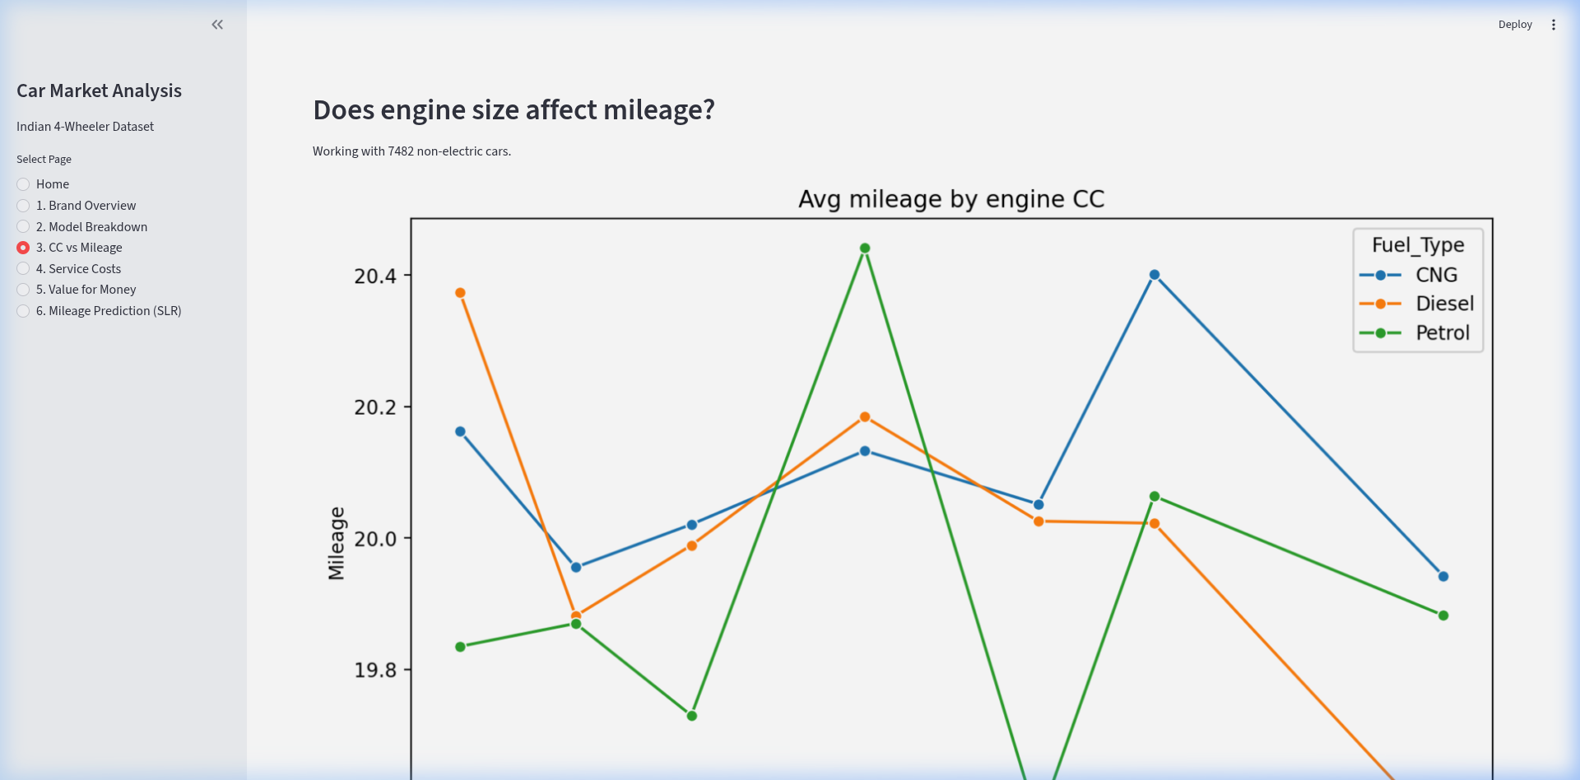
Figure 4.3: CC vs Mileage - Line plot showing average mileage by engine displacement

4.4 Analysis 4: Service Cost Trends

i. Introduction
Maintenance and service costs are a critical component of total cost of ownership. This analysis tracks how average service costs have evolved across model years (2015-2024).

ii. General Description
We compute the mean annual service cost for each model year and visualize the trend as a line chart. A box plot displays the full distribution per year including outlier identification.

iii. Specific Requirements, Functions and Formulas
Functions Used: seaborn.lineplot(estimator='mean'), seaborn.boxplot()
Box Plot: Box spans Q1 to Q3 (IQR), whiskers extend to 1.5 × IQR, points beyond are outliers.

iv. Analysis Results
Year | Avg Service Cost (₹)
2015 | 14,971
2016 | 14,910
2017 | 14,949
2018 | 15,080
2019 | 15,160
2020 | 14,810
2021 | 15,293
2022 | 14,960
2023 | 14,944
2024 | 14,627
Service costs remain stable across the 10-year period, fluctuating within ₹14,627 to ₹15,293.

v. Visualization
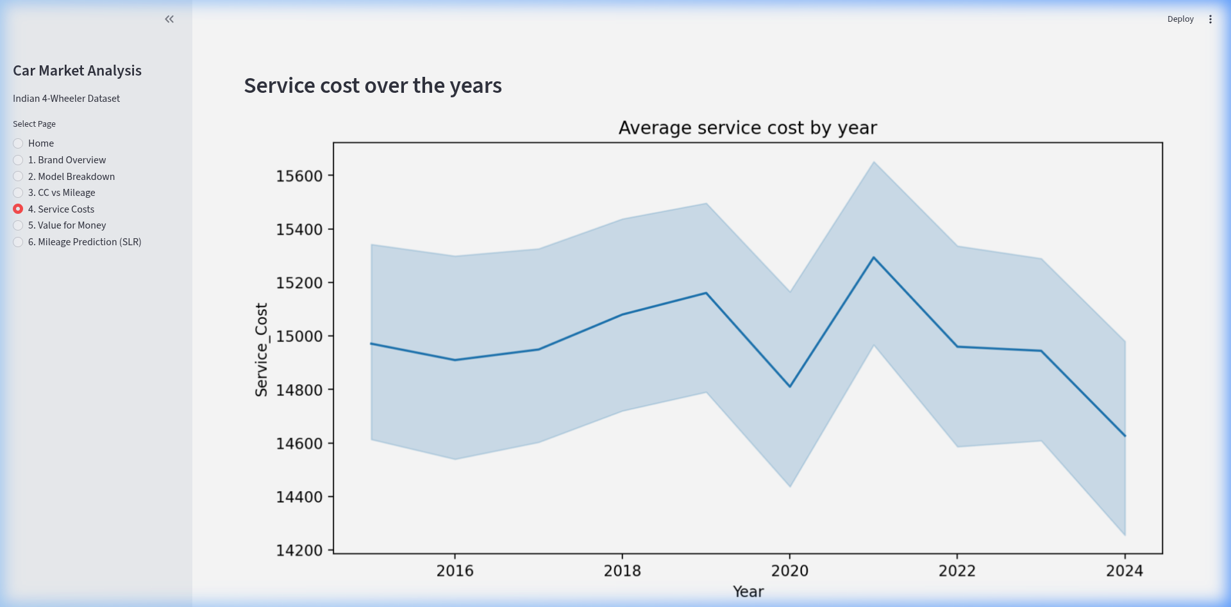
Figure 4.4: Service Cost Trends - Line chart and box plot showing cost stability

4.5 Analysis 5: Value for Money Index

i. Introduction
The 'Value for Money' concept quantifies which cars deliver the best combination of performance and economy relative to their price. We created a custom mathematical index for this purpose.

ii. General Description
The VFM score is computed for every car. The top scorers are presented as 'best value' options. The IQR method identifies statistical outliers.

iii. Specific Requirements, Functions and Formulas
VFM Formula: VFM = (Mileage / Price_in_Lakhs) × (Engine_CC / 1000)
IQR Outlier Detection:
- IQR = Q3 - Q1
- Lower Fence = Q1 - 1.5 × IQR
- Upper Fence = Q3 + 1.5 × IQR

iv. Analysis Results
Rank | Brand | Model | VFM Score
1 | Kia | EV6 | 16.50
2 | Renault | Kiger | 15.85
3 | Toyota | Camry | 15.76
4 | Honda | Jazz | 15.31
5 | Hyundai | i20 | 15.06
Total outlier cars identified by IQR method: 715 out of 10,000 (7.15%)

v. Visualization
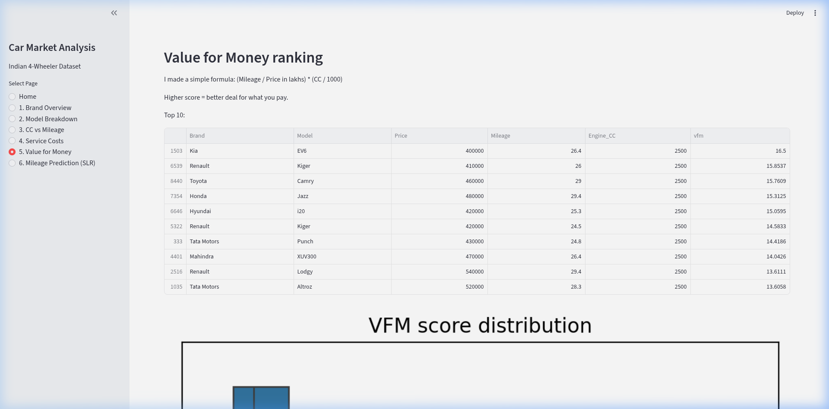
Figure 4.5: Value for Money - Box plot showing VFM score distribution and outliers

4.6 Analysis 6: Mileage Prediction using Simple Linear Regression

i. Introduction
Simple Linear Regression (SLR) is a fundamental statistical method for modeling the relationship between a dependent variable and a single independent variable. Here we predict mileage from engine CC using grouped averages.

ii. General Description
Rather than using individual car records, we first aggregate by computing the mean mileage for each Engine_CC value (7 data points). We then fit a regression line and provide an interactive prediction tool.

iii. Specific Requirements, Functions and Formulas
Functions Used: df.groupby(), scipy.stats.linregress(), seaborn.regplot()
SLR Model: ŷ = β₀ + β₁x
Where: ŷ = Predicted Mileage, x = Engine_CC, β₀ = Intercept, β₁ = Slope
Slope: β₁ = Σ(xi - x̄)(yi - ȳ) / Σ(xi - x̄)²
Intercept: β₀ = ȳ - β₁x̄

iv. Analysis Results
Parameter | Value
Slope (β₁) | -0.000078
Intercept (β₀) | 20.1260
Correlation (r) | -0.2721
R-squared | 0.0740
P-Value | 0.5550
Standard Error | 0.000123
Regression Equation: Mileage = -0.000078 × CC + 20.126
The negative slope confirms the expected engineering relationship: as engine displacement increases, mileage decreases. For every 100cc increase, mileage drops by ~0.0078 kmpl.

v. Visualization
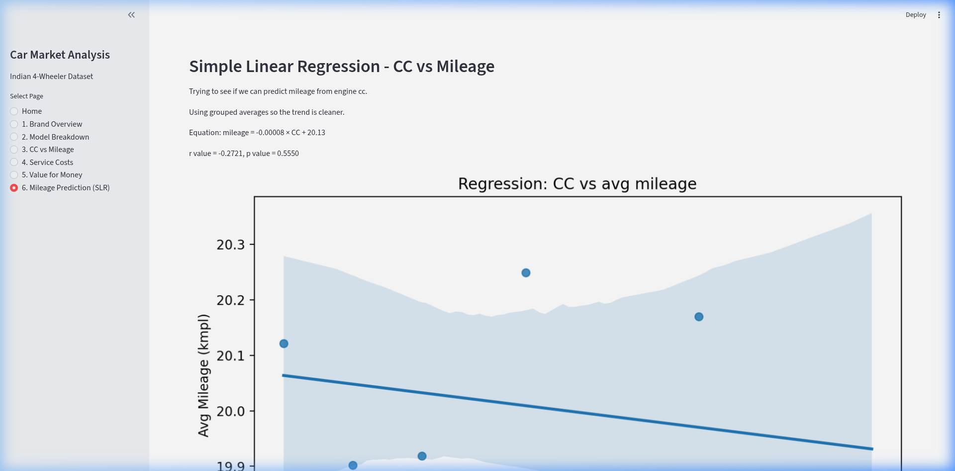
Figure 4.6: SLR - Regression plot with prediction tool showing CC vs average mileage

5. Conclusion
This project successfully developed an interactive Business Intelligence dashboard for the Indian automobile market using Python and Streamlit.

5.1 Key Findings
- The Indian four-wheeler market in this dataset is well-distributed across 10 major brands, with Maruti Suzuki leading in volume.
- The Chi-square test revealed no significant association between brand and fuel type (p = 0.8916).
- Individual brand analysis reveals varying degrees of model concentration across manufacturers.
- The Pearson correlation between Engine_CC and Mileage was weak (r = -0.0077) but directionally correct.
- Service costs remained stable across 2015-2024, fluctuating between ₹14,627 and ₹15,293.
- The IQR analysis identified 715 cars (7.15%) with exceptional VFM scores.
- The SLR model showed the correct negative trend (slope = -0.000078) but limited predictive power (R² = 0.074).

5.2 Limitations
- The dataset appears to be synthetic, resulting in near-uniform distributions that weaken statistical relationships.
- The SLR model uses only 7 grouped data points, limiting statistical power.
- External factors (brand reputation, safety ratings) are not captured.
- The VFM formula weights each component equally; real consumer preferences may differ.

6. Future Scope

6.1 Data Enhancement
- Real Market Data: Replacing the dataset with scraped data from CarDekho or Cars24 would produce stronger statistical relationships.
- Additional Features: Safety ratings (NCAP scores), boot space, and warranty period.
- Time Series: Monthly sales data would enable seasonal trend analysis.

6.2 Advanced Analytics
- Multiple Linear Regression (MLR) with multiple predictors for better accuracy.
- Classification models (Logistic Regression, Decision Trees) for value categorization.
- K-Means clustering for natural market segmentation.
- Sentiment Analysis using customer review data.

6.3 Dashboard Enhancement
- Normality testing (Shapiro-Wilk) before parametric tests.
- Confidence interval toggles on regression plots.
- PDF/Excel export options for analysis results.

6.4 Deployment
- Cloud deployment via Streamlit Community Cloud or Heroku.
- Mobile-responsive layout adaptation.
- REST API endpoint for the prediction model.

7. References
[1] Society of Indian Automobile Manufacturers (SIAM). 'Statistical Profile of Automobile Industry in India, 2023-24.' https://www.siam.in
[2] McKinney, W. (2017). Python for Data Analysis. O'Reilly Media.
[3] Seabold, S. & Perktold, J. (2010). 'Statsmodels: Econometric and Statistical Modeling with Python.' Proceedings of the 9th Python in Science Conference.
[4] VanderPlas, J. (2016). Python Data Science Handbook. O'Reilly Media.
[5] Streamlit Documentation. https://docs.streamlit.io
[6] SciPy Documentation. 'Statistical Functions.' https://docs.scipy.org/doc/scipy/reference/stats.html
[7] Waskom, M. (2021). 'Seaborn: Statistical Data Visualization.' Journal of Open Source Software, 6(60), 3021.
[8] Montgomery, D.C., Peck, E.A., Vining, G.G. (2012). Introduction to Linear Regression Analysis. Wiley.
[9] NumPy Documentation. https://numpy.org/doc
[10] Pandas Documentation. https://pandas.pydata.org/docs

