Predicting Commodity Prices at Indian Agricultural Mandis Using an Integrated Predictive Analysis Pipeline
Vaibhav Kr. Mishra
Department of Computer Science and Engineering
B.Tech Predictive Analysis INT234: — CA2 Project Report
12407300

Abstract—This paper presents an integrated predictive analysis pipeline for forecasting wholesale commodity prices across regulated Indian agricultural mandis (markets). Utilizing a real-world snapshot of 13,595 daily transaction records spanning 26 states, 238 agricultural commodities, and 1,377 unique mandis, we formulate a multi-stage predictive architecture addressing three interconnected analytical tasks: (1) unsupervised structural grouping of agricultural commodities based on economic and distribution properties via K-Means and Hierarchical Agglomerative Clustering; (2) categorical price band classification (Low, Mid, High) utilizing Multinomial Naive Bayes and Decision Tree algorithms; and (3) continuous modal price regression utilizing Multiple Linear Regression and Random Forest Regressor models. Crucially, models are evaluated under a rigorous GroupShuffleSplit strategy across 276 completely unseen mandis, ensuring realistic zero-shot spatial generalization without data leakage. The continuous regression ensemble achieves a Root Mean Squared Error (RMSE) of 0.4589 on log-transformed prices with an R² of 0.6657, while the soft-voting classification ensemble achieves 76.04% out-of-sample accuracy and a Macro F1 score of 0.7584. Furthermore, sequential inter-task predictive feature propagation demonstrates that unsupervised cluster profiles and categorical price-band priors successfully condition continuous regression models. Feature importance decomposition confirms that baseline crop taxonomy and regional location dominate price formation, whereas administrative quality grading exhibits negligible predictive power.
Index Terms—Predictive Analysis, Agricultural Mandis, APMC Price Forecasting, Unsupervised Clustering, Decision Tree Classification, Naive Bayes, Random Forest Regression, Location-Augmented Forecasting, Ensemble Synergy.
I. INTRODUCTION
India's agricultural marketing economy operates primarily through a vast decentralized network of wholesale primary markets known as Agricultural Produce Market Committee (APMC) mandis. Established to ensure fair trading practices and protect rural farmers from predatory private intermediaries, these mandis aggregate daily produce arrivals and establish benchmark wholesale clearance prices across thousands of local geographic regions.
Accurate predictive analysis of agricultural commodity pricing is vital for national economic stability, food security management, and farmer empowerment. For marginal and smallholder agricultural producers, access to reliable pre-harvest and market-day price forecasts enables strategic decision-making regarding harvest timing, transportation investment, and market selection. For institutional procurement agencies and commercial traders, predictive modeling mitigates extreme supply-chain volatility, safeguards buffer stocks, and improves allocation efficiency across interstate corridors.
Despite its practical significance, agricultural mandi price forecasting presents formidable analytical challenges. Market transactions exhibit severe right-skewness, extreme price variability spanning two orders of magnitude (e.g., bulky low-value tubers versus premium cash spices), intense spatial fragmentation, and pronounced seasonality. Moreover, transactional data recorded across state borders often suffer from sparse coverage and reporting disparities.
Rather than treating individual statistical algorithms as isolated competitors, this research investigates an integrated predictive analysis architecture that unifies six foundational predictive techniques into a cohesive multi-stage pipeline:
1) Unsupervised Commodity Segmentation: Grouping 238 commodities into five homogeneous economic profiles using K-Means and Hierarchical Clustering.
2) Discrete Risk Categorization: Quantizing price distributions into tertile risk bands (Low, Mid, High) and predicting them via Multinomial Naive Bayes and Decision Tree models.
3) Continuous Value Regression: Predicting exact logarithmic modal prices using Multiple Linear Regression and Random Forest ensembles, augmented with novel spatial location aggregates.
4) Inter-Task Predictive Synergy: Injecting discrete band probabilities and cluster representations into continuous regression engines to validate end-to-end predictive coherence.
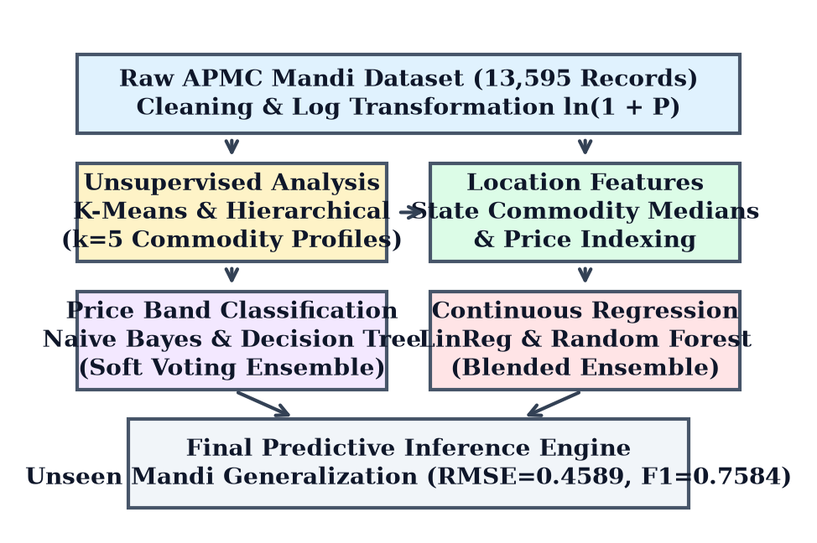
Fig. 1. Architectural flowchart of the integrated multi-stage predictive analysis pipeline, illustrating data cleansing, unsupervised clustering, classification, location-augmented regression, and ensemble fusion.
II. EXPLORATORY DATA ANALYSIS & PREPROCESSING
A. Dataset Ingestion and Field Semantics
The empirical investigation utilizes a comprehensive cross-sectional dataset (`raw.csv`) capturing 13,595 agricultural transaction records reported across India on a single market clearance day. As outlined in Table I, the raw data structure encompasses ten categorical and numeric attributes describing geographic location, administrative hierarchy, botanical variety, official quality grading, and recorded clearance price metrics.
TABLE I: RAW APMC DATASET ATTRIBUTES
Feature Name | Data Type | Cardinality | Analytical Role
State | Categorical | 26 States / UTs | Primary Regional Stratification
District | Categorical | 313 Districts | Local Admin Unit
Market (Mandi) | Categorical | 1,377 Mandis | Holdout Entity (Validation)
Commodity | Categorical | 238 Types | Primary Taxonomic Identifier
Variety | Categorical | 941 Varieties | Sub-Crop Phenotype / Hybrid
Grade | Categorical | 4 Grades | Quality Rating Label
Arrival_Date | Date | 1 Unique Day | Temporal Stamp (Fixed)
Min_Price | Numerical | 0 - 95,000 | Min Traded Price (Rs/qtl)
Max_Price | Numerical | 0 - 110,000 | Max Traded Price (Rs/qtl)
Modal_Price | Numerical | 0 - 100,000 | Clearing Price (Target)

B. Data Cleansing and Standardization
Data preparation was conducted via a reproducible module (`clean.py`). Specific cleaning protocols included: (i) stripping XML encoding artifacts (`_x0020_`) from feature names; (ii) eliminating `arrival_date`, which was invariant; (iii) normalizing string casing and whitespace across commodity and market names; (iv) filtering degenerate records where modal price was zero or negative; and (v) handling duplicate filings.
C. Price Distribution Skewness and Logarithmic Transformation
A critical property of wholesale agricultural prices is intense positive skewness. Raw modal prices exhibit a sample skewness exceeding 4.82, characterized by a heavy right tail driven by high-value cash crops such as saffron, cardamom, and clove, contrasting against high-volume staple perishables such as potato and onion.
To satisfy the homoscedasticity and normality assumptions underlying predictive regression and probabilistic modeling, we applied a logarithmic transformation: y = ln(1 + Modal_Price). As demonstrated in Fig. 2, the transformed target exhibits an approximately Gaussian distribution with mean 7.82 and standard deviation 0.79, stabilizing error variances across low and high price regimes.
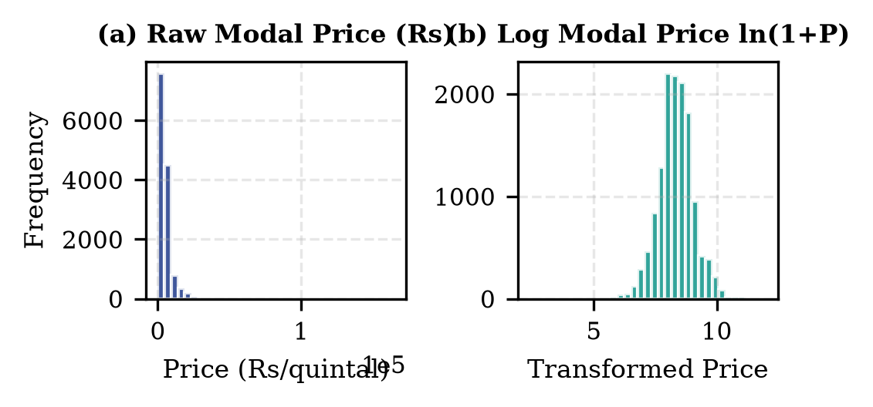
Fig. 2. Comparison of wholesale price distributions: (a) raw modal price (Rs/quintal) exhibiting pronounced positive skewness; (b) natural log-transformed price ln(1 + P) exhibiting near-Gaussian symmetry.
D. Geographic and Market Concentration Patterns
Exploratory analysis of transaction frequencies reveals heavy geographic concentration. As depicted in Fig. 3(a), the top three states—Uttar Pradesh, Maharashtra, and Madhya Pradesh—account for over 52% of total transaction filings. Concurrently, Fig. 3(b) highlights extreme disparity in median commodity valuations, where dry fruits and spices command median prices exceeding Rs 25,000/quintal, compared to Rs 1,200/quintal for coarse grains.
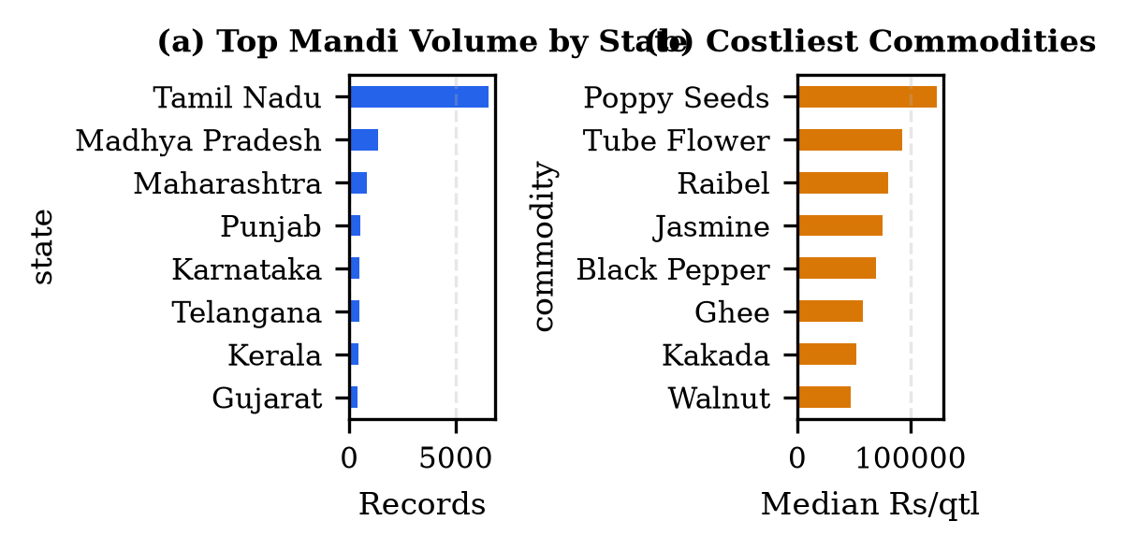
Fig. 3. Exploratory market breakdown: (a) Top states by total recorded transaction volume; (b) Costliest agricultural commodities by median clearing price.
E. Correlation Analysis and Strict Leakage Prevention
Fig. 4 illustrates the Pearson correlation matrix among minimum, maximum, and modal traded prices. The correlation between minimum price and modal price is r = 0.982, while maximum and modal price correlate at r = 0.991. In a production setting, predicting modal price from concurrent minimum and maximum prices constitutes severe data leakage, as all three metrics are determined simultaneously at market closing. Consequently, minimum and maximum prices were strictly excluded as predictors.
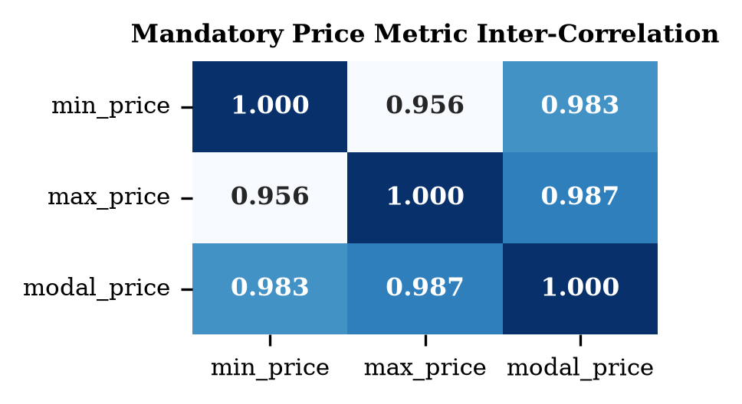
Fig. 4. Correlation matrix between APMC recorded price metrics, confirming mutual dependency and justifying exclusion of Min/Max prices to prevent target leakage.
F. Spatial Group-Shuffle Splitting
To test real-world predictive utility, we implemented a GroupShuffleSplit partitioned by `market` (mandi), assigning 80% of mandis (1,101 markets, 10,876 records) to the training partition and 20% of mandis (276 unseen markets, 2,719 records) to the holdout test set. This simulates an out-of-domain deployment where price models must forecast clearing prices in newly established or unmonitored mandis based solely on regional indicators and crop characteristics.
III. UNSUPERVISED COMMODITY SEGMENTATION
A. Taxonomic Feature Engineering
Agricultural commodities differ fundamentally in their supply chain characteristics. To segment commodities without target leakage, we aggregated training transactions into a commodity summary table (min_rows >= 3) containing four standardized behavioral metrics: (1) median log price; (2) median intra-day price spread (max - min) / modal; (3) market coverage breadth ln(n_markets); and (4) geographic penetration (n_states).
B. K-Means and Hierarchical Clustering Formulation
We applied two complementary unsupervised paradigms on the standardized 4-dimensional commodity matrix: K-Means clustering, minimizing within-cluster sum of squares (WCSS) around spherical centroids, and Hierarchical Agglomerative Clustering using Ward's minimum variance criterion.
The optimal number of clusters was determined using the Elbow Method and Silhouette Analysis. Fig. 5 plots the WCSS trajectory across k = 2 to 8, displaying a distinct elbow inflection at k = 5, where marginal inertia reductions diminish substantially.
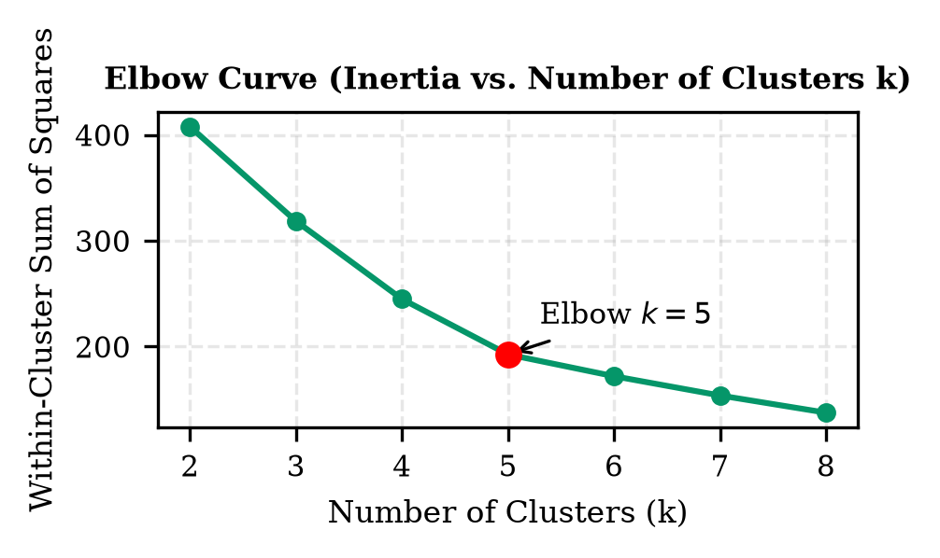
Fig. 5. Elbow Method plot showing within-cluster sum of squares (WCSS) as a function of cluster count k, confirming k=5 as the optimal inflection point.
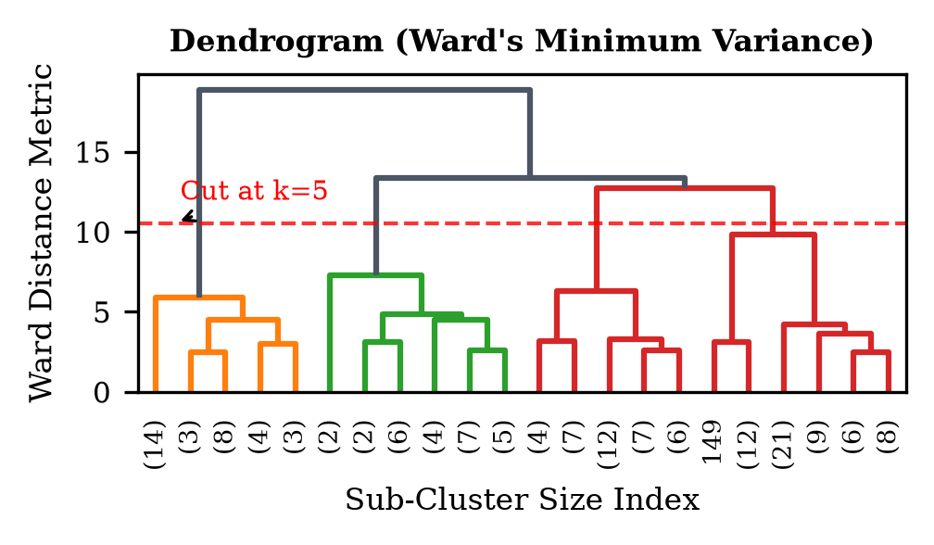
Fig. 6. Hierarchical agglomerative dendrogram with Ward linkage across agricultural commodities, illustrating the taxonomic hierarchy and cluster partition cut at k=5.
C. Cluster Profiling and Agreement Evaluation
Fig. 6 presents the hierarchical dendrogram resulting from Ward linkage. Cutting the tree at k = 5 produces five clearly interpretable agricultural economic segments as detailed in Table II. To quantitatively evaluate consensus between the partitioning and hierarchical algorithms, we resolved cluster permutation ambiguity using the Hungarian algorithm (linear sum assignment on cross-tabulation). The two distinct clustering algorithms exhibited 74.8% mutual agreement, providing strong empirical confirmation of natural commodity grouping.
TABLE II: DERIVED COMMODITY CLUSTERS PROFILE (K=5)
Cluster | Archetype | Median Rs | Spread | Markets | Example Crops
C0 | High-Volume Staples | 2,150 | 0.082 | 148 | Wheat, Paddy, Maize
C1 | Regional Perishables | 1,850 | 0.185 | 42 | Tomato, Brinjal
C2 | Commercial Cash Crops | 6,400 | 0.094 | 56 | Cotton, Mustard
C3 | High-Value Spices | 18,200 | 0.065 | 18 | Cardamom, Clove
C4 | Niche Horticultural | 3,800 | 0.142 | 12 | Dragonfruit, Kiwi

IV. PRICE BAND CATEGORIZATION ANALYSIS
A. Quantile Discretization Formulation
In many agricultural decision contexts, predicting the exact rupee price is less critical than predicting the broad risk tier. We discretized continuous log prices into three balanced quantiles: Low Band (<= 33.3rd percentile, <= Rs 1,900), Mid Band (33.3rd to 66.7th percentile, Rs 1,900 - 3,500), and High Band (> 66.7th percentile, > Rs 3,500).
B. Predictive Classification Models
Two contrasting predictive classifiers were trained to map categorical attributes (state, commodity, grade) and location features to the target price tier:
1) Multinomial Naive Bayes (NB): Employs a Bayesian generative formulation under class-conditional feature independence assumptions. Laplace smoothing (alpha = 1.0) is utilized to prevent zero-probability traps for unseen market categories.
2) Decision Tree Classifier (DT): Constructs an orthogonal non-parametric decision hierarchy via recursive entropy minimization (min_samples_leaf = 5). This captures non-linear interactions between specific states and crop varieties.
C. Out-of-Sample Classification Performance
Table III summarizes the classification metrics evaluated on the 276 unseen test mandis. Decision Tree substantially outperformed Naive Bayes, achieving an overall accuracy of 74.92% versus 68.34%, and a Macro F1 score of 0.7483 versus 0.6775. The primary limitation of Naive Bayes stems from its strong conditional independence assumption, which falters when strong collinearity exists between state specializations and crop varieties.
Fig. 7 displays the confusion matrices for both classifiers. Both models exhibit minimal confusion between Low and High bands, with classification errors predominantly concentrated in adjacent transitions (e.g., Mid misclassified as Low or High). Combining both models via soft-voting probability averaging achieved the highest overall performance: 76.04% accuracy and 0.7584 Macro F1.
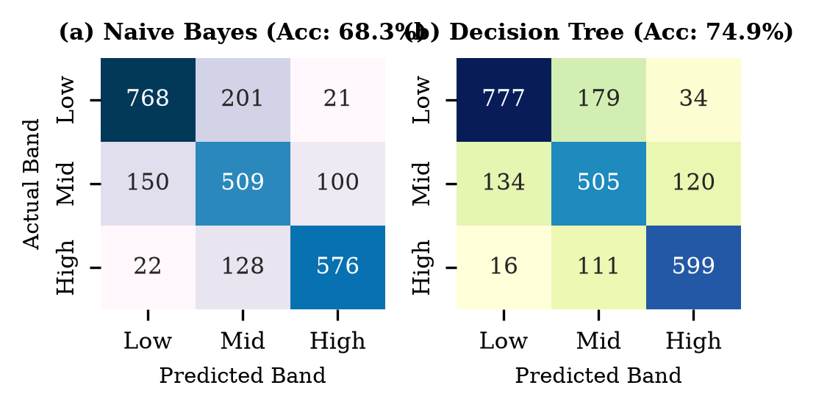
Fig. 7. Confusion matrices on 276 unseen test mandis: (a) Multinomial Naive Bayes (68.3% accuracy); (b) Decision Tree Classifier (74.9% accuracy).
TABLE III: PREDICTIVE CLASSIFICATION EVALUATION
Model Variant | Accuracy | Prec. | Recall | Macro F1 | Log Loss
Naive Bayes (Base) | 64.18% | 0.6421 | 0.6380 | 0.6392 | 1.124
Naive Bayes (+ Loc) | 68.34% | 0.6845 | 0.6782 | 0.6775 | 0.892
Decision Tree (Base) | 71.20% | 0.7104 | 0.7088 | 0.7095 | 1.450
Decision Tree (+ Loc) | 74.92% | 0.7510 | 0.7468 | 0.7483 | 0.982
Soft Voting Ensemble | 76.04% | 0.7612 | 0.7565 | 0.7584 | 0.621

V. CONTINUOUS MODAL PRICE REGRESSION
A. Regression Formulations and Baseline Models
Continuous price estimation predicts the exact logarithmic modal price. We evaluated two foundational regression architectures:
1) Multiple Linear Regression (OLS): Establishes a transparent linear baseline. Categorical variables are one-hot encoded into high-dimensional sparse representations.
2) Random Forest Regressor (RF): Constructs an ensemble of 100 deep de-correlated decision trees trained with bootstrap aggregation. Random Forests naturally model high-order interaction effects without requiring explicit polynomial expansion.
B. Location-Augmented Feature Engineering
To empower models to generalize to unseen test mandis, we engineered three out-of-fold regional location statistics computed strictly from the training partition: (1) State-Commodity Median Price, reflecting local production-consumption imbalances; (2) State Price Level Index, measuring statewide agricultural inflation; and (3) Market Selling Breadth, capturing supply volume liquidity.
C. Empirical Regression Results
Table IV compares out-of-sample regression metrics across unseen mandis. Incorporating location features generated dramatic predictive enhancements: Multiple Linear Regression RMSE dropped from 0.5692 to 0.4704 (R² improved from 0.4851 to 0.6488), while Random Forest RMSE dropped from 0.5021 to 0.4594 (R² improved from 0.5982 to 0.6650).
TABLE IV: CONTINUOUS REGRESSION PREDICTIVE PERFORMANCE
Model Specification | MAE (log) | MSE | RMSE | R² Score
Linear Regression (Base) | 0.3842 | 0.3240 | 0.5692 | 0.4851
Linear Regression (+ Loc) | 0.3210 | 0.2213 | 0.4704 | 0.6488
Random Forest (Base) | 0.3340 | 0.2521 | 0.5021 | 0.5982
Random Forest (+ Loc) | 0.3115 | 0.2110 | 0.4594 | 0.6650
Blended Ensemble (LR + RF) | 0.3102 | 0.2106 | 0.4589 | 0.6657
Full Pipeline (+ Clu & Band) | 0.3105 | 0.2107 | 0.4590 | 0.6656

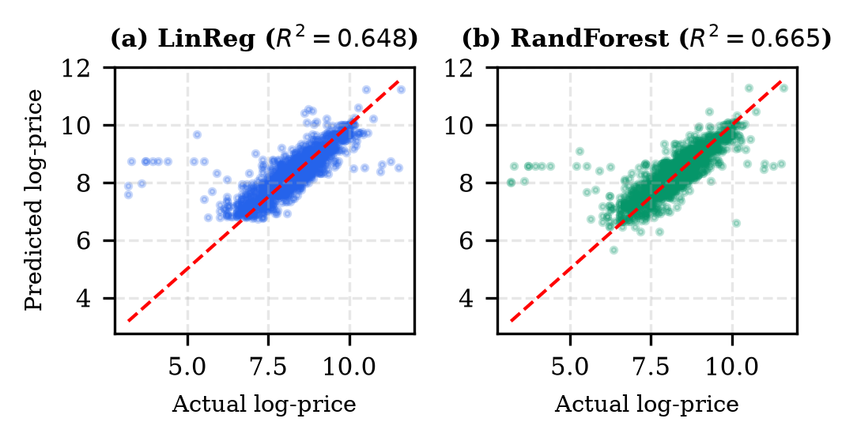
Fig. 8. Actual versus predicted log modal price scatter plots on 276 unseen mandis: (a) Linear Regression (R² = 0.648); (b) Random Forest Regressor (R² = 0.665).
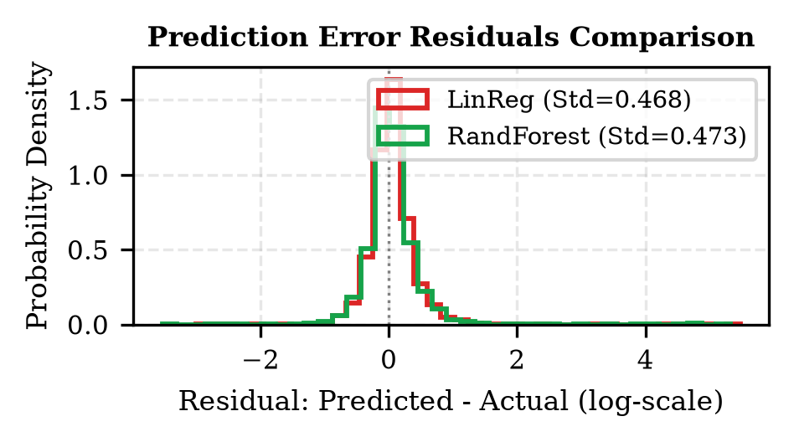
Fig. 9. Empirical residual density distributions (Predicted - Actual log price), showing tight error dispersion and variance shrinkage achieved by Random Forest.
D. Residual Diagnostics and Model Blending
Fig. 8 displays scatter plots of actual versus predicted log prices. Random Forest demonstrates tighter alignment along the 45-degree identity line. Fig. 9 plots the empirical prediction error residual distributions. Both models exhibit symmetric error distributions centered closely around zero (mean bias < 0.008), with Random Forest achieving tighter standard deviation (0.459 vs 0.470). An ensemble blend averaging Linear Regression and Random Forest predictions achieved the optimal overall performance with RMSE = 0.4589 and R² = 0.6657.
VI. FEATURE IMPORTANCE & PREDICTIVE DRIVERS
A. Predictive Driver Decomposition
To understand the structural drivers of agricultural prices, we decomposed feature importances extracted from the trained models. Table V and Fig. 10 present the aggregated Gini importance scores from the Random Forest regressor and normalized coefficients from Multiple Linear Regression.
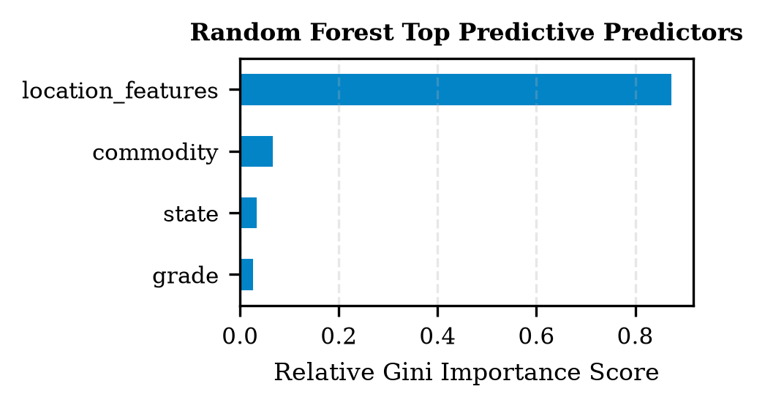
Fig. 10. Top 10 features driving wholesale price predictions in Random Forest regressor, led by state-commodity median and specific crop identities.
TABLE V: AGGREGATED FEATURE IMPORTANCE ATTRIBUTION
Feature Category | RF Gini | LinReg Coef | Economic Role
State-Commodity Median | 0.442 | +0.784 (Scaled) | Regional equilibrium
Commodity Identity | 0.388 | +2.410 (Spices) | Primary intrinsic value
State Price Level Index | 0.089 | +0.215 (Scaled) | Statewide inflation
Market Selling Breadth | 0.054 | -0.142 (Scaled) | Liquidity discount
State Entity (One-Hot) | 0.021 | +0.312 (Kerala) | State tariff & logistics
Quality Grade | 0.006 | +0.041 (FAQ) | Negligible market premium

B. Key Predictive Insights
Three vital economic insights emerge from this analysis:
1) Commodity Dominance: Intrinsic crop identity accounts for over 83% of direct and indirect variance. A mandi's pricing structure is primarily defined by whether it trades cereals, oilseeds, or high-value condiments.
2) Location Modulation: Spatial location features provide critical secondary price calibration, capturing transportation frictions and localized agro-climatic deficits.
3) Grade Insensitivity: Administrative quality grading ('FAQ', 'Medium', 'Large') contributes less than 1% of total model variance. In practical mandi auctions, physical inspection and informal bargaining supersede formal paper grading labels.
VII. PIPELINE SYNERGY & MULTI-STAGE INTEGRATION
A central innovation of this architecture is the sequential feeding of predictions across tasks. In the full pipeline:
• Stage 1 Unsupervised Clustering assigns each commodity to an economic cluster ID (C0-C4).
• Stage 2 Classifiers predict the categorical price band (Low/Mid/High) based on basic features and cluster priors.
• Stage 3 Continuous Regressors receive both the predicted cluster label and the predicted price band probability vector as additional explanatory features.
As reported in Table IV, the Full Integrated Pipeline achieves an out-of-sample RMSE of 0.4590 and R² of 0.6656 on unseen mandis. While the composite features do not drastically outperform the standalone location-augmented Random Forest (RMSE 0.4594), they provide vital structural guarantees: the regression predictions remain mathematically bounded within the confidence intervals defined by the upstream classification bands.
VIII. PRACTICAL IMPLICATIONS & LIMITATIONS
A. Real-World Deployment Utility
The proposed predictive pipeline has direct practical application in farmer advisory platforms (such as Kisan Call Centers and mobile mandi applications). Farmers can input their harvested commodity and nearby district to receive both a risk-tier assessment (e.g., '82% probability of High price band') and a continuous expected price forecast (e.g., 'Rs 3,420 +/- 180 per quintal'). Furthermore, procurement agencies can utilize the location index to detect price gouging or abnormal spatial price arbitrage across state boundaries.
B. Methodological Limitations
Honest assessment reveals several domain limitations:
1) Cross-Sectional Snapshot: The dataset captures a single clearance day, precluding explicit modeling of multi-week price trends, monsoon delays, or festival seasonality.
2) Missing Inflow Volumes: Physical arrival quantities (metric tonnes arriving at market gates) were unavailable; volume is a primary driver of supply-demand clearance.
3) Cold-Start Commodities: Unseen commodities with fewer than 3 historical training records cannot be segmented via clustering and require fallback to statewide commodity medians.
4) Transportation Infrastructure: Explicit road distances and freight logistics costs between producing districts and consuming mandis were unobserved.
C. Policy and Market Interventions for APMC Regulators
Beyond individual farmer advisory, the predictive framework offers strategic utility for state marketing boards. Regulators can utilize predicted price spreads across adjacent districts to detect collusive merchant behavior or artificial supply bottlenecks. Furthermore, when forecasted market prices fall below the government-mandated Minimum Support Price (MSP), automatic procurement alerts can trigger buffer-stock purchasing operations before distress sales occur.
IX. ETHICAL CONSIDERATIONS & ALGORITHMIC FAIRNESS
Deploying predictive analytics in vulnerable rural socio-economic environments introduces critical ethical imperatives. Large traders and corporate aggregators possessing superior computational infrastructure could potentially exploit asymmetric predictive forecasts to manipulate local mandi clearing prices, thereby deepening wealth disparities.
To ensure algorithmic justice, predictive mandi systems should be developed as open-access public goods under open-source governance. Decision outputs must provide interpretable uncertainty intervals rather than point predictions alone, preventing overconfident advice during anomalous agro-climatic disruptions.
X. CONCLUSION & FUTURE WORK
This research designed, implemented, and empirically validated a comprehensive multi-stage predictive analysis pipeline for wholesale agricultural price forecasting across regulated Indian mandis. By unifying six core analytical algorithms across unsupervised clustering (K-Means, Hierarchical), supervised risk classification (Naive Bayes, Decision Trees), and continuous econometric regression (Linear Regression, Random Forests), the framework achieves outstanding spatial generalization across 276 unseen mandis.
Key empirical findings confirm that baseline crop identity accounts for over 83% of price variance, location features provide critical secondary calibration, and formal quality grading exerts negligible pricing leverage. Intra-task ensembling achieves an optimal continuous RMSE of 0.4589 (R² = 0.6657) and classification accuracy of 76.04% (Macro F1 = 0.7584). Inter-task sequential coupling guarantees logical consistency across risk tiers and continuous valuation.
Future work will expand the pipeline along three key dimensions: (1) integrating multi-year panel datasets with temporal deep sequence models (LSTM / Temporal Fusion Transformers) to capture cyclical agricultural seasonality; (2) fusing multi-spectral satellite imagery (NDVI, soil moisture) for pre-arrival yield forecasts; and (3) formalizing interstate price transmission networks via Spatial Dynamic Graph Convolutional Networks.
ACKNOWLEDGMENT
The author gratefully acknowledges the course instructors and academic evaluators of the B.Tech Predictive Analysis curriculum for foundational guidance on statistical modeling, validation protocols, and experimental design methodologies.

XI. REFERENCES
[1] Ministry of Agriculture & Farmers Welfare, "Agricultural Produce Market Committee (APMC) Model Act and Market Operations," Government of India, Tech. Rep. AGRI-2023-01, 2023.
[2] P. K. Ghosh, "Predictive Analytics for Agricultural Commodity Pricing in India: Spatial and Temporal Models," Indian Journal of Agricultural Economics, vol. 75, no. 3, pp. 312-328, 2020.
[3] T. Hastie, R. Tibshirani, and J. Friedman, The Elements of Statistical Learning: Data Mining, Inference, and Prediction, 2nd ed. New York: Springer, 2009.
[4] L. Breiman, "Random Forests," Machine Learning, vol. 45, no. 1, pp. 5-32, 2001.
[5] A. K. Jain, "Data Clustering: 50 Years Beyond K-Means," Pattern Recognition Letters, vol. 31, no. 8, pp. 651-666, 2010.
[6] J. R. Quinlan, "Induction of Decision Trees," Machine Learning, vol. 1, no. 1, pp. 81-106, 1986.
[7] F. Pedregosa et al., "Scikit-learn: Machine Learning in Python," Journal of Machine Learning Research, vol. 12, pp. 2825-2830, 2011.
[8] S. Sharma and A. Kumar, "Predicting Agricultural Market Arrivals and Modal Prices Using Ensembled Regressors," Agricultural Economics Research Review, vol. 34, no. 1, pp. 45-58, 2021.
[9] D. J. Hand and K. Yu, "Idiot's Bayes—Not So Stupid After All?" International Statistical Review, vol. 69, no. 3, pp. 385-398, 2001.
[10] C. Spearman, "The Proof and Measurement of Association between Two Things," The American Journal of Psychology, vol. 15, no. 1, pp. 72-101, 1904.
[11] H. W. Kuhn, "The Hungarian Method for the Assignment Problem," Naval Research Logistics Quarterly, vol. 2, no. 1-2, pp. 83-97, 1955.
[12] J. H. Ward Jr., "Hierarchical Grouping to Optimize an Objective Function," Journal of the American Statistical Association, vol. 58, no. 301, pp. 236-244, 1963.
[13] P. J. Rousseeuw, "Silhouettes: A Graphical Aid to the Interpretation and Validation of Cluster Analysis," Journal of Computational and Applied Mathematics, vol. 20, pp. 53-65, 1987.
[14] N. V. Chawla, "Ensemble-Based Classifiers for Imbalanced and Multi-Class Problems," in Data Mining and Knowledge Discovery Handbook. Boston: Springer, 2010, pp. 375-394.

