DATA ANALYTICS PROJECT REPORT
Customer Shopping Behaviour Analysis Using Power BI

Tools Used
Python,
PostgreSQL,
SQL,
Power BI,
Excel
Technologies
Pandas,
Power Query,
DAX,
Visualization

Student Name
Vaibhav N Badiger

Project Type
Data Analytics Project

ABSTRACT
In today's competitive retail environment, understanding customer purchasing behaviour is essential for making informed business decisions. This project focuses on analysing customer shopping patterns using a combination of data analytics tools including Python, PostgreSQL, SQL, and Power BI.
The project begins with data cleaning and preprocessing using Python in a Jupyter Notebook environment. The cleaned dataset is then stored in a PostgreSQL database using SQL Alchemy. Advanced SQL queries are used to extract business insights from the data. Finally, the processed data is visualized using Power BI to build interactive dashboards.
The dashboard provides insights into customer purchasing trends, product popularity, revenue contribution, shipping preferences, and customer segmentation. The insights derived from the analysis can help businesses optimize marketing strategies, improve product offerings, and enhance customer satisfaction.

INTRODUCTION
Customer behaviour analysis is a crucial component of modern data-driven decision making. Businesses rely heavily on data analytics to understand how customers interact with their products and services. By analysing purchasing patterns, businesses can identify trends, predict future behaviour, and optimize their strategies.
This project focuses on analysing a dataset containing customer shopping behaviour information such as purchase amount, product category, review ratings, shipping type, subscription status, and purchase frequency.
The project integrates multiple technologies including Python for data preprocessing, PostgreSQL for database management, SQL for querying, and Power BI for data visualization. The final outcome is an interactive dashboard that allows users to explore customer purchasing patterns and derive meaningful business insights.

PROBLEM STATEMENT
Retail businesses often collect large volumes of customer data but struggle to convert it into actionable insights. Without proper analysis, valuable patterns related to customer preferences, spending habits, and product popularity remain hidden.
The primary objective of this project is to analyse customer purchasing behaviour and identify patterns that can help businesses improve sales strategies, marketing campaigns, and customer engagement.

PROJECT OBJECTIVES
The main objectives of this project are:
- To clean and preprocess customer shopping data.
- To store structured data in a relational database.
- To analyse customer behaviour using SQL queries.
- To identify key business insights from the dataset.
- To develop an interactive Power BI dashboard.
- To visualize important metrics such as revenue, purchase patterns, and customer segments.

DATASET DESCRIPTION
The dataset used in this project is Customer Shopping Behaviour Dataset containing 3900 customer records and 18 attributes.
Important attributes include:
- Customer ID
- Age
- Gender
- Item Purchased
- Category
- Purchase Amount (USD)
- Location
- Review Rating
- Subscription Status
- Shipping Type
- Discount Applied
- Previous Purchases
- Payment Method
- Frequency of Purchases
This dataset provides detailed insights into customer purchasing patterns and product preferences.

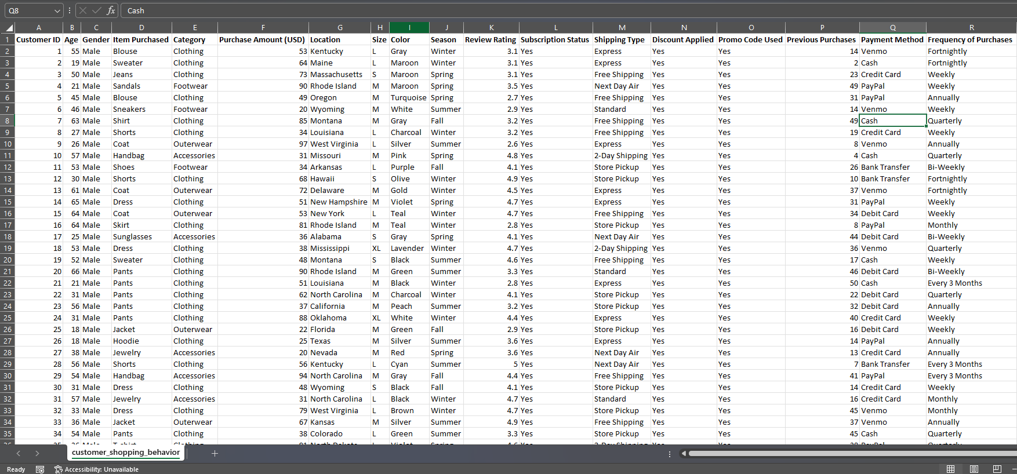
RAW DATASET

Fig 1: Dataset

TOOLS AND TECHNOLOGIES USED
The following tools were used in this project:
Python: Python was used for data preprocessing and cleaning using the Pandas library.
Jupyter Notebook: Jupyter Notebook was used to perform data exploration and transformation operations.
PostgreSQL: PostgreSQL database was used to store structured data after preprocessing.
PgAdmin: pgAdmin was used as the database management interface for executing SQL queries.
SQL: SQL was used to perform business queries and generate analytical insights.
Power BI: Power BI was used to create interactive dashboards and visualize key metrics.

DATA CLEANING AND PREPROCESSING
Data preprocessing was performed using Python in Jupyter Notebook.
The following steps were carried out:
Handling Missing Values
Missing values in the Review Rating column were filled using the median rating of each category.
This ensured that rating values remained realistic within each product category.

Column Name Standardization
Column names were converted into snake_case format to make them more consistent and database-friendly.
Example:
Customer ID → customer_id
Purchase Amount (USD) → purchase_amount

Creating Age Group Column
A new column called age_group was created using quartile segmentation:
- Young Adult
- Adult
- Middle-aged
- Senior
This helps in analyzing revenue contribution across different age groups.

Creating Purchase Frequency Column
A new column purchase_frequency_days was created by converting textual purchase frequencies into numeric values.

Example conversions:
Weekly → 7 days
Monthly → 30 days
Quarterly → 90 days
Annually → 365 days

Removing Redundant Columns
The columns discount_applied and promo_code_used contained similar information.
Therefore, the promo_code_used column was removed to eliminate redundancy.

DATA CLEANING
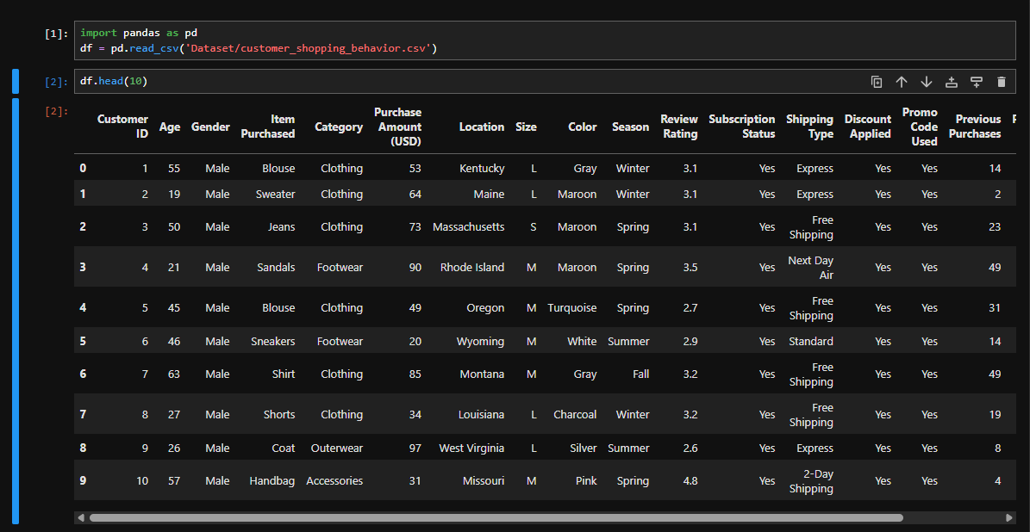
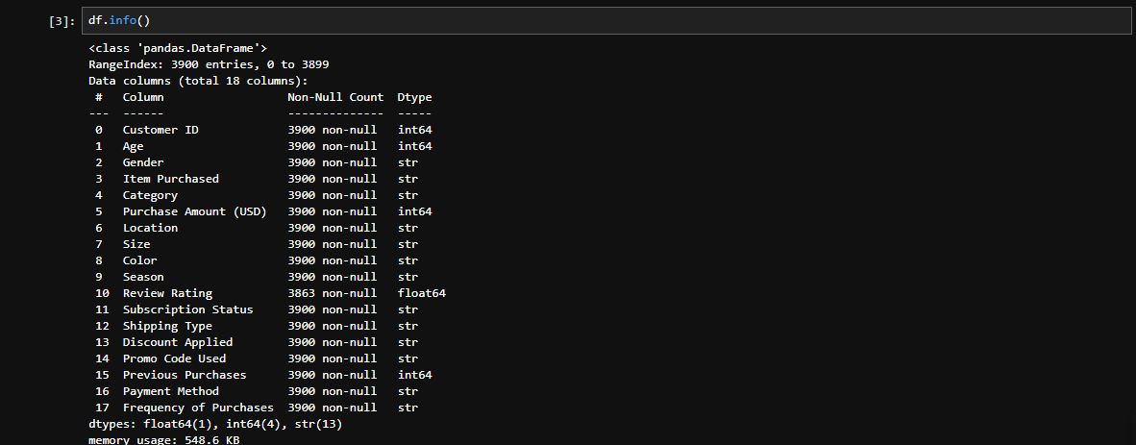
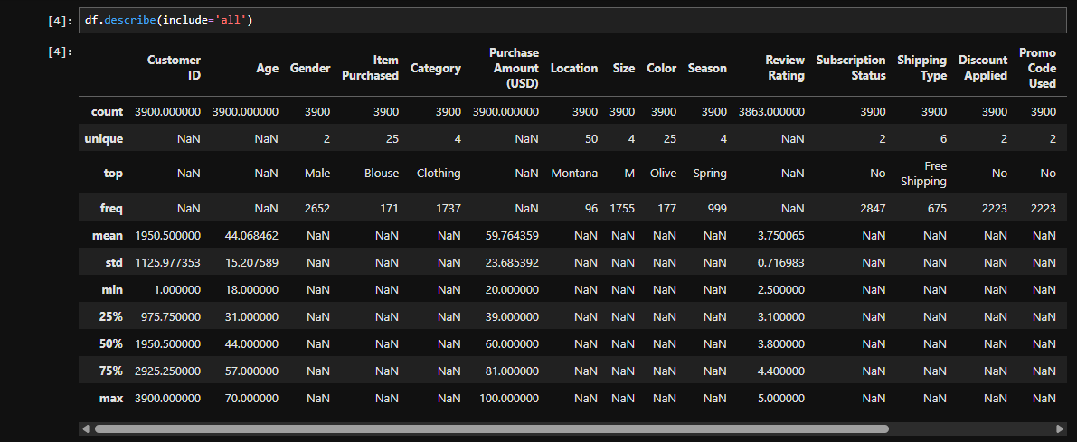
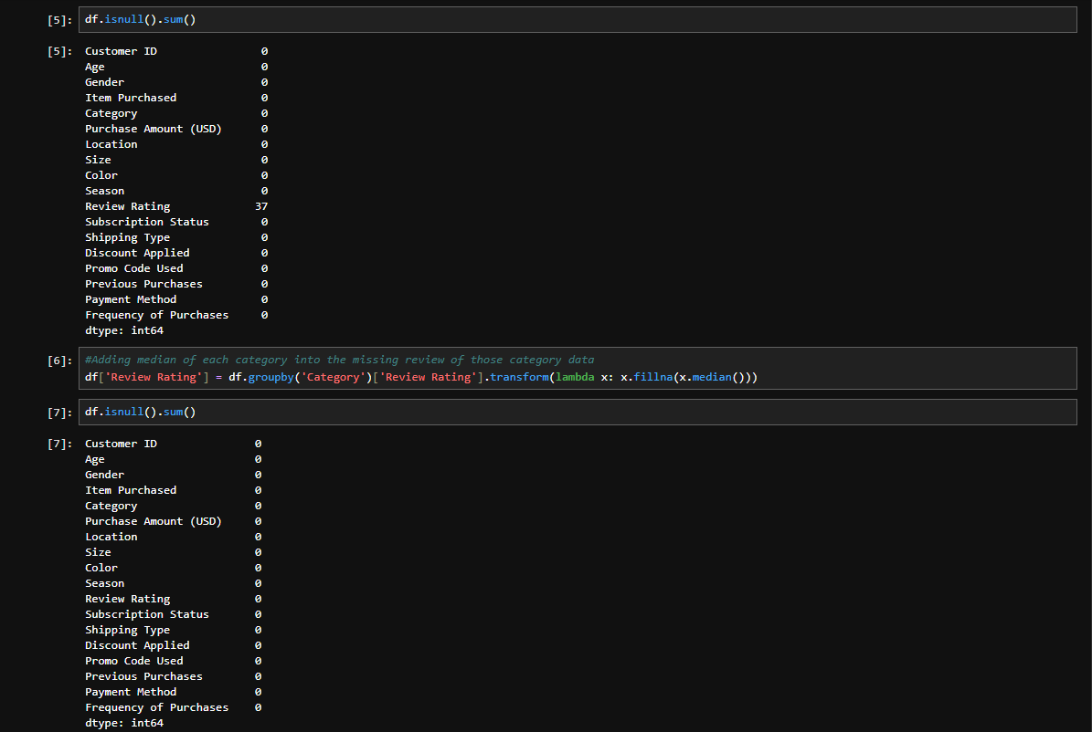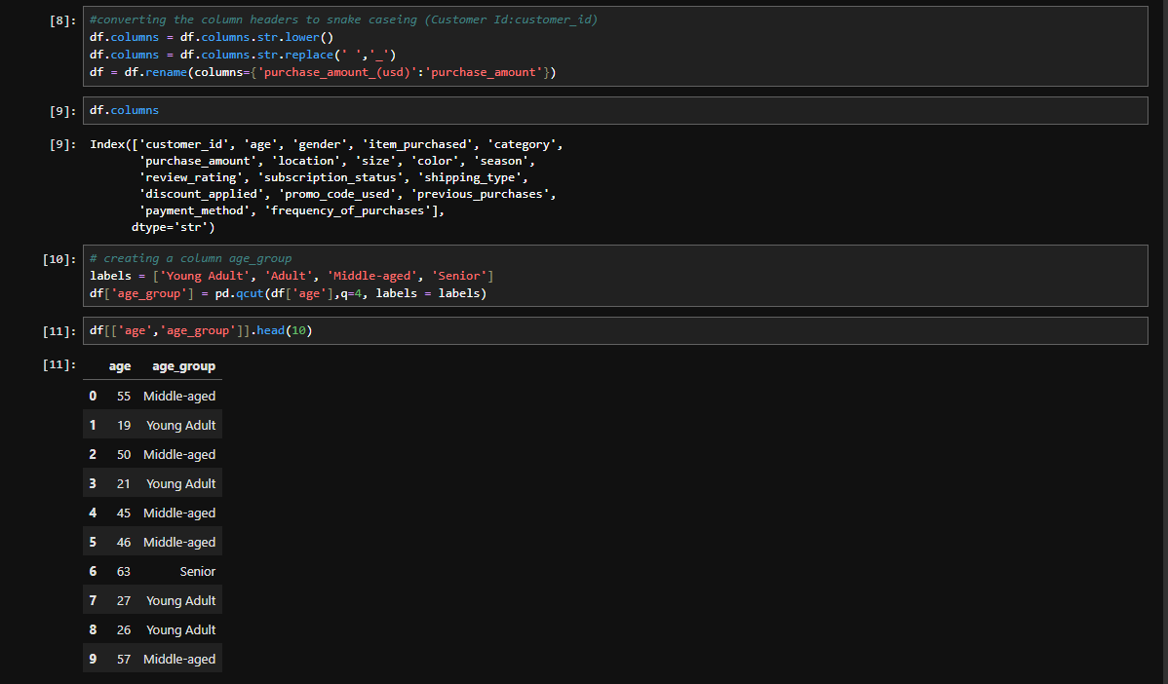

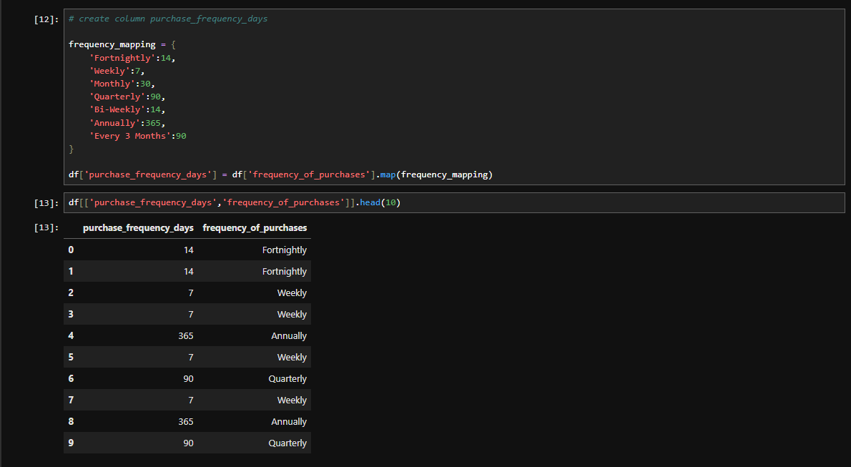
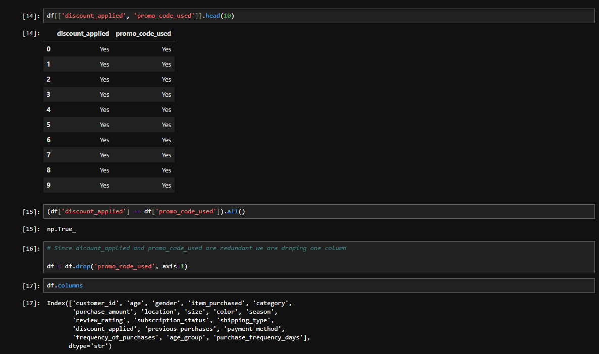
Fig 2: Data cleaning in jupyter notebook

DATA STORAGE IN PostgreSQL
After data preprocessing, the cleaned dataset was loaded into a PostgreSQL database using SQLAlchemy.
Steps performed:
- Established connection to PostgreSQL database.
- Created a database named customer_behaviour.
- Loaded the cleaned dataset into a table called customer.
- Verified data insertion using SQL queries.
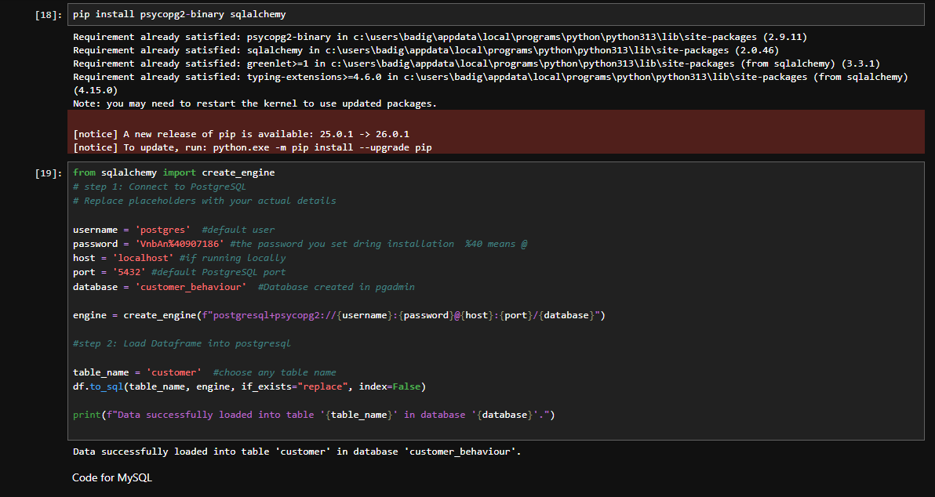
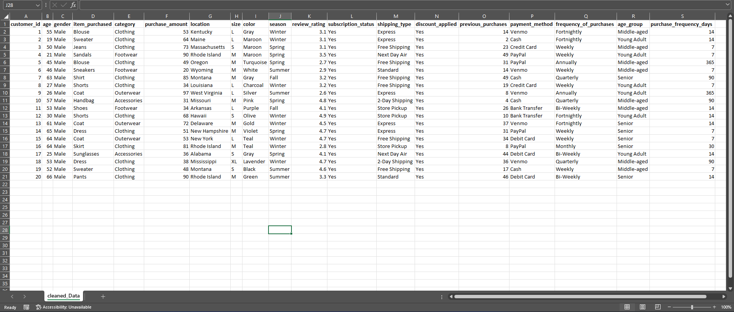
Fig 3: Cleaned Data
SQL BUSINESS ANALYSIS
Several SQL queries were executed to answer key business questions.
Examples include:
Revenue by Gender
The total revenue generated by male and female customers was calculated.
Discount Impact on Spending
Customers who used discounts but still spent above the average purchase amount were identified.
Top Rated Products
Products with the highest average review ratings were identified.
Shipping Type Analysis
Average purchase amounts were compared between Standard and Express shipping.
Customer Subscription Analysis
The spending behavior of subscribed and non-subscribed customers was analyzed.
Customer Segmentation
Customers were classified into:
- New Customers
- Returning Customers
- Loyal Customers
based on their previous purchase count.

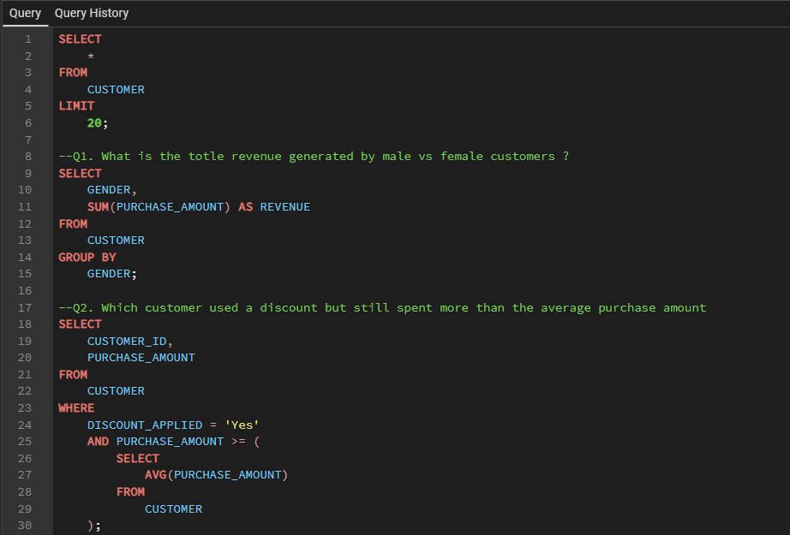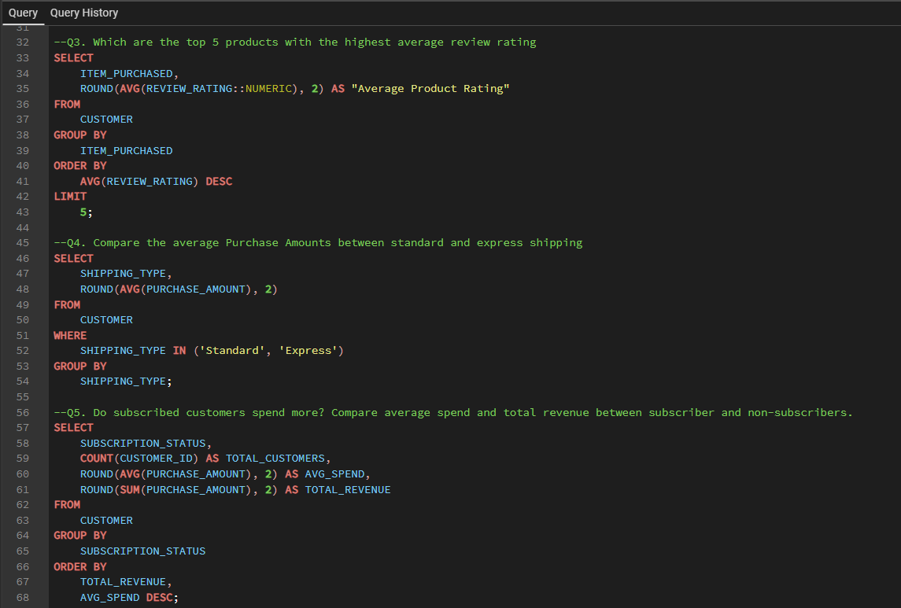
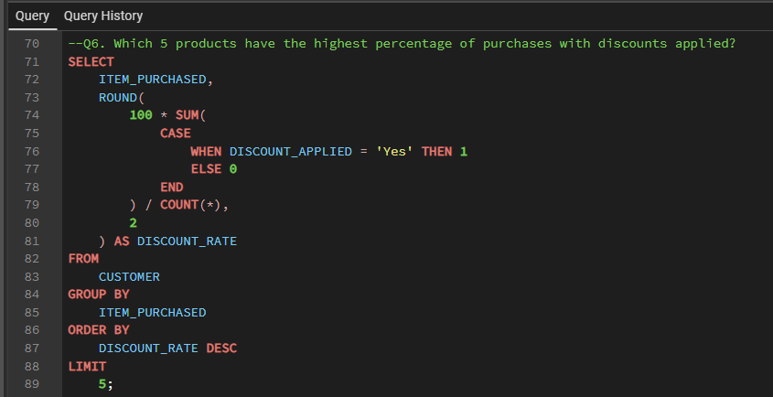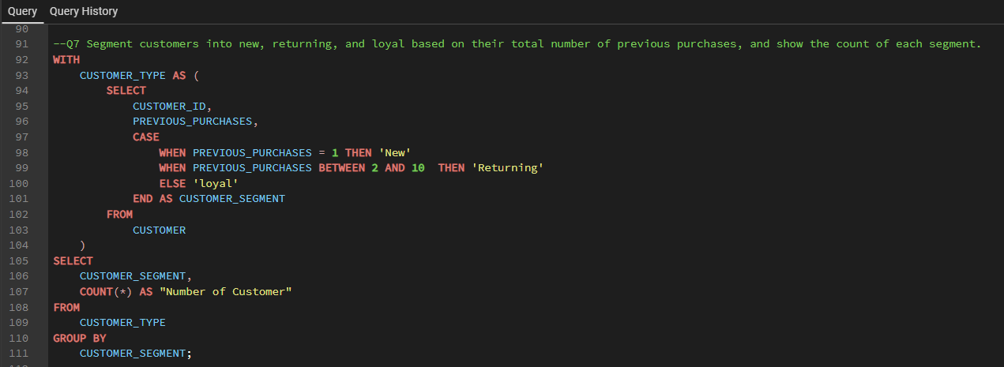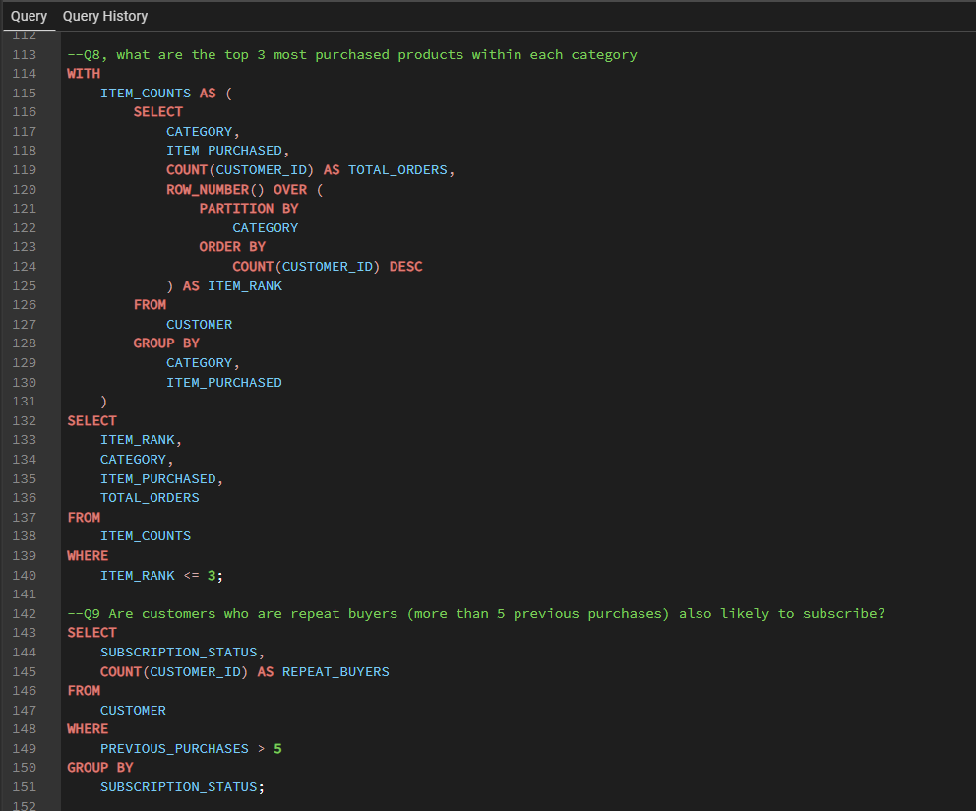
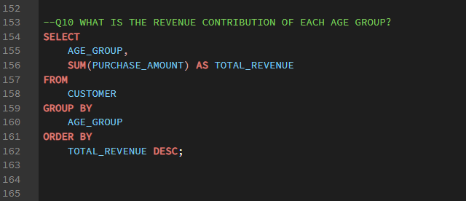
Fig 4: SQL Queries in pgAdmin

POWER BI DASHBOARD DEVELOPMENT
Power BI was used to build an interactive dashboard to visualize customer purchasing patterns.
The dashboard includes multiple visualizations such as:
- Revenue distribution
- Average purchase amount
- Customer count
- Review rating analysis
- Product category performance
- Age group revenue contribution
Power Query was used to import and transform data before visualization.
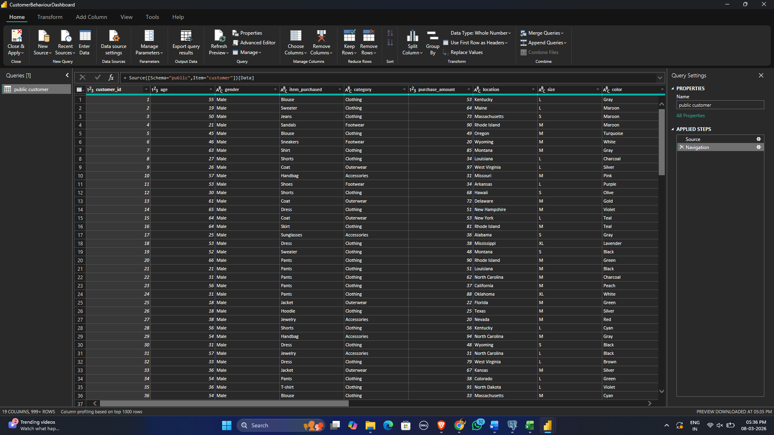
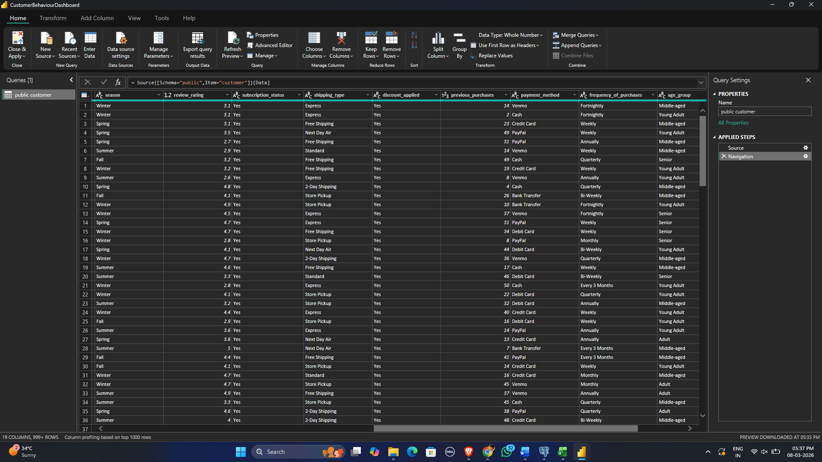

DAX MEASURES CREATED
Several measures were created using DAX for analytical calculations.
Examples include:
Average Purchase Amount
Average Purchase Amount = AVERAGE (customer[purchase_amount])
Average Review Rating
Average Review Rating = AVERAGE (customer[review_rating])
Number of Customers
Number of Customers = DISTINCTCOUNT (customer[customer_id])
These measures help calculate key performance indicators used in the dashboard.

DASHBOARD VISUALIZATIONS
The Power BI dashboard contains multiple visual components including:
- Bar charts
- Pie charts
- KPI cards
- Category-wise analysis
- Revenue breakdown
- Customer segmentation analysis
These visualizations provide quick insights into customer purchasing behaviour.
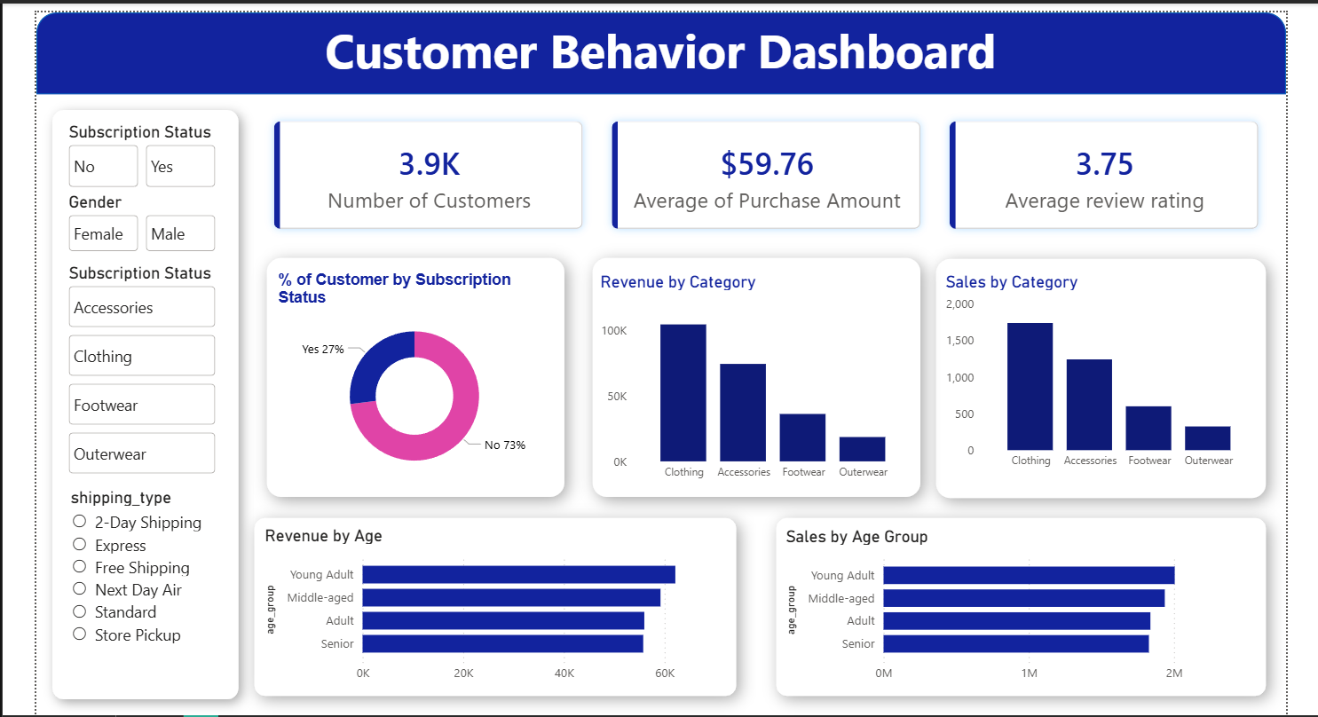
Fig 7: Power BI Dashboard

KEY INSIGHTS DERIVED
Several valuable insights were discovered through the analysis:
- Certain product categories generate significantly higher revenue.
- Customers using subscriptions tend to contribute a large portion of total revenue.
- Some products receive consistently higher review ratings.
- Discount usage influences purchasing patterns.
- Loyal customers contribute significantly to repeat purchases.
These insights can help businesses optimize product offerings and marketing strategies.
CHALLENGES FACED
During the project, several challenges were encountered:
- Handling missing values in the dataset.
- Ensuring consistent column naming conventions.
- Removing redundant columns.
- Integrating multiple tools including Python, PostgreSQL, SQL, and Power BI.
- Creating meaningful visualizations for business insights.
These challenges were overcome through systematic data preprocessing and analytical techniques.

CONCLUSION
This project successfully demonstrates the use of modern data analytics tools to analyse customer shopping behaviour.
By combining Python, SQL, PostgreSQL, and Power BI, raw customer data was transformed into meaningful insights and interactive visualizations.
The results of this analysis can help businesses better understand customer preferences, improve product strategies, and enhance customer satisfaction.

FUTURE SCOPE
Future improvements for this project may include:
- Integrating machine learning models for customer prediction.
- Implementing real-time data analytics.
- Expanding the dataset with more customer attributes.
- Building automated reporting systems.
These improvements can further enhance the analytical capabilities of the system.
REFERENCES
- Python Pandas Documentation
- PostgreSQL Documentation
- Microsoft Power BI Documentation
- Data Analytics Learning Resources

