**Experiment No. 10**

**Title :** Implementation of Binary Search in C++

**Problem Statement :** Implementing Binary Search algorithm in C++

**Algorithm :**

**S1 :** Start

**S2 :** Declare an array and loop control variables and binarysearch().

**S3 :** Ask for the array input and element to be searched from user.

**S4 :** with the array, first, last indexes and element to be searched as arguments to be sent to binarysearch function.

**S5 :** Calculate mid and check if key value is equal to mid value in array else if it is smaller the call binarysearch function with last as mid-1 if it is greater the call function with first as mid+1

**S6 :** If element is found print position else print element not found

**S7 :** Stop

**Code :**

#include <iostream>

using namespace std;

// If found, location of x in the array is returned.

// otherwise -1 is returned.

int binarySearch(int arr[], int first, int last, int x)

{

if (last >= first) {

int mid = first + (last- first) / 2;

// If the element is present at the middle of the array

if (arr[mid] == x)

return mid;

// If element is smaller than mid, then

// it can only be present in left subarray

if (arr[mid] > x)

return binarySearch(arr, first, mid - 1, x);

// Else the element can only be present

// in right subarray

return binarySearch(arr, mid + 1, last, x);

}

// If the element is not found.

return -1;

}

int main()

{

int arr[20],n,x,i;

cout<<"How many elements?";

cin>>n;

cout<<"\nEnter elements of the array\n";

for(i=0;i<n;++i)

cin>>arr[i];

cout<<"\nEnter element to search:";

cin>>x;

int result = binarySearch(arr, 0, n - 1, x);

if (result == -1)

cout << "Element is not present in array.";

else

cout << "Element is present at index " <<result;

return 0;

}

**Output :**

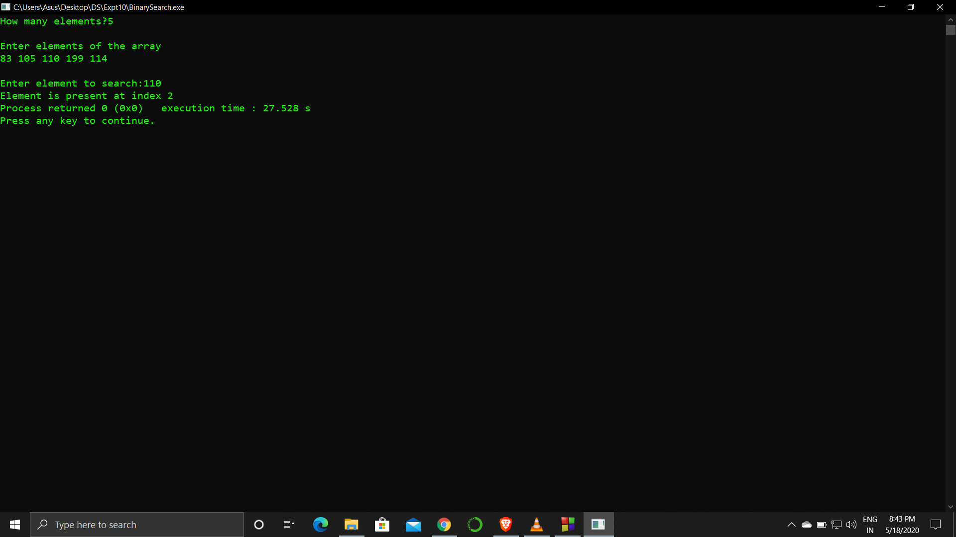

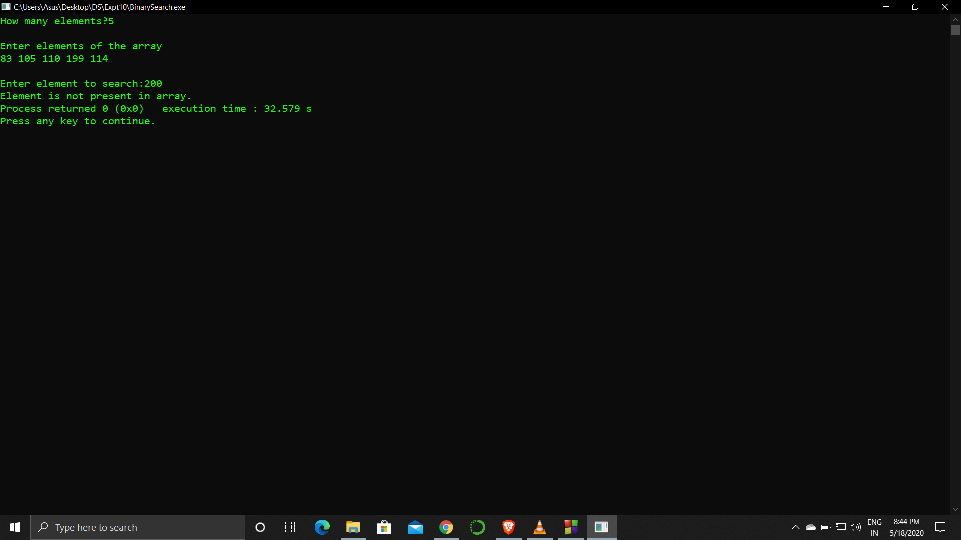

**Analysis :**

The array in which we search has to be sorted. If the array is not sorted the algorithm would not work and be totally inefficient.

It is more complicated than linear search but as compared to efficiency for smaller numbers in array it might increase time complexity but for arrays with huge values the algorithm is efficient.