**Experiment No. 3a**

**Title :** Implementation of Factorial using recursion

**Problem Statement :** Implementing factorial of any number using recursion

**Algorithm :**

**S1 :** Start

**S2 :** Declare an integer variable and a function factorial()

**S3 :** Call the function and send the value whose factorial has to be found

**S4 :** in factorial function if the integer is equal to 1 return else call the function by sending the value one less than previous integer.

**S5 :** Stop

**Code :**

#include<iostream>

using namespace std;

int fact(int n)

{

if(n == 1)

{

return(1);

}

else

return(n*fact(n-1));

}

int main()

{

int n,ans;

cout<<"Enter the number : ";

cin>>n;

ans = fact(n);

cout<<"The factorial is : "<<ans<<endl;

}

**Output :**

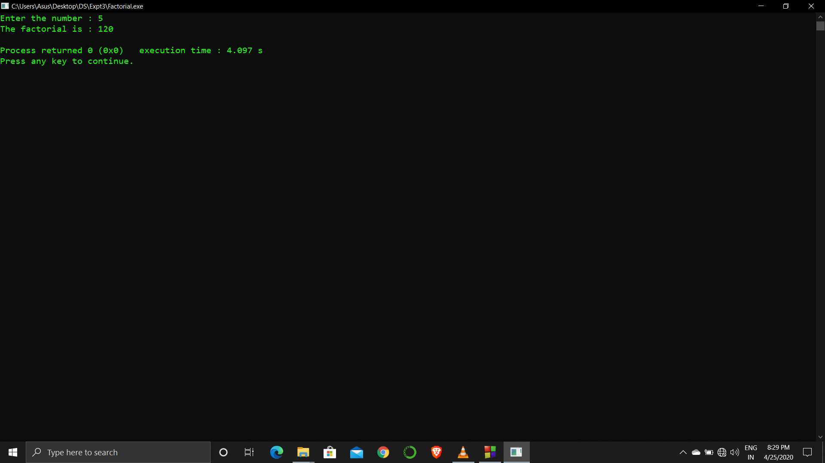

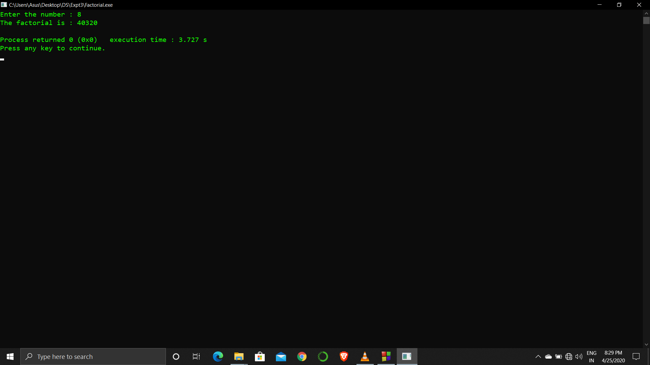

**Analysis :**

Recursion is a very costly process when compared to looping because we can perform the operations using both.

If number is too large either out of integer range or within it might delay the output.