**Experiment No. 7**

**Title :** Implementation of Bubble sort in C++

**Problem Statement :** Implementing Bubble sort algorithm in C++

**Algorithm :**

**S1 :** Start

**S2 :** Declare an array and loop control variables.

**S3 :** Ask for the array input from user that has to be sorted in bubble sort

**S4 :** Declare a nested for loop with range 1 to n for outer for loop and 0 to n-I for inner for loop and if element one is greater than next element swap both.

**S5 :** The loop continues till end of array index and we get a sorted array.

**S6 :** Display the sorted array.

**S7 :** Stop

**Code :**

// Bubble Sort

// To sort given elements in Ascending order

#include<iostream>

using namespace std;

int main()

{

int array[50], n, i, j, k, temp;

cout<<"Enter the size of array: ";

cin>>n;

cout<<"Enter the array elements to be sorted:";

//To read the array

for(i=0;i<n;++i)

cin>>array[i];

cout<<"Array before sorting :";

for(i=0;i<n;++i)

cout<<" "<<array[i];

for(i=1;i<n;++i) // i keeps track of the no. of passes

{

{

for(j=0;j<(n-i);++j)

if(array[j]>array[j+1])

{

temp=array[j];

array[j]=array[j+1];

array[j+1]=temp;

}

}

//To print the array elements after every pass

cout<<"\n\n Array after Pass "<<i<<":" ;

for(k=0;k<n;++k)

cout<<" "<<array[k];

}

cout<<"\n\nArray after bubble sort:";

for(i=0;i<n;++i)

cout<<" "<<array[i];

return 0;

}

**Output :**

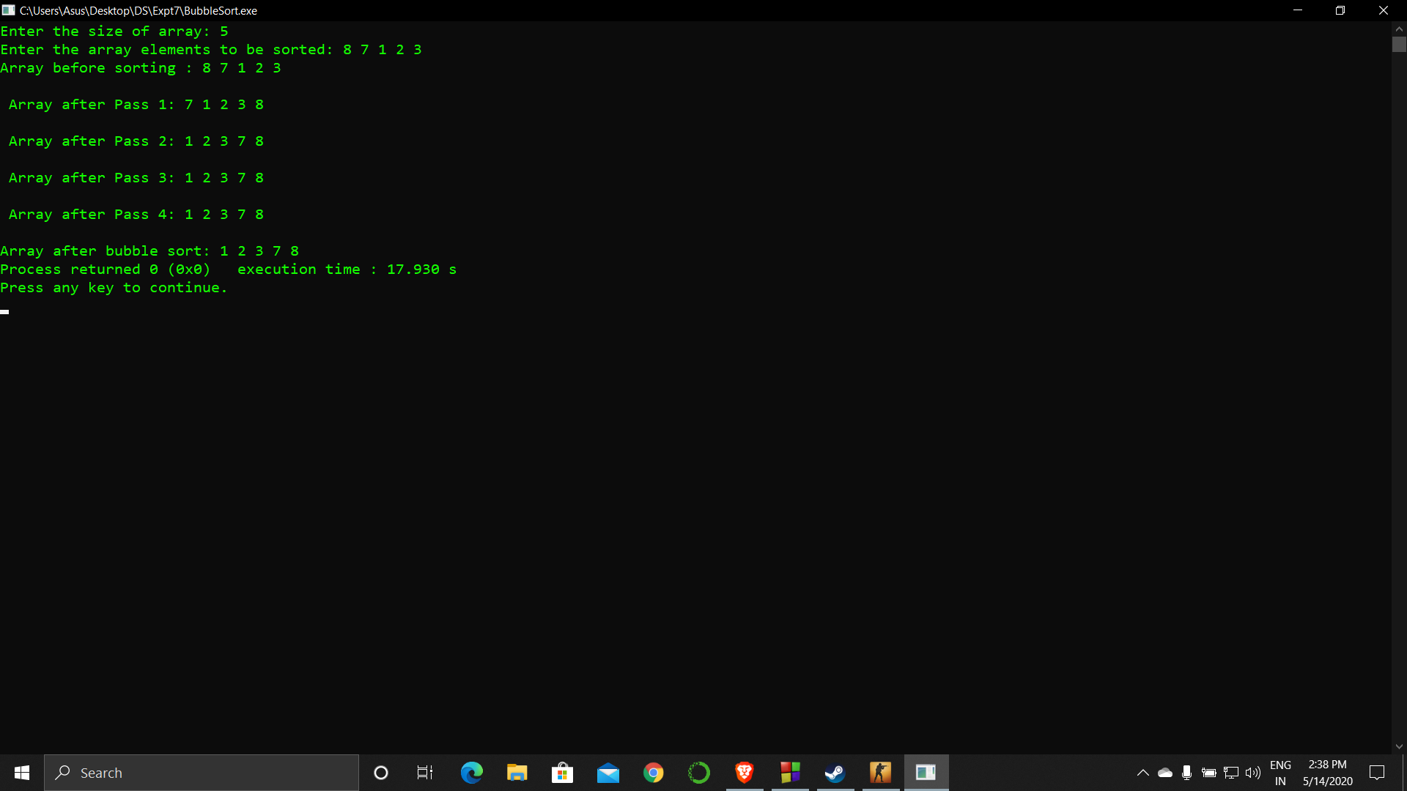

**Analysis :**

The array size is asked from the user which makes the code less flexible in case the array size cannot be counted easily.

If the elements in the array are repeated the operation on it would still be done which is waste of execution time.