**Experiment No. 9**

**Title :** Implementation of Linear Search in C++

**Problem Statement :** Implementing Linear Search algorithm in C++

**Algorithm :**

**S1 :** Start

**S2 :** Declare an array and loop control variables.

**S3 :** Ask for the array input and element to be searched from user.

**S4 :** with the for loop check if element in an array is equal to one searching.

**S5 :** If it is equal the print position of element else print element not found.

**S6 :** Stop

**Code :**

//Linear Search

#include<iostream>

using namespace std;

int main()

{

int arr[20],n,x,i,flag=0;

cout<<"How many elements?";

cin>>n;

cout<<"\nEnter elements of the array\n";

for(i=0;i<n;++i)

cin>>arr[i];

cout<<"\nEnter element to search:";

cin>>x;

for(i=0;i<n;++i)

{ if(arr[i]==x)

{ flag=1;

break;

}

}

if(flag)

cout<<"\nElement is found at position "<<i+1;

else

cout<<"\nElement not found";

return 0;

}

**Output :**

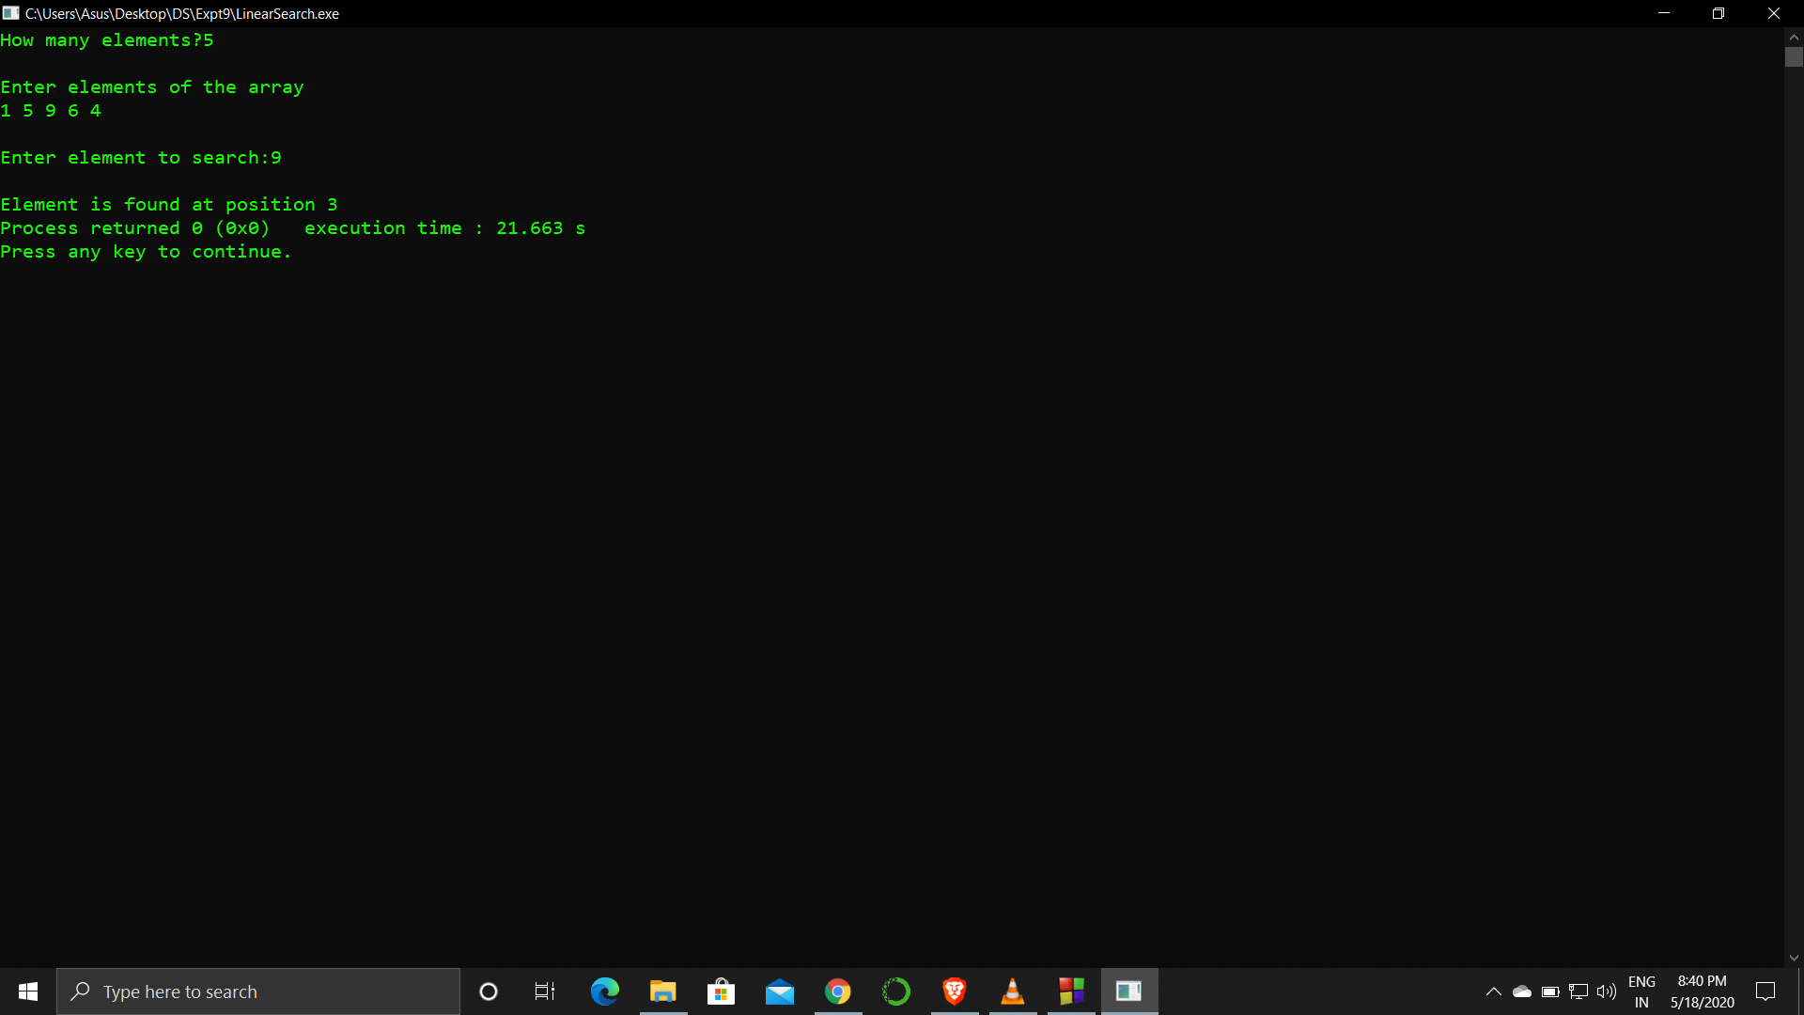

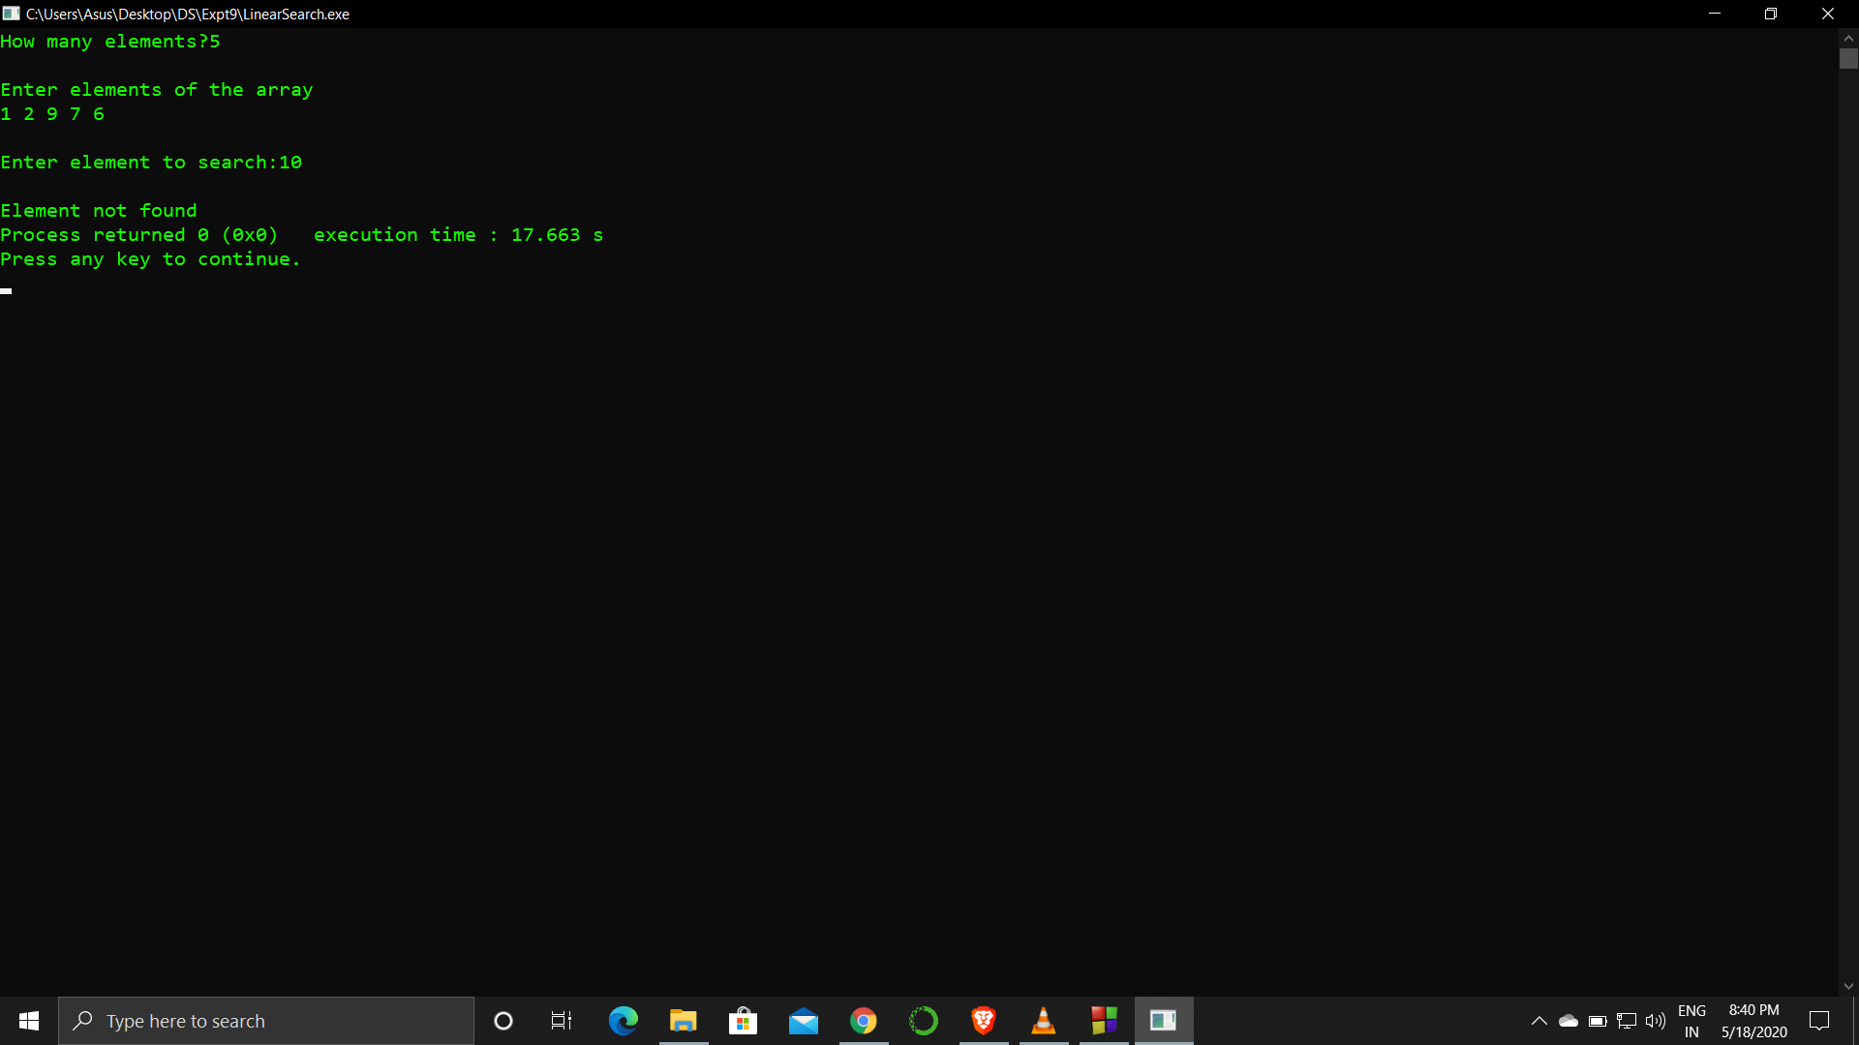

**Analysis :**

The linear search is a long process for an array with many elements and key searched is the last element then it time complexity becomes an issue.

The program returns only the first occurrence of the key element to be searched.