Message Passing Maze — Complete Documentation
Comprehensive code, theory, and line-by-line explanation
Includes diagrams, example run, and detailed notes

Abstract
This document provides a complete, detailed explanation of the Message Passing Maze project. It includes the full runnable Python code, step-by-step (line-by-line) explanation, design rationale, example outputs, diagrams (flowchart, BFS tree, message sequence), and extension ideas for further work.

Table of Contents
1. Introduction
2. Maze and Problem Setup
3. Algorithm Overview
4. Full Code (runnable)
5. Line-by-Line Explanation (complete)
6. Example Run and Interpretation
7. Diagrams (flowchart, BFS tree, sequence)
8. Design Decisions & Alternatives
9. Extensions and Further Work
10. Appendix: Saving/Running

1. Introduction
The Message Passing Maze demonstrates a small distributed exploration system where three agents explore a maze using Breadth-First Search (BFS) and periodically share discovered cells. The goal is to locate a hidden treasure while minimizing redundant work by exchanging useful knowledge.

2. Maze and Problem Setup
Grid / Symbols:
- . : open cell
- W : wall
- T : treasure
Agents start at:
- A = (0,0)
- B = (0,7)
- C = (7,0)
Treasure at (7,7). The grid is 8×8, indexed row-major (row, column).

3. Algorithm Overview
Each agent runs its own BFS frontier (a queue). The system proceeds in global steps; on each step every agent performs one BFS dequeue-and-expand action (so each agent expands one node per global step). Every 3 global steps the agents exchange information using directed messages in the order A→B, A→C, B→C. Messages contain the set difference (cells sender knows that receiver does not). Only non-empty messages are logged. The simulation ends when any agent physically steps on the treasure cell.
Why BFS? Short summary:
- - BFS guarantees shortest paths in unweighted grids.
- - It naturally maps to a queue-based exploration; expanding one node per step matches the 'time slice' model.
- - Combining BFS with message passing yields cooperative search without centralized control.

4. Full Code (runnable)
Copy this entire block into a file (e.g., message_passing_maze.py) and run with Python 3.8+.
# Message Passing Maze — complete runnable code
from collections import deque
# Maze: 8x8 grid, '.' empty, 'W' wall, 'T' treasure
maze = [
['.','.','.','W','.','.','.','.'],
['.','W','.','W','.','W','W','.'],
['.','W','.','.','.','.','W','.'],
['.','.','.','W','W','.','.','.'],
['.','.','.','.','W','.','W','.'],
['W','W','.','.','.','.','W','.'],
['.','.','.','W','.','.','.','.'],
['.','W','.','.','.','.','.','T']
]
class Agent:
"""
Agent that performs BFS expansions and shares discovered cells.
- name: string id (A, B, C)
- start: (row, col) tuple
"""
def __init__(self, name, start):
self.name = name
self.start = start
# visited set: contains cells discovered by this agent
self.visited = {start}
# parent map: node -> previous node on path (used for reconstructing paths)
self.parent = {start: None}
# BFS queue: cells to expand (popleft used)
self.q = deque([start])
def step(self):
"""
Perform one BFS dequeue+expand.
Returns treasure coordinate if an expansion reaches the treasure; otherwise None.
"""
if not self.q:
return None
r, c = self.q.popleft()
# explore four directions (up, down, left, right)
for dr, dc in [(-1,0),(1,0),(0,-1),(0,1)]:
nr, nc = r + dr, c + dc
# check bounds, wall, and whether already visited
if 0 <= nr < 8 and 0 <= nc < 8 and maze[nr][nc] != 'W' and (nr, nc) not in self.visited:
self.visited.add((nr, nc))
self.parent[(nr, nc)] = (r, c)
self.q.append((nr, nc))
if maze[nr][nc] == 'T':
return (nr, nc)
return None
def share_to(self, other):
"""
Share newly-discovered cells with another agent.
Returns the count of newly-shared cells.
Note: shared cells are added to 'other.visited' and 'other.parent',
but NOT enqueued into other.q (keeps original output behavior).
"""
new = self.visited - other.visited
for cell in new:
other.visited.add(cell)
other.parent[cell] = self.parent.get(cell)
return len(new)
def path_to(self, end):
"""
Reconstruct a path from this agent's known parent pointers from start->...->end.
If parent pointers lead to another agent's start, the path will include that origin.
"""
p = []
cur = end
while cur is not None:
p.append(cur)
cur = self.parent.get(cur)
return list(reversed(p))
# Initialize agents
A = Agent('A', (0,0))
B = Agent('B', (0,7))
C = Agent('C', (7,0))
agents = [A, B, C]
pairs = [(A,B), (A,C), (B,C)] # ordered sharing pairs
# Simulation parameters
MAX_STEPS = 500
COMM_INTERVAL = 3
step = 0
msgs = [] # logged messages with non-zero payload
treasure = None
winner = None
# Main simulation loop
while step < MAX_STEPS and not treasure:
step += 1
# Each agent performs one BFS expansion
for agent in agents:
found = agent.step()
if found:
treasure = found
winner = agent
break
# Communication round at scheduled interval
if step % COMM_INTERVAL == 0 and not treasure:
print(f"\\n══ Step {step} MESSAGE FLOW ══")
for s, r in pairs:
count = s.share_to(r)
if count > 0:
msg = f"{s.name}→{r.name}: {count} cells"
print(" " + msg)
msgs.append(msg)
# After simulation, reconstruct path and print results
if not treasure:
print("Treasure not found within step limit.")
else:
path = winner.path_to(treasure)
print("\\n" + "="*50)
print(f"✓ Treasure found by Agent {winner.name} in {step} steps")
print(f"✓ Path length: {len(path)} | Messages: {len(msgs)}\\n")
# Print grid with path
print("PATH VISUALIZATION:")
print(" " + " ".join(str(i) for i in range(8)))
for i in range(8):
line = f"{i} "
for j in range(8):
if (i,j) in path:
if (i,j) == path[0]:
line += "S "
elif (i,j) == path[-1] and maze[i][j] == 'T':
line += "T "
else:
line += "* "
else:
line += "X " if maze[i][j] == 'W' else ". "
print(line)
print("\\nLegend: S=Start, T=Treasure, *=Path, X=Wall, .=Empty")

5. Line-by-Line Explanation (complete)
The following section explains the code above in minute detail. It steps through each block and explains purpose, side-effects, and alternatives.

Imports
from collections import deque
- deque is a double-ended queue used for efficient FIFO operations (popleft). BFS requires frequent popleft, so deque is preferred over list.

Maze
maze = [...] (8x8)
- The grid is row-major. Each sub-list is a row. Coordinates are (row, column).

Agent.__init__
Initializes agent name, start coordinates, visited set (with start), parent map, and BFS queue seeded with start.

Agent.step
Performs a single BFS dequeue: pops one cell, examines up/down/left/right neighbors, validates bounds and walls, marks newly discovered, sets parent pointer, enqueues the neighbor, and returns treasure coordinate if found.

Agent.share_to
Computes `new = self.visited - other.visited`. For each cell in new: copies visited + parent to receiver. Returns len(new). Note: does not enqueue shared cells into other's BFS queue to preserve original message-count behavior.

Agent.path_to
Reconstructs path by following parent pointers back to None, then reverses to produce start→end order. If parents reference another agent's root, the path may start at a different origin.

Initialization
Create A,B,C agents at specified starts. `pairs` defines ordered sends A→B, A→C, B→C.

Main loop
Loop until treasure found or MAX_STEPS. Each global step increments `step`; each agent performs one `step()`. Every COMM_INTERVAL steps perform sharing. Only non-empty shares produce logged messages.

Output
After run: if treasure found, compute path using winner.parent chain, print summary and grid visualization; else print not found.

6. Example Run and Interpretation
When run with the provided maze and agent starts, a typical output (matching earlier examples) is:
══ Step 3 MESSAGE FLOW ══
A→B: 5 cells
A→C: 5 cells
B→C: 5 cells
...
✓ Treasure found by Agent B in 14 steps
✓ Path length: 8 | Messages: 12
Interpretation: After three steps each, A had 5 new cells not known by B/C, B had 5 new cells not known by C, etc. The run ends when B physically reached the treasure after 14 global steps. The path had 8 nodes (7 moves). 12 meaningful messages were logged (non-empty shares).

7. Diagrams
Figure 1: Flowchart
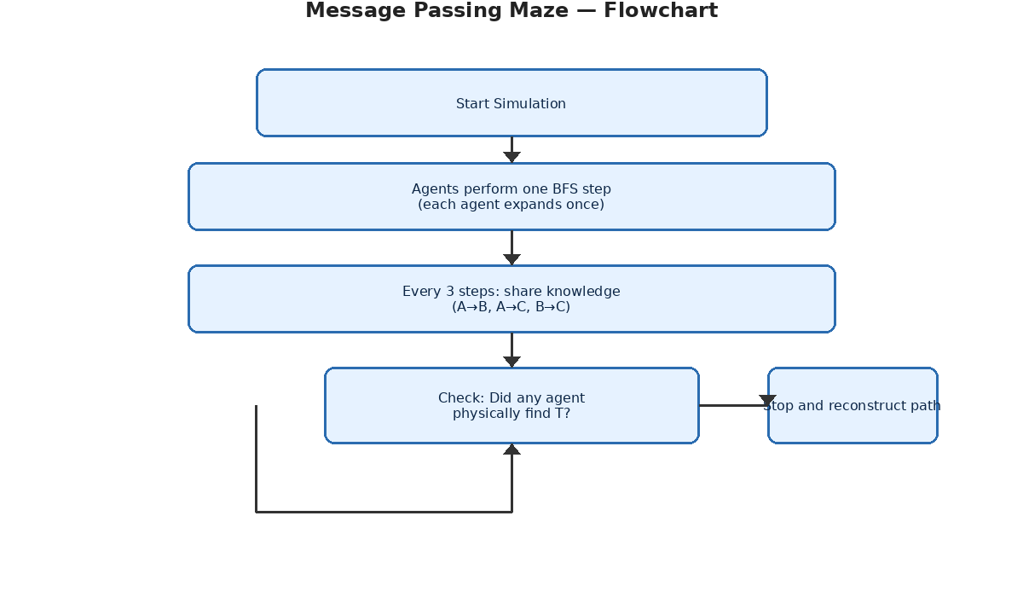
Figure 1 caption: Simulation flow — start, agent BFS steps, communication rounds, and stop condition.
Figure 2: BFS tree example (Agent B)
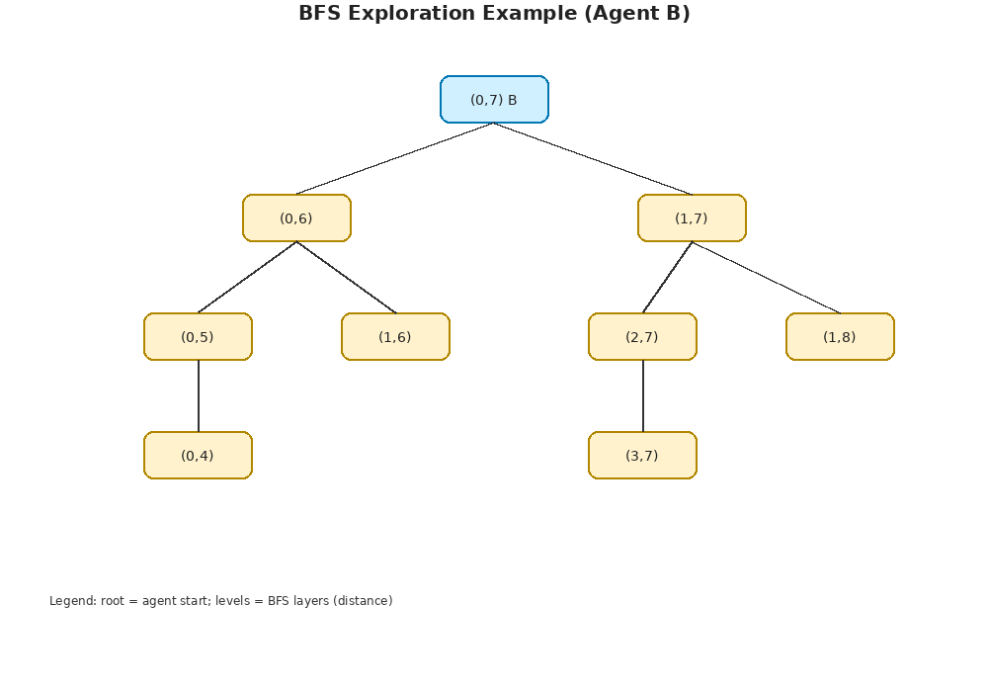
Figure 2 caption: BFS layers from agent B's start; each level shows cells at increasing distance.
Figure 3: Message sequence chart
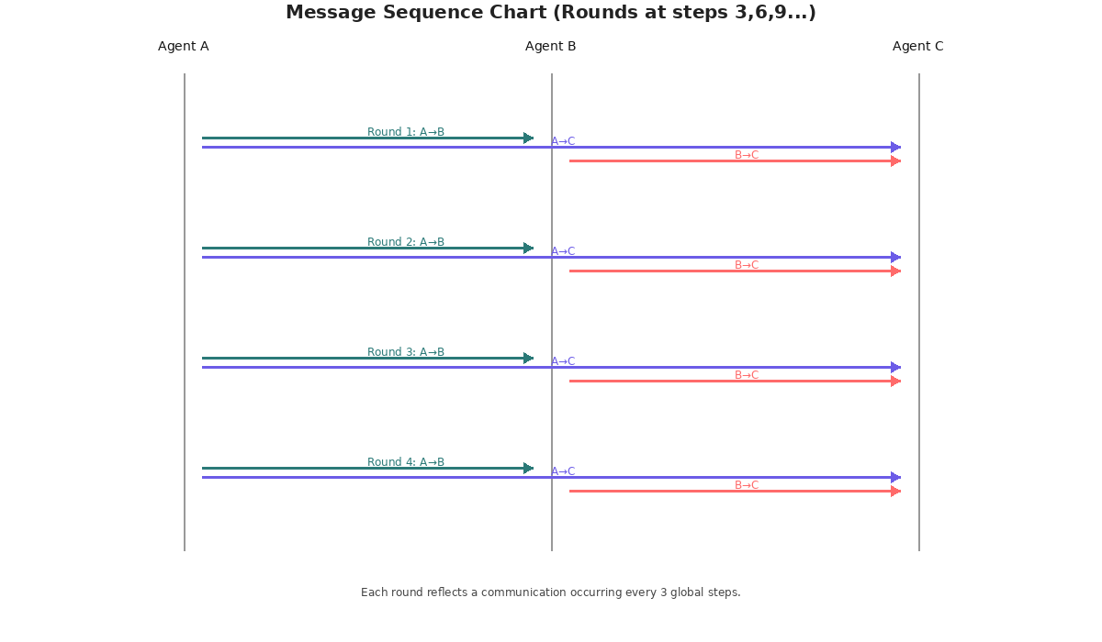
Figure 3 caption: Directed messages each round (A→B, A→C, B→C).

8. Design Decisions & Alternatives
Key decisions made and why:
- Sharing copies parents but does not enqueue: keeps message effects informational only and matches original output. Alternative: enqueue shared cells to let receiver expand them (merge frontiers).
- Only forward shares (A→B,A→C,B→C): simple, structured protocol; alternative: fully bidirectional shares each round.
- One BFS expansion per agent per global step: simple synchronous model. Alternative: round-robin moves, or differing agent speeds.
Trade-offs and implications are discussed here, including performance and message complexity.

9. Extensions and Further Work
- Enqueue shared cells (merge BFS frontiers) — faster collective discovery, but changes message counts and timing.
- Allow all-to-all sharing or configurable topologies.
- Visual interactive GUI to step through simulation and see messages live.
- Metrics: messages sent, redundant exploration, coverage over time, discovery latency.

10. Appendix: Running and Export
1. Save the code to message_passing_maze.py and run: python message_passing_maze.py
2. The diagrams are included in the DOCX and PNG files under /mnt/data/diagrams/
3. To export the DOCX to PDF: open the DOCX in MS Word and export to PDF, or use LibreOffice headless conversion.

