Task1-
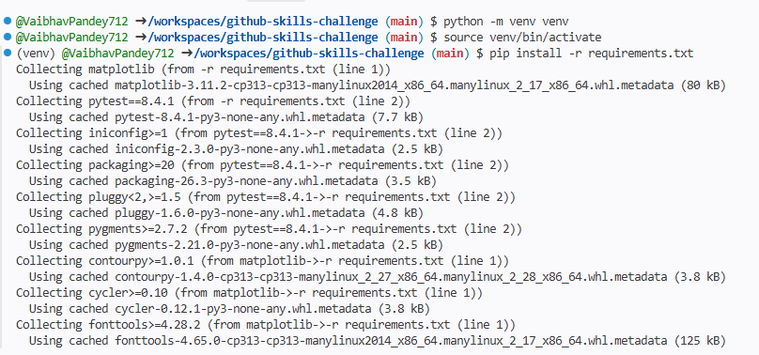
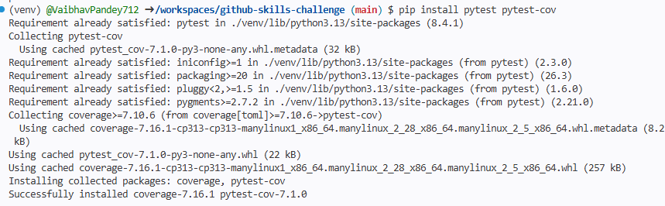
Task-2
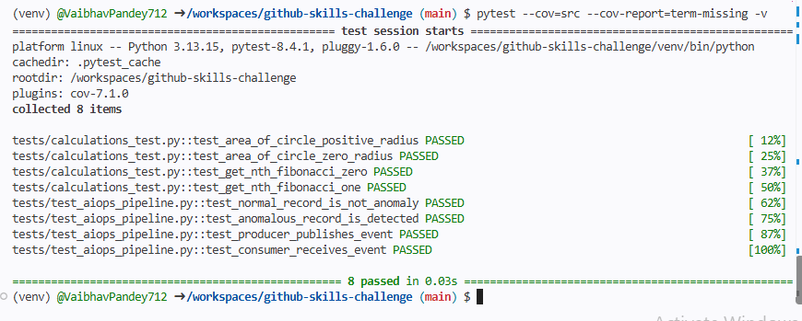

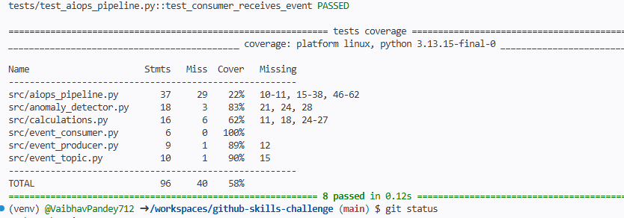

name: Python Tests

on:
pull_request:
branches:
- main

jobs:
test:
runs-on: ubuntu-latest

steps:
- name: Checkout repository
uses: actions/checkout@v4

- name: Set up Python
uses: actions/setup-python@v5
with:
python-version: "3.13"

- name: Install project dependencies
run: |
python -m pip install --upgrade pip
pip install -r requirements.txt

- name: Install testing tools
run: |
pip install pytest pytest-cov

- name: Run tests
env:
PYTHONPATH: .
run: |
pytest -v
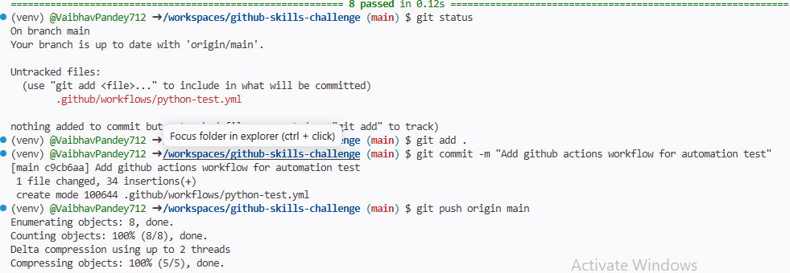
Test.yml
name: Python Test Suite

on:
pull_request:
branches:
- main

jobs:
cet:
test:
runs-on: ubuntu-latest

steps:
- name: Checkout Repository
uses: actions/checkout@v4

- name: Set up Python
uses: actions/setup-python@v5
with:
python-version: '3.10'
cache: 'pip'

- name: Install Dependencies and Testing Tools
run: |
python -m pip install --upgrade pip
if [ -f requirements.txt ]; then pip install -r requirements.txt; fi
pip install pytest

- name: Run Tests
run: |
pytest -v

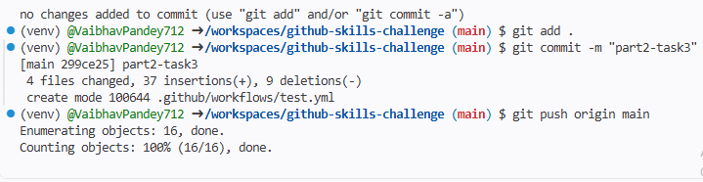
Python-ceoverage.yml
name: Python Test Coverage

on:
pull_request:
branches:
- main

permissions:
pull-requests: write
contents: read

jobs:
coverage:
runs-on: ubuntu-latest

steps:
- name: Checkout Repository
uses: actions/checkout@v4

- name: Set up Python
uses: actions/setup-python@v5
with:
python-version: '3.10'
cache: 'pip'

- name: Install Dependencies and Coverage Tools
run: |
python -m pip install --upgrade pip
if [ -f requirements.txt ]; then pip install -r requirements.txt; fi
pip install pytest pytest-cov

- name: Run Tests with Coverage
run: |
pytest --cov=src --cov-fail-under=80 --junitxml=pytest.xml --cov-report=term-missing | tee pytest-coverage.txt

- name: Publish Coverage Comment
uses: MishaKav/pytest-coverage-comment@v3
with:
pytest-coverage-path: ./pytest-coverage.txt
junitxml-path: ./pytest.xml
