# Introduction

*Prometheus* is an open source systems monitoring and alerting toolkit that has been adopted by a larger number of companies and organizations. Prometheus is now part of the *Cloud Native Computing Foundation (CNCF)*. It comprises of a Prometheus Server that scrapes and stores time series data and an alertmanager to handle alerts.

# Architecture

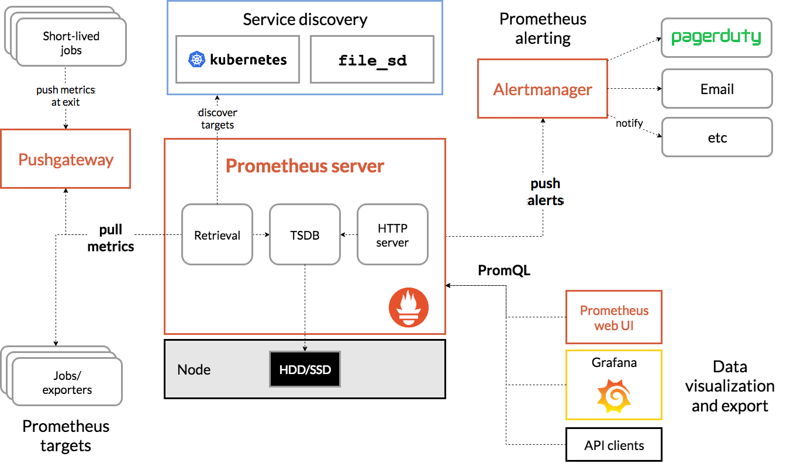

*Prometheus* scrapes metrics from instrumented jobs and stores all scraped samples locally and runs rules over this data or generate alerts. *Grafana* can be used to visualize the collected data.

# Prometheus Installation

We shall be installing Prometheus and Grafana tools on AWS EKS cluster and we assume that the AWS EKS cluster has already been provisioned. Prometheus and Grafana tools can easily be installed using *helm*

helm ls

## Configure Storage Class

In order to install Prometheus and Grafana, we can use gp2 EBS volumes for local storage. However for Production deployments it is highly recommended to use io1 EBS volumes for higher performance.

kubectl create -f prometheus-storageclass.yaml

## Download Prometheus

curl -o prometheus-values.yaml https://raw.githubusercontent.com/helm/charts/master/stable/prometheus/values.yaml

Modify the downloaded file to uncomment the storageClass and set it to "prometheus" at line # 164 and 664

By default Prometheus server is exposed as ClusterIP, hence in order to access the Web UI we need to expose Prometheus server as a NodePort. Search for type: ClusterIP and add nodePort: 30900 and change the type to NodePort as indicated below.

externalIPs: []  
  
 loadBalancerIP: ""  
 loadBalancerSourceRanges: []  
 servicePort: 80  
 nodePort: 30900  
 type: NodePort

## Deploy Prometheus

helm install -f prometheus-values.yaml stable/prometheus --name prometheus --namespace prometheus

## Check the Prometheus deployment

kubectl get all -n prometheus

It shall render an output like this:

NAME READY STATUS RESTARTS AGE  
pod/prometheus-alertmanager-77cfdf85db-s9p48 2/2 Running 0 1m  
pod/prometheus-kube-state-metrics-74d5c694c7-vqtjd 1/1 Running 0 1m  
pod/prometheus-node-exporter-6dhpw 1/1 Running 0 1m  
pod/prometheus-node-exporter-nrfkn 1/1 Running 0 1m  
pod/prometheus-node-exporter-rtrm8 1/1 Running 0 1m  
pod/prometheus-pushgateway-d5fdc4f5b-dbmrg 1/1 Running 0 1m  
pod/prometheus-server-6d665b876-dsmh9 2/2 Running 0 1m  
  
NAME TYPE CLUSTER-IP EXTERNAL-IP PORT(S) AGE  
service/prometheus-alertmanager ClusterIP 10.100.89.154 <none> 80/TCP 1m  
service/prometheus-kube-state-metrics ClusterIP None <none> 80/TCP 1m  
service/prometheus-node-exporter ClusterIP None <none> 9100/TCP 1m  
service/prometheus-pushgateway ClusterIP 10.100.136.143 <none> 9091/TCP 1m  
service/prometheus-server NodePort 10.100.151.245 <none> 80/30900 1m  
  
NAME DESIRED CURRENT READY UP-TO-DATE AVAILABLE NODE SELECTOR AGE  
daemonset.apps/prometheus-node-exporter 3 3 3 3 3 <none> 1m  
  
NAME DESIRED CURRENT UP-TO-DATE AVAILABLE AGE  
deployment.apps/prometheus-alertmanager 1 1 1 1 1m  
deployment.apps/prometheus-kube-state-metrics 1 1 1 1 1m  
deployment.apps/prometheus-pushgateway 1 1 1 1 1m  
deployment.apps/prometheus-server 1 1 1 1 1m  
  
NAME DESIRED CURRENT READY AGE  
replicaset.apps/prometheus-alertmanager-77cfdf85db 1 1 1 1m  
replicaset.apps/prometheus-kube-state-metrics-74d5c694c7 1 1 1 1m  
replicaset.apps/prometheus-pushgateway-d5fdc4f5b 1 1 1 1m  
replicaset.apps/prometheus-server-6d665b876 1 1 1 1m

## Access the Prometheus server

The Prometheus server can now be accessed at one of the node IP addresses at port 30900.

# Grafana Installation

## Download Prometheus

Run the following:

curl -o grafana-values.yaml https://raw.githubusercontent.com/helm/charts/master/stable/grafana/values.yaml

Edit the *grafana-values.yaml* file by replacing *storageClass* with *"prometheus"*, *enabled* with true and *adminPassword* with your password *"password"*

persistence:  
 enabled: true  
 storageClassName: "prometheus"  
 # accessModes:  
 # - ReadWriteOnce  
 # size: 10Gi  
 # annotations: {}  
 # subPath: ""  
 # existingClaim:  
  
adminUser: admin  
adminPassword: password

Uncomment the datasources section inside the *grafana-values.yaml* file and set the url attribute to point to the url of the Prometheus server

datasources:  
 datasources.yaml:  
 apiVersion: 1  
 datasources:  
 - name: Prometheus  
 type: prometheus  
 url: http://prometheus-server.prometheus.svc.cluster.local  
 access: proxy  
 isDefault: true

Change the grafana service type to LoadBalancer so that its is accessible using a AWS ELB Service url, all of these changes have been made to the file.

service:  
 type: LoadBalancer  
 port: 80  
 annotations: {}  
 labels: {}

## Deploy Grafana

helm install -f grafana-values.yaml stable/grafana --name grafana --namespace grafana

kubectl get all -n grafana

Retrieve the ELB url by running the following:

export ELB=$(kubectl get svc -n grafana grafana -o jsonpath='{.status.loadBalancer.ingress[0].hostname}')  
  
echo "http://$ELB"

# Create Dashboards

Using the ELB url, login to the Grafana dashboard. Since we configured the *datasources* section above, you will notice that *Install Grafana* & *create your first data source* are already completed. Click *+* button on the left panel and select import, enter 3131 dashboard id under Grafana.com Dashboard and click *Load*. Leave the defaults, select *Prometheus* as the endpoint under prometheus data sources drop down, click *Import*. This will sow monitoring dashboard for all the cluster nodes.

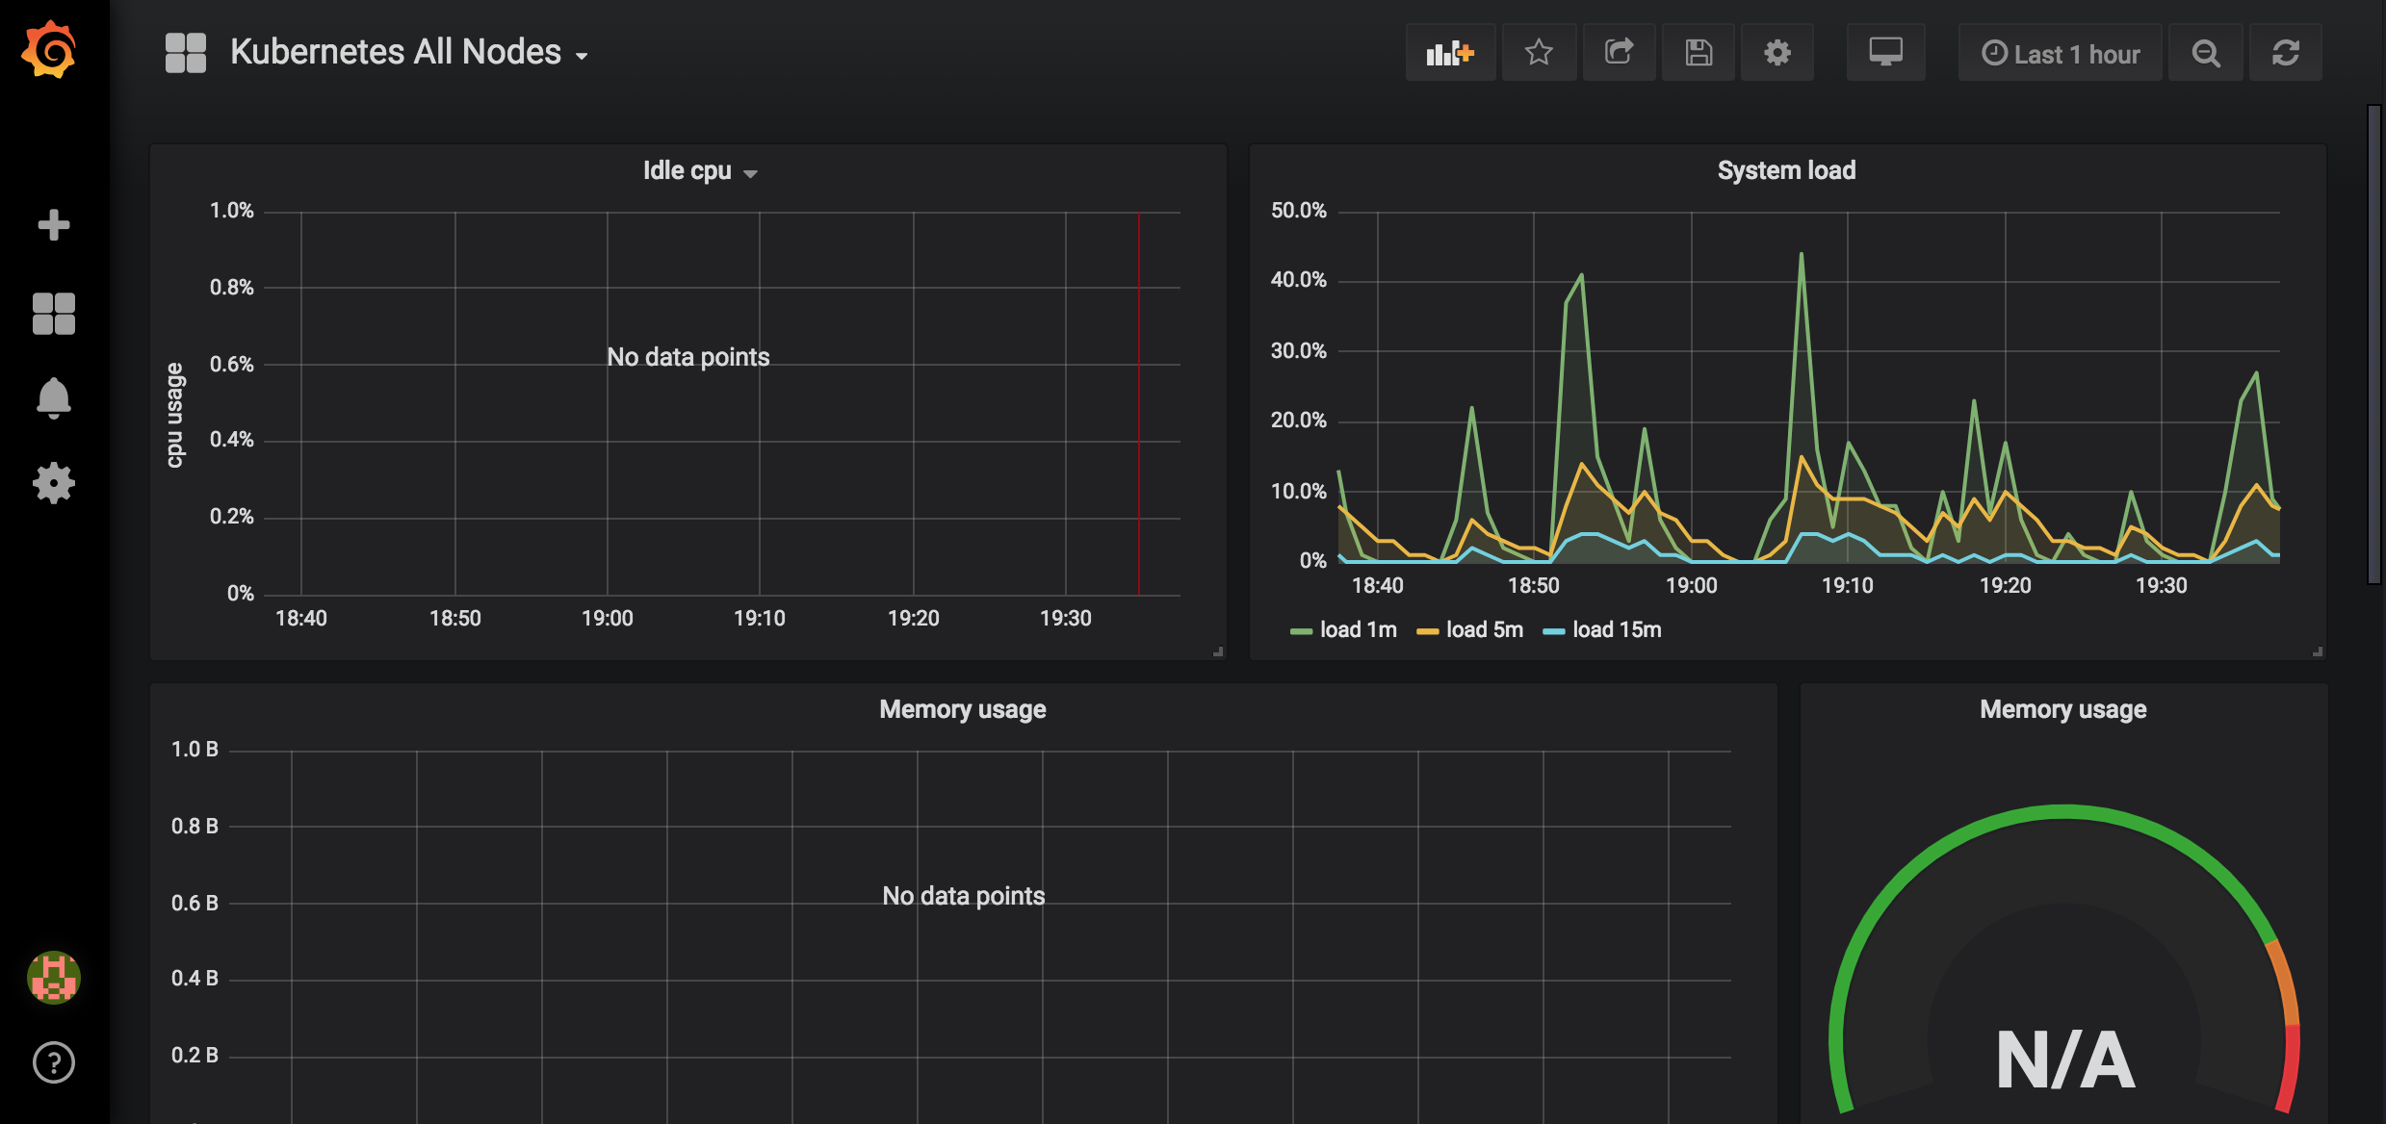

In order to monitor the EKS Kubernetes cluster pods, create a dashboard and enter 3146 for dashboard id.

