Title : Smart Irrigation System

Introduction

Smart irrigation systems are advanced technological solutions that help farmers and gardeners to water their plants efficiently and sustainably. These systems use various sensors and algorithms to determine the optimal amount of water required by the plants and deliver it precisely. One of the critical factors that affect the water requirements of plants is the temperature and humidity of the environment in which they grow. Therefore, integrating temperature and humidity sensors into a smart irrigation system can significantly improve its accuracy and effectiveness. These sensors can measure the current weather conditions and adjust the irrigation schedule accordingly, preventing over or under-watering of the plants. In this way, a smart irrigation system with temperature and humidity sensors can help to conserve water, reduce the cost of irrigation, and promote healthier plant growth.

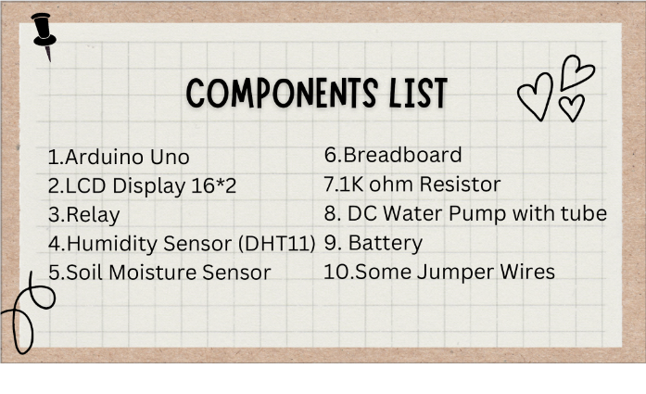

Problem Statement

Irrigation is a crucial process for maintaining healthy plant growth, and it is essential for agriculture, landscaping, and gardening. However, traditional irrigation methods are often wasteful, inefficient, and costly, leading to overuse of water resources and environmental degradation. One of the main challenges of irrigation is the difficulty in determining the optimal amount of water required by plants. Underwatering can lead to plant stress, reduced yields, and plant death, while overwatering can cause waterlogging, nutrient leaching, and soil erosion. Moreover, climate change and unpredictable weather patterns make it even harder to manage irrigation effectively.

To address these challenges, the development of smart irrigation systems has become increasingly popular. Smart irrigation systems use sensors, weather data, and algorithms to determine the optimal amount of water required by plants and deliver it precisely, resulting in improved plant growth, reduced water usage, and lower costs. However, there are still several challenges that need to be addressed to make smart irrigation systems more accessible and effective.

One of the primary challenges is the high cost and complexity of smart irrigation systems, which can limit their adoption by small-scale farmers and gardeners. Moreover, the lack of proper maintenance, calibration, and data management can reduce the accuracy and reliability of smart irrigation systems, leading to under or over-irrigation. Furthermore, the integration of various sensors, including temperature and humidity sensors, requires a reliable wireless network and compatible software, which can be a challenge in remote or rural areas. Therefore, addressing these challenges and developing affordable and easy-to-use smart irrigation systems is crucial to promote sustainable irrigation practices and protect water resources.

System Overview

A smart irrigation system with temperature and humidity sensors is an automated solution that uses advanced technology to optimize water usage and improve plant growth. The system consists of several components, including sensors, controllers, and software, that work together to monitor environmental conditions and deliver water precisely to the plants.

The temperature and humidity sensors are essential components of the system that measure the current weather conditions, including temperature, humidity, and air pressure. These sensors provide real-time data to the controllers, which use algorithms to determine the optimal amount of water required by the plants based on their growth stage, soil type, and weather conditions. The controllers then activate the irrigation valves, which deliver water precisely to the plant roots, preventing over or under-irrigation.

The software component of the smart irrigation system provides a user interface that allows farmers and gardeners to monitor and control the irrigation process remotely. This software can display real-time data on weather conditions, soil moisture levels, and water usage, enabling users to adjust the irrigation schedule and optimize plant growth. Furthermore, the software can provide alerts and notifications to the users in case of any malfunctions or irregularities in the system. Overall, a smart irrigation system with temperature and humidity sensors provides an efficient, sustainable, and cost-effective solution for irrigation, helping farmers and gardeners to conserve water resources and promote healthier plant growth.

Benefits

A smart irrigation system with temperature and humidity sensors offers several benefits, including:

Water conservation: The system delivers water precisely to the plant roots, preventing over or under-irrigation and reducing water waste. By using real-time data from temperature and humidity sensors, the system adjusts the irrigation schedule to match the plants' water requirements, resulting in significant water savings.

Improved plant growth: The system optimizes the amount and timing of water delivery, ensuring that plants receive the right amount of water when they need it. This improves plant growth, reduces plant stress, and increases yields.

Cost savings: By reducing water usage and optimizing plant growth, the system can significantly lower the cost of irrigation. The system can also reduce labor costs by automating the irrigation process and providing remote monitoring and control.

Sustainable irrigation practices: The system promotes sustainable irrigation practices by reducing water waste, protecting water resources, and preventing environmental degradation.

Easy maintenance: The system requires minimal maintenance and calibration, reducing the need for frequent manual adjustments.

User-friendly interface: The system provides a user-friendly interface that allows farmers and gardeners to monitor and control the irrigation process remotely. This enables users to adjust the irrigation schedule and optimize plant growth easily.

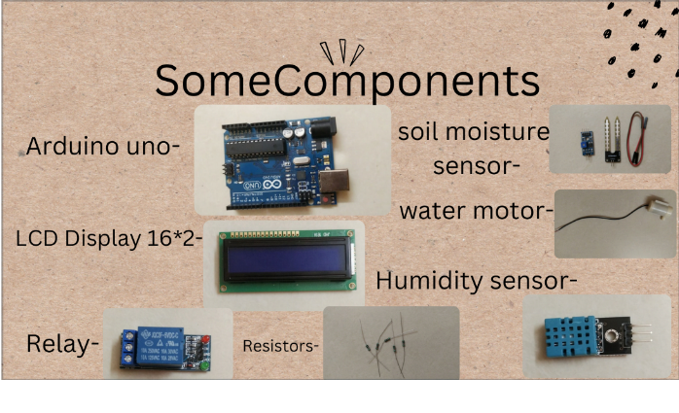

Group Member Roll Nos :

S086

S078

S076

S100

S099

S075

S116