
MATHEMATICS FOR COMPUTER SCIENCE ENGINEERS
Data Visualization and Interpretation

Mamatha H R
Department of Computer Science and Engineering
mamathahr@pes.edu

MATHEMATICS FOR COMPUTER SCIENCE ENGINEERS

Data Visualization and Interpretation - Bar Charts

Mamatha H R
Department of Computer Science and Engineering

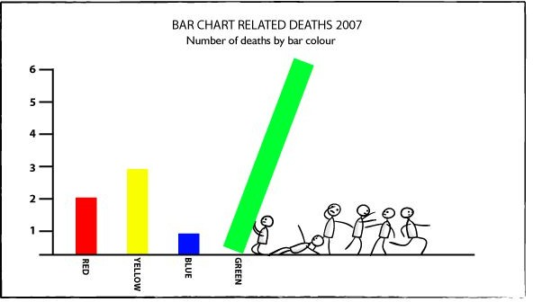
- Often known as the “King of Charts”, Bar Charts are one of the most commonly used charts in the field of Data Science.

- The advantage of bar plots (or “bar charts”, “column charts”) over other chart types is that the human eye has evolved a refined ability to compare the length of objects, as opposed to angle or area.

- Summarizes categorical data.

- Horizontal axis represents categories, while vertical axis represents either counts (“frequencies”) or percentages (“relative frequencies”).

- Used to illustrate the differences in percentages (or counts) between categories.

- The graph represents categories on one axis and a discrete value in the other. The goal is to show the relationship between the two axes

- Bar charts can also show big changes in data over time

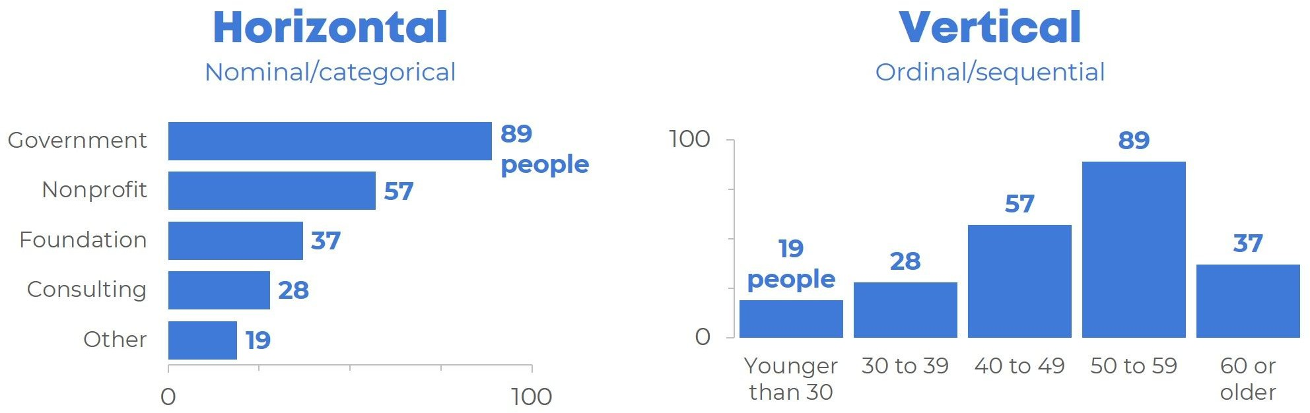

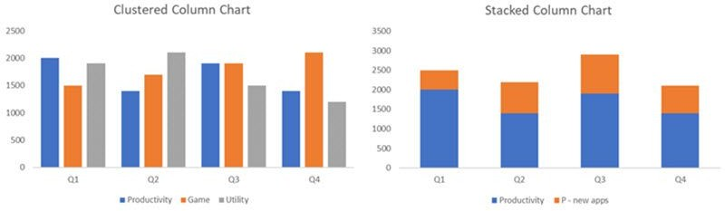

- Horizontal Bar Graphs: The classes are displayed on the y-axis, and the values(scores) of those classes are displayed on the x-axis. Useful only when comparing one set of data.
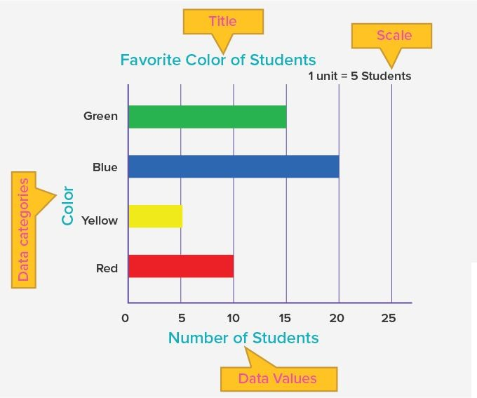

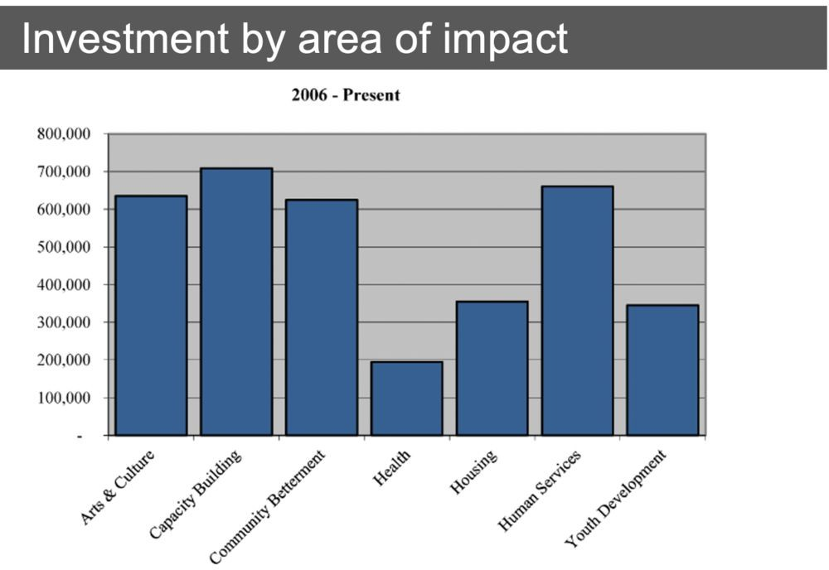
- Vertical Bar Graphs : The classes are displayed on the x-axis, and the values(scores) of those classes are displayed on the y-axis. Useful only when comparing one set of data.

- Stacked Bar Graphs : Each bar has multiple datasets to be compared, each set of values belonging to the class of different datasets are stacked over one other.

- Useful when comparing multiple datasets but having same set of classes
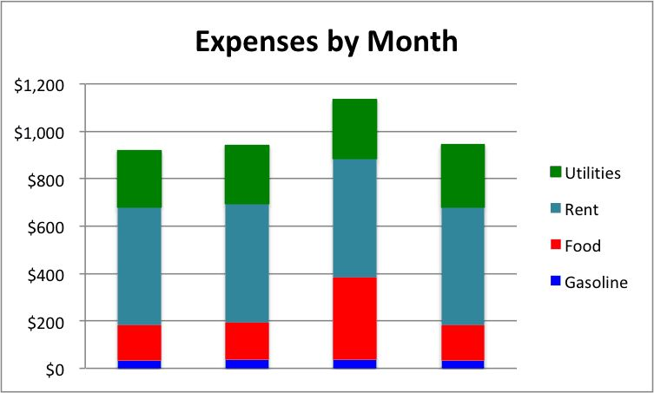

  - Grouped Bar Graphs : Grouped bar charts are Bar charts in which multiple sets of data items are compared, with a single color used to denote a specific series across all sets.
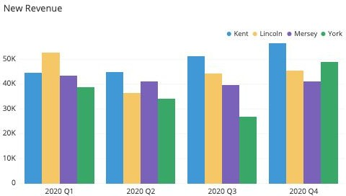
  - A grouped or clustered bar graph is used to represent discrete values for more than one item that share the same category.
  - Grouped bar charts are a way of showing information about different sub-groups of the main categories.
  - But care needs to be taken to ensure that the chart does not contain too much information making it complicated to read and interpret.

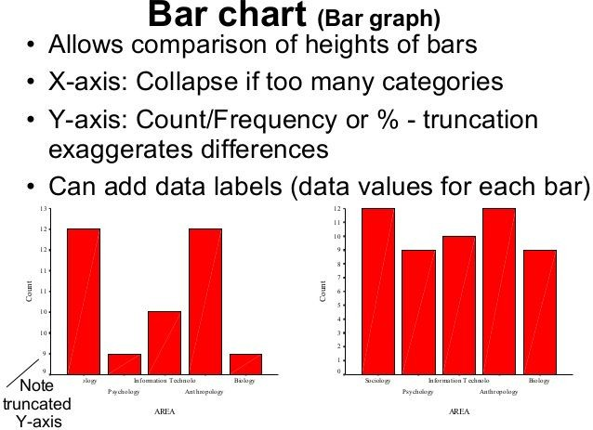

The vehicular traffic at a busy road crossing in a particular
place was recorded on a particular day from 6am to 2 pm and the data was rounded off to the nearest tens. Construct a Bar Chart.
Time in Hours | 6 - 7 | 7 - 8 | 8 - 9 | 9 - 10 | 10 - 11 | 11 - 12 | 12 - 1 | 1 - 2
Number of Vehicles | 100 | 450 | 1250 | 1050 | 750 | 600 | 550 | 200

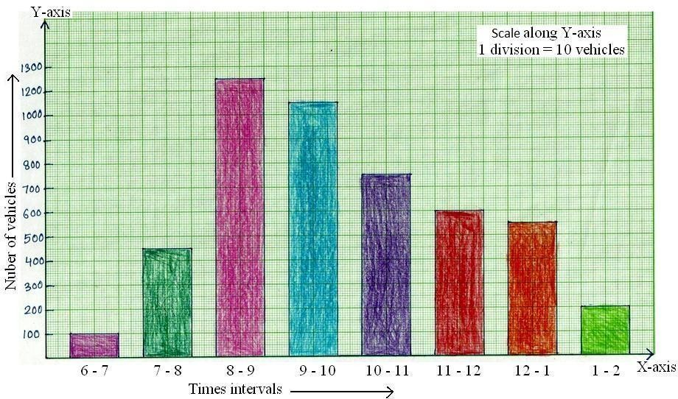

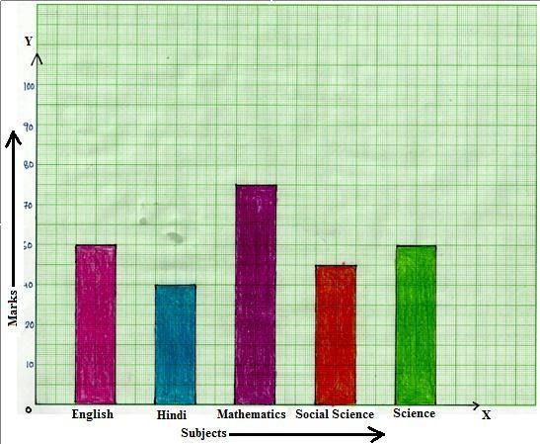
Look at the graph given

Read it carefully and answer the following questions.
- What information does the bar graph give?
- In which subject is the student very good
- In which subject is he poor?
- What are the average of his marks?

  - It shows the marks obtained by a student in five subjects
  - Mathematics
  - Hindi
  - 56

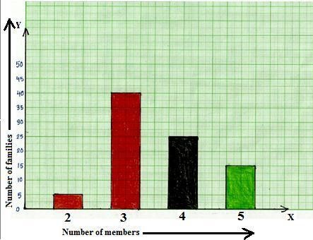
In a survey of 85
families of a colony, the number of members in each family was recorded, and the data has been represented by the following bar graph.

MATHEMATICS FOR COMPUTER SCIENCE ENGINEERS
Data Visualization: Bar Charts Examples
Read the bar graph carefully and answer the following questions:
- What information does the bar graph give?
- How many families have 3 members?
- How many people live alone?
- Which type of family is the most common? How many members are there in each family of this kind?

  - It gives the number of families containing 2, 3, 4, 5 members each.
  - 40
  - none
  - Family having 3 members, 3 members.

Determine the discrete range
- Examine your data to find the bar with the largest value. This will help you determine the range of the vertical axis and the size of each increment.



Determine the number of bars

Examine your data to find how many bars your chart will contain. Use this number to draw and label the horizontal axis

Source: www.slideshare.net
Slide Courtesy: Dr.Uma

Determin e the order of the bars
Bars may be arranged in any order. (A bar
chart arranged from highest to lowest incidence is called a Pareto chart)

Draw the bars
If you are preparing a grouped bar graph, remember to present the information in the same order in each grouping

Source: www.slideshare.net
Slide Courtesy: Dr.Uma

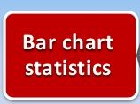
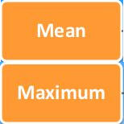

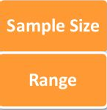
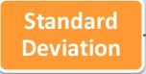
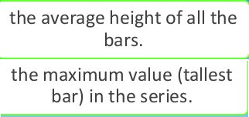

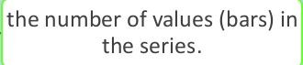
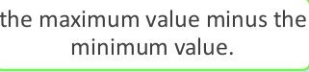
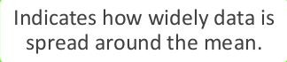
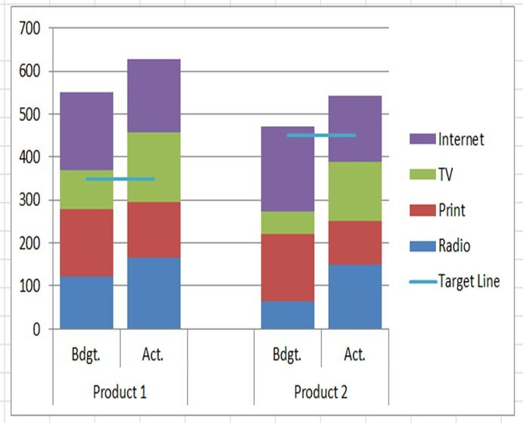

Source: www.slideshare.net
Slide Courtesy: Dr.Uma

Difference between Bar and Histogram


Bar
Histogram

Type of Data

In bar graphs are usually used to display "categorical data", that is data that fits into categories.
Type of Data

Used to present "continuous data", that is data that represents measured quantity where, at least in theory, the numbers can take on any value in a certain range.

Slide Courtesy: Dr.Uma

THANK YOU

Mamatha H R

Department of Computer Science
mamathahr@pes.edu

