
Arithmetic Logic Unit
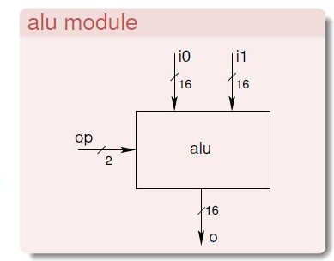
Aim of the Experiment: Implement a
16 bit ALU supporting:
Arithmetic operations : add, subtract
Logic operations : and, or

The ALU (Arithmetic and Logic Unit) is the heart of a CPU since it performs the arithmetic and logic operations which are the key computations.
Your task in this assignment is to design and simulate a 16-bit1 ALU which performs the following core operations
- Arithmetic Addition and subtraction (two’s complement)
- Logic AND along with OR operation
Each operation would receive as input two 16-bit operands and the output would be a 16-bit result (along with carry and overflow).
The decision on which of the four operations is to be performed would be indicated by a two bit operation input. So the ALU module inputs are:
- i0[15:0] 16-bit operand 0
- i1[15:0] 16-bit operand 1
- op[1:0] 2-bit operation code

Operation Code meaning

op[1:0] | operation
00 | Addition
01 | Subtraction
10 | and
11 | or
The ALU module outputs should be:
- o[15:0] 16-bit operation result
- carry Carry out of MSB
- overflow Arithmetic overflow
During logic operations the values of the carry and overflow outputs are irrelevant.

The ALU module inputs are:
i0[15:0]  16-bit operand i0 | i1[15:0]  16-bit operand i1
The opcode bits are op1,op0(2 bit operation code)
00  01  10  11 | add subtract and  or
The ALU module outputs are:
o[15:0]
16-bit operation result
The status bits are
Carry  Carry out of MSB | Overflow Arithmetic overflow


- Once you have designed the ALU logic, it needs to specified using the Verilog syntax .
be
- The entire ALU should be composed of purely combinational
logic elements that have been discussed in class.
- Also, only the Verilog module definition and instantiation syntax discussed in class should be used.
- Once the ALU is designed, it needs to be simulated to verify
proper functionality of its various operations.
- Appropriate inputs need to be applied to the ALU.

The inputs are specified as test vectors, four of which are specified
as samples on lines 14 to 17 of tb_alu.v.
The samples test only the arithmetic functionality.
Additional test vectors need to be added not only for logic but arithmetic operations as well.
Be sure to change value of TESTVECS on line 2 whenever the number of test vectors is modified.

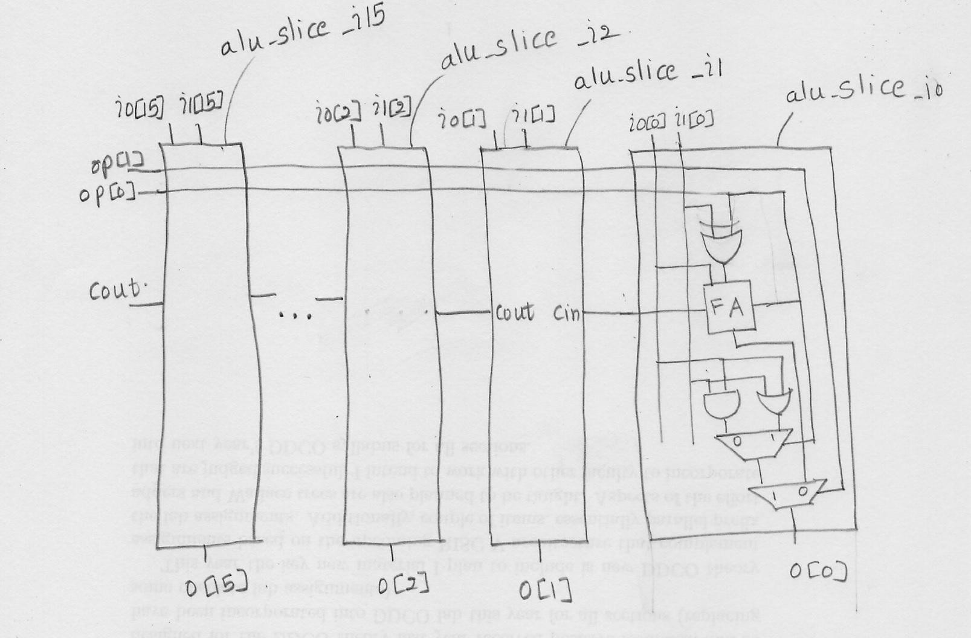

Source File alu.v
module fa (input wire i0, i1, cin, output wire sum, cout); wire t0, t1, t2;
xor3 _i0 ( );
and2 _i1 ( );
and2 _i2 ( );
and2 _i3 ( );
or3 _i4 ( );
endmodule
module addsub (input wire addsub, i0, i1, cin, output wire sumdiff, cout);
wire t;
fa _i0 ( );
xor2 _i1 ( );endmodule

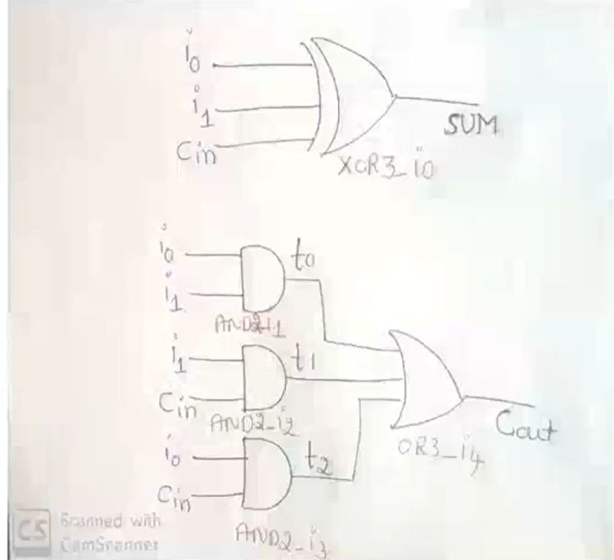

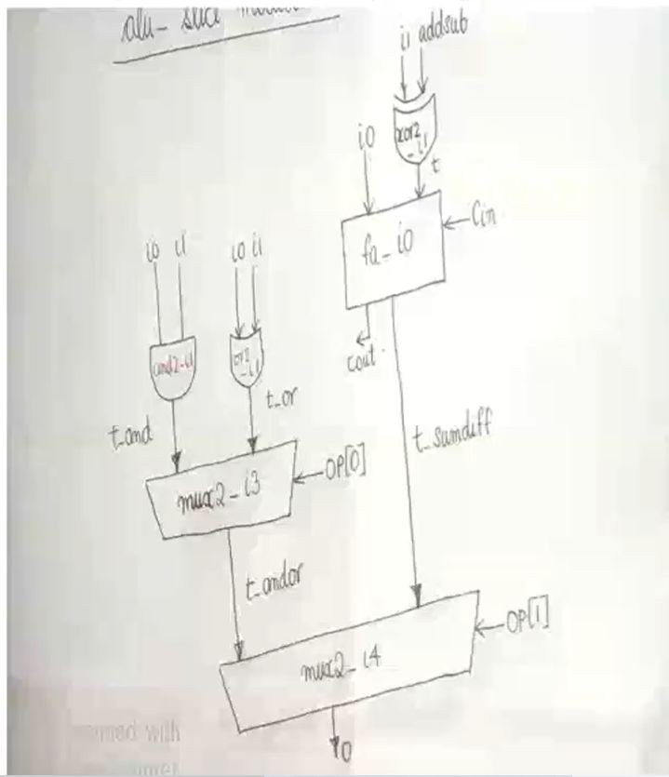

module alu_slice (input wire [1:0] op, input wire i0, i1,
cin, output wire o, cout);
wire t_sumdiff, t_and, t_or, t_andor; addsub _i0 ( );
and2 _i1 ( );
or2 _i2 ( );
mux2 _i3 ( );
mux2 _i4 ( );
endmodule

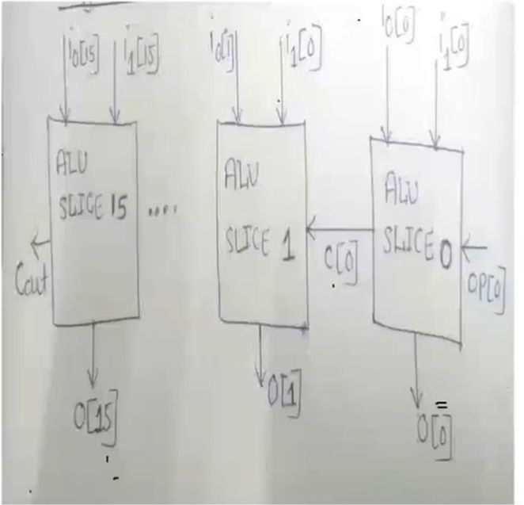

module alu (input wire [1:0] op, input wire [15:0] i0, i1,
output wire [15:0] o, output wire cout); wire [14:0] c;
alu_slice _i0 ( );
alu_slice _i1 ( );
alu_slice _i2 ( );
alu_slice _i3 ( );
alu_slice _i4 ( );
alu_slice _i5 ( );
alu_slice _i6 ( );
alu_slice _i7 ( );
alu_slice _i8 ( );
alu_slice _i9 ( );
alu_slice _i10 ( );

alu_slice _i11 ( );
alu_slice _i12 ( );
alu_slice _i13 ( );
alu_slice _i14 ( );
alu_slice _i15 ( );
endmodule

Testbench tb_alu.v
`timescale 1 ns / 100 ps
`define TESTVECS 16 module tb;
reg clk, reset; reg [1:0] op;
reg [15:0] i0, i1;
wire [15:0] o; wire cout; reg [33:0]
test_vecs [0:(`TESTVECS-1)]; integer i;
initial begin

$dumpfile("tb_alu.vcd");
$dumpvars(0,tb); end
initial begin
reset = 1'b1; #12.5
reset = 1'b0; end
initial clk = 1'b0; always
#5
clk =~ clk; initial begin

test_vecs[0][33:32] = 2'b00;
test_vecs[0][31:16] = 16'h0000; test_vecs[0][15:0] = 16'h0000; test_vecs[1][33:32] = 2'b00; test_vecs[1][31:16] = 16'haa55; test_vecs[1][15:0] = 16'h55aa; test_vecs[2][33:32] = 2'b00; test_vecs[2][31:16] = 16'hffff; test_vecs[2][15:0] = 16'h0001; test_vecs[3][33:32] = 2'b00; test_vecs[3][31:16] = 16'h0001; test_vecs[3][15:0] = 16'h7fff; test_vecs[4][33:32] = 2'b01; test_vecs[4][31:16] = 16'h0000; test_vecs[4][15:0] = 16'h0000;

test_vecs[5][33:32] = 2'b01;
;
test_vecs[5][31:16] = 16'haa55; test_vecs[5][15:0] = 16'h55aa; test_vecs[6][33:32] = 2'b01; test_vecs[6][31:16] = 16'hffff; test_vecs[6][15:0] = 16'h0001; test_vecs[7][33:32] = 2'b01; test_vecs[7][31:16] = 16'h0001; test_vecs[7][15:0] = 16'h7fff; test_vecs[8][33:32] = 2'b10; test_vecs[8][31:16] = 16'h0000; test_vecs[8][15:0] = 16'h0000; test_vecs[9][33:32] = 2'b10; test_vecs[9][31:16] = 16'haa55; test_vecs[9][15:0] = 16'h55aa;

test_vecs[10][33:32] = 2'b10;
test_vecs[10][31:16] = 16'hffff test_vecs[10][15:0] = 16'h0001; test_vecs[11][33:32] = 2'b10; test_vecs[11][31:16] = 16'h0001; test_vecs[11][15:0] = 16'h7fff; test_vecs[12][33:32] = 2'b11; test_vecs[12][31:16] = 16'h0000; test_vecs[12][15:0] = 16'h0000; test_vecs[13][33:32] = 2'b11; test_vecs[13][31:16] = 16'haa55; test_vecs[13][15:0] = 16'h55aa; test_vecs[14][33:32] = 2'b11; test_vecs[14][31:16] = 16'hffff; test_vecs[14][15:0] = 16'h0001;

test_vecs[15][33:32] = 2'b11;
test_vecs[15][31:16] = 16'h0001; test_vecs[15][15:0] = 16'h7fff; end initial {op, i0, i1} = 0;
alu alu_0 (op, i0, i1, o, cout); initial begin
#6
for(i=0;i<`TESTVECS ; i=i+1) begin
#10
{op, i0, i1}=test_vecs[i]; end #100 $finish;
end endmodule

DESIGN AND SIMULATION
- To simulate the ALU with the test vectors, run the commands:
iverilog -o tb_alu lib.v alu.v tb_alu.v
- vvp tb_alu
- Above commands should produce the tb_alu.vcd file.
- To view the waveforms, run the command: gtkwave tb_alu.vcd

 | op[1:0] | i0[15:0] | i1[15:0] | Output
TESTVECTOR1 | 2’b00 | 16’h0000 | 16’h0000
TESTVECTOR2 | 2’b00 | 16’haa55 | 16’h55aa
TESTVECTOR3 | 2’b00 | 16'hffff | 16'h0001
TESTVECTOR3 | 2’b00 | 16'h0001 | 16'h7fff
TESTVECTOR4 | 2'b01 | 16'h0000 | 16'h0000
TESTVECTOR5 | 2'b01 | 16'haa55 | 16'h55aa
TESTVECTOR6 | 2'b01 | 16'hffff | 16'h0001;
TESTVECTOR7 | 2'b01 | 16‘h0001 | 16'h7fff;

 | op[1:0] | i0[15:0] | i1[15:0] | Output
TESTVECTOR8 | 2’b10 | 16’h0000 | 16’h0000
TESTVECTOR9 | 2’b10 | 16’haa55 | 16’h55aa
TESTVECTOR10 | 2’b10 | 16'hffff | 16'h0001
TESTVECTOR11 | 2’b10 | 16'h0001 | 16'h7fff
TESTVECTOR 12 | 2'b11 | 16'h0000 | 16'h0000
TESTVECTOR 13 | 2'b11 | 16'haa55 | 16'h55aa
TESTVECTOR 14 | 2'b11 | 16'hffff | 16'h0001;
TESTVECTOR 15 | 2'b11 | 16‘h0001 | 16'h7fff;

