

DIGITAL DESIGN AND COMPUTER ORGANIZATION
Basic Structure of computers T2: Chapter 1: 1.1-1.4

Department of Computer Science and Engineering

DIGITAL DESIGN AND COMPUTER ORGANIZATION
Computer Types T2:Ch1 1.1

Department of Computer Science and Engineering

- Computer Types
- Functional Units:
  - Input Unit,
  - Memory Unit,
  - ALU,
  - Output Unit,
  - Control Unit,
- Basic operational concepts

- What is Computer Organization ?
Computer Organization: This field focuses on the functional units of a computer system and how they work together to execute instructions. It deals with the internal structure and operation of a computer, including its components like the CPU, memory, I/O devices, and control unit.

- How is Computer Organization Different from Digital Design ?
While computer organization deals with the high-level structure and function of a computer, digital design focuses on the low-level implementation of its components.

- Simply put, a computer is a sophisticated electronic calculating machine that:
  - Accepts input information,
  - Processes the information according to a list of internally stored instructions and
  - Produces the resulting output information.
- Functions performed by a computer are:
  - Accepting information to be processed as input.
  - Storing a list of instructions to process the information.
  - Processing the information according to the list of instructions.
  - Providing the results of the processing as output.
What are the functional units of a computer?

Classification #1:
  - Micro Computers
  - Mini Computers
  - Mainframes
  - Super Computers
Classification #2:
  - Analog Computers
  - Digital Computers
  - Hybrid Computers
More General Classification:
  - General Purpose Computers
  - Special Purpose Computers

Types Of Computers
Workstations
- Workstations are industry – standard desktop computers with more computational power and high-resolution graphic display with variety of graphic input/output capability.
What is the use of a workstation ?
- Workstation PC’s are usually employed in the applications of Computer Aided Design and Drafting (CADD). Simulation & Modeling, Interactive Graphic design, Multimedia and other engineering applications.

Types Of Computers
Enterprise Systems or Mainframes

Enterprise systems or mainframes are like a family of computers with tremendous computing power beyond workstations.

  - Their computational activities are distributed among one main system (usually a server) and number of child nodes or intelligent PC’s with or without local computing power / processor (usually client computers) called dumb terminals.

  - Mainframes are preferred at business data processing corporate offices. They are quite expensive with several hard disks, RAID’s and backup storage units.

Types Of Computers
Super Computers
- One of the fastest computer’s type currently available, They are

problem scalable.
- Computational speed of a super computer is measured in terms of Floating Point Operations Per Second or FLOPS.
- Examples: Cray X/MP-14 , Param – 8000, Param - Padma
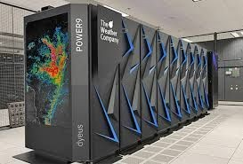

A computer in its simplest form comprises five functional units:
- Input Unit
- Output Unit
- Memory Unit
- Arithmetic & Logic Unit
- Control Unit

The following figure depicts functional units of a computer:
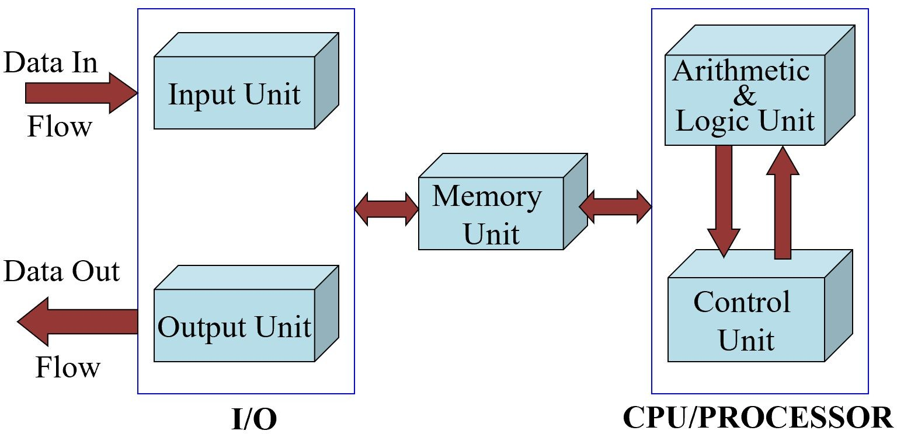
Stored program concept-Serially fetching and executing machine code instructions stored in main memory by a processor that performs arithmetic and logical operations Language translators- compilers
Information must be encoded -encodings- ASCII,EBCDIC

Functional Units of a Computer
Input Unit
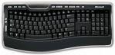
- Computer accepts encoded information through input unit. The standard input device is a keyboard of a video monitor or terminal.

- Whenever a key is pressed, keyboard controller sends the scanned code of that letter, digit or symbol to CPU/Memory.
- Examples include Mouse, Joystick, Tablet or Digitizer, Scanner etc.

Functional Units of a Computer
Memory Unit
Memory unit stores the program instructions, data operands on and results of computations etc.
Memory has large semi-conductor storage cells.
  - Words
  - Word length
  - Memory access time- time required to access one word
  - RAM, cache, mainmemory(slowest and largest)
  - Memory unit is classified as:
    - 1. Primary /Main Memory
    - 2. Secondary /Auxiliary Memory

Functional Units of a Computer
Memory Unit
Primary memory is the computer memory that is directly accessible by CPU. It is comprised of DRAM and provides the actual working space to the processor. It holds the data and instructions that the processor is currently working on.

- Advantages of Primary Memory
  - Speed: Provides fast access to data and instructions.
  - Direct Access: Allows the CPU to quickly read from and write to memory.
- Disadvantages of Primary Memory
  - Limited Size: Is smaller compared to secondary memory

Functional Units of a Computer Memory Unit
Secondary Memory / Mass Storage
The contents of the secondary memory first get transferred to the primary memory and then are accessed by the processor, this is because the processor does not directly interact with the secondary memory.
- Advantages of Secondary Memory
- Persistence: Retains data even without power.
- Large Capacity: Typically offers much more storage space than primary memory.
- Disadvantages of Secondary Memory
- Speed: Slower access compared to primary memory.

- Main memory is classified again as RAM and ROM.
  - RAM is termed as Read/Write memory or user memory that holds run time program instruction and data.
  - ROM holds system programs and firmware routines such as BIOS, POST, I/O Drivers that are essential to manage the hardware of a computer.
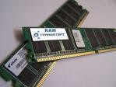
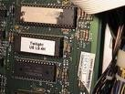
RAM ROM

The key difference between RAM and ROM lies in their:

Purpose:
RAM: Temporary storage for data and program instructions, lost when power is turned off.
ROM: Permanent storage for firmware or system software.
Write capability:
RAM: Read-write (data can be written, modified, and erased). ROM: Read-only (data cannot be modified after manufacture).
Volatility:
RAM: Volatile (loses data when power is turned off). ROM: Non-volatile (retains data even without power).

- Secondary /Auxiliary Memory:
- While primary storage is essential, it is volatile in nature (i.e. its contents will be lost in the absence of power) and expensive too. Additional requirement of memory would be supplied as auxiliary memory at cheaper cost.
- Secondary memory are magnetic memories viz Floppy disk, Hard disk, Magnetic tape, CD-ROM etc.
- Secondary memories are non volatile in nature (contents will not be lost in the absence of power).
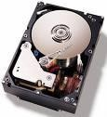


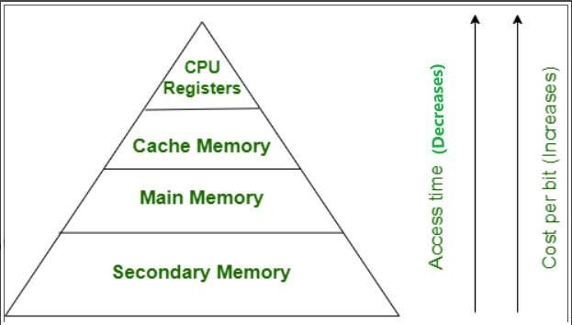

What is an ALU?

  - An ALU is a digital circuit that performs arithmetic and logic operations on binary numbers.
  - ALUs are essential components of computer systems, as they enable the execution of various computational tasks.
How does an ALU work?

  - ALUs process binary data using logic gates, which perform operations like AND, OR, NOT, and XOR. The combination of these gates allows ALUs to execute complex arithmetic and logic operations.

Functional Units of a Computer
Functions of an ALU
- Operations are executed in the Arithmetic and Logic Unit (ALU).
  - Arithmetic operations such as addition, subtraction.
  - Logic operations such as comparison of numbers.
- In order to execute an instruction, operands need to be brought into the ALU from the memory.
  - Operands are stored in general purpose registers available in the ALU.
  - Access times of general purpose registers are faster than the cache.
- Results of the operations are stored back in the memory or retained in the processor for immediate use.

Functional Units of a Computer
Output Unit
- Computer returns the computed results, error messages, etc., via output unit.

The standard output device is a video monitor, LCD/TFT monitor.
- Other output devices are printers, plotters to take a paper copy of the results, programs, graphs called print out or a hardcopy

Printers types: Dot Matrix printer, Inkjet printer, Laser printer. . .

  - Coordinates activities: The control unit oversees the operations of all components within the CPU.
  - Issues timing signals: It sends signals like MEMR (Memory Read), MEMW (Memory Write), IOR (Input Output Read), and IOW (Input Output Write) to control data transfers.
  - Governs data transfers: These timing signals determine when specific operations should occur.
  - Interprets instructions: The control unit decodes instructions to determine the required actions.

Operation of a computer can be summarized as:
- Accepts information from the input units (Input unit).
- Stores the information (Memory).
- Processes the information (ALU).
- Provides processed results through the output units (Output unit).
- Operations of Input unit, Memory, ALU and Output unit are coordinated by
Control unit.
  - Instructions control “what” operations take place (e.g. data transfer, processing).
  - Control unit generates timing signals which determines “when” a particular operation takes place.

Main conceptual events/operations of a computer
- A set of instructions which perform a given task, called a program must reside in the main memory of computer during its execution.
- The CPU fetches those instructions sequentially one-by-one from the main memory, decodes them and perform the specified operation on associated data operands in ALU.
- Processed data i.e. useful information will be displayed on an output unit.
- All activities pertaining to processing and data movement inside the computer machine are governed by control unit.

Information Handled by a Computer:
Instructions/machine instructions
- Govern the transfer of information within a computer as well as between the computer and its I/O devices
- Specify the arithmetic and logic operations to be performed
- List of instructions is called a Program(in memory)

Data (numbers or encoded chars)
- Used as operands by the instructions. Eg(Binary, BCD, ASCII,EBCDIC)

Information in a computer -- Instructions Instructions specify commands to:
- Transfer information within a computer (e.g., from memory to ALU)
- Transfer of information between the computer and I/O devices (e.g., from keyboard to computer, or computer to printer)
- Perform arithmetic and logic operations (e.g., Add two numbers, Perform a logical AND).
A sequence of instructions to perform a task is called a program, which is stored in the memory.
Processor fetches instructions that make up a program from the memory and performs the operations stated in those instructions.
What do the instructions operate upon?

Functional Units of a Computer

MCQ
Which is NOT a characteristic of secondary memory?
- Non-volatile storage
- Cheaper per bit than primary memory
- Directly accessible by the CPU
- Provides large storage capacity

Which of the following best describes the function of the Control Unit (CU)?
- Performs logical comparisons of data.
- Generates timing and control signals to coordinate computer operations.
- Stores frequently accessed data and instructions.
- Acts as a permanent repository for system programs.

Which is NOT a characteristic of secondary memory?
- Non-volatile storage
- Cheaper per bit than primary memory
- Directly accessible by the CPU
- Provides large storage capacity Ans: c) Directly accessible by the CPU
Which of the following best describes the function of the Control Unit (CU)?
- Performs logical comparisons of data.
- Generates timing and control signals to coordinate computer operations.
- Stores frequently accessed data and instructions.
- Acts as a permanent repository for system programs.
Answer: b) Generates timing and control signals to coordinate computer operations

Which of the following statements is correct regarding primary vs secondary memory?
- Primary memory is slower but larger than secondary memory.
- Secondary memory is volatile, whereas primary memory is non-volatile.
- Primary memory is directly accessible by the CPU, while secondary memory is not.
- Both memories are equally fast but differ in size.

Functional Units of a Computer

MCQ
Which of the following statements is correct regarding primary vs secondary memory?
- Primary memory is slower but larger than secondary memory.
- Secondary memory is volatile, whereas primary memory is non-volatile.
- Primary memory is directly accessible by the CPU, while secondary memory is not.
- Both memories are equally fast but differ in size.

Answer: c) Primary memory is directly accessible by the CPU, while secondary memory is not

THANK YOU

Team DDCO
Department of Computer Science

