


PLY Syntax Validator
Python Lex-Yacc Implementation

A practical application of lexical analysis and parsing to validate lambda functions, list comprehensions, class declarations, function declarations, and dictionary method calls.

lambda x: x * 2 [x for x in data]
class MyClass: pass

Compiler Design & Parsing

Project Goal and Scope

TARGET CONSTRUCTS

PRIMARY GOAL

OBJECTIVE

Build a functional syntax validator for a targeted subset of the Python language using PLY (Python Lex-Yacc).

TECHNOLOGY

PLY is a powerful library for implementing lexical analysis and parsing tools in Python, separating tokenization from grammar validation.
→ Lambda Functions
→ List Comprehensions
→ Class Declarations
→ Function Declarations
→ Dictionary Methods

SCOPE LIMITATION
The validator focuses on syntactic structure only and does not handle complex features like indentation, nested blocks, or semantic validation.

The Two Pillars of PLY: Lexer and Parser

Lexical Analysis

LEXER

Reads the input code and converts it into a stream of tokens (e.g., NAME, LAMBDA, COLON). This is the first stage of parsing.
Defined in: python_lexer.py

Syntactic Analysis

PARSER

Takes the tokens and checks if their sequence matches the defined grammar rules. This validates the structure of the code.
Defined in: python_parser.py

PROCESS PIPELINE

Input Code
↓
Lexer (Tokenization)
↓
Token Stream
↓
Parser (Grammar Validation)
↓
Valid Syntax / Syntax Error

Tokenizing Python: Recognizing Keywords and
Symbols

CATEGORY | EXAMPLE TOKENS |  | DESCRIPTION
Keywords | DEF, CLASS, LAMBDA, FOR, IN, IF, RETURN, PASS |  | Reserved words with special meaning in the grammar
Operators | ASSIGN (=), COLON (:), DOT (.), PLUS (+), MODULO | (%) | Symbols used for operations and structure
Punctuation | LPAREN, RPAREN, LBRACKET, RBRACKET, COMMA |  | Symbols used to group or separate elements
Identifiers | NAME |  | Variable names, function names, and class names

EXAMPLE TOKENIZATION
Input: my_func = lambda a, b: a + b

Tokens: NAME, ASSIGN, LAMBDA, NAME, COMMA, NAME, COLON, NAME, PLUS, NAME

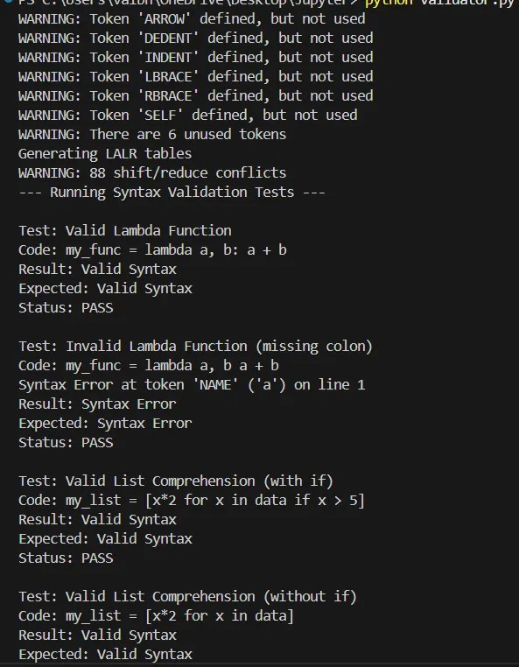
Validation in Action: Testing the Constructs

LAMBDA FUNCTION TESTS
my_func = lambda a, b: a + b

- Valid Syntax
my_func = lambda a, b a + b

✗ Syntax Error

LIST COMPREHENSION TESTS
[x*2 for x in data if x > 5]

- Valid Syntax
[x*2 x in data]

✗ Syntax Error

CLASS DECLARATION TESTS
class MyClass: pass

- Valid Syntax
class MyClass pass

✗ Syntax Error

Actual validator test suite execution

Project Success and Future Work

PROJECT SUCCESS FUTURE ENHANCEMENTS

- FUNCTIONAL VALIDATOR
Successfully implemented a PLY-based validator that accurately checks the syntax of all five specified Python constructs.
→ INDENTATION HANDLING
Integrate Python's indentation rules (INDENT/DEDENT tokens) to support multi-line blocks and nested structures.

- COMPLETE TEST SUITE
Comprehensive test cases validate both correct acceptance of valid code and rejection of invalid syntax across all constructs.
→ GRAMMAR EXPANSION
Extend the grammar to cover additional Python features including loops, conditionals, exception handling, and dictionary/set literals.

- INTERACTIVE INTERFACE
Command-line interface enables real-time validation of user-provided code snippets with immediate feedback.
→ SEMANTIC ANALYSIS
Implement semantic validation to check variable definitions, type consistency, and function signatures beyond structural syntax.

→ ERROR RECOVERY
Enhance error reporting with suggestions for common mistakes and automatic error recovery to continue parsing.

LEARNING OUTCOME
Gained practical experience in compiler design principles, specifically lexical analysis, context-free grammars, and syntax validation using industry-standard tools.



Questions & Discussion

Open Forum

Thank you for your attention. I welcome any questions you may have about the PLY syntax validator implementation, the design decisions, or the compiler design principles demonstrated in this project.

Let's explore the parsing process together

