

DIGITAL DESIGN AND COMPUTER ORGANIZATION
Memory Operations
Instructions And Instruction Sequencing
T2: Chapter 2: 2.3-2.4

Department of Computer Science and Engineering

Memory Operations

with
Introduction(T2 –section 2.3)
While executing a program, two distinct operations associated Processor-Memory interaction are:
- Load operation / Memory Read - (Instruction fetch / Operand fetch)
- Store operation / Memory Write - ( Write computed results)
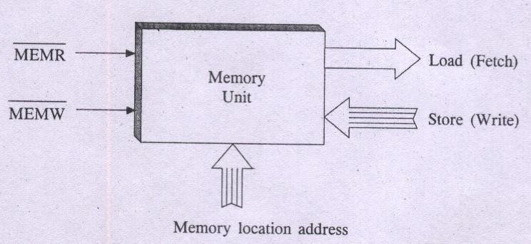

□Transfers a copy of the contents of a specific memory location to the processor
□Processor sends address of the desired location to memory and requests that its contents be read(Issues read signal)
□Memory reads the data and sends it to the processor
□Memory contents remains unchanged

Memory Operations
Store Or Write
□Transfers an item of info from the CPU to a specific memory location, destroying the former contents of that location
□Processor sends the address of the desired location to the memory, together with the data to be written
□Issues write signal
□Sends the data via data bus and write into the selected particular memory location

Instructions And Instruction Sequencing
Introduction(T2 – section 2.4)
□An instruction is a command to the processor to perform a given task on data operands.
- A program is a set of instructions that specify operations, operands & the sequence
by which processing has to occur.
- Thus operation of a computer is controlled by stored program
- In general a computer must support 4 categories of operations:
  - Data Movement : To conduct I/O transfers
  - Data Storage : Across Memory and processor registers.
  - Data Processing : Arithmetic and logical operations
  - Program sequencing and control : Test and Branch.

- Data operands & Instructions are situated in main memory locations & processor registers.
- Like mnemonics for Opcodes, Symbolic names or label identifiers are used to name or identify such locations.
- For instances memory location names include M, LOC, A, B, C, SUM, N1, VAR1, VAR2, NUM1, etc.,
- Similarly processor register names include R0, R1, R2, R3, R4, R5, etc., and registers of I/O subsystem may be designated as DATAIN, DATAOUT etc.

Register Transfer Notation

- While depicting operations, the contents of a memory location or a register are denoted by placing the corresponding name in a pair of square brackets.
For instance : R0 □ [M]


Suggests to copy contents of memory location M to register R0

- The corresponding instruction is MOVE M, R0,
Memory Register
Location



- Similarly : MOVE R1, SUM Suggests : SUM □ [R1]
Register Memory Location
- The instruction : MOVE B, LOC Means : LOC □ [B]

- Similar operations that involve Registers only are: R1 □ [R2] MOVE R2, R1
□ R1 □ [R1] + [R3] ADD R3, R1
Suggest to add contents of register R1 and register R3 and rewrite the R1 contents to store the sum.
- All such notations with leftward arrow (□) assignment operations involving register locations give rise to what is known as Register Transfer Notation

DIGITAL DESIGN AND COMPUTER ORGANIZATION

- Assembly Language Notation T2:Ch2 2.4

Department of Computer Science and Engineering

- An assignment statement in a High Level Language Program:
S = P + Q
- Here P, Q & S are variables.
- Variable name refers to symbolic address of memory location from which data operand can be read or written.
S □ [P] + [Q]
- This operation suggests contents of two memory locations P and Q are fetched from memory and transferred into processor where sum of two numbers is performed. The resulting sum is then sent back to memory and stored in memory location S.
- An instruction to this effect in Assembly Language Notation:
Add P, Q, S

Assembly Language Notation

- Consider R1 □ [R1] + [R3]
- Equivalent Assembly Language instruction is Add R3, R1.
- Here the operation Code Mnemonic is Add
- Register Locations R1, R3 represent operand fields

- Similarly, in the instruction ADD R1, SUM

Opcode

Register Operand
Memory Operand

- i.e. SUM □ [SUM] + [R1]

DIGITAL DESIGN AND COMPUTER ORGANIZATION

- Basic Instruction Types T2:Ch2 2.4

Department of Computer Science and Engineering

  - Three – Address Instruction
  - Two – Address Instruction
  - One – Address Instruction
  - Zero – Address Instruction
□ Three – Address Instruction
Suppose we would like to use a single machine instruction to perform the following addition operation:
S □ [P] + [Q]
We will have to use a three – address instruction to carry out addition and to store the sum in a third variable S.
- Then three address instruction to perform addition is:
Add P, Q, S

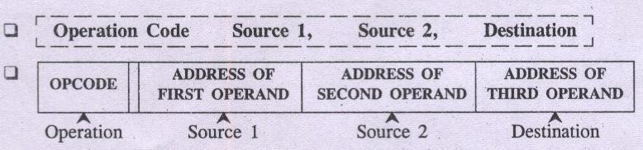

- Two – address instruction general format:
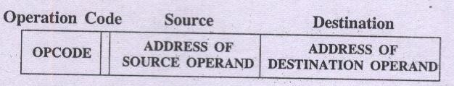
- Example of two – address instruction Add P, Q
- To perform operation of addition as : Q □ [P] + [Q]

Destination Operand
Source Operand/s

Basic Instruction Types

- Here one of the operand i.e. destination operand Q acts as source as well as destination.
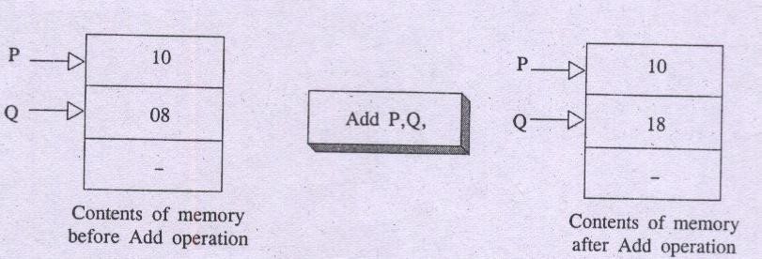
  - To perform S □[P] + [Q]
  - Use two – address instructions sequence: MOVE Q, S ADD P, S

Basic Instruction Types
One-Address Instruction
  - One –address instruction format specify a single operand along with operation code.
  - The requirement of second operand is fulfilled by an implicit processor register
known as Accumulator (AC).
  - Example of one-address instruction: ADD Q
□ | It Specify: AC □ [AC] + [Q]
□ | Load P Suggest AC □[P] (Fetch P into AC)
- Store S  - To perform |  | Indicate  S □ [P] + [Q] | S □ [AC] | (Write AC into S)

Basic Instruction Types
One-Address Instruction
  - One –address instruction format specify a single operand along with operation code.
  - The requirement of second operand is fulfilled by an implicit processor register
known as Accumulator (AC).
  - Example of one-address instruction: ADD Q
  - It Specify: AC □ [AC] + [Q]
  - Load P Suggest AC □[P] (Fetch P into AC)
  - Store S Indicate S □ [AC] (Write AC into S)
  - To perform S □ [P] + [Q]
  - Use one – address instructions : Load P; AC □[P]
Add Q; AC □[AC] + [Q]
Store S; S □[AC]

Basic Instruction Types Zero – Address Instruction

    - Stack – organized computer make use of a special memory structure called push down stack to store operands. In such computer machines it is possible to use instructions that contain only operation codes and no explicit operands.
    - The name Zero – address specifies the absence of an address field of operands in
machine instructions.
    - Example of Zero – address instruction: ADD
    - To perform operation of addition as TOS □ (P + Q)

Mov A,Ri is equivalent Load A,Ri

and

Move Ri,A is equivalent to Store Ri,A

□If processor supports ALU operations where one data may be in memory and other in register then the instruction sequence is for
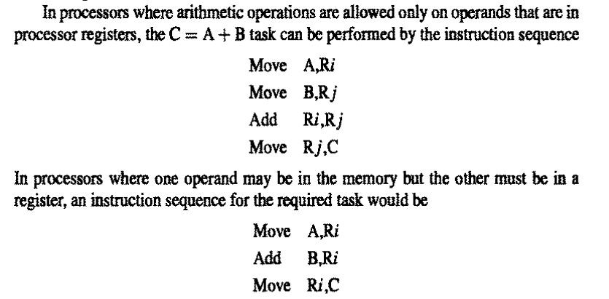
ADD A,B,C :

DIGITAL DESIGN AND COMPUTER ORGANIZATION

Instruction Execution And Straight-Line Sequencing
T2:Ch2 2.4

Department of Computer Science and Engineering

Instruction Execution And Straight-Line Sequencing

Assumptions:
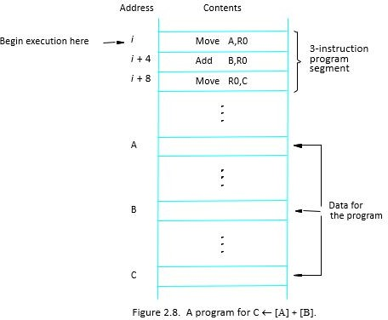
- One memory operand per instruction
- 32-bit word length
- Memory is byte addressable
- Full memory address can be directly specified
in a single-word instruction

Two-phase procedure
-Instruction fetch
-Instruction execute

□PC – Program counter: hold the address of the next instruction to be executed
□Straight line sequencing: If fetching and executing of instructions is carried out one by one from successive addresses of memory, it is called straight line sequencing.
□Major two phase of instruction execution
- Instruction fetch phase: Instruction is fetched from memory and is placed in instruction register IR
- Instruction execute phase: Contents of IR is decoded and processor carries out the operation either by reading data from memory or registers.

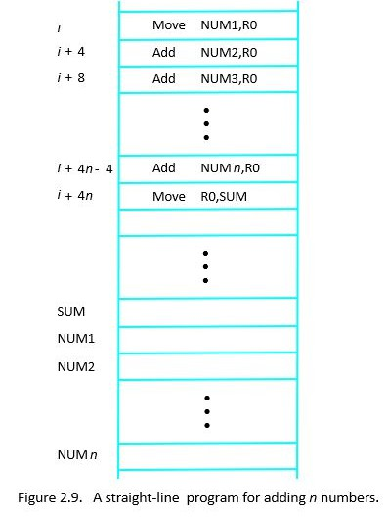

COMPUTER
ORGANIZATION

- Branching T2:Ch2 2.4

Department of Computer Science and Engineering

□Branch instruction are those which changes the normal sequence of execution.
□Sequence can be changed either conditionally or unconditionally.
□Accordingly we have conditional branch instructions and unconditional branch instruction.
□conditional branch instruction changes the sequence only when certain conditions are met.
□Unconditional branch instruction changes the sequence of execution irrespective of condition of the results.

- Consider branch instruction in a program:
Branch > 0 Loop
- Program execution continues in a straight line sequence until encountering of
Branch > 0 Loop instruction
- Execution results in a jump to location of Loop.
- That is a branch instruction loads a new value in PC - the memory location address (loop) at which program control is to be transferred to start/resume execution.
- As a result processor is prohibited from fetching and executing next instruction in
straight – line sequence.

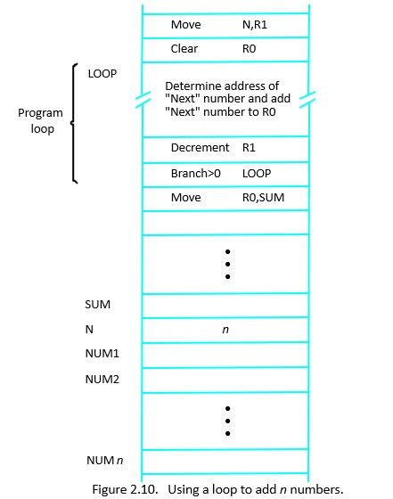

Branch target Conditional branch

Check whether number Positive or negative

Move a,R0 Branch >0 Pos Move R0,R2 Pos:
Move R0,R1

DIGITAL DESIGN AND COMPUTER ORGANIZATION

- Condition Codes T2:Ch2 2.4

Department of Computer Science and Engineering

- The data conditions or status, after an arithmetic or logical operation are indicated by setting or clearing the flip – flops called flags or condition codes.
- Each flip-flop holding a data condition code is a one –bit storage cell (logic circuit) that can be set to a 1 or reset to 0 value.
- These condition codes are set/reset as a result of arithmetic and logical operations in the ALU.
- Condition code bits or flag bits are accommodated in a groups of 4 – bit, 8 bit or 16 – bit flag register or a status register in CPU.

□Results of various instructions are stored for subsequent use by conditional instructions
□This is done by recording the required info in individual bits, called as condition code flags – grouped together in special processor register called as condition code register or status register

  - CONDITIONAL CODE FLAGS:
CNo–nNdeigtaitoiven C1oifdreessults are Negative
0 if results are Positive
Z – Zero 1 if results are Zero
0 if results are Non zero
V – Overflow 1 if arithmetic overflow occurs
0 no overflow occurs C – Carry 1 if carry from MSB bit
0 if there is no carry from MSB bit

Branch>0. Brach is taken when neither N or Z=1

  - Pentium processor makes use of following condition codes:
C (carry flag) P (parity flag)
A (Auxiliary carry flag) Z (zero flag)
S (sign flag)
O (over flow flag)

List the steps needed to execute the machine instruction Add LOC, R0 in terms of transfers between memory and processor and some simple control commands. Assume that the instruction itself is stored in the memory at location INSTR and that this address is initially in register PC.

- Transfer the contents of register PC to register MAR
C•onIsdsuiteiaoRneaCd ocodmemsand to memory, and then wait until it has transferred the requested word into register MDR
- Transfer the instruction from MDR into IR and decode it
- Transfer the address LOCA from IR to MAR
- Issue a Read command and wait until MDR is loaded
- Transfer contents of MDR to the ALU
- Transfer contents of R0 to the ALU
- Perform addition of the two operands in the ALU and transfer result into R0
- Transfer contents of PC to ALU
- Add 1 to operand in ALU and transfer incremented address to PC

Repeat the problem for machine instruction Add R1,R2,R3

- Transfer the contents of register PC to register MAR
- Issue a Read command to memory, and then wait until it has transferred the requested word into register MDR
- Transfer the instruction from MDR into IR and decode it
- Transfer contents of R1 and R2 to the ALU
- Perform addition of two operands in the ALU and transfer answer into R3
- Transfer contents of PC to ALU
- Add 1 to operand in ALU and transfer incremented address to PC

Give a short sequence of machine instructions for the task: “Add the contents of memory location A to those of location B, and place the answer in location C.”
Instructions Load LOC, Ri
and Store Ri, LOC
are the only instructions available to transfer data between the memory and general
purpose register Ri. Do not destroy the contents of either location A or B.

Load A,R0 Load B,R1 Add R0,R1
Store R1,C

Suppose that move and add instructions are available in the format Move/Add loc1,loc2
Loci can be either memory or reg. Is it possible to use fewer instructions? Give the seq

Move B,C Add A,C

DIGITAL DESIGN AND COMPUTER ORGANIZATION

- Generating Memory Addresses T2:Ch2 2.4

Department of Computer Science and Engineering

Generating Memory Addresses

- The instruction block at LOOP needs to add a different number from a list during each iteration.
- The Add instruction must refer to a different memory address during each pass through the loop.
- The memory operand address cannot be directly given in a single Add instruction because it would require modification on each pass.
- A possible solution is to use a processor register, such as Ri, to hold the memory address.
- Ri can be initialized with the address NUMI before the loop and incremented by 4 after each iteration to point to the next memory address.
- This situation highlights the need for flexible ways to specify operand addresses.
- These methods are known as addressing modes, which vary in implementation but share common underlying concepts across different computers.

- Write assembly code in three two and one address format for SUB A,B,C
- Write assembly code in three two and one address format for A=B+C-D

A processor executes instructions in straight-line sequencing unless:
- A Load instruction is encountered
- A Store instruction is encountered
- A Branch instruction is encountered
- A Condition Code is set

Which condition flag is set to 1 if an arithmetic operation results in a value too large for the number of bits available?
- Zero (Z)
- Carry (C)
- Overflow (V)
- Sign (N)

A processor executes instructions in straight-line sequencing unless:
- A Load instruction is encountered
- A Store instruction is encountered
- A Branch instruction is encountered
- A Condition Code is set
Answer: c) A Branch instruction is encountered
Explanation: Branch instructions alter the normal program counter (PC) sequence

Which condition flag is set to 1 if an arithmetic operation results in a value too large for the number of bits available?
- Zero (Z)
- Carry (C)
- Overflow (V)
- Sign (N)
Answer: c) Overflow (V)
Explanation: Overflow flag is set when the signed result exceeds representable range

- Which one of the following instruction formats uses the accumulator (AC) implicitly as one operand?
- Zero-address instruction b) One-address instruction c) Two-address instruction d) Three-address instruction

  - Consider the sequence of instructions: Load P
Add Q Store S
This corresponds to which instruction format?
- Three-address
- Two-address
- One-address
- Zero-address

  - Which one of the following instruction formats uses the accumulator (AC) implicitly as one operand?
- Zero-address instruction b) One-address instruction c) Two-address instruction d) Three-address instruction Answer: b) One-address instruction
Explanation: In one-address instructions, one operand is explicitly given, while the accumulator (AC) is the implicit second operand
  - Consider the sequence of instructions: Load P
Add Q Store S
This corresponds to which instruction format?
- Three-address
- Two-address
- One-address
- Zero-address

Answer: b) One-address instruction

THANK YOU

Team DDCO
Department of Computer Science

