

PES UNIVERSITY

PES University, Electronic City Campus, Hosur Road, Bangalore- 560 100 Department of Computer Science & Engineering
Curriculum of CSE
Course Title:UE23CS242A: Web Technologies

Semester: III Credits:4
Course Type: Core / Elective / Special Topic:Core Experiential Learning (2025-26):

(Orange Problem) Level -2

Problem Statement:

Design and develop a single, responsive web page that demonstrates the integration of key modern web technologies. The page should showcase the use of HTML5 multimedia elements (audio and video), implement the Geolocation API to retrieve and display user location, utilize Flexbox for layout design, simulate asynchronous data fetching using Promises and async/await, and demonstrate the conversion of XML to JSON for structured data representation. This project aims to provide an interactive learning interface that combines functionality, responsiveness, and dynamic data handling.

HTML5 Multimedia API – Embed and control video/audio Geolocation API – Get and display user's current location Asynchronous Data Simulation – Using Promises and async/await
XML to JSON Conversion – Demonstrate parsing XML and converting to JSON

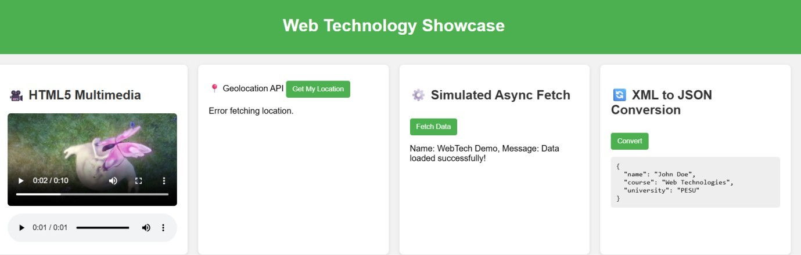
Rubrics:
HTML5 Media | 2 marks
Geolocation | 2 marks
Axios | 2 marks
JSON | 2 marks

ReactJS | 2 marks
Total | 10 marks

