Please answer the 6 mandatory questions

1. Please confirm your consent to sign a bond for 3 years (including a 1-year internship). Only

submit your assignment if you are comfortable with this bond.

- YES

2. Have you received the stipend and CTC details? Please confirm by providing the details here.

- YES

3. Are you willing to relocate to Gachibowli, Hyderabad?

-YES

4. What motivated you to pursue a career in software testing?

I chose to pursue a career in software testing because of my profound interest in ensuring the reliability and quality of software applications. Throughout my MCA program, I gained a deep understanding of software development processes and the critical role that testing plays in delivering flawless products to end-users. The meticulous nature of testing, where I can systematically identify and resolve bugs, appeals to my analytical mindset and problem-solving skills.

Moreover, I am motivated by the dynamic and evolving nature of software testing, where each project presents unique challenges and opportunities to learn and grow. I am passionate about contributing to the enhancement of user experience by ensuring software functionality, security, and usability.

5. Why do you want to join a software testing firm like Frugal Testing?

"I am eager to join a software testing firm like Frugal Testing because of its reputation for innovation and excellence in quality assurance. Frugal Testing's commitment to delivering high-quality software solutions resonates with my own passion for ensuring flawless user experiences. I am particularly drawn to Frugal Testing's collaborative and supportive work culture, which fosters continuous learning and professional growth.

Moreover, I am excited about the opportunity to contribute to Frugal Testing's diverse range of projects, where I can apply my skills in testing methodologies and problem-solving to deliver impactful results. I believe that Frugal Testing's focus on efficiency and cost-effectiveness aligns perfectly with my goal of making a meaningful contribution to the software testing field.

Section A:

1. Automate e-commerce product purchases on Amazon:

Navigate to https://www.amazon.in/

Verify landing on the correct page

Print the URL and Title of the Page

Search for "mobile"

Select 4 stars under customer review filter section

Select the price range between ₹10,000 - ₹20,000

Click on the first search result

Add the phone to the cart

Click on the Go to cart button

Record the automation script using any screen recording software

Share the drive link for the recording

Save screenshots and logs for all the steps

Video Link : <https://drive.google.com/file/d/1mU8frQKp8ZpNZFG4ijpSUz4ba0g3LR3y/view?usp=sharing>

Section B:

3. Visit the website of Frugal Testing:

a. What features or content on our website caught your attention the most, and how do

you think they reflect our company's values and goals?

Functional testing, performance testing, security testing, and automation testing are some of the features that caught my attention on the Frugal Testing website. The company is committed to comprehensive and specialized solutions. Client testimonials and case studies show a focus on trust and results. The resource library shows a dedication to education and thought leadership. The user-friendly interface and multiple contact options emphasize a user-centered approach and strong customer support. These features highlight Frugal Testing's values of quality, transparency, continuous learning, and customer satisfaction.

b. Identify a service or case study featured on our website that you found particularly

impressive. Explain why it stood out to you.

The AI-driven automated test generation service stood out due to its ability to significantly enhance testing efficiency and coverage. By automating the creation of test scenarios and predicting defects accurately, Frugal Testing ensures thorough software evaluation while optimizing costs and resources. This service exemplifies their dedication to innovation and practical application of AI in software testing, underscoring their capability to deliver reliable and value-driven solutions to clients.

I found the case study on performance testing for a leading e-commerce platform particularly impressive. It stood out because of how Frugal Testing identified and fixed performance issues, ensuring the platform could handle high traffic during peak shopping times. The detailed approach, use of advanced tools, and clear presentation of results showed the company’s expertise and commitment to quality. It demonstrated Frugal Testing’s ability to tackle complex challenges and improve system performance, reflecting their dedication to client success and delivering real, impactful results.

4. Can you describe your approach to problem-solving in software testing and development? How do you think this role will help you refine these skills?"

In software testing and development, my approach to problem-solving revolves around a structured methodology that begins with thorough requirement analysis. I prioritize understanding user needs to design comprehensive test scenarios that cover both functional and non-functional aspects of the software. Rigorous testing execution, meticulous defect tracking, and proactive communication with stakeholders are integral to my process. This role will refine my problem-solving skills by exposing me to diverse challenges in testing methodologies, emerging technologies, and collaboration with cross-functional teams. I aim to continually enhance my ability to identify, analyze, and resolve issues efficiently, contributing to the overall quality and success of software projects.

5. Share an experience where you encountered unexpected challenges or bugs during testing. How did you adapt your testing strategy to address these issues effectively?"

In a recent testing project, I faced unexpected challenges with a web application's integration with a third-party payment gateway. Despite initial smooth functionality, we encountered intermittent issues under high transaction volumes and network latency. To address this, I prioritized real-world usage scenarios in testing, conducted thorough stress testing, and collaborated closely with developers to isolate root causes. Implementing enhanced monitoring tools helped us pinpoint issues related to data synchronization and error handling, leading to refined test cases and ultimately stable payment processing functionality."

6. Reflect on a past project where your strengths as a Software Engineer QA were demonstrated. How did these strengths contribute to the project's success? Conversely, describe a situation where you identified a personal limitation and outline your plan for addressing it.

"In my past project developing a voice assistant using Python and Selenium, my strengths as a Software Engineer QA were crucial in ensuring the project's success. I was responsible for designing and implementing robust test cases to validate the voice recognition and response functionalities. Through meticulous testing and debugging, I identified and resolved various issues related to voice command interpretation and integration with external APIs.

My proficiency in Python programming enabled me to automate test scenarios effectively using Selenium, ensuring comprehensive test coverage and reliable results. By anticipating potential challenges in voice recognition accuracy and interaction flows, I contributed to refining the assistant's performance and enhancing user experience.

7. Discuss an instance where you faced significant challenges within a team setting in a software project. How did you address these challenges, and what role did you play in ensuring the team's success?

In a previous software project, our team faced significant challenges due to tight deadlines and evolving client requirements. These factors created pressure to deliver high-quality software within a constrained timeframe while ensuring all features met user expectations. As a team member, I recognized the importance of effective collaboration and clear communication to overcome these obstacles.

To address these challenges, I initiated daily stand-up meetings where we discussed progress, identified blockers, and prioritized tasks collaboratively. This helped us stay aligned and agile in responding to changes promptly. I also took the lead in refining our testing strategy, emphasizing thorough regression testing and prioritizing critical functionalities based on user feedback and project timelines.

My role extended to mentoring junior team members, sharing best practices, and providing support in troubleshooting complex issues. By fostering a supportive and proactive team environment, we were able to streamline our development and testing processes, improving efficiency and ensuring the timely delivery of milestones.

8. Looking ahead, how do you envision your career path evolving over the next decade, and how do your personal goals align with this vision? Additionally, describe any long-term aspirations you have outside of your professional life and how you plan to balance these with your career ambitions.

AI is expected to revolutionize testing software by making it smarter, faster, and more reliable. With the help of AI, we can analyze application code to identify relevant issues and create tests. Predictive analytics will enable AI to identify points of failure based on historical data, allowing us to fix issues before they occur. AI-powered tools will improve detection, detection, and recovery more precisely than traditional methods. AI can also optimize tests by prioritizing them based on risk and impact, ensuring that the most important tests are run first. These advancements will allow QA engineers to focus on more complex investigations and expertise in managing day-to-day operations. This change will speed up the testing process and make the software better.**.**

9. Considering the significant advancements in AI and its influence on global markets, how do you anticipate these developments will transform the landscape of software testing?"

AI is expected to revolutionize testing software by making it smarter, faster, and more reliable. With the help of AI, we can analyze application code to identify relevant issues and create tests. Predictive analytics will enable AI to identify points of failure based on historical data, allowing us to fix issues before they occur. AI-powered tools will improve detection, detection, and recovery more precisely than traditional methods. AI can also optimize tests by prioritizing them based on risk and impact, ensuring that the most important tests are run first. These advancements will allow QA engineers to focus on more complex investigations and expertise in managing day-to-day operations. This change will speed up the testing process and make the software better.10. Please share the following details in your Profile

1. LinkedIn Profile Link :

<https://www.linkedin.com/in/vaibhav-gupta-4b20b0258?utm_source=share&utm_campaign=share_via&utm_content=profile&utm_medium=android_app>

2. Resume (PDF file) :

<https://drive.google.com/file/d/1zNT5EFKrBxudiLdsgzCdnt2r_7f6gezJ/view?usp=sharing>

3. Any other Technical profiles like Hackerrank, CodeChef, Github, HackerEarth?

<https://github.com/VaibhavRO45?tab=repositories>

4. Any other Project links about which you are really proud of

[GitHub - VaibhavRO45/Voice-Assistant: In this project we created a Voice Assistant like Alexa and Siri](https://github.com/VaibhavRO45/Voice-Assistant)

11. Visit and follow the Frugal Testing page on all the social media platforms. Like/Share the posts

and also share your views on the posts in the comment section.

● You have to share the screenshot in the answer sheet as proof for this task.

a. LinkedIn : https://www.linkedin.com/company/frugaltesting/mycompany/

b. FaceBook : https://www.facebook.com/FrugalTest

c. Instagram : https://instagram.com/frugaltesting?igshid=YmMyMTA2M2Y=

d. YouTube: https://www.youtube.com/channel/UCjikgYGfeqU4ZPKQNm1V5tg/featured

e. GooglePage: https://frugaltesting.com/

f. Whatsapp Community: <https://chat.whatsapp.com/INM3eWxLYIW5VrJaKWHAVE>

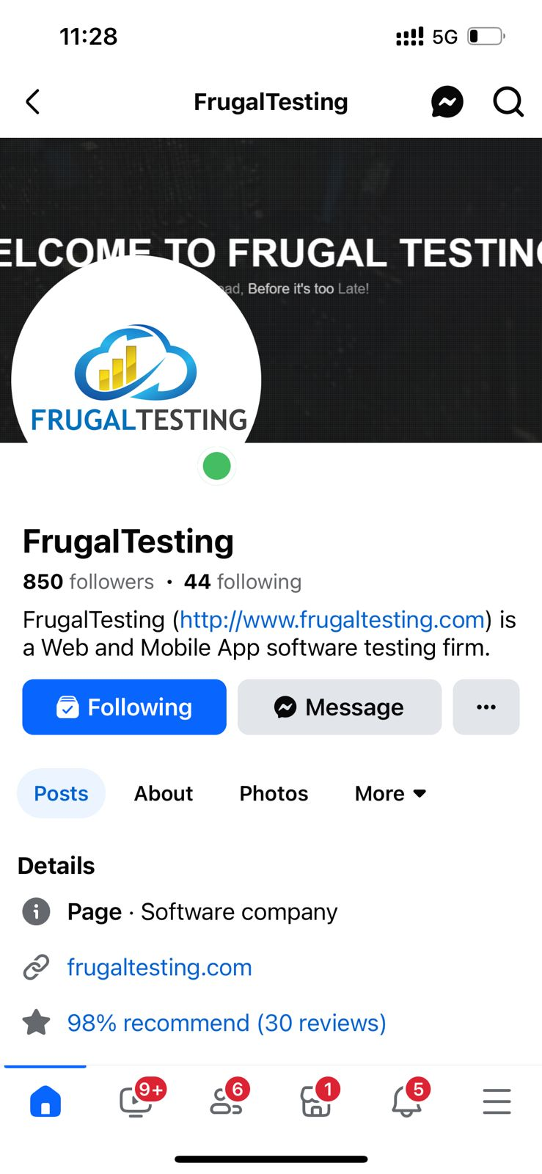

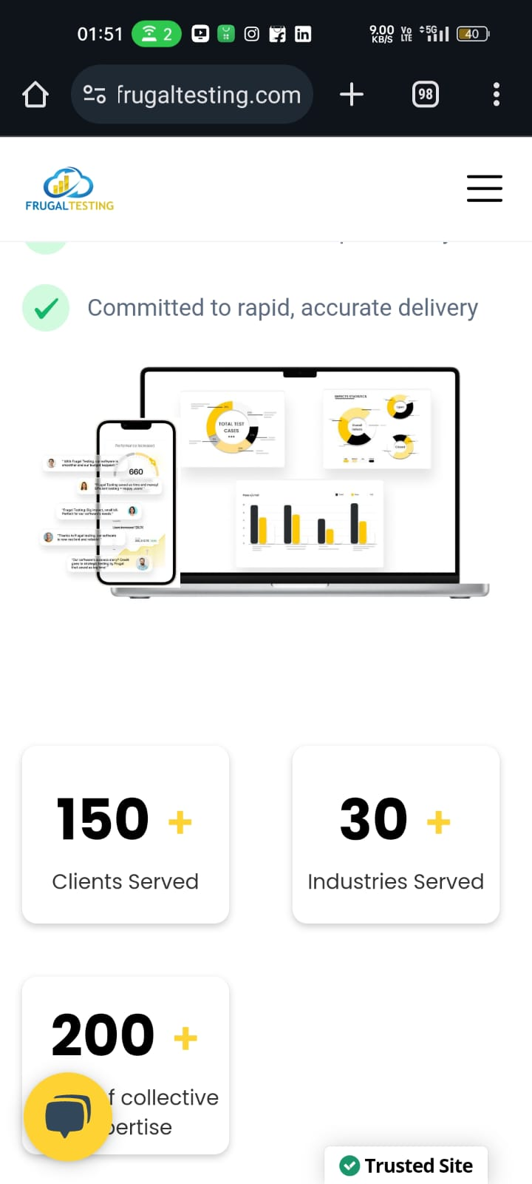

12. Can you describe the process and significance of test sign-off in software testing?

Test signing is the final confirmation by the manager and product owner that a specific level or standard of software testing has been completed, including successful completion of testing, solutions, recovery measures, and information. These important steps ensure software quality, reduce risk, inform decision-making, support communication, and meet industry standards. Managers and business owners review test results to ensure testing objectives are met and the software meets desired standards, and provide collaborative seal of approval as the software is prepared for the next phase or release.

13. Explain the concept of fuzz testing and how it differs from structured testing approaches.

"Fuzz testing, also known as fuzzing, is an automated technique used to test software by inputting random or unexpected data (fuzz) to detect vulnerabilities and crashes. It helps uncover flaws that may not be found with traditional testing methods, particularly in handling invalid or unexpected inputs."

**Differences from Structured Testing Approaches:** "Fuzz testing contrasts with structured testing approaches in the following ways:

1. **Input Generation:** Fuzz testing generates random or malformed data to stress the software, while structured testing uses predefined test cases based on expected scenarios.
2. **Objective:** Fuzz testing aims to discover vulnerabilities and unexpected behaviors caused by input variations. Structured testing verifies functionality against specified requirements.
3. **Automation:** Fuzz testing is largely automated, continuously generating and executing tests. Structured testing may involve both manual and automated testing, focusing on planned test cases.
4. **Coverage:** Fuzz testing explores a broad range of inputs to uncover edge cases and vulnerabilities. Structured testing targets specific functionalities and user scenarios outlined in test plans.
5. **Applicability:** Fuzz testing is effective for uncovering security vulnerabilities and robustness issues. Structured testing ensures software meets functional requirements and expected behaviors."

14. Describe the Six Sigma process improvement methodology and its relevance in software

development.

Six Sigma is a data improvement process designed to reduce defects and variations in processes. The goal in software development is to improve performance, reduce defects, and increase quality by using statistical data and continuous improvement techniques. By applying Six Sigma principles such as DMAIC (Define, Measure, Measure, Improve, Control), software teams can improve development, increase customer satisfaction, and achieve higher levels of performance and reliability in software products. By applying Six Sigma to software development, we can reduce defects, improve code quality, and improve our overall performance. It’s all about creating a culture of continuous improvement where we strive to deliver and deliver quality software that satisfies our customers. So let’s embrace Six Sigma and take our software development to the next level!

15. How do you think you can leverage the power of ChatGPT? Utilizing the capabilities of ChatGPT,

describe a specific task where U employed the AI to resolve a problem swiftly and uniquely.

The customer support team faces issues when handling repetitive queries, which results in delayed response times and reduced customer satisfaction. To solve this problem, they built a chatbot using ChatGPT’s API to resolve a multitude of questions related to products, pricing, solutions, and account management. The chatbot is trained using extensive data, and regular updates and feedback are designed to improve its accuracy. The chatbot is used and monitored with continuous improvement based on actual usage. The results showed that the chatbot addresses nearly 70% of incoming queries, reducing the work of human agents. Increased customer satisfaction by reducing the response time to frequently asked questions from an average of 5 minutes to instant responses. Chatbots also improve the customer experience by providing instant, accurate answers, increasing customer satisfaction by 20% and reducing customer churn. Human agents can spend more time on complex issues, resulting in faster resolution times and higher productivity. This example shows how AI can be used to resolve issues quickly and seamlessly, increasing efficiency and improving the user experience.

16. What is your perspective on the most effective approaches to quality assurance in software

development? How would you prioritize and implement these approaches in a theoretical

project?

Effective quality assurance in software development combines structured methodologies such as Agile testing, continuous integration, and test-driven development (TDD). It begins with understanding the project requirements thoroughly and setting specific testing objectives. Implementation involves creating robust test environments, conducting detailed functional and non-functional tests, and integrating automated testing frameworks for efficiency. Continuous feedback loops play a crucial role in maintaining quality throughout the development lifecycle, helping to identify and address defects early on. This approach ensures that the software meets evolving user needs and expectations, delivering reliable solutions consistently.

17. How would you develop a test automation strategy for a new software project? Discuss the key

factors you would consider when designing this strategy.

To create a test automation strategy for a new software project, I first understand the project’s goals and needs and focus on the key features that need to be tested. Then, I choose the right automation tool that fits the technology and project needs. It’s important to prioritize automated assessments, especially for high-risk or high-use ones. It’s also important to create a good assessment framework that’s easy to maintain and extend. Integrating automated processes with CI/CD pipelines enables continuous monitoring. Training your team on tools and practices is key to success. Regularly reviewing and updating the strategy based on feedback and changes to the project is critical to project success.

18. In your previous roles or projects, have you had the opportunity to utilize artificial intelligence

tools, such as ChatGPT or similar AI platforms? Please elaborate on your experience, specifying

the tools you used, and the context in which they were applied.

In my previous roles, I have had the opportunity to utilize artificial intelligence tools, including ChatGPT. One notable experience was integrating ChatGPT into our customer support system to enhance response times and provide accurate information. We used ChatGPT to handle common queries, allowing our support team to focus on more complex issues. Additionally, I experimented with AI-driven testing tools that use machine learning to identify patterns in test data and predict potential problem areas. These tools helped streamline our testing process and improve overall software quality by catching issues earlier in the development cycle. My experience with AI tools has shown me their potential to significantly boost efficiency and effectiveness in various aspects of software development and support.

19. Discuss how ChatGPT could be utilized to automate and enhance test case generation, improve

bug reporting, or facilitate the analysis of test results.

ChatGPT can be a valuable tool in automating and enhancing various aspects of software testing. For test case generation, ChatGPT can help by interpreting requirements and generating a diverse set of test cases, including edge cases that might not be immediately obvious. It can also suggest scenarios based on similar projects or industry standards. In bug reporting, ChatGPT can assist by automatically summarizing bug descriptions, steps to reproduce, and potential impacts from logs and user reports, making the process more efficient and consistent. For analyzing test results, ChatGPT can quickly sift through large datasets, identifying patterns and anomalies, and providing insights into potential problem areas. This can help testers focus on critical issues faster and improve overall software quality.

20. Please write an article on any ONE of the below topics

(500-1500 words, no plagiarism, better to use some graphics)

A. Impact of Machine Learning on Software Development

B. The Evolution of Mobile App Security Testing

C. The Role of Artificial Intelligence in DevOps

Frugal Testing Copyright 2024

Frugal Testing Software Engineer (QA)

D. Essential Browser Extensions for Web Developers in 2023

E. Understanding CPU Usage in Unix/Linux Systems

F. The Benefits and Challenges of Heuristic Testing

G. Review of Emerging Automated Testing Tools in 2023

H. Enhancing Cloud Security: Strategies and Practices

I. An Overview of Advanced Persistent Threats in Cybersecurity

J. Techniques and Best Practices for REST API Security Testing

K. Steps in the Agile Software Testing Process

Your article will be evaluated on the following parameters:

a. Genuine Effort to write article

b. No Plagiarism

c. Overall Tone and Tonality of the article

d. Overall Outline

e. Clear and terse

Solution C

The Role of Artificial Intelligence in DevOps

Artificial Intelligence (AI) is significantly impacting various industries, and its influence on DevOps is particularly transformative. DevOps, a set of practices that combines software development (Dev) and IT operations (Ops), aims to shorten the development lifecycle and deliver high-quality software continuously. Integrating AI into DevOps can elevate efficiency, performance, and collaboration to new heights. This article delves into the multifaceted roles AI plays in DevOps, illustrating how it revolutionizes the software development lifecycle.

Enhancing Automation in DevOps

Automation is at the heart of DevOps, aiming to streamline processes and minimize manual intervention. AI enhances this by introducing intelligent automation, where systems learn and adapt to perform tasks autonomously. For example, AI can optimize the deployment process by analyzing historical data to identify the best strategies and times for deployment, reducing risks and enhancing efficiency.

AI algorithms can manage continuous integration and continuous deployment (CI/CD) pipelines by predicting potential issues and optimizing build processes. This ensures smoother and faster deployments, significantly reducing the downtime and manual effort required by development and operations teams.

Predictive Analytics for Proactive Problem Solving

One of the most powerful applications of AI in DevOps is predictive analytics. AI can analyze vast amounts of historical and real-time data to identify patterns and predict future issues before they occur. This proactive approach allows teams to address potential problems early, minimizing downtime and enhancing system reliability.

For instance, AI can monitor application performance to predict server failures or traffic surges, enabling teams to take preventive measures such as scaling resources or performing maintenance. Predictive analytics also help in identifying performance bottlenecks and inefficiencies, guiding teams to optimize system performance continuously.

Intelligent Monitoring and Alerting

Traditional monitoring tools often overwhelm DevOps teams with data, making it challenging to distinguish critical issues from normal fluctuations. AI enhances monitoring by providing intelligent alerting systems that filter out noise and highlight significant issues. AI algorithms can analyze logs, metrics, and other data sources to detect anomalies that indicate potential problems, reducing false positives and ensuring timely alerts for genuine issues.

Moreover, AI can provide context-aware alerts, offering insights into the root cause of problems and suggesting potential solutions. This enables quicker and more accurate responses to issues, maintaining high system availability and performance.

Improving Continuous Integration and Continuous Deployment (CI/CD)

CI/CD is a core practice in DevOps, facilitating rapid and reliable software delivery. AI can significantly enhance CI/CD processes by predicting build outcomes, identifying flaky tests, and optimizing the test execution order. By analyzing code changes and historical build data, AI can predict the success or failure of builds, helping teams prioritize their efforts and avoid wasting time on likely failures.

AI can also identify tests that are unstable or prone to failure, allowing teams to address these issues and improve the reliability of the CI/CD pipeline. Additionally, AI can recommend the best times for deployment based on historical data, ensuring minimal disruption and maximum efficiency.

Enhancing Collaboration and Communication

Effective collaboration and communication are vital for DevOps success. AI-powered tools can facilitate better communication between development and operations teams, ensuring that everyone is informed and aligned. For example, AI chatbots integrated into collaboration platforms like Slack or Microsoft Teams can provide real-time updates on deployment status, performance metrics, and other key information.

These chatbots can also answer queries, escalate issues, and automate routine tasks such as triggering deployments or rolling back releases. By providing instant access to critical information and automating repetitive tasks, AI helps teams collaborate more effectively and make informed decisions quickly.

Optimizing Resource Management

Resource management is a critical aspect of DevOps, involving the allocation and scaling of resources to meet application demands. AI can optimize resource management by analyzing usage patterns and predicting future needs. AI algorithms can dynamically adjust resource allocation based on real-time data, ensuring that applications have the necessary resources to perform optimally without overprovisioning.

This not only improves application performance but also reduces infrastructure costs. AI can also identify underutilized resources, enabling teams to reallocate or decommission them, further optimizing resource utilization and cost efficiency.

Enhancing Security and Compliance

Security and compliance are paramount concerns in any DevOps practice. AI can significantly enhance security by identifying vulnerabilities, detecting threats, and ensuring compliance with regulatory requirements. AI-powered security tools can analyze code and configuration files to identify potential vulnerabilities before they are exploited. These tools can also monitor network traffic and user behavior to detect unusual activities that may indicate a security breach.

In terms of compliance, AI can automate the process of ensuring that applications and infrastructure adhere to regulatory standards. This includes checking for compliance with data protection regulations, industry standards, and internal policies. By automating compliance checks, AI reduces the burden on DevOps teams and ensures that organizations remain compliant with minimal effort.

Facilitating Continuous Improvement

Continuous improvement is a core principle of DevOps, and AI plays a crucial role in facilitating this process. By providing insights into performance, efficiency, and user experience, AI enables teams to identify areas for improvement and make data-driven decisions. For example, AI can analyze user feedback and usage patterns to identify underperforming features or those causing issues, guiding teams to prioritize their development efforts effectively.

AI can also provide recommendations for optimizing development processes, such as reducing build times or improving test coverage. This continuous feedback loop ensures that teams can adapt and improve their practices, delivering higher quality software and better user experiences.

Real-time Error Detection and Resolution

AI’s ability to process and analyze large volumes of data in real-time is particularly beneficial for error detection and resolution. AI models can continuously monitor software performance and detect anomalies that may indicate errors or performance degradation. By identifying patterns that precede errors, AI enables teams to address issues proactively, often before users are impacted.

For instance, AI can analyze log files and system metrics to detect signs of an impending failure, allowing teams to take corrective action immediately. This real-time insight helps maintain high availability and performance of applications, which is crucial for user satisfaction and business continuity.

Future Prospects of AI in DevOps

The future of AI in DevOps is promising, with ongoing advancements and new applications emerging regularly. As AI technology continues to evolve, its integration into DevOps practices will become even more seamless and impactful. Emerging trends such as Explainable AI (XAI) aim to make AI models more transparent and understandable, which is crucial for building trust and ensuring the responsible use of AI in DevOps.

Additionally, the convergence of AI with other technologies like machine learning operations (MLOps) and AIOps (AI for IT operations) is likely to create more intelligent and autonomous DevOps practices. AI's ability to process and analyze vast amounts of data in real-time will further enhance its role in predictive analytics, intelligent automation, and proactive problem-solving. As organizations continue to embrace AI, we can expect DevOps practices to become more efficient, reliable, and innovative.

Conclusion

AI is playing a transformative role in DevOps, enhancing automation, improving problem-solving, and optimizing various aspects of the software development lifecycle. By integrating AI into DevOps practices, organizations can achieve greater efficiency, improved performance, and better collaboration between development and operations teams. AI’s capabilities in predictive analytics, intelligent monitoring, and resource management are particularly impactful, enabling teams to address issues proactively and optimize their processes continuously.

The following questions have no right or wrong answer. It is a basic measure to judge your personality.

Please exhibit integrity while answering the following. You need to choose only one option.

A: If you have a free weekend with no obligations, what activity would you most likely choose?

Answer: Exploring a new hobby or skill I've been interested in.

i.) Exploring a new hobby or skill I've been interested in.

ii.) Catching up on rest and relaxation, possibly with a good book or movie.

B: When faced with a significant decision, how do you typically arrive at your choice?

Answer: I make a list of pros and cons and consult with trusted friends or mentors.

i.) I make a list of pros and cons and consult with trusted friends or mentors.

ii.) I rely on my instincts and gut feeling to guide me.

C: Your current project at work is suddenly changed, and you're now responsible for an area outside your expertise. How do you approach this challenge?

Answer: I would research and learn about the new area while seeking guidance from more experienced colleagues.

i.) I would research and learn about the new area while seeking guidance from more experienced

colleagues.

ii.) I'd rely on my ability to adapt quickly and use my foundational skills to navigate this new

challenge.

D: You have an important work deadline and a personal commitment clashing on the same day. How do you handle this situation?

Answer: I try to find a compromise or a way to fulfill both commitments, even if it means asking for help.

i.) I try to find a compromise or a way to fulfill both commitments, even if it means asking for help.

ii.) I prioritize based on the urgency and importance of each and make a decision accordingly.