

_____________________________________

Projects in Machine Learning

INFO8665 - Spring 2025 - Section 1

Prof. Anasuya Bhima

Group 4 - Section 1

Assignment 2

Due on June 3, 2025

_____________________________________

Assignment 2

# 1.1 DevOps Project Board

## 1.1.1 Project Board URL and Snapshots

URL: <https://dev.azure.com/Vsharma3188/SageCare%202.0/_sprints/taskboard/SageCare%202.0%20Team/SageCare%202.0/Sprint%200>

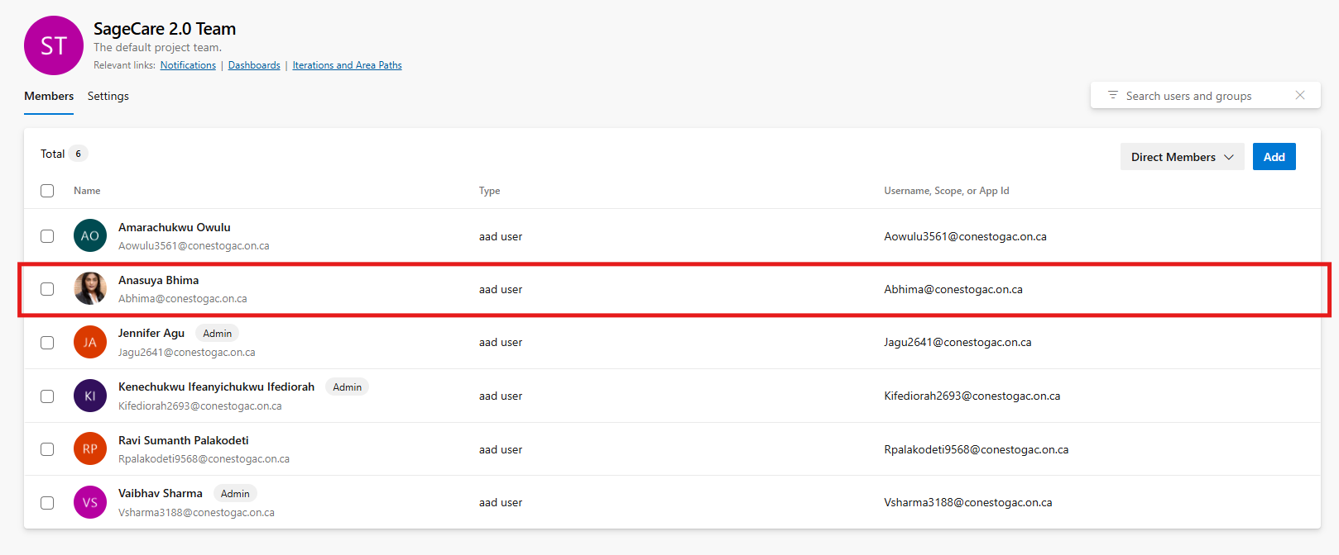

fig 1.1 Snapshot of team members including professor

# 1.2 ML Use Case Description

|  |  |  |  |  |
| --- | --- | --- | --- | --- |
| **Use Case** | **Gap** | **Critical Point of Occurrence** | **Technological Countermeasure** | **Target** |
| **Food Nutritional Analysis** | Seniors struggle to manage their diets due to cognitive decline, poor nutritional knowledge, and limited mobility. | When meals are consumed without understanding their nutritional content or tracking dietary habits. | Computer Vision model (CNN/Transfer Learning) to analyze food images, map results to a nutrition database (e.g., USDA), visualize data, track trends, and generate personalized diet suggestions. | Promote healthy eating, reduce diet-related illnesses, empower caregivers, and reduce hospital admissions. |
| **NLP and Deep Learning for Free-Text Diagnosis** | Elderly patients often use vague or non-medical terms to describe symptoms, leading to miscommunication, misdiagnosis, or referral delays. | When users input symptoms in free text (typed or spoken), especially during triage or initial interaction with the system. | GenAI-enhanced NLP using BioBERT/Bioformer to generate embeddings, predict diagnoses, map to medical specialties, and suggest next actions via a plain-language interface. | Improve diagnosis accuracy, bridge communication gaps, accelerate specialist referrals, and enhance triage in digital health settings. |
| **Speech-to-Text for Doctor-Patient Consultation** | Aids understanding and patient engagement by transcribing consultations in real-time, improving communication and documentation. | During video consultations where vital health information is shared verbally and needs to be clearly understood, retained, or reviewed later. | Real-time transcription using Whisper AI, AWS Transcribe, or Google Speech API; transcripts with timestamps; NLP-based key term highlighting; caregiver access; accessibility options. | Enhance understanding, documentation, caregiver collaboration, and reduce treatment errors through improved communication and record keeping. |

Table 1.1 ML Use Case description in TBP format

# 1.3 Product Backlog Items

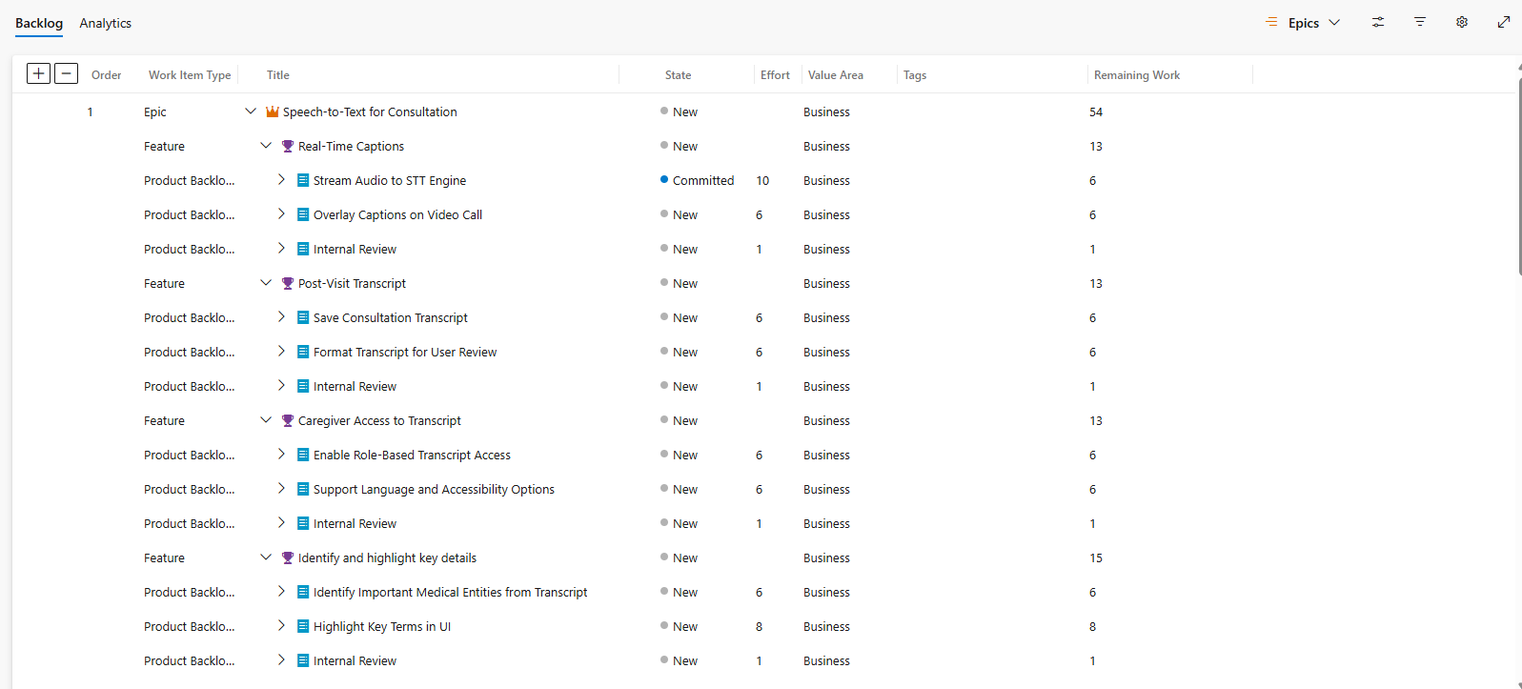

Fig 1.2 Snapshot of product backlog with epics. Features, PBIs and tasks

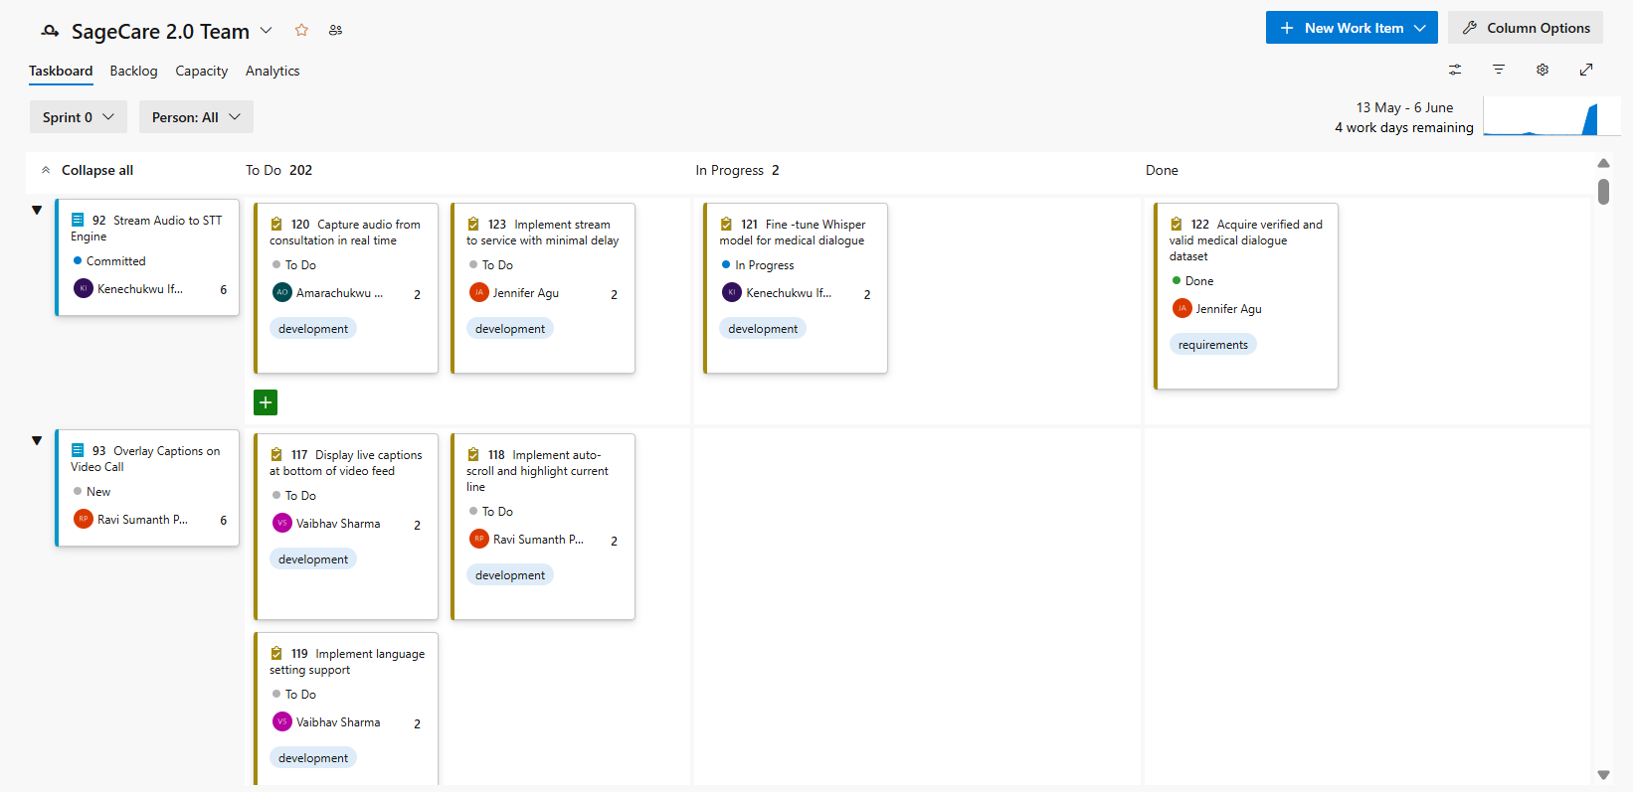

Fig 1.3 Snapshot of project board with tasks for sprint 0

# 1.4 GitHub Repo and DevOps Board Integration

## 1.4.1 GitHub URL and Folder Structure

URL: <https://github.com/CelebrityITPro/SageCare-2.0>

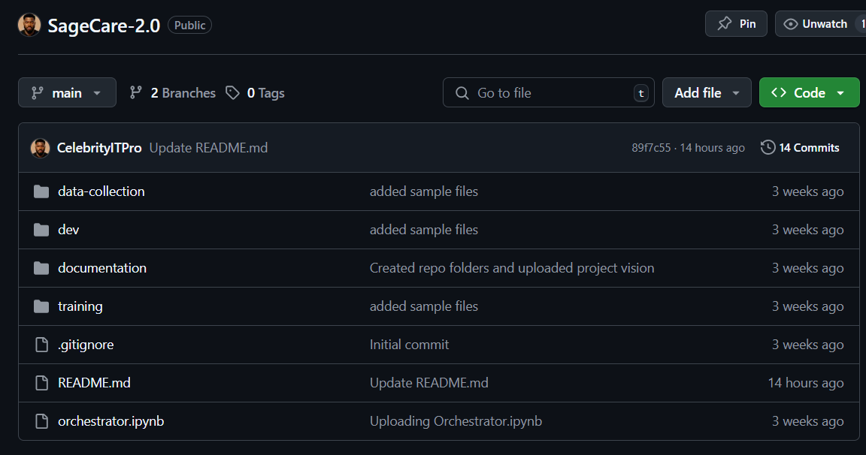

Fig 1.4 Snapshot of GitHub folder structure

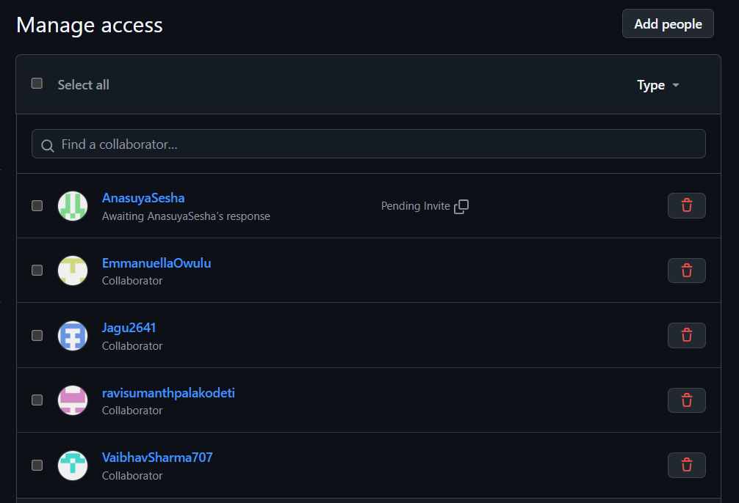

Fig 1.5 Snapshot of GitHub Repo access

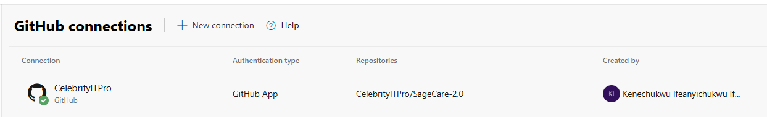

Fig 2.6 GitHub Repo integration with Azure DevOps board

# 1.5 Team Roles and Responsibilities

|  |  |  |
| --- | --- | --- |
| **Names** | **Roles** | **Responsibilities** |
| Ifediorah Kenechukwu | Project Manager | - Break down tasks and ensures alignment with vision - Work on project submission documents - Works on ML model development |
| Agu Jennifer | Scrum Master | - Ensures team follows agile process and all tasks are updated accordingly - Works on ML model development - Manages Azure DevOps board |
| Palakodeti Ravi Sumanth | Developer | - Works on ML model development - Explore and Preprocesses collected data and selects the best algorithms.  - Deploys models into production and ensures they perform reliably. |
| Sharma Vaibhav | Developer | - Designs the product frontend interface  - Develops backend and frontend architectures - Works with APIs, databases, and UI. |
| Owulu Amarachukwu | Software Tester | - Designs and runs test cases. - Explore and preprocesses collected data.  - Develops presentation slides. |

Table 1.2 Team roles and responsibilities