Tasks
*All the following analysis are done for the data where the call/chat status is “Complete”.

Objective Questions:

- What is the total no. of tables present in the data?
- There is only one table in the given dataset.

- What is the total no. of attributes present in the data?
- There are total no. of 35 attributes in the given dataset.

- The data consists of some inconsistent and missing values so ensure that the data used for further analysis is cleaned.

- Duplicates: Used Remove duplicate function to find out duplicate data, but in the given data no duplicates were found.

- Spell Checking/Typo:
  - To find out if there are any spelling errors in GuruName, created a pivot table to find out distinct count of guruName and gid (as Excel 2019v doesn’t support UNIQUE function).
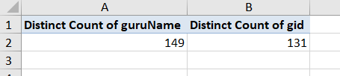
  - As both values were different, it confirmed spelling errors as with same gid there were different guruName.
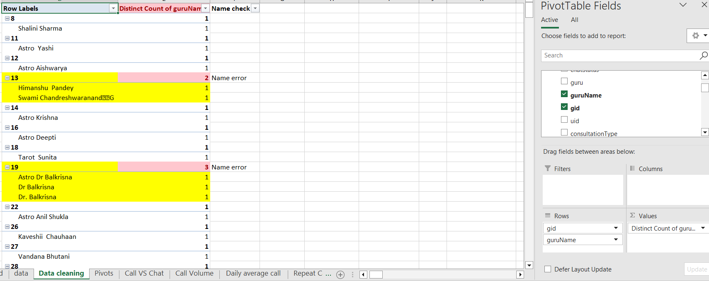
  - Created another pivot table to find out multiple names under same gid.
  - Renamed guruName in the data using FIND AND REPLACE function. also replaced “astro” with “Astro”
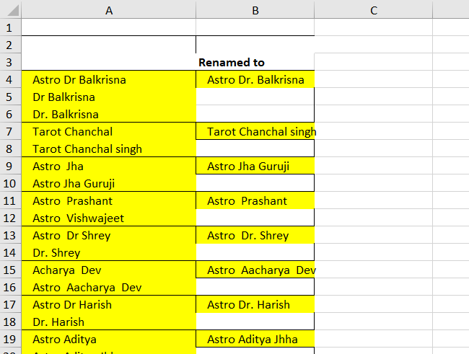

- What is the average daily call volume over the day by day and what’s the change on it?
Approach –
    - Extracted date from createdAT
    - Created a pivot table with Date in Rows, Count of CallSid in Values
Observation –
Overall average daily call volume is 246

From the below table we can observe that there are significant changes in the call volume per day and volume is not constant.
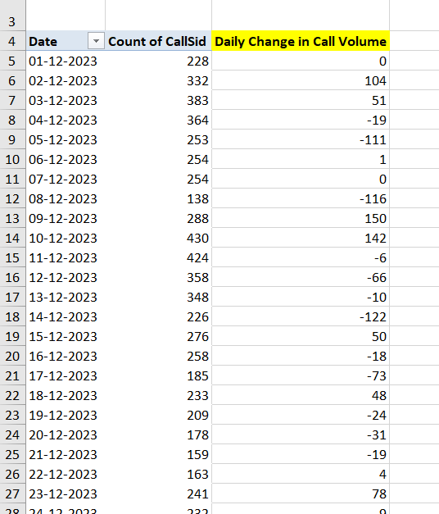

- Which months experienced the highest and lowest call volumes?
Approach –
- Using pivot table found out the average call volume for different months

Observation –
- December experiences the highest call volume with an average volume of 256.4
- January experiences the lowest call volume with an average volume of 139.3
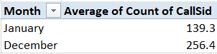

- What is the total operational cost for that month?
Approach –
- Found out total sum of netAmount which Is an operational cost by grouping the months using pivot table.

Observation –
- Total operational cost for December was 159926.2
- Total operational cost for January was 8566.4
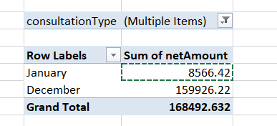

- What is the average number of calls handled per agent per day?
Approach –
- Found out the number of calls handled by per agent using a pivot table
- Calculated the average number of calls handled by each agent per day using average function.
Used IFERROR and AVERAGE function
Observation –
- Overall, 1.1 (≈1) calls on an average are handled by an agent per day.
*Considering completed calls only

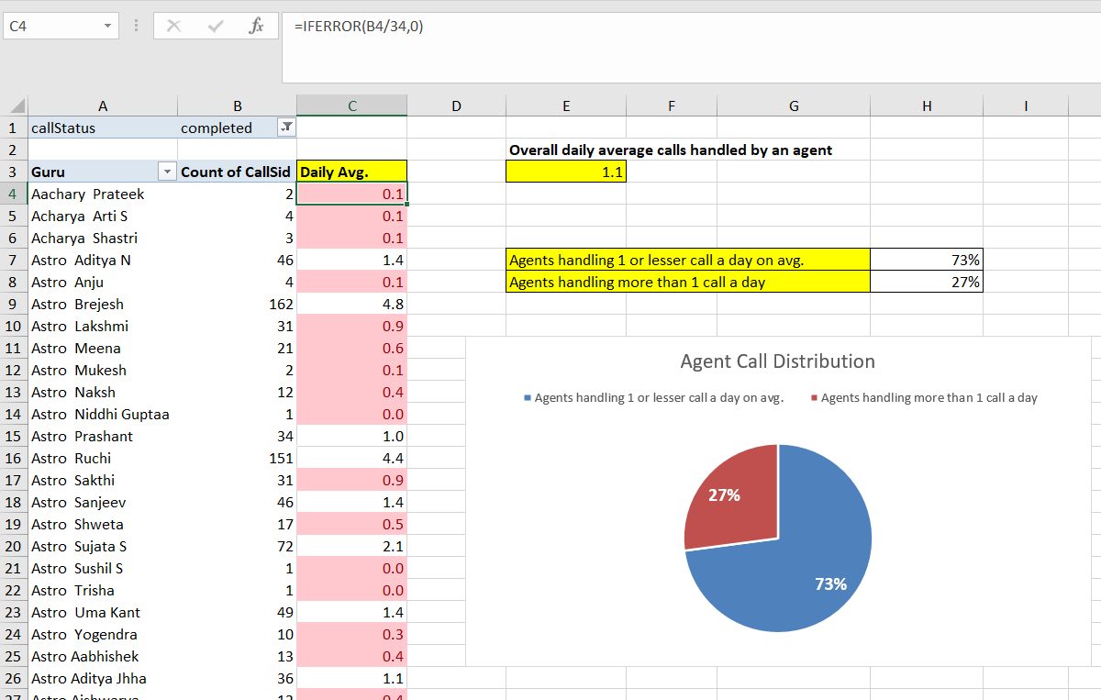

- How many repeat callers are there, and what percentage of total calls do they represent?
Approach –
- Counted the no. of calls made by each user using pivot table.
- Filtered out the users who have made call more than one time, which are repeat calls.

Observation –
- 13% of the calls are repeat.
- 87% of call one time only.

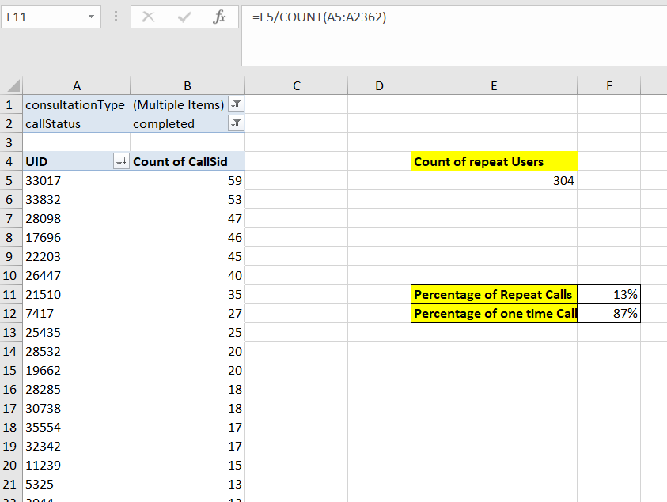

- What is the total sales generated by the call centre for each product category?
Approach –
- Calculated the sum of sales of call centre across different category using pivot table.

Observation –
- There are 3 categories but out of them only two categories have generated revenue.
- Those two categories are app and gurucool with 125267.38 and 43225.25 respectively in revenue.

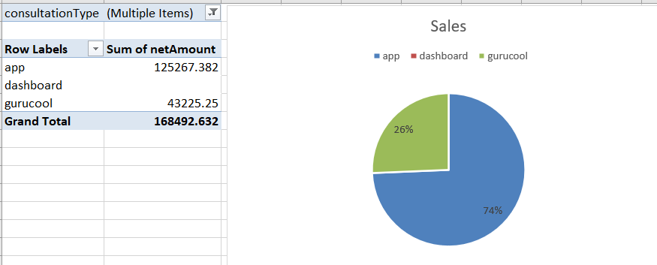

- How many calls were made for each user ID and guru ID?
Approach –
- Calculated count of calls for both guru and user individually
Observation –
- 3453 total calls were made.
- Average calls by per Guru are 31.6
- Average calls by per User are 1.5
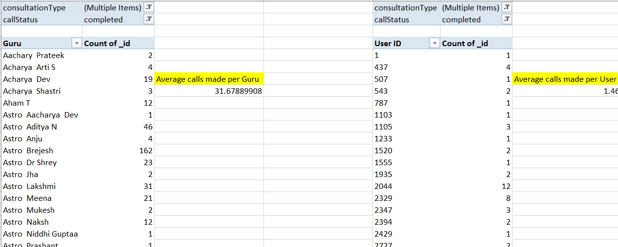

- What is the correlation between call duration and customer satisfaction?
Approach –
- Calculated correlation coefficient between call duration and customer satisfaction rating using correlation function (CORREL)

Observation –
- Correlation coefficient between call duration and customer satisfaction rating came out to be 0.13
- Correlation is close to zero, it implies that there is little to no linear relationship between call duration and customer satisfaction.

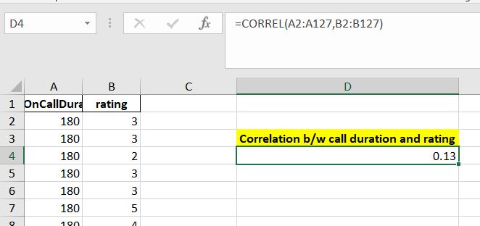

- Which guru have the highest and lowest customer satisfaction scores?
Approach –
- Calculated the average customer satisfaction rating for each guru as for each guru there are more than one rating using pivot table.

Observation –
- There are two guru with highest customer satisfaction score of 7.5, named
Astro Pujaa Rai and Tarot Mystical
- Guru with the lowest satisfaction score is Tarot Ritika with 0 score.

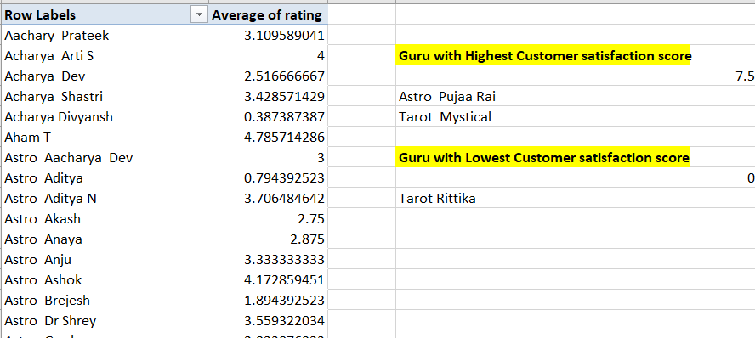

- What is the average customer satisfaction score by month?
Approach –
- Calculated the average of ratings, grouped by months using pivot table.
Observation –
- In month of January average satisfaction rating was 2.68
- In month of December average satisfaction rating was 2.95

- How many categorical columns are there in the data? [Search about categorical and continuous data, and try to answer this question]
- There are 15 categorical columns in the given dataset.
  - chatStatus: Status of the chat (e.g., incomplete, failed, completed).
  - guruName: Name of the guru.
  - consultationType: Type of consultation (e.g., Chat, Call).
  - website: Source of the consultation (e.g., gurucool).
  - refundStatus: Indicates if the session is refundable or not (e.g., no-refund).
  - isWhiteListUser: Boolean indicating if the user is whitelisted.
  - queue: Boolean indicating if the session was queued.
  - freeCall: Boolean indicating if the call was free.
  - freeChat: Boolean indicating if the chat was free.
  - callChannel: Channel used for the call.
  - callIvrType: IVR type used during the call.
  - callStatus: Status of the call.
  - astrologerCallStatus: Status of the astrologer during the call.
  - userCallStatus: Status of the user's call.
  - region: Region of the user.

Subjective Question:

- Should the investment be used to hire more agents, improve training programs, or upgrade call centre technology?

To determine where the investment should be allocated, we can analyze each factor based on current data trends.

- Hiring More Agents
Analysis:
  - Average Calls per Agent: On average, each agent handles only 1 call per day.
  - Low Utilization: 73% of agents handle 1 or fewer calls per day, indicating under-utilization of current agents.
  - Only 27% of agents handle more than 1 call per day.

Recommendation:
- Hiring More Agents may not be necessary at this stage, as low utilization of Agents.
- Instead, optimizing agent utilization by redistributing calls and scheduling more efficiently could improve call handling without additional hires.

- Improving Training Programs
Analysis:

- Customer Satisfaction:
- The average agent rating is 3.5, which indicates a need for improvement in service quality.
- Repeat Calls:
- 87% of users called only once, suggesting that most customers do not return, possibly due to low satisfaction.
- Only 13% of calls are repeat calls.

Recommendation:
- Invest in training programs focused on improving communication, problem-solving skills, and customer interaction.
- This would help boost customer satisfaction.
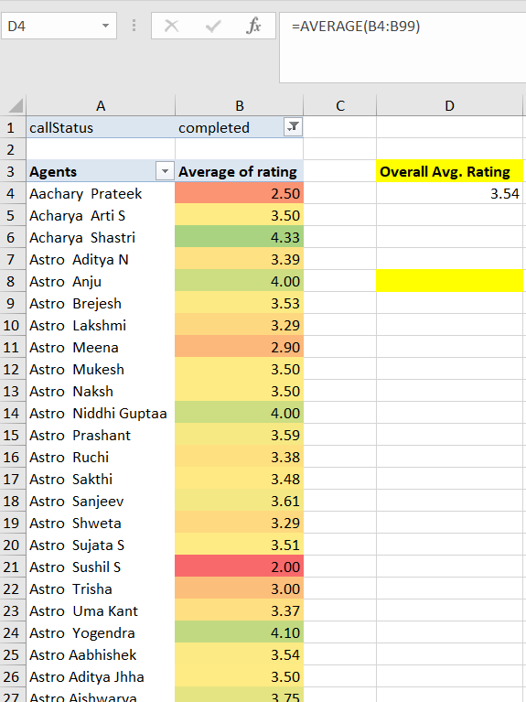

- Upgrading Call Center Technology

- Technology upgrades like advanced call routing and automation tools could significantly optimize agent workload by evenly distributing calls and managing queries more efficiently.

- automated call routing systems to optimize peak period handling

Recommendation –

- Investment should be done on improving training to enhance communication and problem-solving skills to boost customer satisfaction.
- Introduce Incentives: Implementing performance-based incentives will motivate agents and improve both productivity and customer satisfaction.

- What are the potential risks of each investment option (hiring, training, technology upgrades), and how can they be mitigated?
Name the chart/spreadsheet function you will use for solving the problem?

- Potential Risks and Mitigation Strategies:
- Hiring More Agents -
  - Risks:
    - It will increase operational cost
    - reduced productivity if new hires are not adequately trained.
  - Mitigation:
    - Phased hiring as per requirement with the increase in call volume, and robust training.

- Improving Training Programs -
  - Risks:
    - High cost of conducting these training programs.
    - Resistance from the agents to new training methods or additional training time.
  - Mitigation:
    - Giving training to those only who require it.
    - Providing incentives for agents to complete training.

- Upgrading Technology -
  - Risks:
    - High initial cost and low adoption rates.
  - Mitigation:
    - Phased implementation, comprehensive training, and support.

- How does AstroSage call center performance compare to that of AstroGuru in terms of average call volume, customer satisfaction, and agent performance?
Will you use any aggregation function or a visualization here to solve the problem?
*Analysis is done considering consulatationType ‘Call’ as AstroSage call centre and consultationTyoe ‘Chat’ as AstroGuru .

- Average daily volume

- AstroSage call center on an average handles 102 in call volume daily.
- AstroGuru handle 163 users on an average daily.

Average daily volume handled by an agent.

- AstroGuru agent handle 7 users on an average daily.
- AstroSage call center’s agent handle 4 users on an average daily.

Average customer rating

- AstroGuru got an average rating of 7 from their users.
- AstroSage call center got an average rating of 3.5 from their users.

Clearly from the above analysis, AstroGuru performed better than AstroSage call center as they got 60% more volume, 75% higher agent performance and 100% higher ratings.

- How can the call centre improve its handling of peak call periods to ensure high customer satisfaction?
Mention the functionality which you will use for giving the suggestions, will it be any aggregated function or a visualization?

- To improve the call center's handling of peak call periods and ensure high customer satisfaction, we need to analyze call patterns and performance during these periods. The goal is to identify when peak times occur and understand how the call center's resources are currently being utilized.

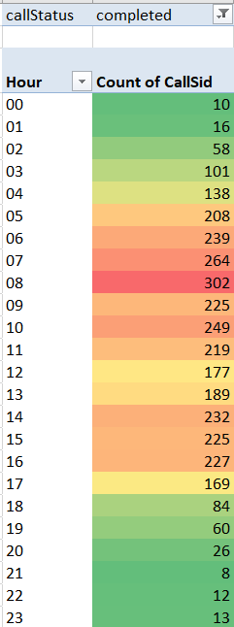

Insights –
- From chart, we can analyse that call volume during 06 to 09 hour is high.
- 08 – 09 hour records the highest call volume in a whole day.
Recommendation –
- We can motivate agents to manage more calls during the peak time.
- We can also introduce incentives for working on weekends.

- Based on historical data, what strategic initiatives should be prioritized to improve overall efficiency and customer satisfaction?

Insights from Historical Data:
- Low Average Calls Handled per Agent:
  - Agents handling an average of only 1 call per day and over half of the agents handling 1 or fewer calls, there is a clear opportunity to improve agent utilization.
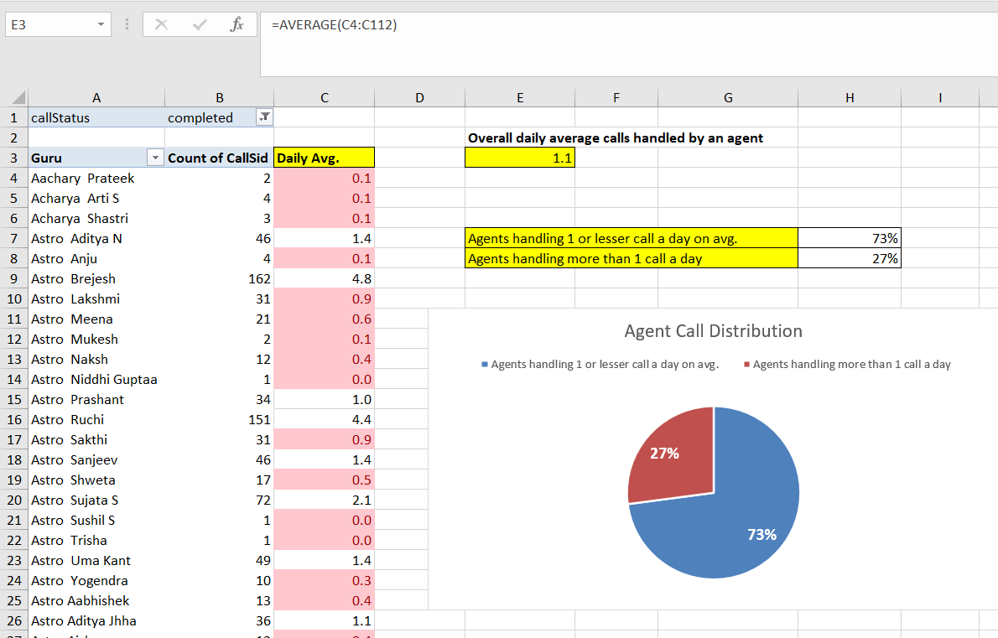

- Moderate Customer Satisfaction Scores:
  - The average customer satisfaction rating is 3.5, indicating room for improvement in how agents handle calls, resolve issues, and communicate with customers.

- High Call Volumes During Peak Periods:
  - Certain time of the day experience significantly higher call volumes, leading to longer wait times, and lower customer satisfaction.

Recommendation –
- By focusing on optimizing agent utilization, enhancing training programs, leveraging technology for efficient call handling, and maintaining a feedback-driven approach, the call centre can significantly improve both operational efficiency and customer satisfaction. Prioritizing these initiatives will create a more responsive, efficient, and customer-focused call centre environment.

- What can be the key factors contributing to high customer satisfaction scores, and how can these be leveraged to improve overall performance?
What is the basis for the suggestions? And mention how did you decide if the satisfaction score affect the ratings?

- Key factors contributing to high customer satisfaction scores
  - Agent communication skill – empathetic and professional communication by agents often results in higher satisfaction scores.
  - Problem resolution
  - Minimal wait time – shorter wait times directly correlate with higher satisfaction levels, as users do not want to be left waiting.

- Customer satisfaction scores are a direct measure of service quality and are often reflected in overall ratings.
- High satisfaction scores are usually tied to favorable reviews and ratings. Conversely, poor scores indicate dissatisfaction, likely leading to lower ratings and negative feedback.

- How should the call center balance the workload among agents to ensure optimal performance and avoid burnout?
Mention your approach and spreadsheet function for the answer?

Approach –
- Analyze Call Volume Patterns:
- As discussed above its observed there is comparatively high volume during the weekends.
- Using pivot table, we can find out daily average call volume.
- Use conditional formatting to highlight agents who are handling more calls than the average, indicating a need for workload redistribution.

- Monitor Agent Performance and Breaks:
Regularly monitoring agent performance metrics such as Average Handle Time and customer satisfaction score. Adjust workloads based on their metrics to ensure agents are not overburdened.

- Flexible Scheduling:
Implementing flexible scheduling, where agents work in shifts that align with peak call periods. This helps distribute the workload evenly throughout the day.

- What new technologies or tools could be implemented to enhance call center operations and customer service?
  - AI-Powered Virtual Assistants: Automate handling of frequently asked questions, to reduce astrologer workload and wait times.
  - Personalized Call Routing Systems: Use customer data to route calls to astrologers specializing in specific areas to provide more better consultations.
  - Customer Relationship Management (CRM) with Astrology Profiles: Integrate a CRM system that includes detailed customer astrology profiles and previous consultation history, enabling astrologers to provide personalized and insightful advice.
  - Sentiment and Voice Analysis Tools: Utilize AI to analyze the tone and sentiment of customer interactions in real-time, allowing astrologers to adjust their approach and enhance customer satisfaction.
  - Appointment Scheduling and Queue Management Systems: Implement automated scheduling to manage peak times efficiently and reduce customer wait times.

- What metrics should be included in the final dashboard to provide a comprehensive view of call centre performance and guide investment decisions?

1. Operational Metrics:
- Call Volume by Consultation Type: Track the volume of calls and chats to understand the distribution and popularity of services.
- Average Call Duration: Monitor the average duration of user and astrologer calls to assess efficiency.
- Call Status Distribution: Visualize the percentage of completed, incomplete, and canceled calls to identify service gaps.

2. Financial Metrics:
- Total Revenue: Track the total revenue generated from sessions to see financial performance.
- Net Earnings: Monitor the net amount after deductions and astrologer earnings to manage profitability.
- Cost of Free Services: Track the number of free calls and chats to understand the cost of promotional or retention strategies.

3. Customer Satisfaction Metrics:
- Customer Satisfaction Score: Monitor customer satisfaction scores from post-session feedback to measure overall service quality.
- Repeat Caller Rate: Identify repeat users by tracking unique user IDs to see customer loyalty and satisfaction.

4. Agent Performance Metrics:
- Average Rating per Guru: Track performance based on customer ratings to identify top and underperforming gurus.
- Guru Earnings: Monitor individual earnings to provide insights on productivity and incentivization.
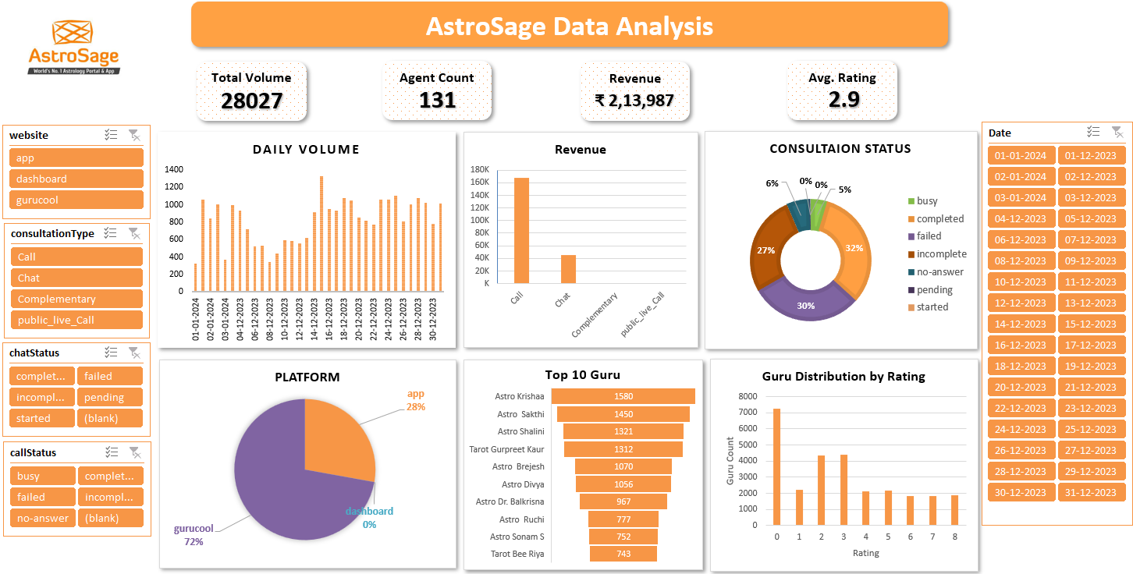

- Explain your approach in brief for suggesting countries/cities in order to open new restaurants, if the objective and subjective questions would have not been given to assist you.
[you have to give bullet pointers in order to answer this question]

- Market Research:
  - Analyze the market size and growth potential for the restaurant industry in different countries/cities.
  - Identify consumer spending habits on dining and food services in various regions.
- Demographics and Target Audience:
  - Study population demographics, such as age, income, lifestyle, and preferences, to identify potential customers.
  - E.g. If opening a fast-food restaurant, we can target schools and colleges.
- Competitive Analysis:
  - Assess the competition level in potential cities, including the number and type of existing restaurants.
  - Identify gaps in the market where certain cuisines or dining experiences are underrepresented.
- Real Estate and Infrastructure:
  - Look for locations with affordable real estate prices, good accessibility.
  - Like schools, colleges
- Cultural Fit and Local Preferences:
  - Assess the cultural acceptance and demand for the type of restaurant or cuisine being proposed.
- Operational Costs:
  - Compare labor costs, food supply costs, utility expenses, and overall operational expenses across cities.
- Consumer Trends and Preferences:
  - Analyze local food trends and dining habits, such as a preference for casual dining, healthy food options, or unique culinary experiences.

By following these steps, we can strategically determine the best locations for opening new restaurants based on a data-driven analysis of market potential and business feasibility.

