**ASSIGNMENT-5**

To perform: Create and execute C programs for following CPU Scheduling Algorithms:

1. First Come First Serve (FCFS)

2. Shortest Job First (SJF)

3. Round Robin Scheduling

 1. First Come First Serve (FCFS)

#include <iostream>

using namespace std;

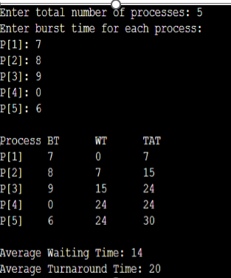

int main() {

    int n, bt[20], wt[20], tat[20];

    float avg_wt = 0, avg_tat = 0;

    cout << "Enter total number of processes: ";

    cin >> n;

    cout << "Enter burst time for each process:\n";

    for (int i = 0; i < n; i++) {

        cout << "P[" << i + 1 << "]: ";

        cin >> bt[i];

    }

    wt[0] = 0;

    for (int i = 1; i < n; i++) {

        wt[i] = 0;

        for (int j = 0; j < i; j++)

            wt[i] += bt[j];

    }

    cout << "\nProcess\tBT\tWT\tTAT";

    for (int i = 0; i < n; i++) {

        tat[i] = bt[i] + wt[i];

        avg_wt += wt[i];

        avg_tat += tat[i];

        cout << "\nP[" << i + 1 << "]\t" << bt[i] << "\t" << wt[i] << "\t" << tat[i];

    }

    cout << "\n\nAverage Waiting Time: " << avg_wt / n;

    cout << "\nAverage Turnaround Time: " << avg_tat / n;

    return 0;

}

2. Shortest Job First (SJF) – Non-preemptive

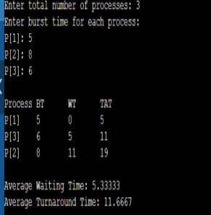

#include <iostream>

using namespace std;

int main() {

    int n, bt[20], p[20], wt[20], tat[20], i, j, temp;

    float avg_wt = 0, avg_tat = 0;

    cout << "Enter total number of processes: ";

    cin >> n;

    cout << "Enter burst time for each process:\n";

    for (i = 0; i < n; i++) {

        cout << "P[" << i + 1 << "]: ";

        cin >> bt[i];

        p[i] = i + 1;

    }

    // Sorting burst times

    for (i = 0; i < n - 1; i++) {

        for (j = i + 1; j < n; j++) {

            if (bt[i] > bt[j]) {

                temp = bt[i]; bt[i] = bt[j]; bt[j] = temp;

                temp = p[i]; p[i] = p[j]; p[j] = temp;

            }

        }

    }

    wt[0] = 0;

    for (i = 1; i < n; i++) {

        wt[i] = 0;

        for (j = 0; j < i; j++)

            wt[i] += bt[j];

    }

    cout << "\nProcess\tBT\tWT\tTAT";

    for (i = 0; i < n; i++) {

        tat[i] = bt[i] + wt[i];

        avg_wt += wt[i];

        avg_tat += tat[i];

        cout << "\nP[" << p[i] << "]\t" << bt[i] << "\t" << wt[i] << "\t" << tat[i];

    }

    cout << "\n\nAverage Waiting Time: " << avg_wt / n;

    cout << "\nAverage Turnaround Time: " << avg_tat / n;

    return 0;

}

3. Round Robin Scheduling

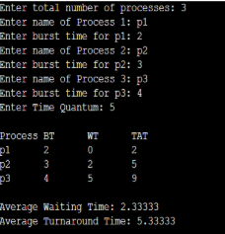

#include <iostream>

using namespace std;

int main() {

    int n, time_quantum, remaining[10], bt[10], wt[10], tat[10], t = 0;

    bool done;

    float avg_wt = 0, avg_tat = 0;

    cout << "Enter total number of processes: ";

    cin >> n;

    cout << "Enter burst time for each process:\n";

    for (int i = 0; i < n; i++) {

        cout << "P[" << i + 1 << "]: ";

        cin >> bt[i];

        remaining[i] = bt[i];

    }

    cout << "Enter time quantum: ";

    cin >> time_quantum;

    do {

        done = true;

        for (int i = 0; i < n; i++) {

            if (remaining[i] > 0) {

                done = false;

                if (remaining[i] > time_quantum) {

                    t += time_quantum;

                    remaining[i] -= time_quantum;

                } else {

                    t += remaining[i];

                    wt[i] = t - bt[i];

                    remaining[i] = 0;

                }

            }

        }

    } while (!done);

    cout << "\nProcess\tBT\tWT\tTAT";

    for (int i = 0; i < n; i++) {

        tat[i] = bt[i] + wt[i];

        avg_wt += wt[i];

        avg_tat += tat[i];

        cout << "\nP[" << i + 1 << "]\t" << bt[i] << "\t" << wt[i] << "\t" << tat[i];

    }

    cout << "\n\nAverage Waiting Time: " << avg_wt / n;

    cout << "\nAverage Turnaround Time: " << avg_tat / n;

    return 0;

}