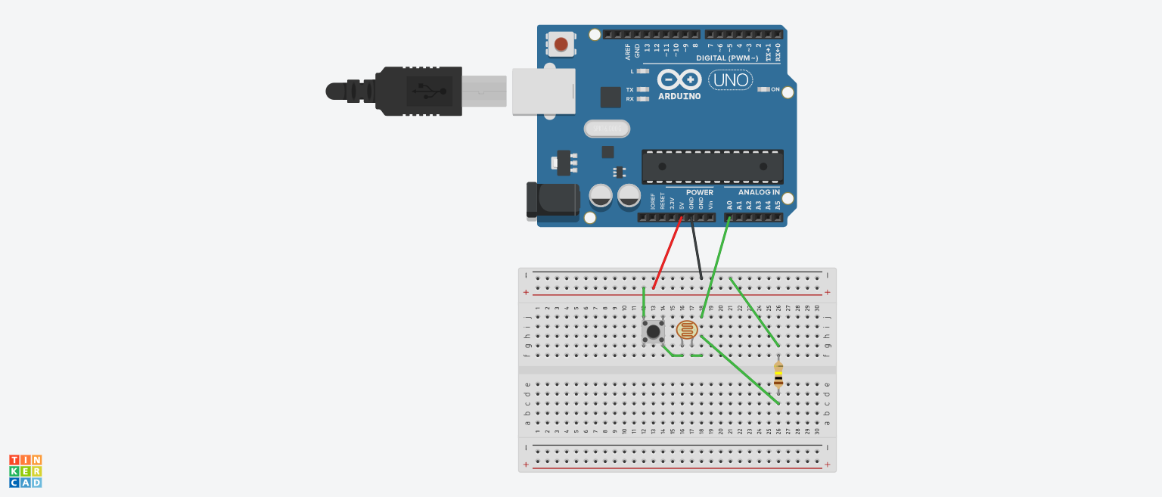

THEORY

**CONCEPT USED** :> DIRECTING THE LIGHT INTENSITY BY USING LDR SENSER .. LIGHT WILL FALL

ON LDR AND THE READING WILL BE SHONED ON “Serial monitor" THIS ALL WILL HAPPEN

WHEN WE PRESS THE PUSH BUTTEN.

**SOURCE CODE** :> int sensorPin = A0;

int sensorValue = 0;   
void setup()

{  
Serial.begin(9600);   
}  
void loop()

{  
sensorValue = analogRead(sensorPin);   
Serial.println(sensorValue);

delay(100);

}

**LEARNING AND OBSERVATION** :> I HAVE LEADED TO SEE CHANGING VALUES ON ARDUINO UNO

BY CLICKING ON “Serial monitor" AND I OBSERVED THE WHEN WE INCREASE OR DECREASE THE

LIGHT INTENSITY , THE VALUES CHANGES WITH RESPECT TO LIGHT INTENSITY

**PROBLEMS AND TROUBLESHOOTING** :> PROBLEM COME WHILE , CONNECTING ARDUINO AND LDR SENSERS , RESISTORS , BUTTEN BUT AFTER SOME TRY WE SUCCESSFULLY CONNECTED THE

CIRCUIT.

**PRECAUTION** :> ONE SHOULD CONNECT THE WIREING PROPERLY AND SHOULD CONNET IT TO PROPER ARDUINO PORTS TO SUCCESSFULLY CARYOUT THE EXPRIMENT. ONE SHOULD THAKE

CARE THAT THE SENSERS WHICH ONE IS USING SHOULD WORD PROPERLY AND TAKE CARE OF

THE RESISTOR TOO DON’T USE HIGH RESISTOR .

**LEARNING OUTCOMES** :> I HAVE LEARNED THE USEAGE OF LDR SENSER AND LEARNED HOW

TO READ IT’S READING IN ARDUINO APP , I HAVE LEARNED WHO TO CONNECT THE CIRCUIT

OF LDR WITH ARDUINO THROUGH BREADBOARD.

UID :>19BEC1043