**MTMS Design Document**

**Requirements**

**Contents**

1. Revision History 2

2. Outstanding Queries 2

3. Approvals 2

4. Overview 3

5. Requirements 3

5.1 Authentication Technnique 3

# Revision History

|  |  |  |  |
| --- | --- | --- | --- |
| **Name** | **Date** | **Reason for changes** | **Version** |
| Vaibhav Tyagi | 10/30/21 | Initial Draft | 1.0 |
|  |  |  |  |
|  |  |  |  |
|  |  |  |  |
|  |  |  |  |
|  |  |  |  |

# Outstanding Issues

|  |  |  |  |  |  |
| --- | --- | --- | --- | --- | --- |
| **Date Identified** | **Section** | **Description** | **Resolution** | **Resource** | **Date Resolved** |
|  |  |  |  |  |  |
|  |  |  |  |  |  |
|  |  |  |  |  |  |

# Approvals

|  |  |  |  |
| --- | --- | --- | --- |
| **Date** | **Name** | **Area** | **Comments** |
|  |  |  |  |
|  |  |  |  |
|  |  |  |  |
|  |  |  |  |

# Overview

Need to design an enterprise level software system which will perform following high-level tasks

* Web UI for Corporate Type of Users
* Mobile App for Technicians Type of users
* RebitMQ/ ServiceBus Topics for disconnected Microservice Architecture.
* Message Listeners and corresponding processers APIs
* Distributed Database design - To make application capable to handle high volume of data and transaction.
* Notification service for send and receive alerts and notification
* Complete Log Track?
* Datawarehouse development for robust reporting capabilities

# High level Architecture diagram

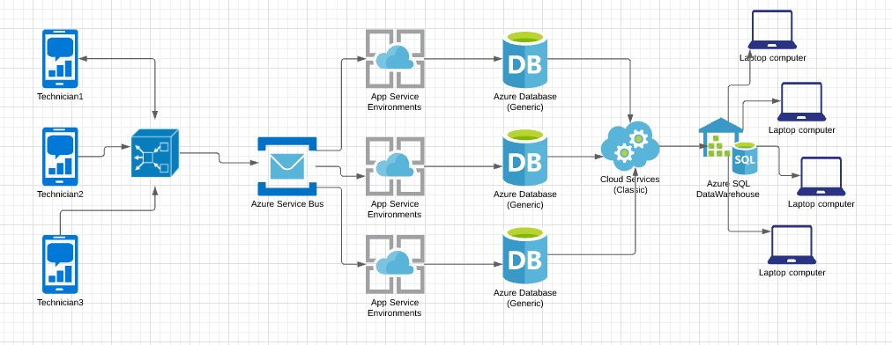

# Component level design

Fire and forget Gateway.

Servidebus for disconnected architecture.

AppServices for Data processing – CQRS pattern.

Background service for Date migration.

SSRS reports integration we web application.

Angular based Single page application for Dashboard and Admin related approvals.