This repository will help you install [Mediawiki](https://www.mediawiki.org/) on AWS in fully automated fashion using Terraforma, AWS cli and Ansible.

Terraform is responsible for provisioning infrastructure on AWS while Ansible helps install Mediawiki.

**Diagrams - Infra**

[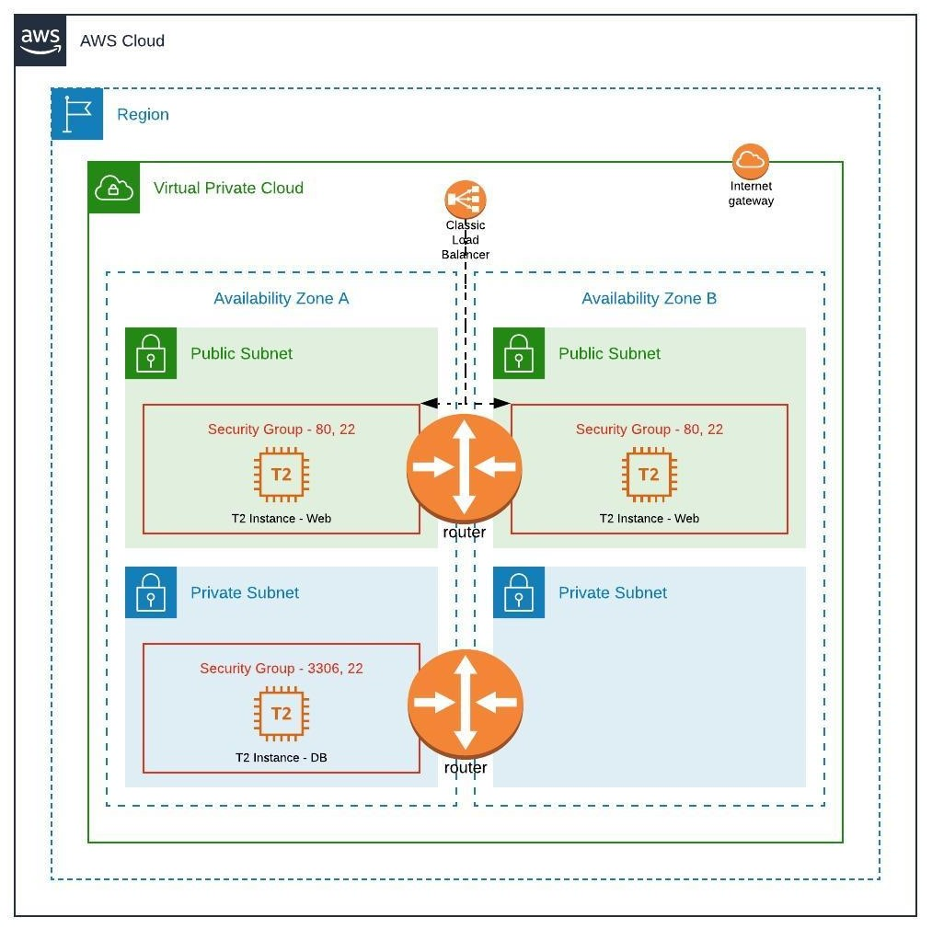](https://github.com/Vaibhavarora08/mediawiki-1/blob/master/static/mediawiki.jpeg)

**Diagram - Execution**

1. Traffic arrives on load balancer and get routed to web servers in public subnet
2. Web servers can only make calls to DB server in private subnet

**How to Execute Terrform Scripts**

**Plan**

terrform plan

**Apply**

terraform apply

**Destroy**

terraform destroy

**How to Execute Ansible Playbook independent of Terraform**

ansible-playbook -i non-production master-install-mediawiki.yaml

**Things to consider**

1. Check python version of destination machines. If version <= 3 then please comment "ansible_python_interpreter" in group_vars
2. Pre-bake your image and provide ami-id in terraform.tfvars
3. The path for key file in terraform compute code is specific to my system location. You need to change the location as per your resources.