**Project Name: Flight Price Prediction**

*-Analysis by Vaibhav Banke*

**About Project:**

We have prices of flight tickets for various airlines between the months of March and June of 2019 and between various cities. So we are going to build a machine learning model to predict the price of the flight ticket based on features such as Airline, Date_of_Journey, Dep_Time, Arrival_TimeTotal_Stops etc.

* **Import Libraries**

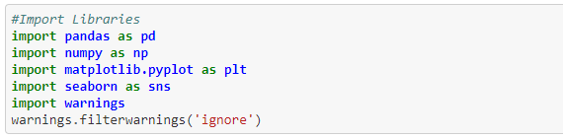

Here we import libraries for getting data and for making EDA Analysis.

* **Import Dataset**

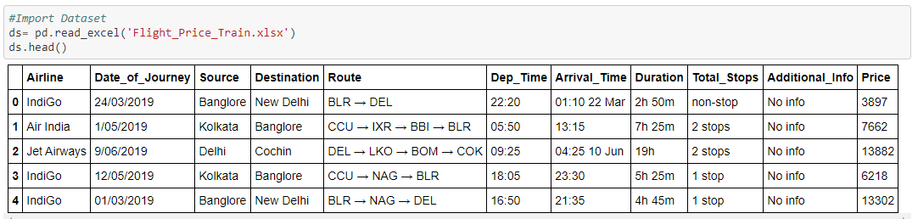

We can see now top 5 rows of Dataset.

* **Fitting data into Pandas Dataframe**

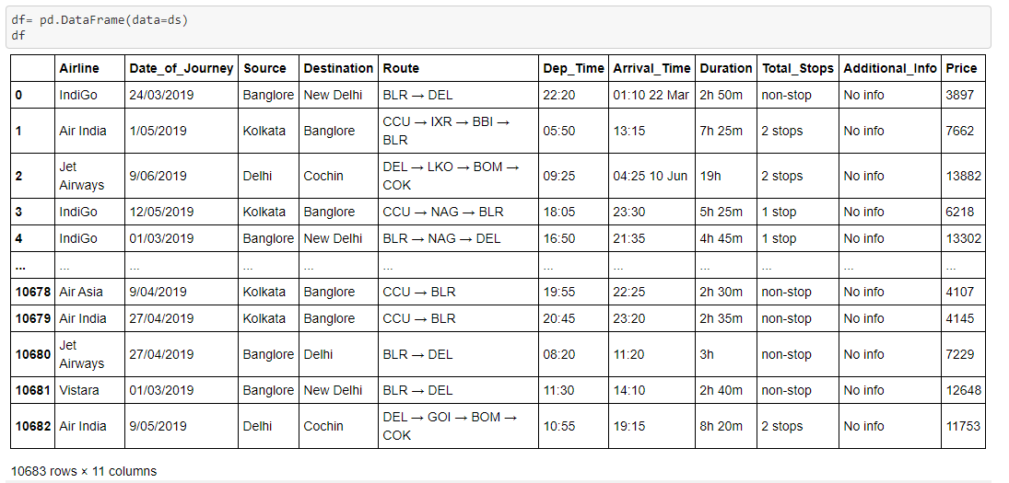

Here we fitted our dataset into Pandas Dataframe, so that we can do all Dataframe methods.

* **Appling Pandas DataFrame methods**

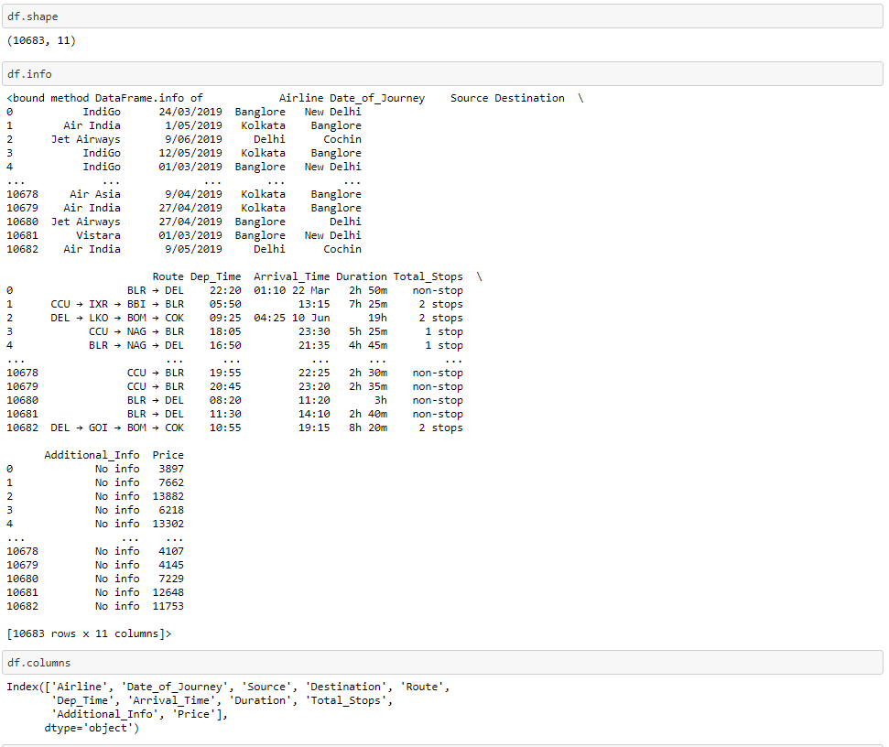

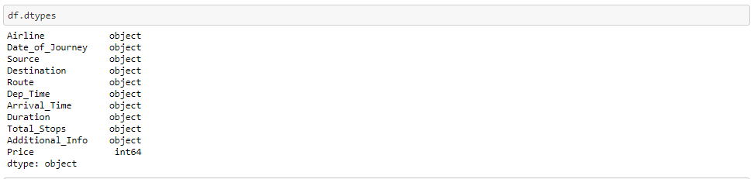

* **Checking for Null values**

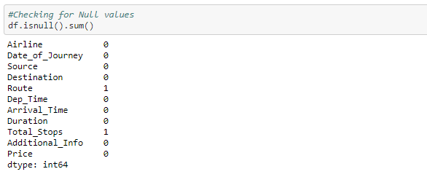

Observations: There are Null Values and 1 in each in column Route and Total Stops, so we can drop these.

* **Removing Null values**

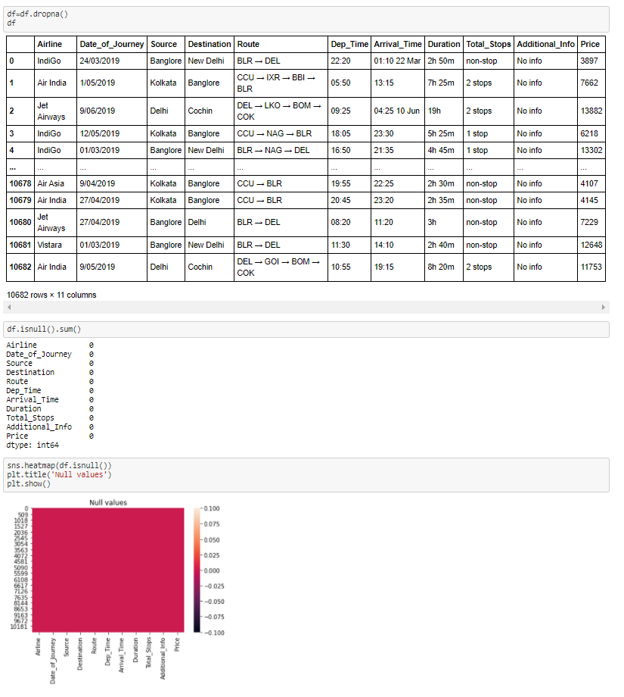

Observations: Now no null values present in dataset.

* **Feature Engineering**

Here we are going to add more features in our dataset from existing one and deleting unwanted features.

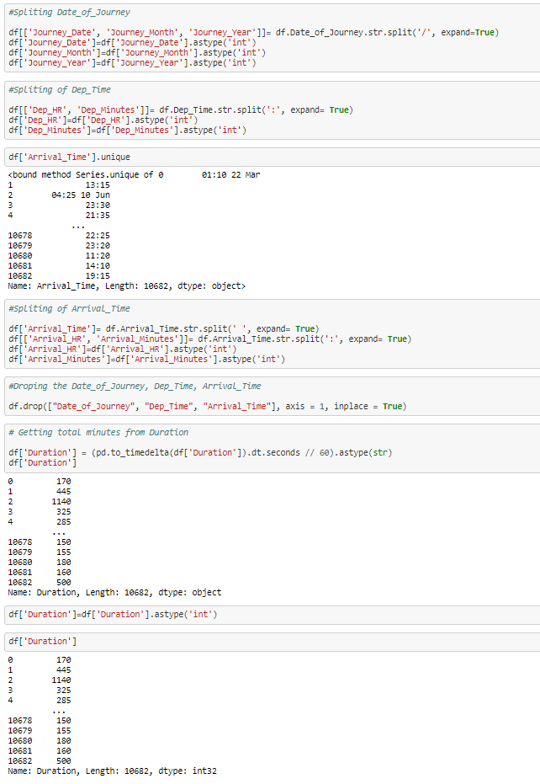

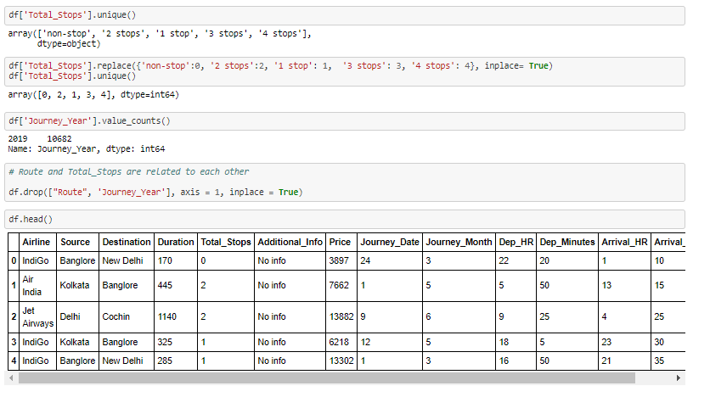

* **EDA**

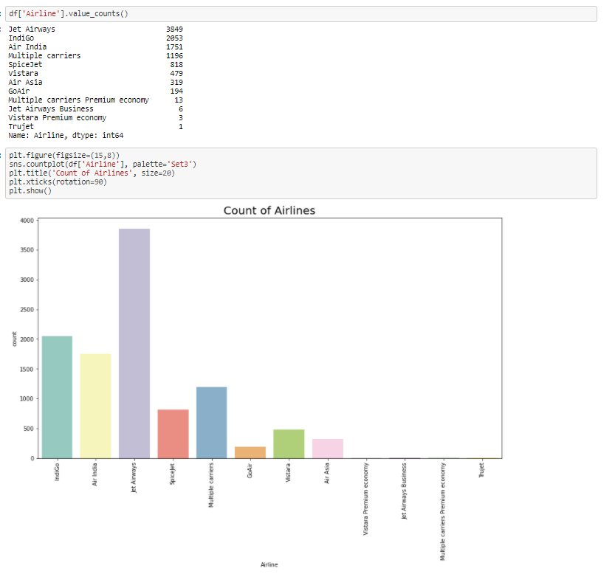

Observations: There are most of Jet-Airways having almost 3800 counts.

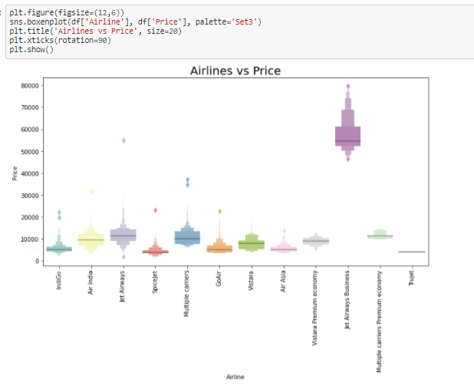

Observations: We can see that for Jet Airways Business having maximum price rate which is distributed from min. 50000 to 80000, whereas spice Jet having less than all minimum price rate which is distributed from min. 2500 to 10000.

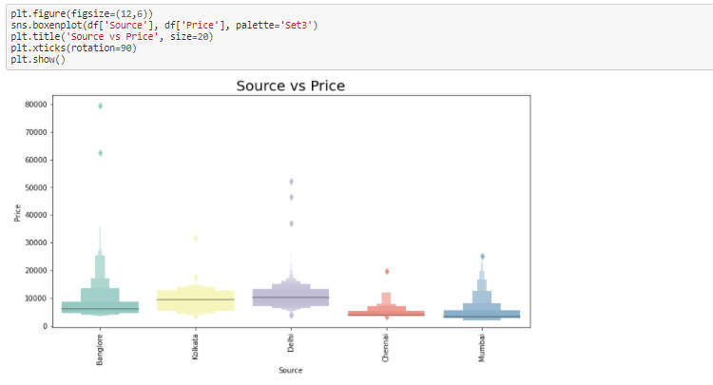

Observations: Flight which are started from Lokata and Delhi has more price distributed in 5000 to 15000.

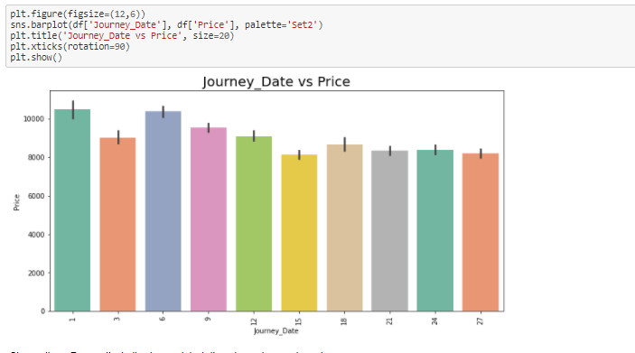

Observations: For month starting i.e. on date 1, there is maximum price value.

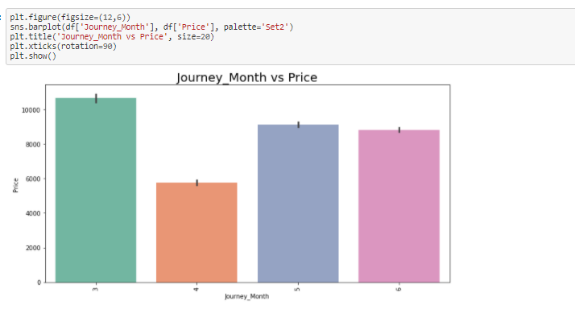

Observations: There is maximum flight price in 3rd i.t. in March month.

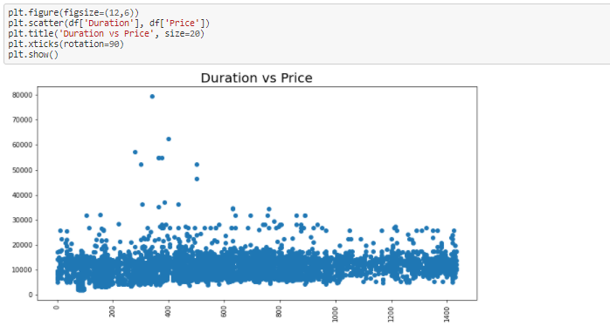

Observations: Almost for all duration flight price is distributed in between 5000 to 20000.

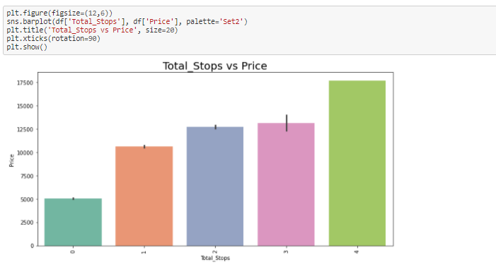

Observations: As number of total_stops increases, price of flight also increases.

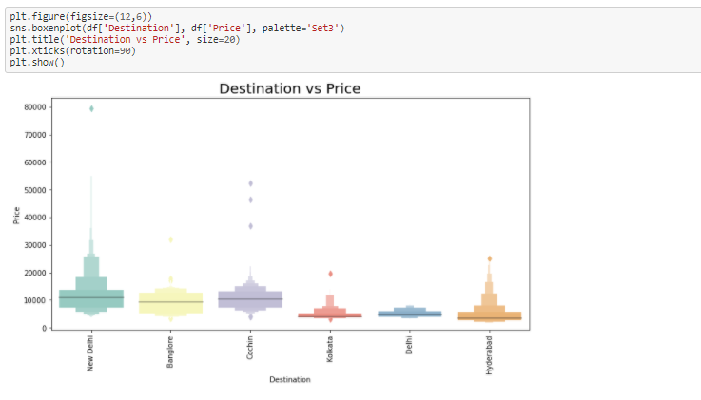

Observations: Flights those are going to New Delhi are having more price distribution.

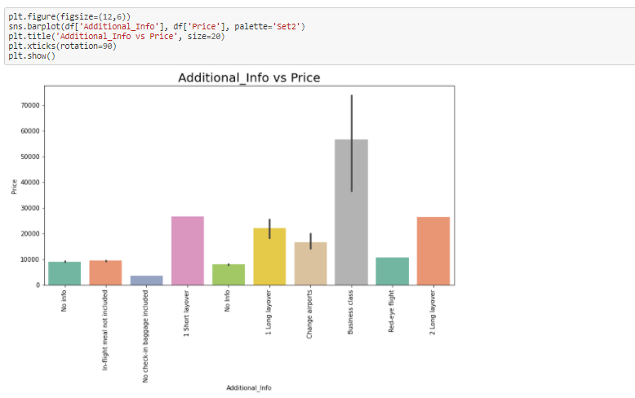

Observations: For Business class there is higher price.

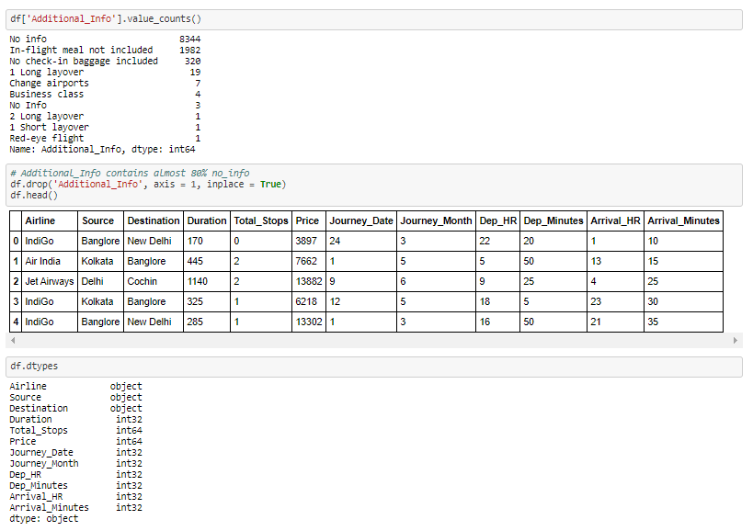

* **Encoding**

Here we are going to convert all object data type into numerical data type by using Label Encoding.

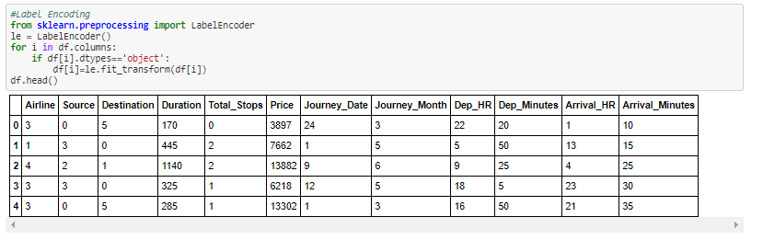

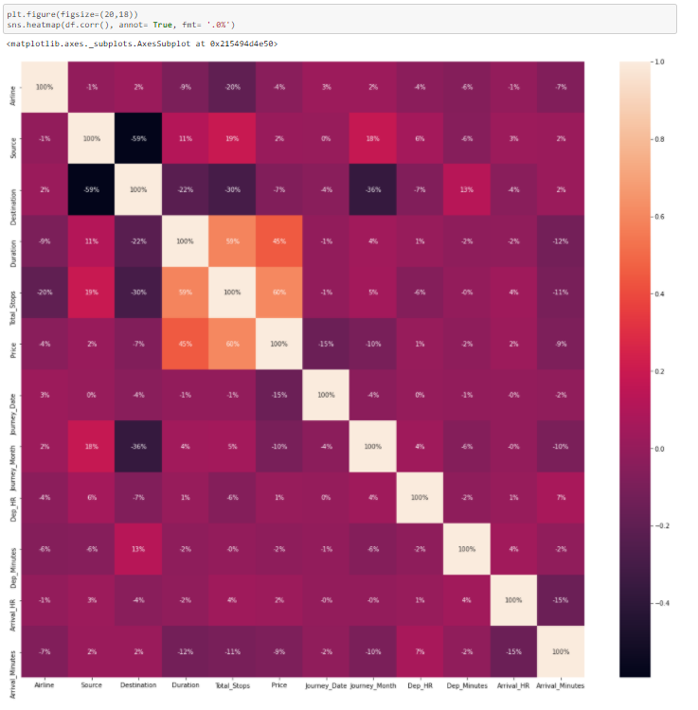

Observations: Flight price is highly correlated with total stops and Duration of flight.

* **Checking For Outliers**

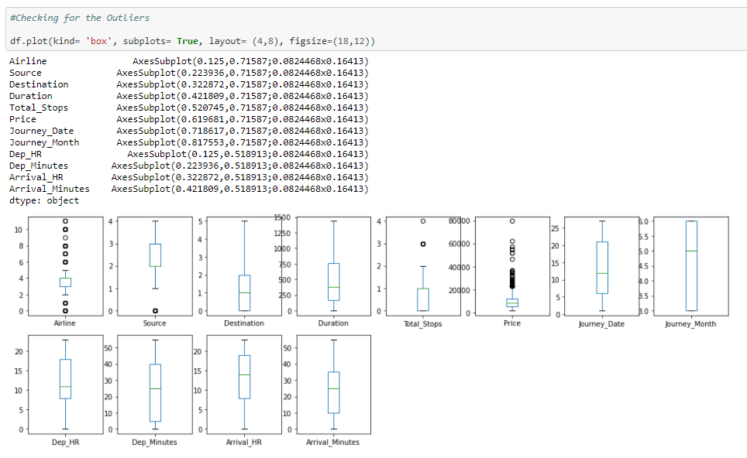

Observations: There are maximum outliers are present in Price. That one we need to remove.

* **Outliers Removing**

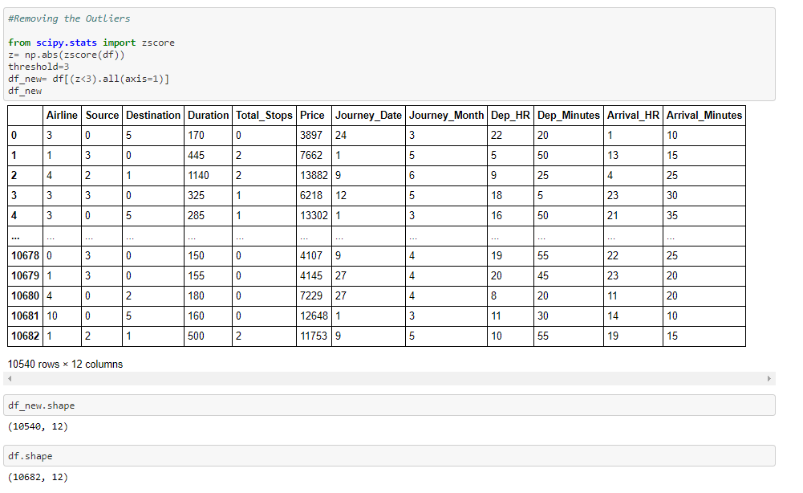

Observations: We can observe that there are almost 142 rows removed due to outliers.

* **Splitting Data**

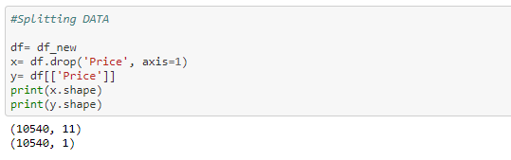

* **Checking for Skewness**

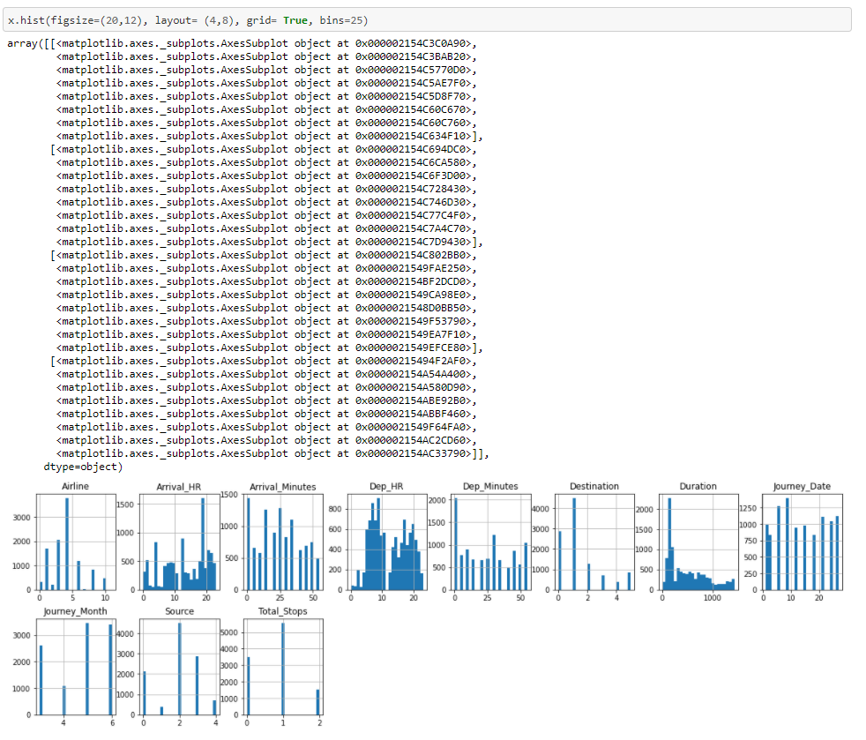

Observations: We can see that duration, Dep_Hr are somewhat left skewed.

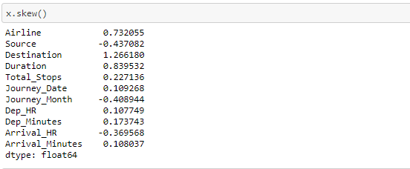

* **Skewness removal**

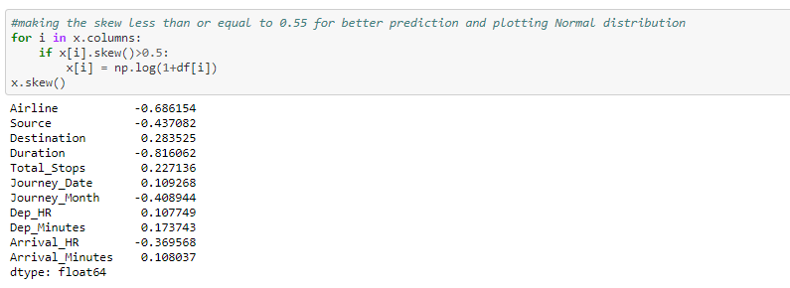

* **Standardization of Data**

Here we are doing Standardization i.e. scaling of data by using StandardScaler.

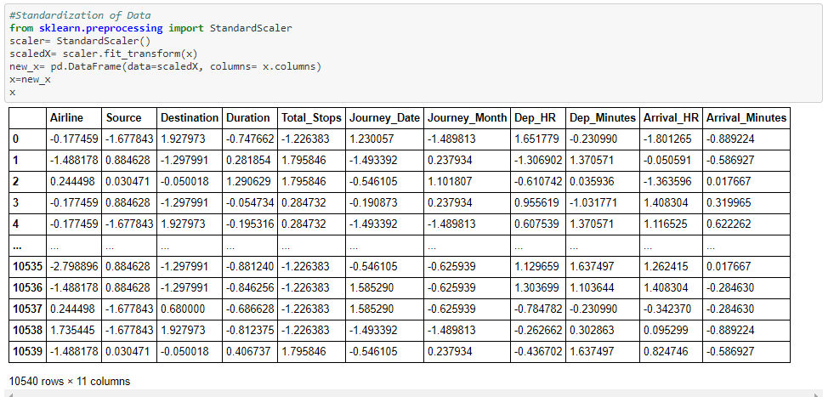

* **Machine Learning**

1. First we are going to import Libraries for Machine Learning.

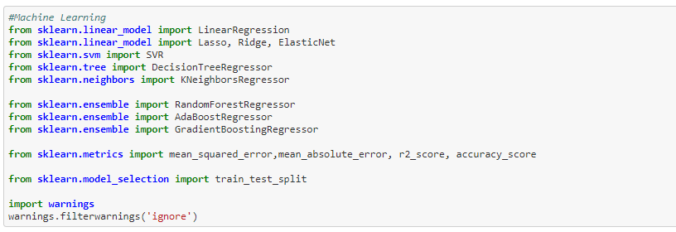

1. Finding best random state.

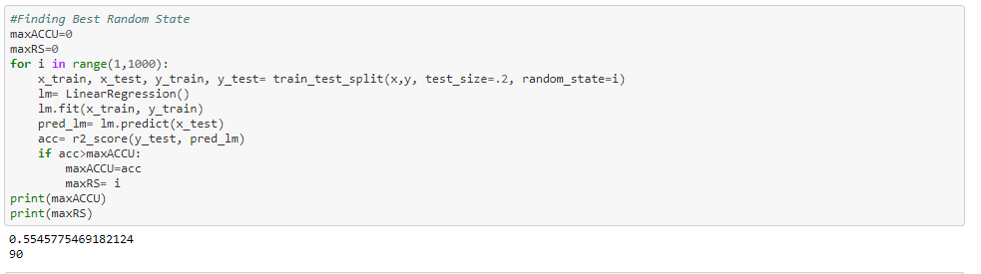

Here we can see that best random state is 90.

1. Splitting the data for training and testing purpose.



1. Selection of best model.

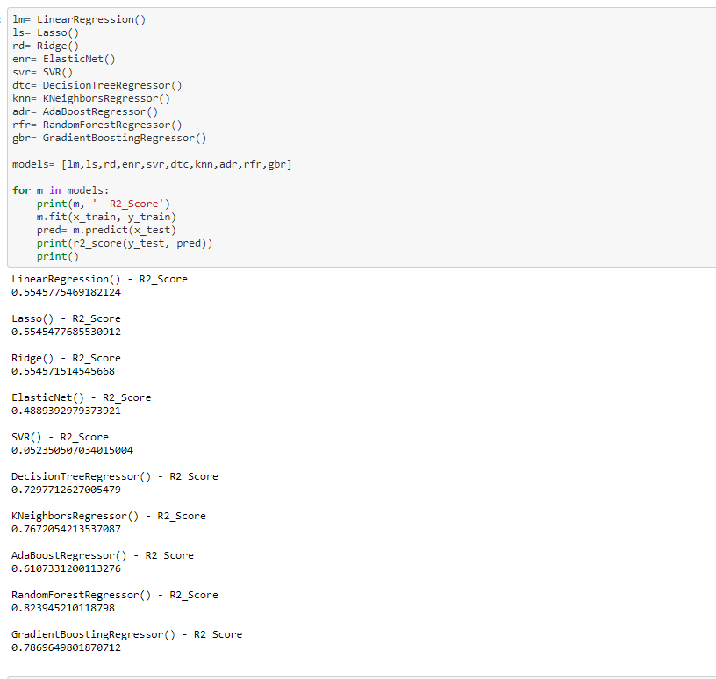

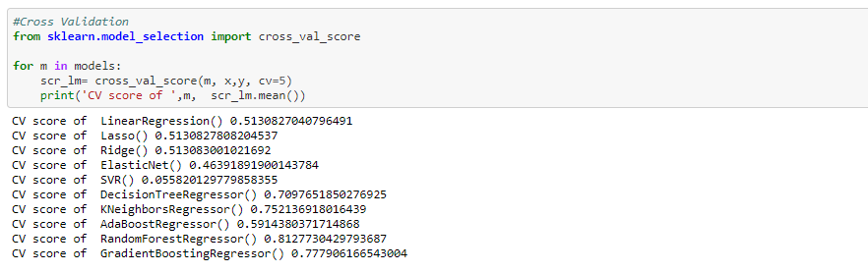

Observations: From above we can observe that for RandomForestRegressor model there is less difference in r2_score and cross validation r2_score so we will select RandomForestRegressor model for final predictions.

1. Hyperparameter Tuning for Best selected model RandomForestRegressor

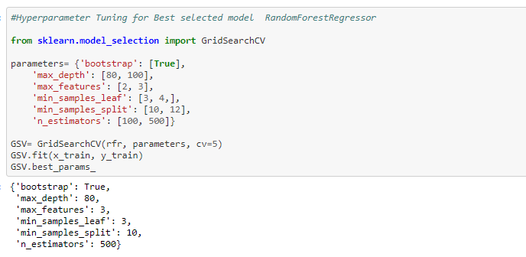

1. Getting best of RandomForestRegressor model from best Parameters.

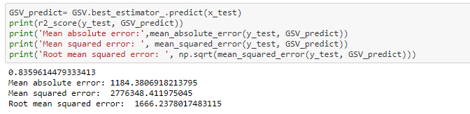

* **Saving the best model**

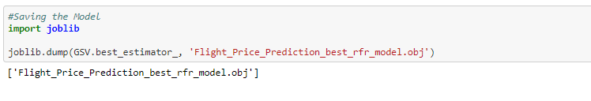

* **Working on Test Data**

Now we will do all data cleaning, Feature Engineering and EDA on test data, then we will pass this data into our best selected model.

1. Import Test data

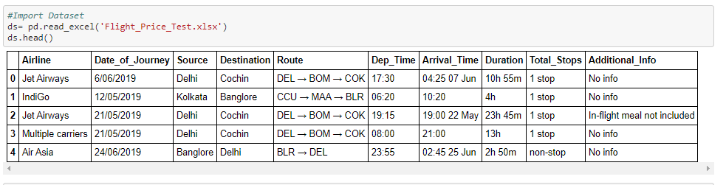

1. Fitting test data into dataframe and use of pandas dataframe methods.

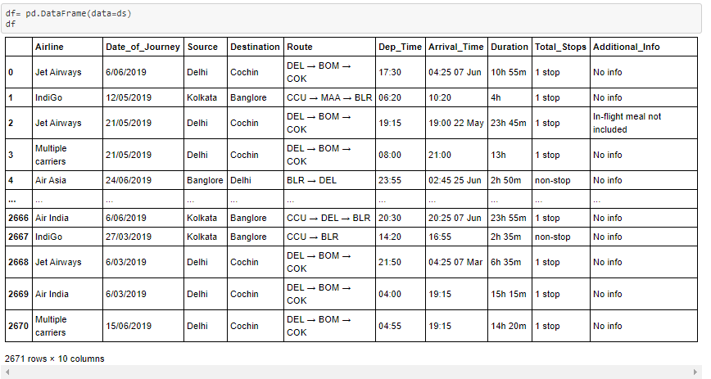

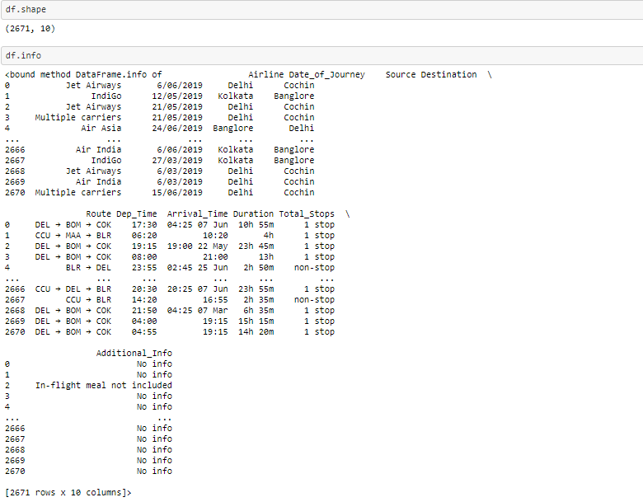

1. Checking of Null Values and removing if Null values present.

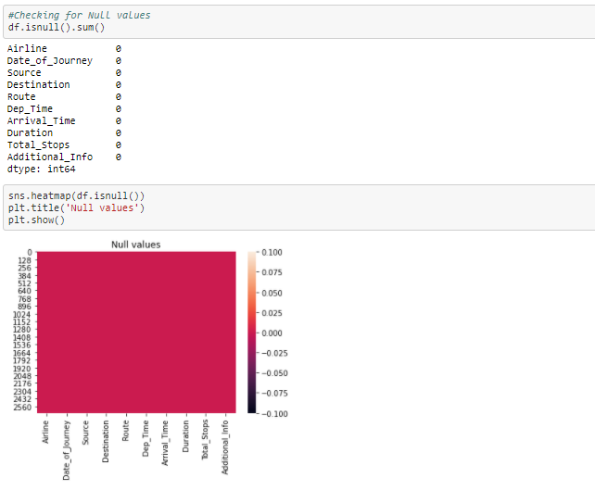

Observations: No null values are present in dataset.

1. Feature engineering for Test Data

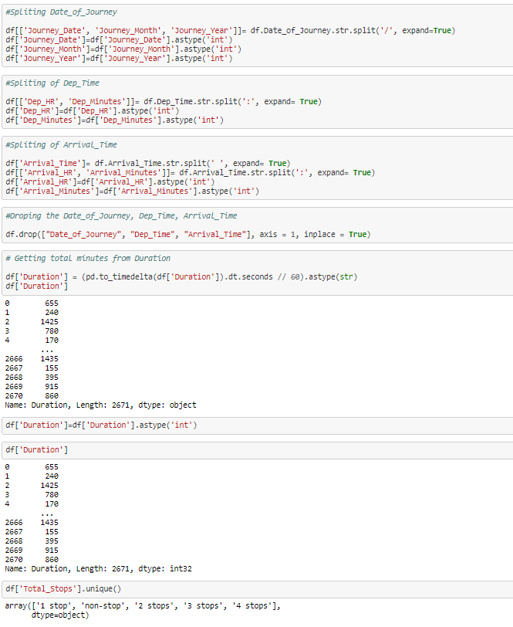

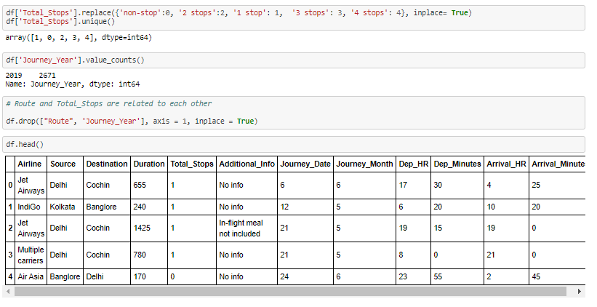

1. EDA for Test data

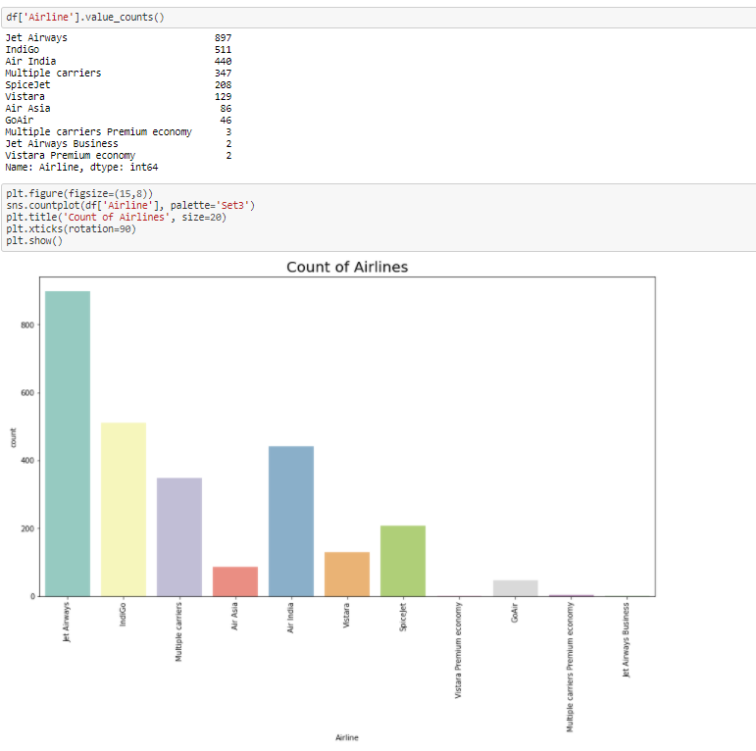

Observations: There are most of Jet-Airways having almost 900 counts.

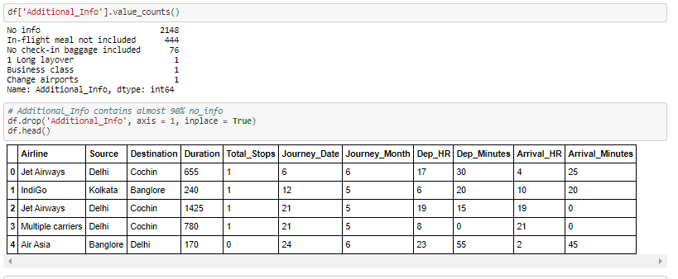

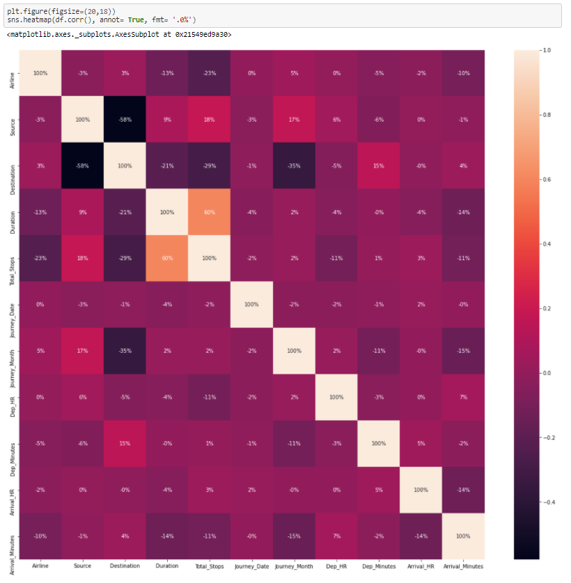

Observations: We can see that Duration is highly correlated with total stops.

1. Checking for Outliers and removing if present.

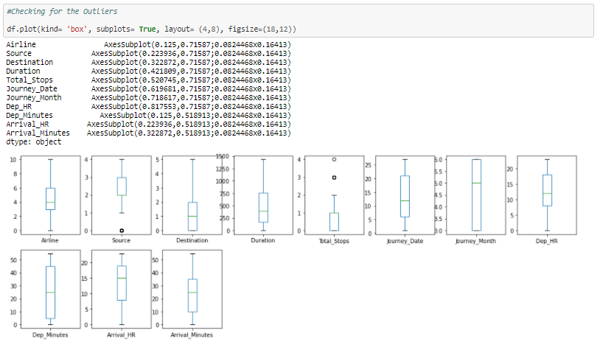

Observations: We can see that there no outliers present.

1. Checking for Skewness and removing if present.

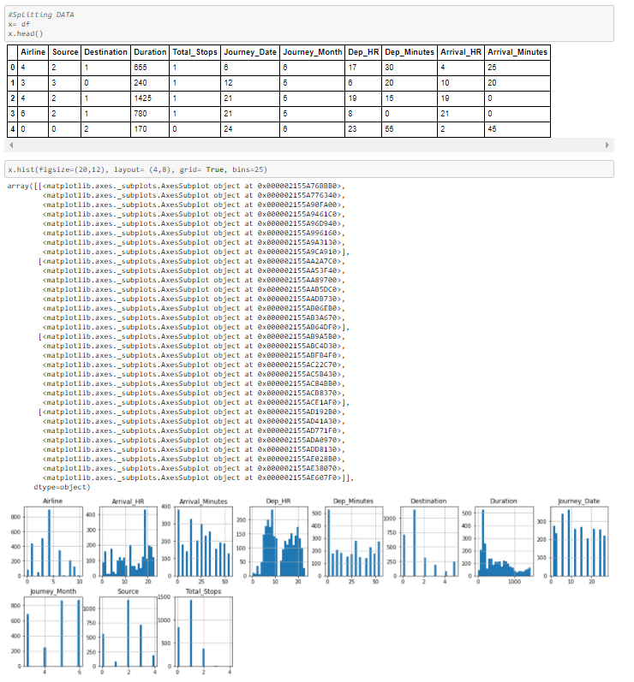

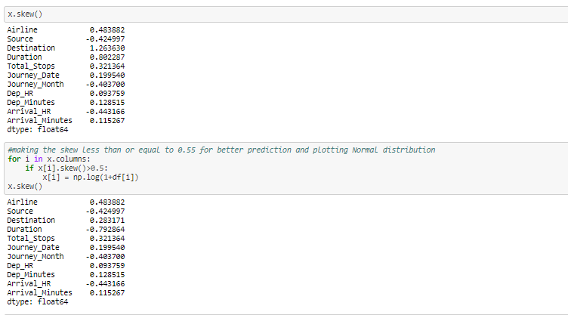

1. Standardization of Test Data

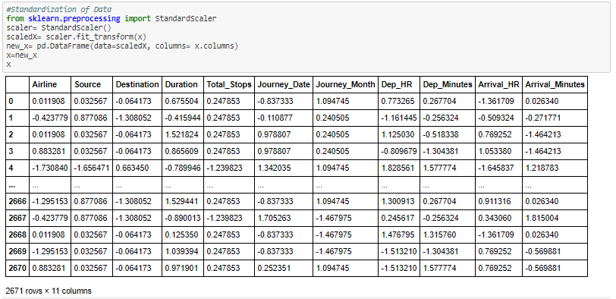

* **Loading the best model and fitting Test data**

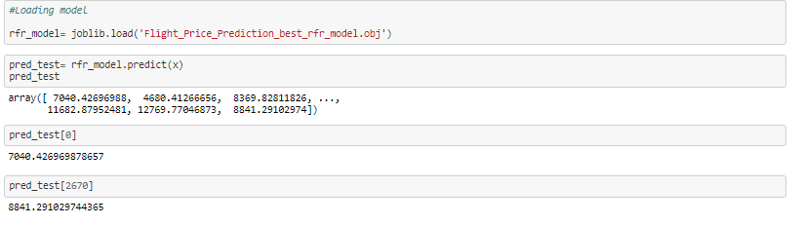

* **Conclusion**

For Analysis of Flight_Price_Prediction project we have selected RandomForestRegressor model which having accuracy 84%.