**Digital Library management**

**Criteria B - Design**

**Modular Design**

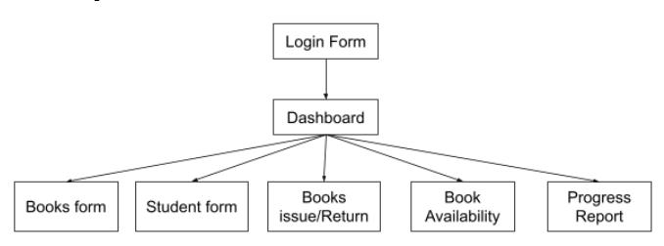

**System Flowchart**

The System flowchart displays how the information produced by the client is stored in the database and after that the information from the database is used to output information to the other parts to output the progress report and generate a bar chart

**Forms Layout**

These are the layout of the form which was presented to the client to get an overview of what the solution will look like and how the solution will function. Based on these layouts of the form I had received feedback from the client.

**Login form:**

This form will be the first form when the client will open the application. The purpose of this form is to authentic the client before letting them access the software. The reason for this is to not let the student or any undesired individual have access to this solution except my client

On click a validation check is run to cross check the email and password and error is outputted if incorrect password or email or one of them not entered.

Text box to enter username and password

**Dashboard:**

The dashboard will allow the client to easily navigate between various different forms and access the form needed by them.

Using action event these buttons will redirect the client to specific form they desire to go to.

Text box to enter username and password

**Student form:**

The student form allows the client to record data of all the new students who have joined the reading program. Also, it allows the client to update any student record or delete it. A table below is present for the client to go over all the data recorded stored and make it convenient for the client to just click on the table row that they want to update or delete and automatically the values will be updated in the text fields above reducing the need for the client to re-enter values.

The table depicts the values from the database records, and it also allows the user to on click of the row, automatically update values on the textboxes

The add, update and delete buttons are respectively used to perform their task. Once the changes are done the database automatically updated.

Text box is used to enter the student ID, student class and student name

The refresh button is used to automatically update value in tables from the database on the changes in the value.

Go back button let the client re-direct to the dashboard. This will reduce the need for the client to go back to repetitively close for changing between forms

**Books form:**

The book form allows the client to add a new book in the database if a new book is bought for the library or to update any information related to book details or delete book details for the books removed from the library. The table is present to display information from database records and to make a user-friendly where the user can on click copy info from the table to the textbox.

Go back button is used to re-direct the client to the dashboard

The refresh button is used to automatically update value in tables from the database on the changes in the value.

The add, update and delete buttons are respectively used to perform their task. Once the changes are done the database automatically updated.

Text box is used to enter the Book Genre, Book Publisher and Book Author

The table depicts the values from the database records, and it also allows the user to on click of the row, automatically update values on the textboxes

Text box is used to enter the Book ID, Book Name and Book Class

**Books availability form:**

The books Availability form cross-checks with the database if a book is available to be issued to the student or not. To provide it with a more filtered manner - a range of criteria are given like book’s level, book’s genre, book’s publisher, and book’s author to look for the right match of books according to the demands of the client.

The chosen criteria will be displayed here above the drop-down box.

Go back button is used to re-direct the client to the dashboard

The table depicts the values from the database after the criteria is set and the value is entered in the textbox. In this case, the criteria chosen was book level and the value entered was 10 so this is how the output looks like.

On click of search button, the values are displayed on the table below.

In this textbox, the client can simply enter the initials or the value for the criteria set

Once the criteria is chosen, the client can click on the Okay button so the values can be filtered from the database related to the criteria.

The client can use the dropdown option to choose from the four criteria: book’s level, book’s genre, book’s publisher, and book’s author.

**Books inventory form:**

The book inventory form provides the client with a platform to issue and return books to students. The client can simply in clicks of buttons add the values in the table to issue a book. In the table below, the list of books issued is displayed. To return the book, the client can click on the row of the book issued in the table and then just click return automatically the book will be returned. The changes in the status of the book issued or returned will automatically happen in the database according to the actions performed by the client.

The book name and student name will automatically be entered once the client chooses the values in the dropdown box above them respectively.

Go back button is used to re-direct the client to the dashboard

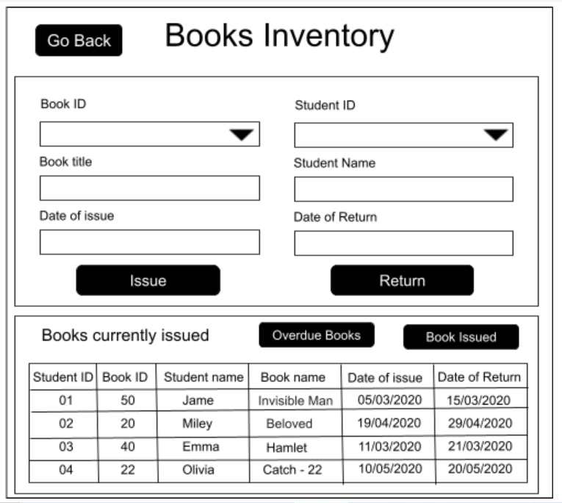

The issue button is used to store the book in the inventory database where all the books are issued. Also, before the book is issued a search and sorting algorithm will run to check if the chosen student ID has an overdue book or not. If there is overdue book with that student ID, then a error message will pop up restricting the client to issue a new book. Once the client clicks on return button then the books status is changed to “N” issued meaning not issued.

The table presents the list of all the books which are currently issued and have not yet been returned.

The date of issue and date of return will have a calendar which will let the client choose the date of issue and date of return of a particular book.

The Book ID and the student ID are informed of dropdown box so the client can type in the value instead of searching it.

After clicking the Overdue button, the table view will change like this

To return to see the currently books issued click on the book issued button

The title will also automatically change on overdue button click

The overdue books button lets the client view the list of books which are overdue by comparing it automatically with today’s date and the table view changes to figure 1. For the client to view back the book which are currently issued they can simply click on book issued button.

Figure 1

**Progress Report form:**

The progress report form will let the client perform analysis based on the performance of each student over a period. The client can simply add the student id with the start and end date. Automatically the list of the books with the details of the books for specific students which that student has read will be outputted in form of a table. Once the information is loaded in the table it will also be added into a temporary database where all the records will be stored. The purpose of this is to assist the program in automatically generating a table monthly to see the progress of the students over the chosen time frame by the client. The client can even convert the table in form of a report which can be downloaded by the client for keeping a personal record or sharing it with the parents.

Go back button is used to re-direct the client to the dashboard

There will be a data chooser that will let the client choose from a calendar the start and end date

The search button takes the input of the student ID, start date and end date to output the list of the tables form the database into the table.

The graph button will create a pop up where a graph will be created with a monthly division of no of books read in each month.

Figure 3 depicts how the graph will looks like with its features.

Once the Student ID is chosen then the student’s name will automatically appear

The dropdown box will let the client choose the student ID

After the search button is clicked, automatically a database search is run, and the output values are listed in form of tables.

The download report button will create a report where the values from the table will be inform of a report.

Figure 2 depicts how the download report looks like with its features.

**Report of the Progress Report form:**

The report depicts all the books the student has read over some time. The information is similar to the table in the progress report, however, the purpose of this is to present the same information with an option for the client to download it or print it or zoom in or zoom out.

The zoom in and zoom out icon lets the client zoom into the report or zoom out according to the need of their device size.

The list of book details is sorted in form of ascending order according to the name and then according to the date of issue.

The save button lets the client download the report in form of pdf. The print button will let the client print the report directly.

Figure 2

**Graph of the Progress Report form:**

The Graph will appear once the client clicks on the graph button in the progress report form. The graph will appear as a pop-up. The graph will be outputted in form of a bar chart to make it easier for the client to analyse the progress of a specific student.

The y-axis has depicted the no of books the student has read

The graph will be outputted in form of bar charts like depicted.

The month is plotted in the x-axis according to the time period selected by the client

Figure 3

**Database Tables**

**Student Table** - This table is used to store the data of the students who are enrolled in the school and this table keeps a record of all the students that are part of the library program.

|  |  |  |  |
| --- | --- | --- | --- |
| Attribute | Type | Primary key | Description |
| ID | Integer | Yes | A unique key assigned to every student to identify them uniquely amongst other participants |
| Name | Characters | No | The name of the student will be stored |
| Class | Integer | No | The grade will be stored to keep a record of which student belongs to which class |

**Book table** - This table is used to store information about the books the library currently has bought for its usage and the books which are available and not available in the library

|  |  |  |  |
| --- | --- | --- | --- |
| Attribute | Type | Primary key | Description |
| ID | Integer | Yes | This is a unique ID assigned to each book to distinguish them from the other books. |
| name | Characters | No | The name of the book is stored in this attribute |
| Level | Integer | No | The level of the book is stored in this attribute |
| Genre | Characters | No | The genre of the book is stored in this attribute |
| Publisher | Characters | No | The publisher of the book is stored in this attribute |
| Author | Characters | No | The author of the book is stored in this attribute |
| Issued | Characters | No | This takes to values either ‘Y’ or ‘N’ to decide whether the book in the library is issued or available to get issued |

**Inventory table** - This table is used to keep a record of all the books assigned to each student every time they issue a book or return a book from the library.

|  |  |  |  |
| --- | --- | --- | --- |
| Attribute | Type | Primary key | Description |
| ID | Integer | Yes | This is used to uniquely identify each issue or return that takes place |
| IDS | Integer | No | This is the value taken from the ID of the book table and uniquely identifies the book issued |
| IDB | Integer | No | This is the value taken from the ID of the student table and uniquely identifies the student to whom the book is issued |
| title | Characters | No | This is to keep the record of the name of the book issued or returned by which student |
| name | Characters | No | This is to keep the record of the name of the student to whom a book was issued or returned |
| Datei | Date | No | This is used to keep the record of the day the book is issued |
| Dater | Date | No | This is used to keep the record of the possible day the book will be returned |
| Issued | Characters | No | This takes to values either ‘Y’ or ‘N’ to decide whether the book in the library is issued or available to get issued |

**Report** - This table takes value from the inventory table to store records into the report table depending on the values set by the client to look for a specific student. Based on that, all the books issued or returned by the students will be recorded in this table to be displayed in form of a report.

|  |  |  |  |
| --- | --- | --- | --- |
| Attribute | Type | Primary key | Description |
| Title | Characters | No | This is to keep the record of the name of the book issued or returned by the chosen student by the client search |
| Datei | Characters | No | This is the date on which the book was issued to the student |
| Dater | Characters | No | This is the date on which the book was returned by the student |

**Entity Relation diagram**

Entity Relation diagram is used to depict how the database fields and values are related to different java forms. This depicts the relationship between the book, student, report and Inventory database tables.

This is the book table and it has three different fields in its database

The relation between Book table and inventory table is ‘many to many’. In this case, the Book ID, Book name and issued from the Book table is sending the values to inventory table.

This is the Inventory table, and it has 8 different fields in its database. The Student ID and Student name are values from the Student Table. The Book ID, Book name and issued is values taken from the Book Table. The Title, Date of issue and Date of return field are sent to Report table.

The relation between Report table and inventory table is ‘many to many’. In this case, the Title, Date of issue and Date of return for a particular student is being taken from Inventory table to the report table.

This is the Report table and it has three different fields in its database. The values for these fields are being copied from the Inventory table for a specific student over a specific time according to the client search criteria

The relation between student table and inventory table is ‘one to one’. In this case, the student ID and Student name from the student table is sending the values to inventory table.

This is the student table and it has three different fields in its database

**Bubble sort**

The bubble sort is used to sort an array in ascending or descending order. In this case, an array is created where the list of all students ID is added who have 1 or more books overdue. Bubble sort is used to sort the list of student ID in ascending order. This will allow the array to be used for Binary search as mentioned below. Also, we needed to sort the array as binary search needs a sorted array.

OverdueArr[] = 0

Temp = 0

For I -> 1 to length.overdueArr

For m = 1 to I < length.overdueArr

IF OverdueArr[I] > OverdueArr[m]

Then

Temp = OverdueArr[I]

OverdueArr[m] = OverdueArr[I]

OverdueArr[m] = Temp

End If

Next

Next

**Binary search**

On the array with the list of student ID whose books are overdue is sorted in ascending order. Then the binary search is used in the books inventory form. So, when all the information is added by the client in the books inventory form and the client clicks on the issue. A binary search is run and uses the student ID selected by the client to compare with the array of student ID whose book is overdue. If there is a match then the client is informed that this student has an overdue book and the book is not issued to that student.

Found = -1

StudentID = 0

First = 0

Mid = 0

Last = OverdueArr.length – 1

While last > first and found = -1

Do Mid = first+Last/2

If OverdueArr[mid] < Student_ID

Then First = mid+1

Else If Student_ID < Overdue[mid]

Then Last = mid-1

Else Found = Found + 1

End IF

End IF

End While

**UML Class Diagram** - Unified Modelling Language (UML) Class diagram is used to describe the structure of classes used in a program as well as the relationship between the objects used in the library management software.

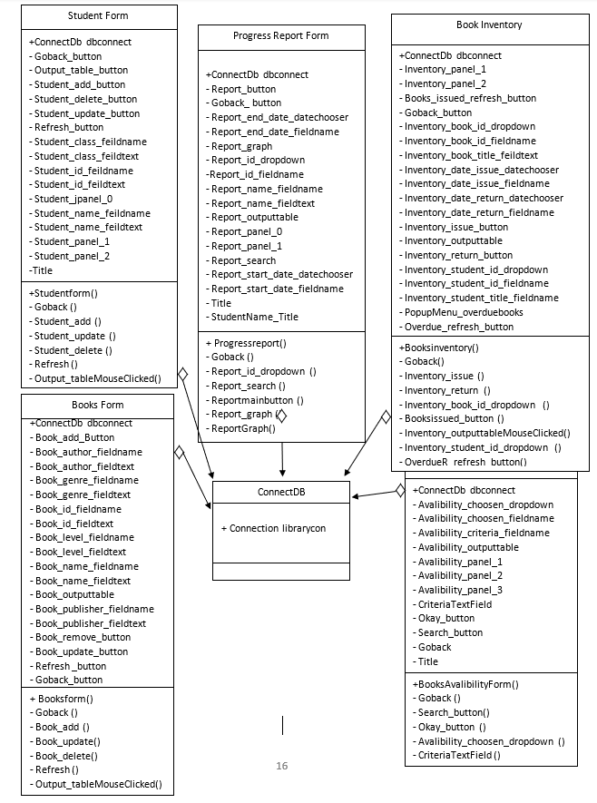



**Test plan**

|  |  |  |
| --- | --- | --- |
| Test Type | Nature of test with | Example |
| The program starts and switch on. The client will input the appropriate username and password | Enter the username or password incorrect then the login fails, and an error message will appear. | In the login form, incorrect credentials were entered and a warning about entering wrong credentials is generated. |
| In the books and student forms, seeing if the data can be added/updated/deleted | Sample data will be added into the Textboxes to check if the added button functions. Also, random data such as with the wrong format to test if it accepts it or not. For update/delete we will see if clicking on the specific row where we want to update/delete automatically takes in data and update/delete all the info. | In the book form, sample student details entered were student name “Arvind”, student ID – “5” and student grade – “4” and add button is clicked.  When the new student details were entered successfully and are visible in the table at bottom of the form.  To check the functioning of update/delete a pre-entered info of student name lily is chosen and onclick of the row colour turns blue and the information gets copied in the textbox above.  To delete just click on the delete button and change any information and click on the update information. This student information is deleted. |
| In the book Availability form, choose the criteria and then enter the keywords to locate the availability of the desired book. | Choosing different criteria and seeing if, on the right-hand box, the criteria is visible at the top. Once it is visible, enter keywords related to the criteria to see if that list of books for example based on a specific genre and which all books are based on that genre are available. Also, sample data that is used is then cross-checked if the searched data gives the desirable data or not. | In the book availability form, on choosing the criteria this is how it will look when the criteria are chosen and, for instance, the level is chosen.  Once the “Okay” button is clicked then the level appears in the next panel, and we choose the level as “10” in this case.  Once the search button is clicked so all the books with level 10 can be seen. |
| In the Book issue/return form, inputting appropriate information to issue a book and correct row click for self-input of the book to return. | Sample data will be entered and then the issue button will be clicked to check if the book is issued or not. Also, an erroneous form of information is entered to rule out the possibility that the system will accept the undesired form of information. To test the book return, the book which should be returned will be chosen from the list of books issued. Cross-check if the correct information from the table is self-inputted into the textbox and the book is successfully returned. Also, the book should no longer appear in the list of books below. | In the book inventory (book issue/return) form, book ID 1 is issued to student ID 2. Once they are chosen automatically the Book title and the student’s name are loaded. Then the Date of issue and date of return is entered by the client.  Once the client clicks on the issue button, the book details are issued and can be viewed by clicking on the book issued button.  To return the book, the client as shown below can do it by clicking on the row so the information loads in. For instance, the student ID 2 to which book ID 1 is issued.  On click of the return button and then on click on the book issued button once again to refresh we can see the book has been returned and has been removed from the table. |
| In the book issue/return form, on click, the table below values changes from overdue books to book issued list and visa-versa. | First, sample data will be inputted, and the list of books issued will be added. A few of the books from the sample data will be added to be depicted as an overdue list. Once this is done then with onclick of the button we can see if the table below changes, and the sample data matches. Also, we could cross-check with the sample data if the books listed as issue and overdue are correct or not? | On click of the books issued button, the list of all the books currently issued by clicking on the books issued.  The client can view the list of overdue books by clicking on the overdue books button. |
| In the book issue/return form, on click of the issue button, an automatic verification will take place checking if a book is overdue to a particular student and will restrict the book from being issued. | A sample data of books issued and some of them will be overdue. Then a check will run crosschecking if an overdue book is there or not. We will run the check for a specific student who has an overdue book. If a warning message comes then the automated verification system is working correctly. | In the book inventory (book issue/return) form, a book is already issued as seen with the student ID 1.  If the same student Id is issued another book, then that book is not issued, and a warning is generated. |
| In the progress report form, appropriate data will be inputted to search for all the books issued to the student over a period of time. | A sample data will be used for a particular student and the student ID will be inputted with the start and end date. First parameter will be to cross-check with the sample data that after inputting the Student ID does the correct student's name reflect or not. Then On click of the search button, the values in the table will be outputted. Then we will need to verify if the list of books issued over a certain time period matches the sample data used. | In the progress report form, to test the functionality of this form the following information is entered. The chosen student Id is 1 and respectively the student’s name loads in automatically. Also, the time period chosen is Jan 1st 2021 to 31st Aug 2021.  Once the search button is clicked, automatically the list of the books this student read in this time period is visible in the table at the bottom of the form. |
| In the progress report form, click the graph button automatically a bar graph should be generated showing the students' progress. Similarly, on click of the report button, a report should be generated letting the client view all the books issued. | Sample information will be inputted for a certain student, and this would result in values being generated and visible in the table. Once, the graph button is clicked an automatic graph should be generated and all the values from the sample should reflect on the graph. Similarly, on click of the report button, an automatically generated report should be visible and the values from the table/sample data should match with the values visible in the report. | Based on student ID 2, from Jan 1st, 2021 to Feb 10 2020 a bar chart is automatically generated.  Based on Student ID 1, the automatic progress report is generated on the list of the books that were read by student ID 1 from Jan 1st 2021 to April 31st 2021. |