Assignment-1: Warm-up with python

1. Write a command to get the Python version you are using.

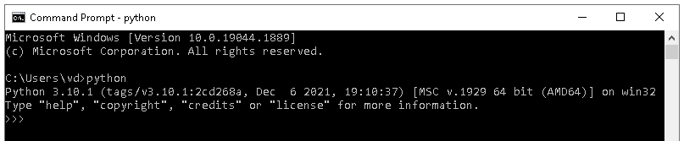

1. Write a python script to print Hello Python on the screen directly in the command line.

>>>print (“Hello Python”)

1. Write a python script and store it in a file and execute the file from the command line.

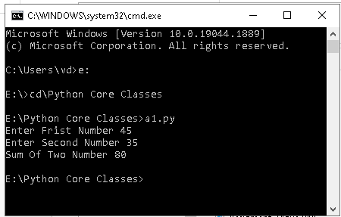

1. Write a python script to print Hello Python on the screen using visual studio code.

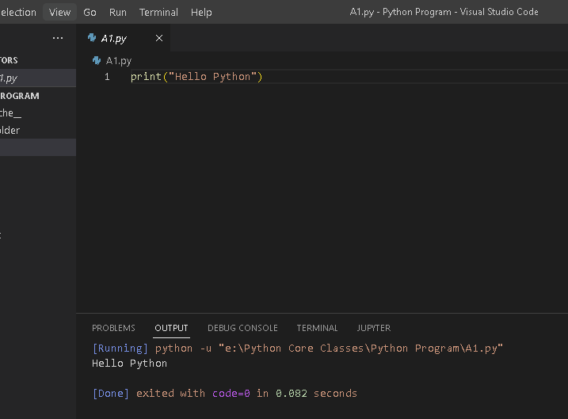

1. Write a python script to print Hello on the first line and Python on the second line

print (“Hello \nPyhton”)

1. Write a python script to print “MySirG” on the screen.

print (‘ ‘’MySirG” ‘)

1. Write a python script to print “Teacher’s Day” on the screen.

print (‘’’ “Teacher’s Day” ‘’’)

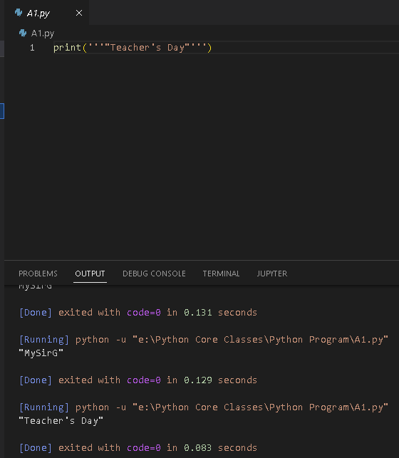

1. Write a python script to print the value of a variable. Variable contains your name as data.

A=input(“Enter your Name “)

print(A)

1. Write a python script to create variables to store your name, age, qualification, years of experience and print it.

a=input("Enter Your Name ")

b=input("Your Age ")

c=input("Your Qualification ")

d=input("Years Of Experience ")

print("Name",a,"Age",b,"Qualification",c,"Experience",d,sep=':',end='')

1. Write a python script to print values of three variables, each in a new line. Variable contains integer values

a,b,c=30,50,15

print(a,b,c,sep='\n')