Assignment – 10

For loop and range

1. Write a python script to print MySirG N times on the screen

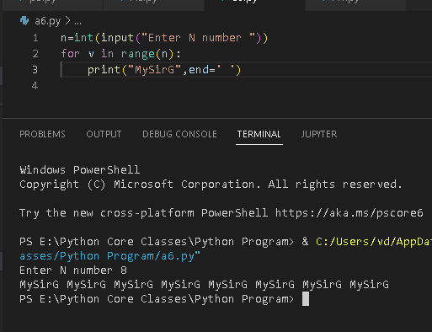

1. Write a python script to print first N natural numbers

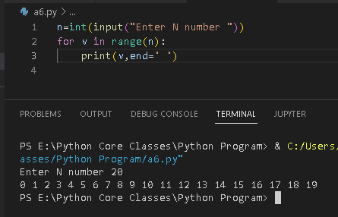

1. Write a python script to print first N natural numbers in reverse order

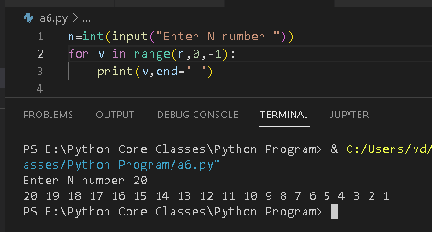

1. Write a python script to print first N odd natural numbers

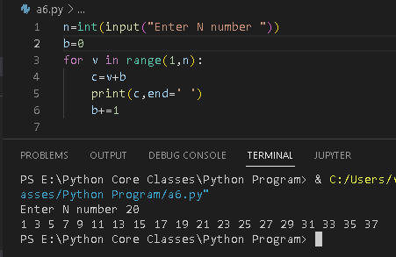

1. Write a python script to print first N even natural numbers

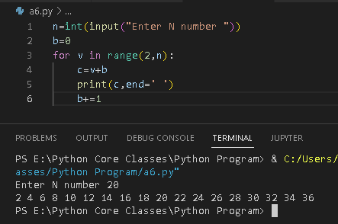

8. Write a python script to print squares of first N natural numbers

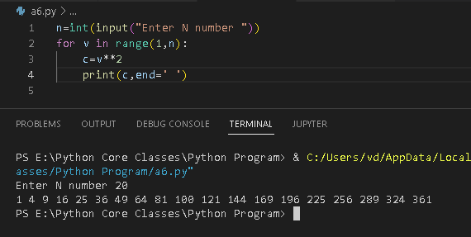

9. Write a python script to print cubes of first N natural numbers

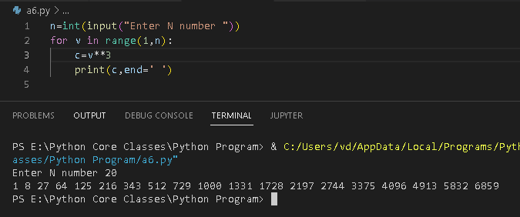

10. Write a python script to print first 10 multiples of Nq

