Assignment – 11 loops

1. Write a python script to calculate sum of first N natural numbers

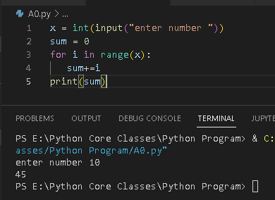

1. Write a python script to calculate sum of squares of first N natural numbers

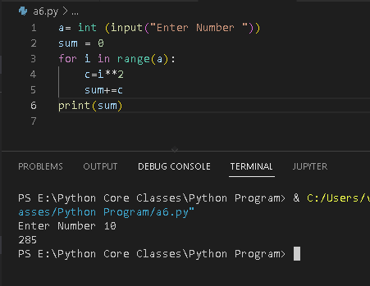

1. Write a python script to calculate sum of cubes of first N natural numbers

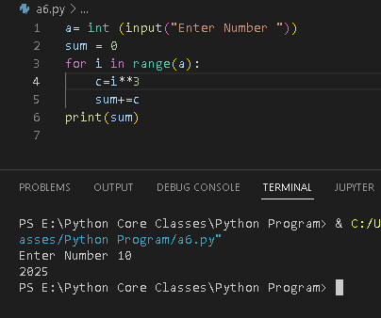

1. Write a python script to calculate sum of first N odd natural numbers

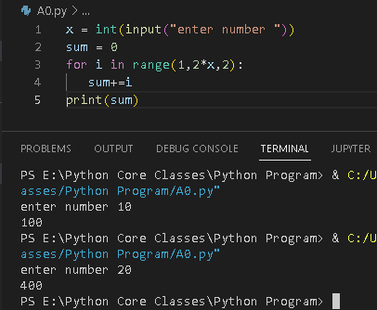

1. Write a python script to calculate sum of first N even natural numbers

