Assignment – 13 List

1. Write a python script to store multiple items in a single variable ( Items are “Java”,“Python”, “SQL”, “C” ) using list

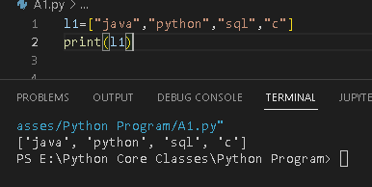

1. Write a python script to get the data type of a list.

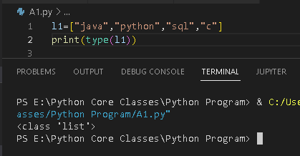

1. Write a python script to get the last item of the list ( mylist = ["Java", "C", "Python"])

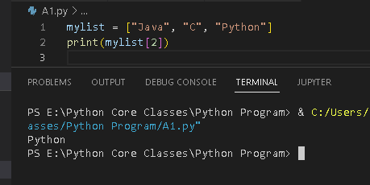

1. Write a python script to Change the values "SQL" and "Reactnative" with the values"NoSQL" and "Flutter" (List is thislist = ["Java", "SQL", "C", "Reactnative","Javascript", "Python"]

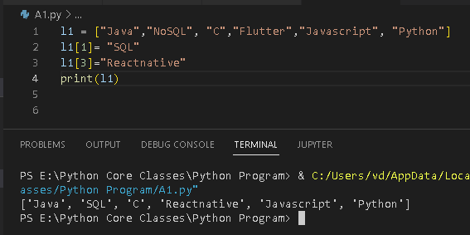

5. Write a python script to add an item to the end of the list (item “Python”. (mylist =

["Java", "SQL", "C", "Reactnative"]

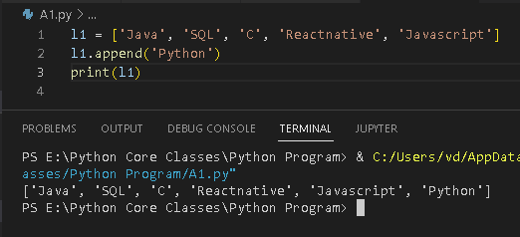

7. Write a python program to Print all items by referring to their index number (thislist =

["Java", "SQL", "C", "Reactnative", "Javascript", "Python"]

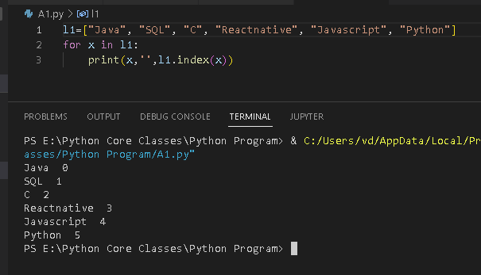

8. Write a python program to sort the list alphanumerically – thislist = ["Java", "SQL",

"C", "Reactjs", "Javascript", "Python"]

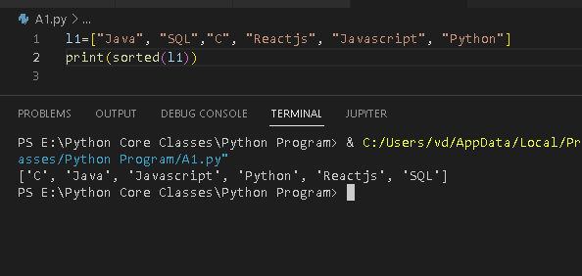

9. Write a Python script to create a list of city names taken from the user.

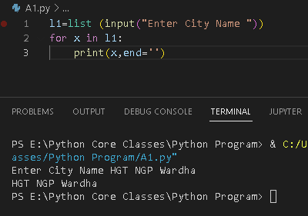

10. Write a Python script to create a list, where each element of the list is a digit of a

given number.

