Assignment – 14 More on List

1. Write a Python script to create a list of first N natural numbers.

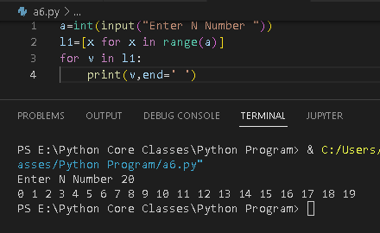

1. Write a Python script to create a list of first N odd natural numbers.

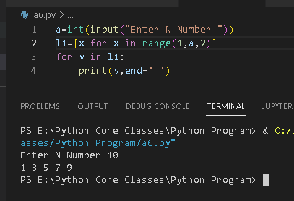

3. Write a Python script to create a list of first N even natural numbers.

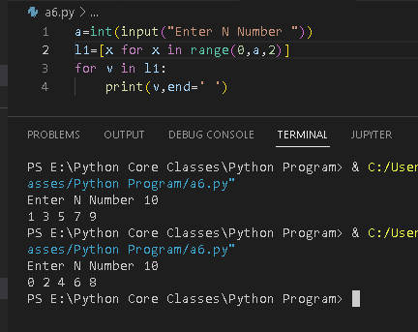

1. Write a Python script to find the greatest number in a given list of numbers.

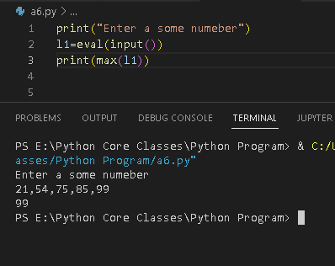

5. Write a Python script to find the smallest number in a given list of numbers.

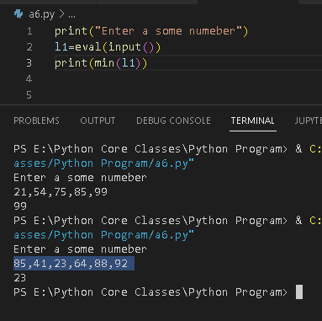

6. Write a Python script to calculate the sum of elements in a given list of numbers.

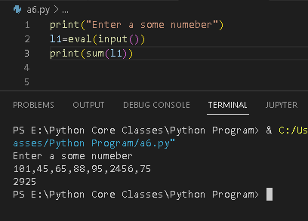

10. Write a python script to sort a list.

