Assignment – 15 Strings

1. Write a python script to create a String in 3 different possible ways

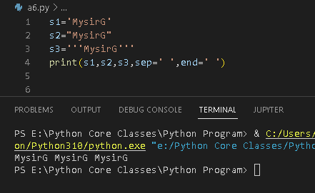

1. Write a python script to Get the characters from the start to position 5 (Given String “iNeuron” using the slice syntax)

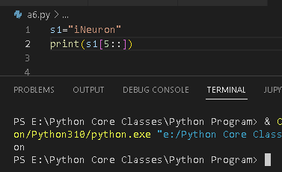

1. Write a python script to Get the characters from position 2 to position 5 (Given String“Hello Learners” using the slice syntax)

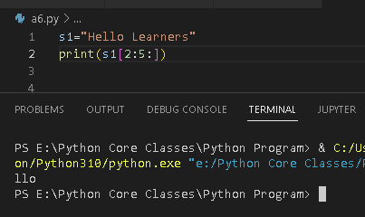

5. Write a python script to get the count of total number of characters in String a=

“iNeuron”

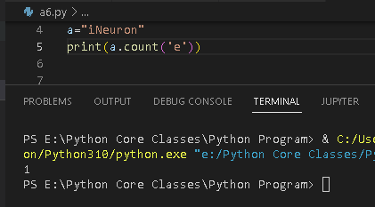

6. Write a python script to reverse a String. (“iNeuron”)

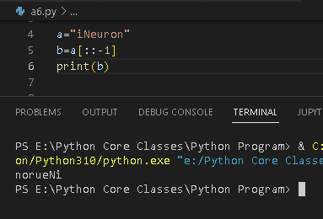

Write a python script to check if a string contains only numbers.

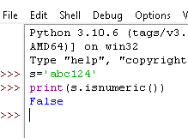

9. Write a python script to check if a string contains only characters of the alphabet.

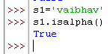

10. Write a python script to convert an integer to a string.

