Assignment – 16 Tuple

1. Write a python script to store multiple items in a single variable ( Items are “Java”,“Python”, “SQL”, “C” ) using tuple

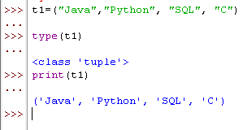

1. Write a python program to store only one item using tuple.

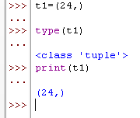

1. Write a python program to reverse the tuple.

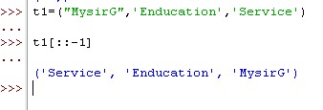

4. Write a python program to Swap two tuples in Python.