Assignment – 17 Set

1. Write a python program to store all the programming languages known to you using Set.

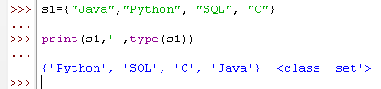

1. Write a python program to store your own information {name, age, gender, so on..}

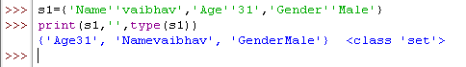

1. Write a python script to get the data type of a Set.

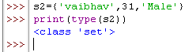

1. Write a Python script to find if “Python” is present in the set thisset = {"Java","Python", "Django"}

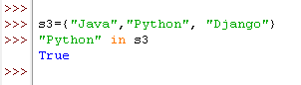

5. Write a python program to add items from another set to the current set. thisset =

{"Java", "Python", "SQL"}

secondset= {"C", "Cpp", "NoSQL"}

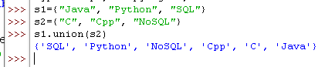

6. Write a python program to add elements of list to a set

thisset = {"Python", "Django", "JavaScript"}

mylist = ["Java", "C"]

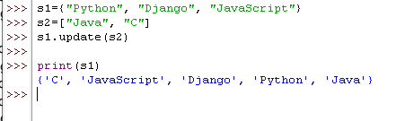

7. Write a python program to remove last item of the given set

thisset = {"Python", "Django", "JavaScript", “SQL”}

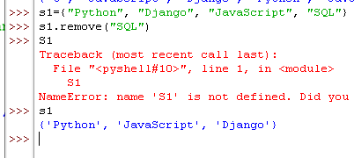

9. Write a python program to loop through the set and print values

thisset = {"Python", "Django", "JavaScript", “SQL”}

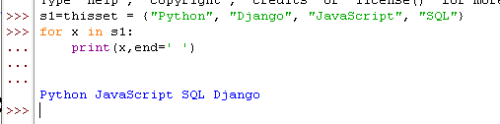

10. Write a python program to find the maximum and minimum value in a set.

