Assignment – 18 Dictionary

1. Write a python program to create and print a dictionary which stores your information.

(name, age, gender .....)

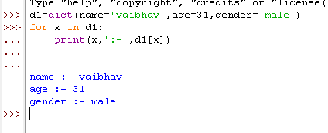

2. Write a python program to access the items of a dictionary by referring to its key

name.

d1={105: 'Payal', 106: 'Arjun', 107: 'Prachi', 102: 'vd'}

d1[107]

'Prachi'

3. Write a python program to get a list of the values from a dictionary.

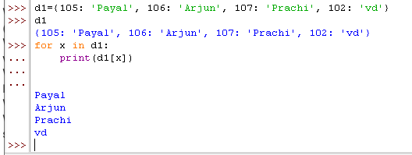

4. Write a python program to change the value of a specific item by referring to its key

name.

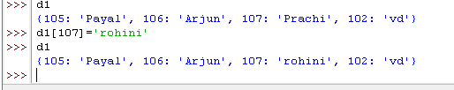

5. Write a python program to print all key names in the dictionary, one by one.

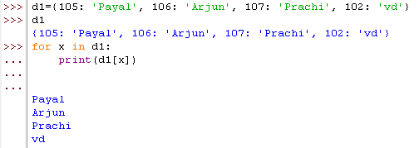

6. Write a python program to create a dictionary that contains three dictionaries.

(nested)