Assignment – 19 Functions

1. Write a python program to create a simple function which prints “MySirG”.

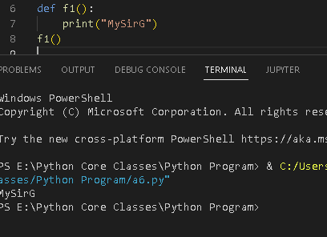

1. Write a python program to create a function which expects two arguments and print them in the function body.

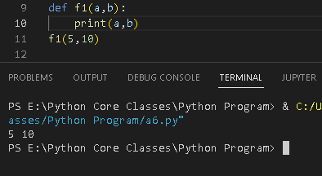

1. Write a python program to create a function which expects an unknown number of arguments.

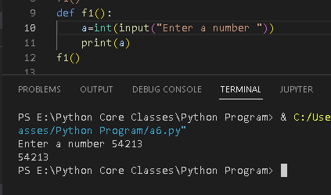

1. Write a python program to create a function which expects kwargs arguments.

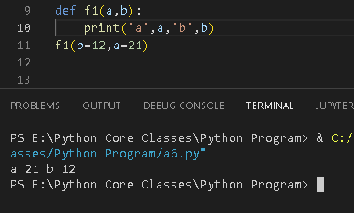

6. Write a python program to create a function that finds a maximum of four numbers.

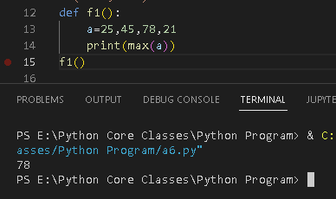

7. Write a python program to sum all the numbers in a list.

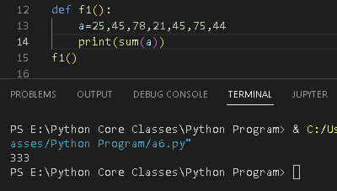

8. Write a python program to multiply all the numbers in a list.

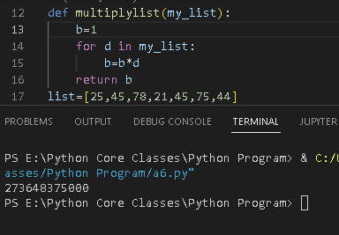

10. Write a python program to create a function to check whether a given number is even

or odd.

