Assignment – 21 Recursion

1. Write a recursive python function to print first N natural numbers.

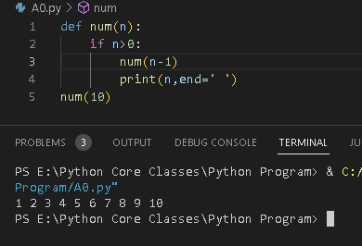

1. Write a recursive python function to print first N natural numbers in reverse order

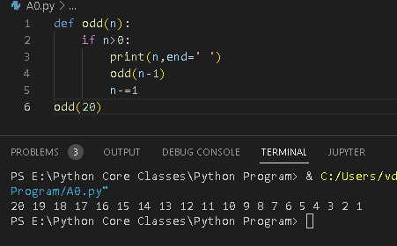

1. Write a recursive python function to print first N odd natural numbers in reverse order

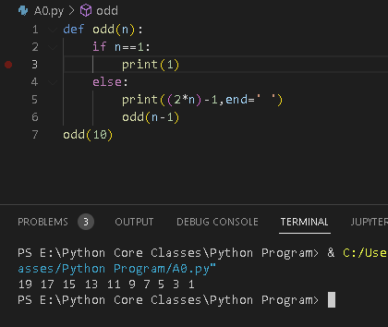

6. Write a recursive python function to print first N even natural numbers in reverse

order..

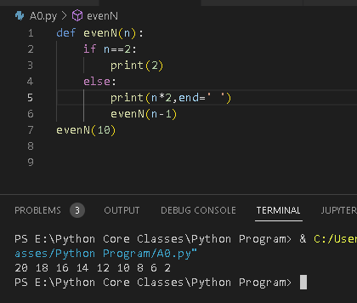

7. Write a recursive python function to print squares of first N natural numbers

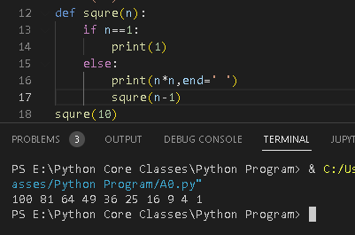

8. Write a recursive python function to print cubes of first N natural numbers

